Resource: Human-made Things in the Bible
Human-made Things in the Bible © United Bible Societies, 2025. Adapted from: The Works of Their Hands: Man-made Things in the Bible, by Ray Pritz © 2009 United Bible Societies. This work is licensed under Creative Commons Attribution-ShareAlike 4.0 International (https://creativecommons.org/licenses/by-sa/4.0/).

Human-made Things in the Bible

Fishing

1.3 Fishing
Boat: See 8.1 Boat, ship<REALIA:8.1>.

Nets

1.3.1 Nets

Casting net

1.3.1.1 Casting net

References:Hebrew מִכְמָר, מִכְמֶרֶת, מִכְמֹרֶת (mikmor, mikmereth, mikmoreth)PSA 141:10, ISA 19:8, HAB 1:15, HAB 1:16Hebrew רֶשֶׁת (resheth)EZK 32:3Greek ἀμφιβάλλω, ἀμφίβληστρον (amfiballō (verb), amfiblēstron)MAT 4:18, MRK 1:16Greek δίκτυον (diktuon)JHN 21:6, JHN 21:8, JHN 21:11, JHN 21:11

Description:
Fisherman casting his net from a boat (© Free Bible Images © David Padfield)The casting net was a circular net with weights and a draw rope around its edge. It was roughly 6–7.5 meters (20–25 feet) in diameter.
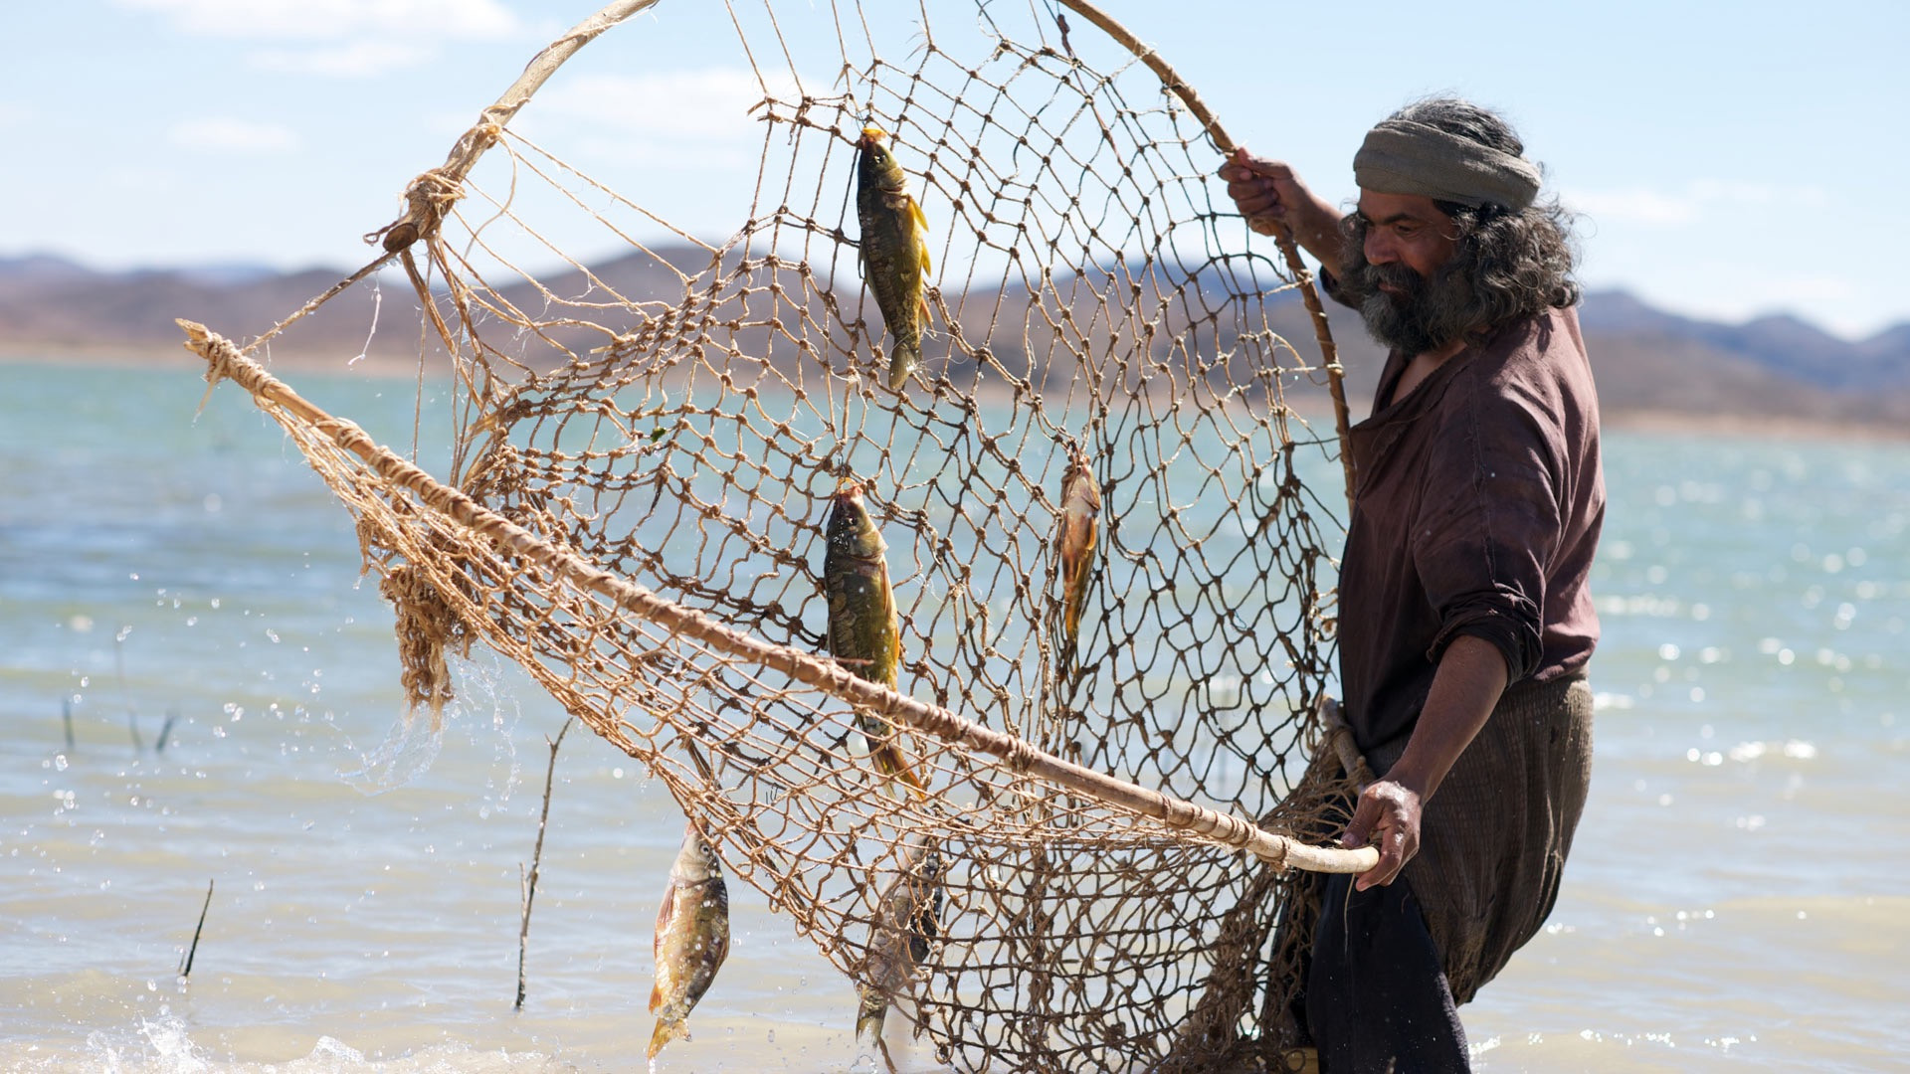

Usage:
Fisherman pulling up a catch of fish in a net (© Free Bible Images © David Padfield)The net was thrown from a boat or the shore in a circular motion so that it landed with the net fully spread out on the water. The weights carried it down, trapping fish underneath. Then the fisherman used the draw rope to close the net and pull it back to himself.
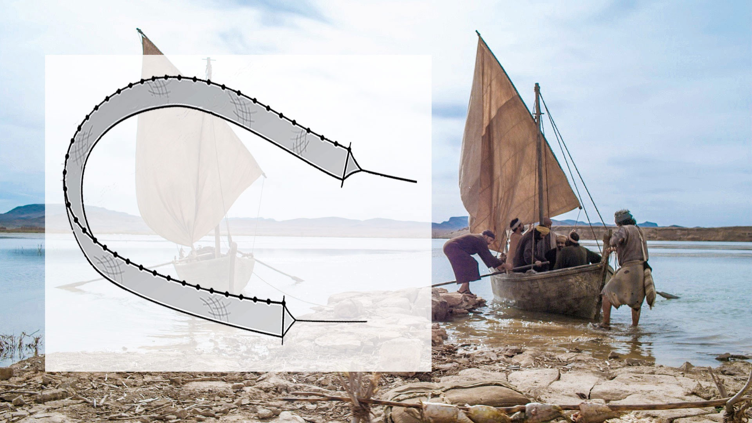

Translation:
It is not necessary to express all the details of the “casting net” in order to render it adequately in another language. What is important is that such a net was thrown rather than dragged. A generic term for “net” may be used in languages that do not have distinct terms for different kinds of nets.
The Hebrew word resheth normally refers to a hunting net for animals or birds (see 1.4.2 Net<REALIA:1.4.2>). In EZK 32:3 it is used in parallel with the Hebrew word cherem, which means “dragnet” (see 1.3.1.2 Dragnet, seine<REALIA:1.3.1.2>). The Hebrew verb that accompanies resheth means “throw” or “spread out,” the action associated with the casting net, and for that reason it is included here. Most translations agree that the context of this verse is fishing and not hunting. However, most translations choose a general word for “net” rather than trying to specify which type of fishing net is intended.
HAB 1:15; HAB 1:16: Two different words for net are used in these verses (see 1.3.1.2 Dragnet, seine<REALIA:1.3.1.2> for a discussion on the other type of net). If different kinds of fishing nets are familiar in a culture, translators will have no difficulty in speaking about them. If they are not, then it will probably be best to use one generic term for both types of fishing nets here (so GNT “nets”).
JHN 21:3: When Peter says “I am going fishing” (GNT), some languages will need to make clear what kind of fishing is intended, whether, for example, Peter will be using a hook and line, a trap, or a net. The most normal method of fishing in biblical times was with nets, and this is the meaning here.

Dragnet, seine

1.3.1.2 Dragnet, seine

References:Hebrew חֵרֶם (cherem)EZK 26:5, EZK 26:14, EZK 32:3, EZK 47:10, HAB 1:15, HAB 1:16, HAB 1:17Greek σαγήνη (sagēnē)MAT 13:47

Description:
Men drawing in a dragnet (George Louis Faber, Public domain, via Wikimedia Commons)The dragnet was a long net hanging vertically in the water with floats at the upper edge and weights at the lower edge.
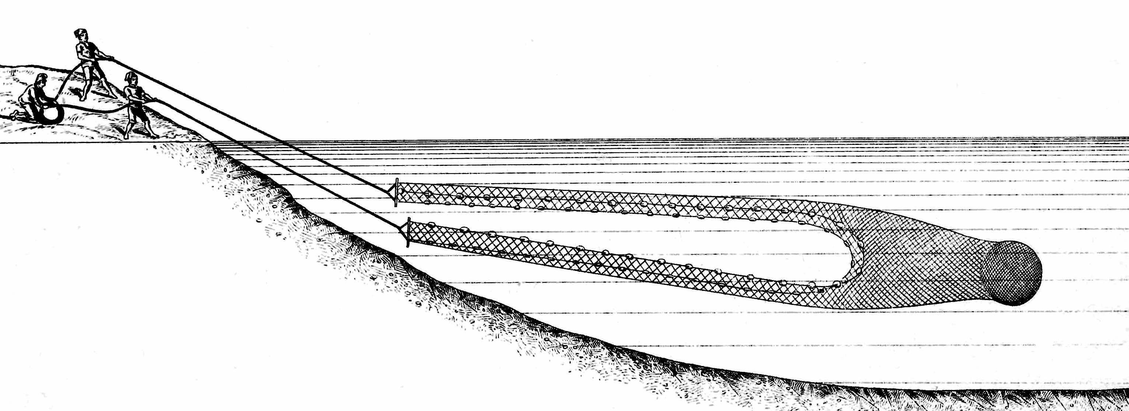

Usage:
The dragnet was drawn in by men working in boats or from shore. As the ends were drawn together to the boat or drawn ashore, fish were trapped in the area enclosed by the net.

Translation:
A generic term for “net” may be used in languages that do not require that a distinction be made.
In MAT 13:47 the actual form of the net is not so important. What is significant is that the net was sufficiently large to catch a large number of different kinds of fish.
HAB 1:15; HAB 1:16; HAB 1:17: See the comments at 1.3.1.1 Casting net<REALIA:1.3.1.1>.

Net, trammel net

1.3.1.3 Net, trammel net

References:Hebrew מָצוֹד (matsod (see also )JOB 19:6, ECC 7:26Hebrew מְצוֹדָה (mtsodah)ECC 9:12Greek δίκτυον (diktuon)MAT 4:20, MAT 4:21, MRK 1:18, MRK 1:19, LUK 5:2, LUK 5:4, LUK 5:5, LUK 5:6

Description:
Fish in a trammel net (Lindsay G. Thompson, University of Washington, CC0, via Wikimedia Commons)The trammel net was actually two or three nets combined in layers, usually a small-mesh inner net sandwiched between two nets of looser mesh.
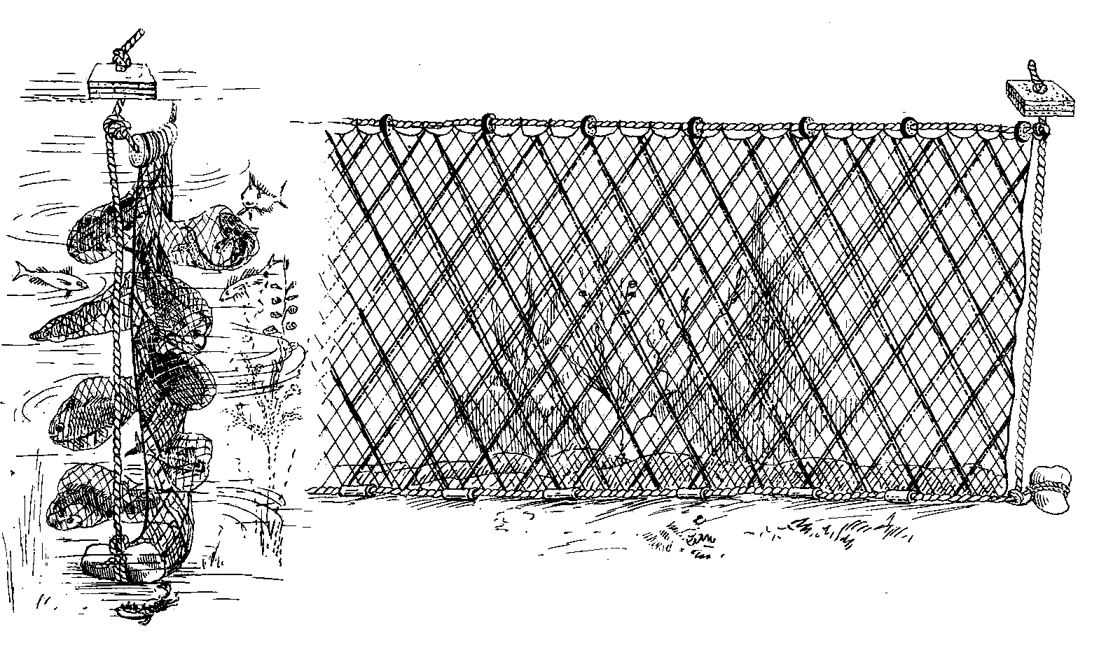

Usage:
Similar to the dragnet, the trammel net was set out vertically in the water, held in place by floats on the surface of the water and weighted down by a single weighted rope at the bottom. Fish swam through the outer layer and into the fine-mesh net (1), pushing it through the other layer of loose mesh (2). This caught the fish in a kind of pocket from which they could not return (3). Unlike the dragnet, which was drawn in immediately after it was spread out, the trammel net was left in place for several hours to give time for fish to accumulate in it.

Translation:
The Hebrew words matsod and mtsodah probably refer to “net” in a generic sense, whether for fishing or for hunting.
In MAT 4:20; MAT 4:21; MRK 1:18; MRK 1:19; and LUK 5:2; LUK 5:4; LUK 5:5; LUK 5:6, it is possible that the Greek word diktuon refers to the dragnet (1.3.1.2), although the plural “nets” makes it likely that a trammel net is meant since it alone was made up of multiple nets. A generic term for “net” may be used in languages that do not require that a distinction be made.

Hook

1.3.2 Hook

References:Hebrew סִירָה, דּוּגָה (sir dugah)AMO 4:2Hebrew צֵן (tsinah)AMO 4:2Greek ἄγκιστρον (agkistron)MAT 17:27

Description:
Metal fish hooks (© Olaf Tausch, CC BY 3.0, via Wikimedia Commons)The fishhook was a small, curved piece of metal or bone or even a strong thorn (in fact, the Hebrew word sir in AMO 4:2 means “thorn”). One end of the hook was sharply pointed, usually with a barb just behind the point. The other end had a loop or bend to which a fishing line could be attached.
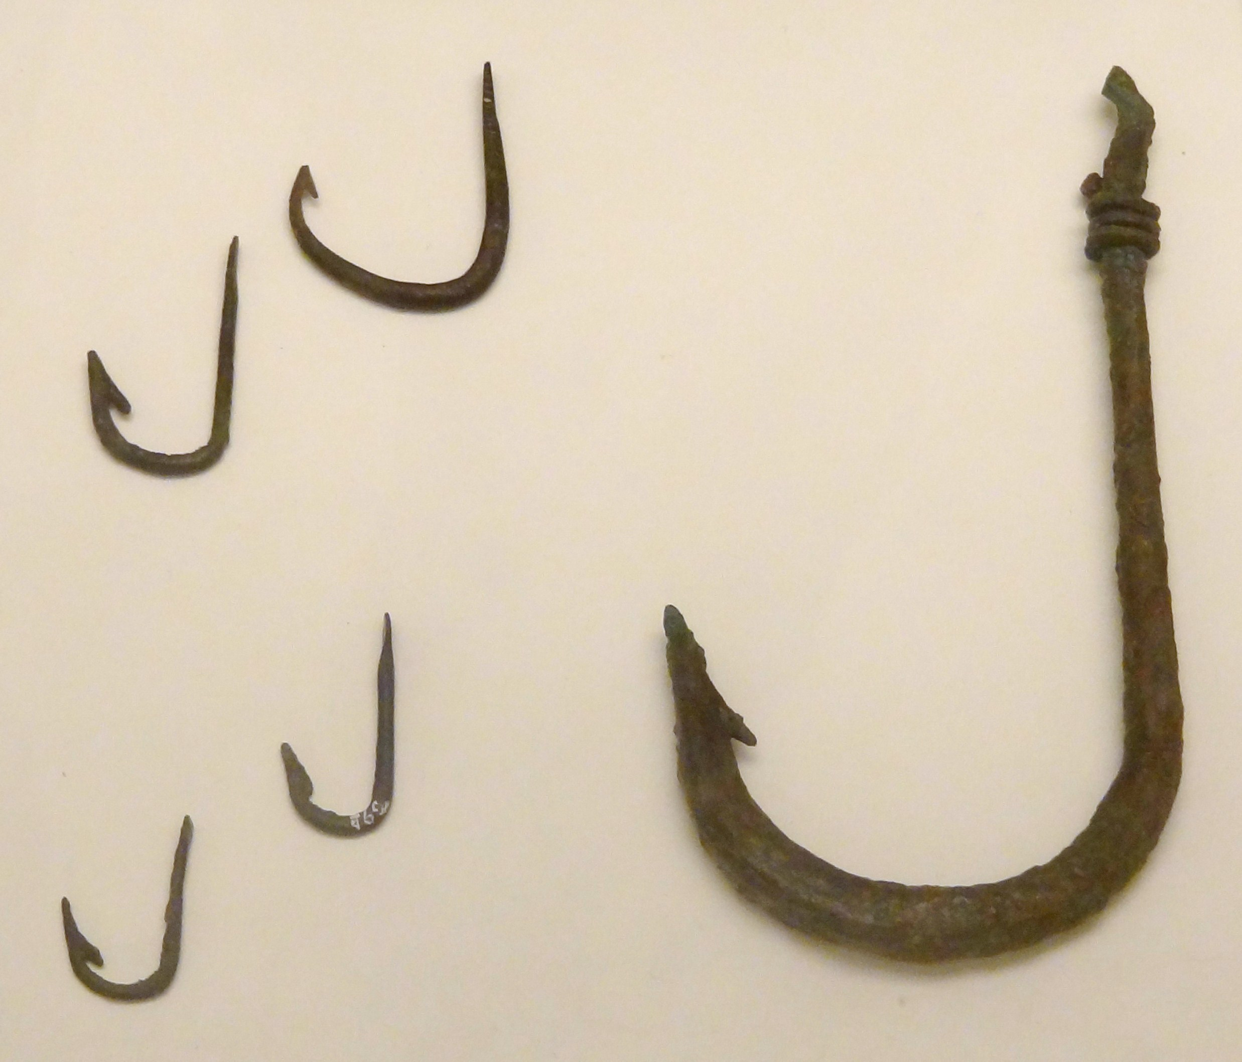

Usage:
Some kind of bait was attached to the fishing hook to attract a fish, and the hook, which was attached to a string, was thrown or lowered into the water. When a fish swallowed the bait, it got stuck on the hook.

Translation:
A literal rendering of MAT 17:27 could be quite misleading, since it would imply that only the hook was thrown into the water. In some languages it may be necessary to make explicit what is implied in order to avoid misunderstanding by expanding the translation to indicate that what was thrown into the water was a line with a baited hook on the end of it.

Fishing spear, harpoon

1.3.3 Fishing spear, harpoon

References:Hebrew חָח, חוֹחַ (chach, choach)2KI 19:28, 2CH 33:11, JOB 40:26, ISA 37:29, EZK 19:4, EZK 19:9, EZK 29:4, EZK 38:4Hebrew חַכָּה (chakah)JOB 40:25, ISA 19:8, HAB 1:15Hebrew מַסָּע (masa‘)JOB 41:18Hebrew שֻׂכָּה (sukah)JOB 40:31Hebrew צִלְצָל (tsiltsal)JOB 40:31

Description:
Point of a harpoon used for fishing (Bronze or Copper alloy, Egypt, ca. 1550–1070 BCE) (Metropolitan Museum of Art, Public domain)The fishing spear/harpoon was a wooden rod about the length of a man. To one end of the spear was attached a metal or bone point with barbs. It is likely that a rope was attached to the other end, so that the spear could be pulled back to the thrower.
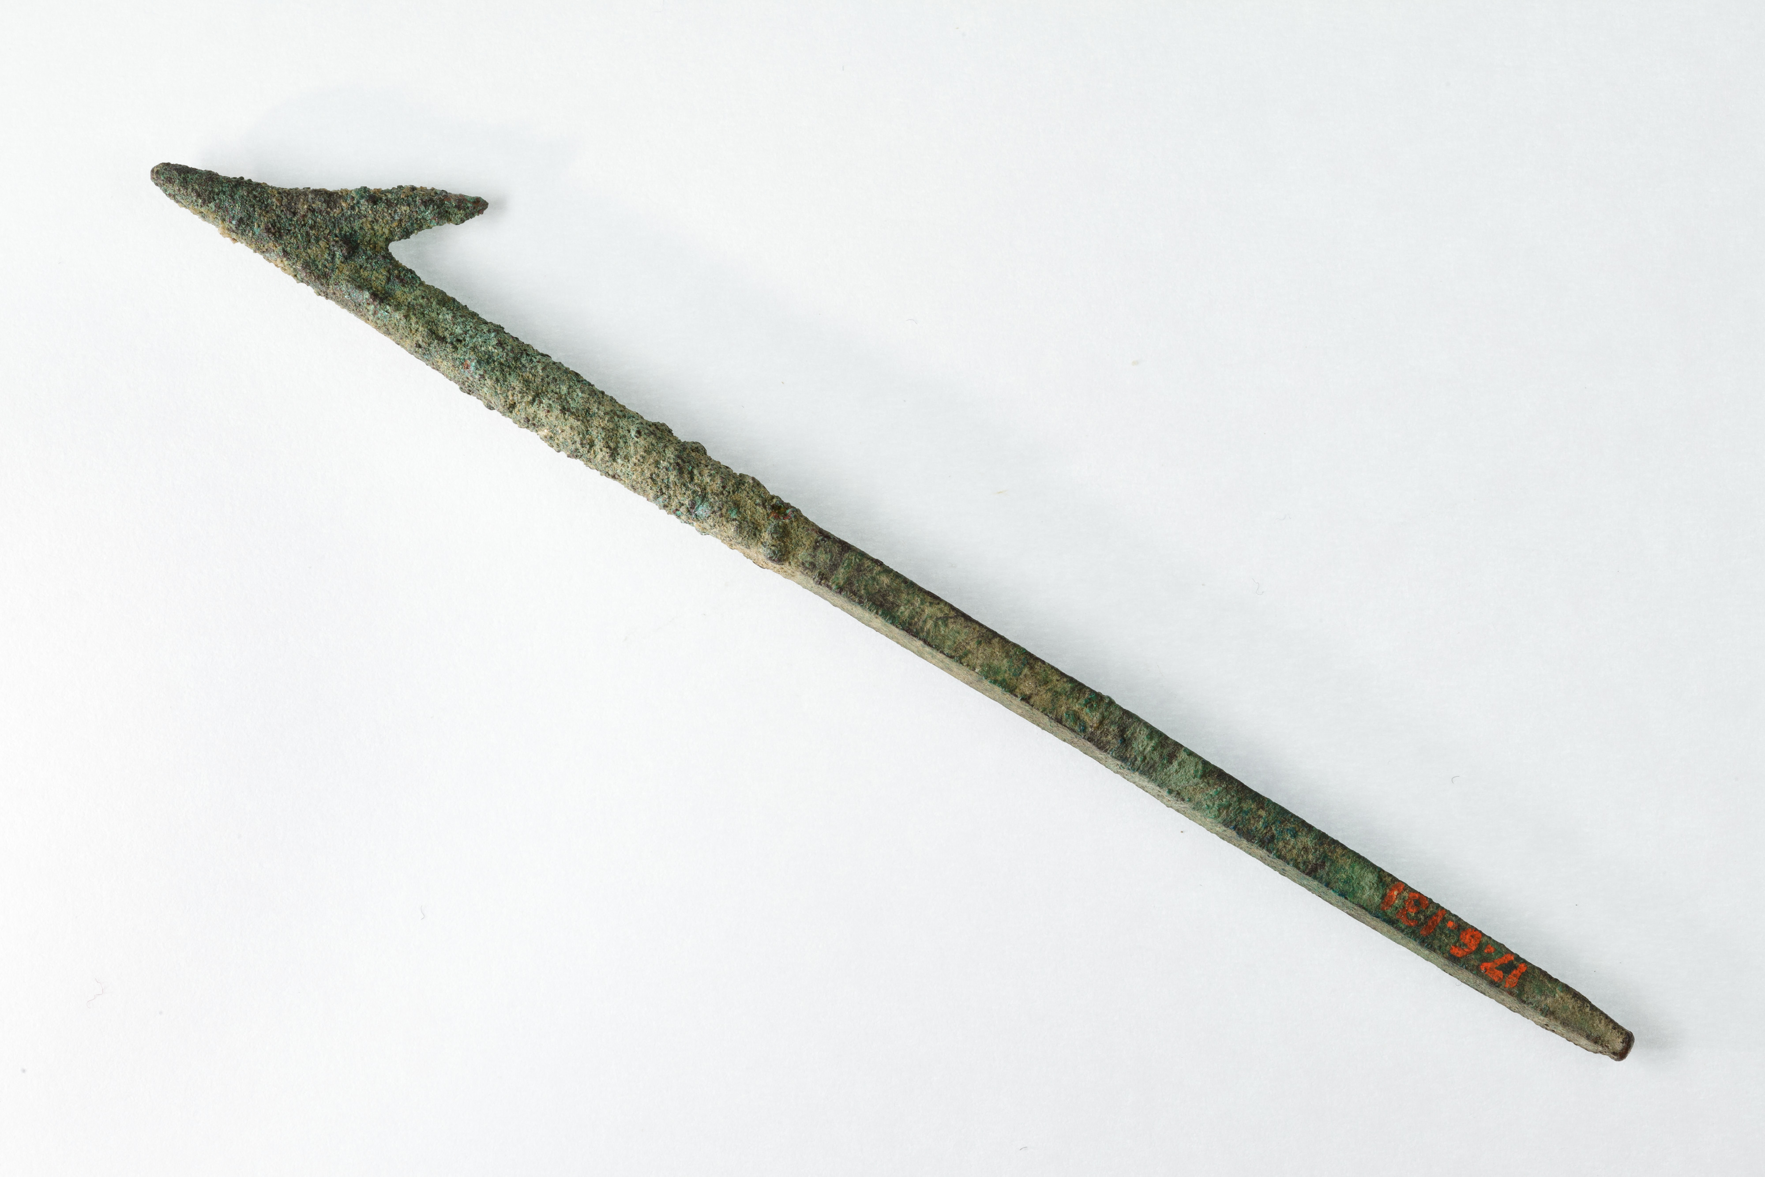

Usage:
The spear was thrown at fish or aquatic animals. The barbs prevented the point from falling out easily. The rope attached to the end opposite the point enabled the thrower to retrieve the spear quickly and easily to prepare for another throw, or to prevent the wounded animal from swimming away with the embedded spear.

Translation:
A Handbook on The Book of Job notes that the Hebrew word choach in JOB 40:26 indicates a kind of hook, but one “much larger than the fishhook in the previous verse” (page 752). The word occurs most often in descriptions of the treatment of prisoners, and this is the way it is used of Leviathan in JOB 40:25; JOB 40:31.
The meaning of the Hebrew word masa‘ in JOB 41:18 is uncertain. From the context it is clear that it is some sort of weapon, perhaps a throwing weapon, for hunting a large animal. The Hebrew text has three words at the end of the verse, which CEV simply combines as “spear.” The word masa‘ is most often rendered “dart” (RSV, NIV, NASB, NCV, REB), but also “missile” (NJPSV), “javelin” (NJB), and “arrow” (GNT). The English word “dart,” despite its popularity in modern translations, will only mean one thing to the modern reader unschooled in the English of King James or Shakespeare, that is, the very small pointed, feathered missile thrown at a board in the game of darts.

