Resource: Human-made Things in the Bible
Human-made Things in the Bible © United Bible Societies, 2025. Adapted from: The Works of Their Hands: Man-made Things in the Bible, by Ray Pritz © 2009 United Bible Societies. This work is licensed under Creative Commons Attribution-ShareAlike 4.0 International (https://creativecommons.org/licenses/by-sa/4.0/).

Human-made Things in the Bible

Artisans

1.5 Artisans

Potter

1.5.1 Potter

Potter’s wheel

1.5.1.1 Potter’s wheel

References:Hebrew אָבְנַיִם (’ovnayim)JER 18:3Greek τροχός (trochos)SIR 38:29

Description:
Potter's wheel (Old Testament times) (© Deutsche Bibelgesellschaft, Stuttgart by United Bible Societies)In Old Testament times the potter’s wheel was a flat, horizontal wheel made of stone. On the underside of the stone there was a pointed projection. This projection sat in an indentation on a stationary lower stone and served as an axis around which the upper stone turned. The stone was turned by hand or perhaps by a person other than the potter. In intertestamental and New Testament times the construction was different. An upper wheel, made of wood, was connected by a shaft to a second, larger wheel situated below. The upper wheel was at a height convenient for the potter to work when seated.
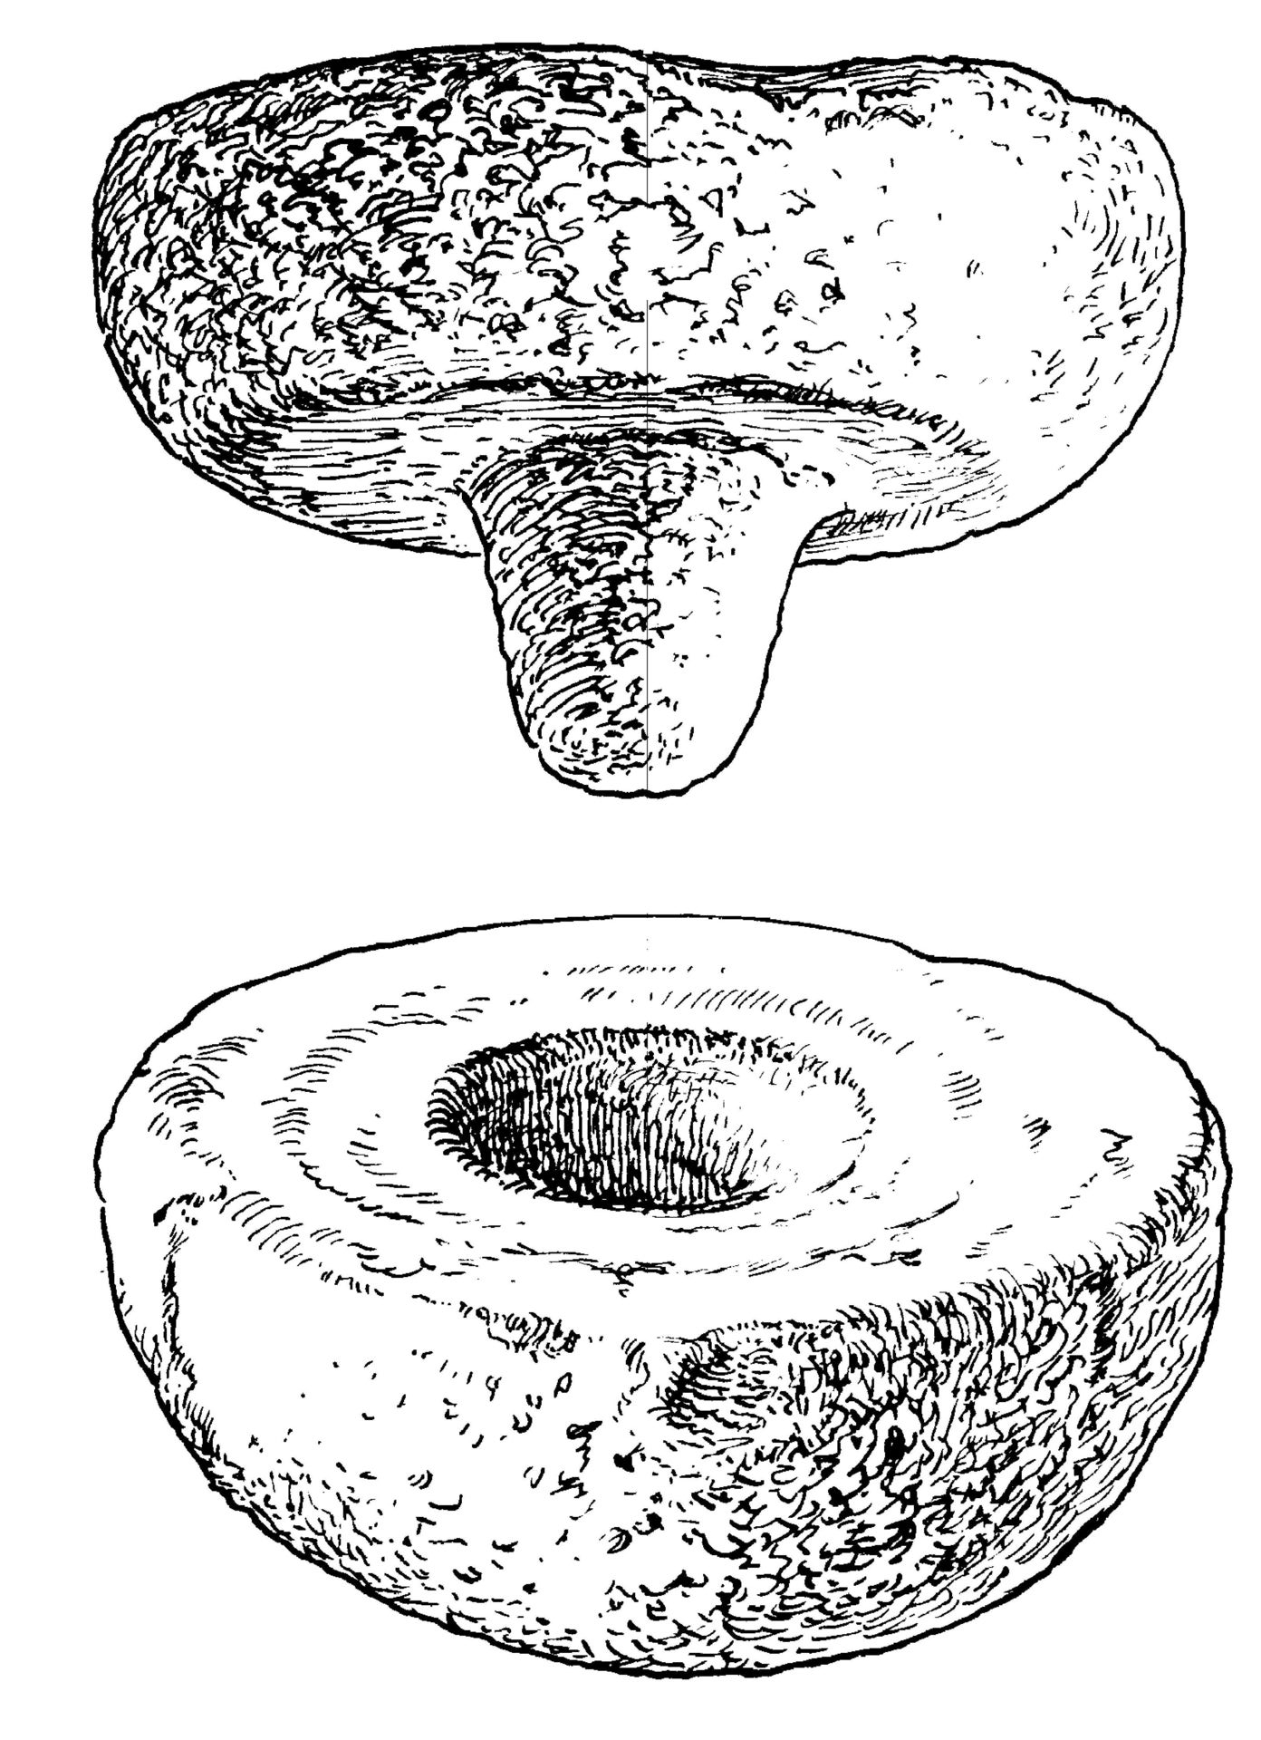

Usage:

Potter’s wheel

1.5.1.1 Potter’s wheel

References:Hebrew אָבְנַיִם (’ovnayim)JER 18:3Greek τροχός (trochos)SIR 38:29

Description:
Potter's wheel (Old Testament times) (© Deutsche Bibelgesellschaft, Stuttgart by United Bible Societies)In Old Testament times the potter’s wheel was a flat, horizontal wheel made of stone. On the underside of the stone there was a pointed projection. This projection sat in an indentation on a stationary lower stone and served as an axis around which the upper stone turned. The stone was turned by hand or perhaps by a person other than the potter. In intertestamental and New Testament times the construction was different. An upper wheel, made of wood, was connected by a shaft to a second, larger wheel situated below. The upper wheel was at a height convenient for the potter to work when seated.

Usage:

Potter’s wheel

1.5.1.1 Potter’s wheel

References:Hebrew אָבְנַיִם (’ovnayim)JER 18:3Greek τροχός (trochos)SIR 38:29

Description:
Potter's wheel (Old Testament times) (© Deutsche Bibelgesellschaft, Stuttgart by United Bible Societies)In Old Testament times the potter’s wheel was a flat, horizontal wheel made of stone. On the underside of the stone there was a pointed projection. This projection sat in an indentation on a stationary lower stone and served as an axis around which the upper stone turned. The stone was turned by hand or perhaps by a person other than the potter. In intertestamental and New Testament times the construction was different. An upper wheel, made of wood, was connected by a shaft to a second, larger wheel situated below. The upper wheel was at a height convenient for the potter to work when seated.

Usage:

Potter’s wheel

1.5.1.1 Potter’s wheel

References:Hebrew אָבְנַיִם (’ovnayim)JER 18:3Greek τροχός (trochos)SIR 38:29

Description:
Potter's wheel (Old Testament times) (© Deutsche Bibelgesellschaft, Stuttgart by United Bible Societies)In Old Testament times the potter’s wheel was a flat, horizontal wheel made of stone. On the underside of the stone there was a pointed projection. This projection sat in an indentation on a stationary lower stone and served as an axis around which the upper stone turned. The stone was turned by hand or perhaps by a person other than the potter. In intertestamental and New Testament times the construction was different. An upper wheel, made of wood, was connected by a shaft to a second, larger wheel situated below. The upper wheel was at a height convenient for the potter to work when seated.

Usage:

Potter’s wheel

1.5.1.1 Potter’s wheel

References:Hebrew אָבְנַיִם (’ovnayim)JER 18:3Greek τροχός (trochos)SIR 38:29

Description:
Potter's wheel (Old Testament times) (© Deutsche Bibelgesellschaft, Stuttgart by United Bible Societies)In Old Testament times the potter’s wheel was a flat, horizontal wheel made of stone. On the underside of the stone there was a pointed projection. This projection sat in an indentation on a stationary lower stone and served as an axis around which the upper stone turned. The stone was turned by hand or perhaps by a person other than the potter. In intertestamental and New Testament times the construction was different. An upper wheel, made of wood, was connected by a shaft to a second, larger wheel situated below. The upper wheel was at a height convenient for the potter to work when seated.

Usage:

Potter’s wheel

1.5.1.1 Potter’s wheel

References:Hebrew אָבְנַיִם (’ovnayim)JER 18:3Greek τροχός (trochos)SIR 38:29

Description:
Potter's wheel (Old Testament times) (© Deutsche Bibelgesellschaft, Stuttgart by United Bible Societies)In Old Testament times the potter’s wheel was a flat, horizontal wheel made of stone. On the underside of the stone there was a pointed projection. This projection sat in an indentation on a stationary lower stone and served as an axis around which the upper stone turned. The stone was turned by hand or perhaps by a person other than the potter. In intertestamental and New Testament times the construction was different. An upper wheel, made of wood, was connected by a shaft to a second, larger wheel situated below. The upper wheel was at a height convenient for the potter to work when seated.

Usage:

Potter’s wheel

1.5.1.1 Potter’s wheel

References:Hebrew אָבְנַיִם (’ovnayim)JER 18:3Greek τροχός (trochos)SIR 38:29

Description:
Potter's wheel (Old Testament times) (© Deutsche Bibelgesellschaft, Stuttgart by United Bible Societies)In Old Testament times the potter’s wheel was a flat, horizontal wheel made of stone. On the underside of the stone there was a pointed projection. This projection sat in an indentation on a stationary lower stone and served as an axis around which the upper stone turned. The stone was turned by hand or perhaps by a person other than the potter. In intertestamental and New Testament times the construction was different. An upper wheel, made of wood, was connected by a shaft to a second, larger wheel situated below. The upper wheel was at a height convenient for the potter to work when seated.

Usage:

Potter’s wheel

1.5.1.1 Potter’s wheel

References:Hebrew אָבְנַיִם (’ovnayim)JER 18:3Greek τροχός (trochos)SIR 38:29

Description:
Potter's wheel (Old Testament times) (© Deutsche Bibelgesellschaft, Stuttgart by United Bible Societies)In Old Testament times the potter’s wheel was a flat, horizontal wheel made of stone. On the underside of the stone there was a pointed projection. This projection sat in an indentation on a stationary lower stone and served as an axis around which the upper stone turned. The stone was turned by hand or perhaps by a person other than the potter. In intertestamental and New Testament times the construction was different. An upper wheel, made of wood, was connected by a shaft to a second, larger wheel situated below. The upper wheel was at a height convenient for the potter to work when seated.

Usage:

Potter’s wheel

1.5.1.1 Potter’s wheel

References:Hebrew אָבְנַיִם (’ovnayim)JER 18:3Greek τροχός (trochos)SIR 38:29

Description:
Potter's wheel (Old Testament times) (© Deutsche Bibelgesellschaft, Stuttgart by United Bible Societies)In Old Testament times the potter’s wheel was a flat, horizontal wheel made of stone. On the underside of the stone there was a pointed projection. This projection sat in an indentation on a stationary lower stone and served as an axis around which the upper stone turned. The stone was turned by hand or perhaps by a person other than the potter. In intertestamental and New Testament times the construction was different. An upper wheel, made of wood, was connected by a shaft to a second, larger wheel situated below. The upper wheel was at a height convenient for the potter to work when seated.

Usage:

Potter’s wheel

1.5.1.1 Potter’s wheel

References:Hebrew אָבְנַיִם (’ovnayim)JER 18:3Greek τροχός (trochos)SIR 38:29

Description:
Potter's wheel (Old Testament times) (© Deutsche Bibelgesellschaft, Stuttgart by United Bible Societies)In Old Testament times the potter’s wheel was a flat, horizontal wheel made of stone. On the underside of the stone there was a pointed projection. This projection sat in an indentation on a stationary lower stone and served as an axis around which the upper stone turned. The stone was turned by hand or perhaps by a person other than the potter. In intertestamental and New Testament times the construction was different. An upper wheel, made of wood, was connected by a shaft to a second, larger wheel situated below. The upper wheel was at a height convenient for the potter to work when seated.

Usage:

Potter’s wheel

1.5.1.1 Potter’s wheel

References:Hebrew אָבְנַיִם (’ovnayim)JER 18:3Greek τροχός (trochos)SIR 38:29

Description:
Potter's wheel (Old Testament times) (© Deutsche Bibelgesellschaft, Stuttgart by United Bible Societies)In Old Testament times the potter’s wheel was a flat, horizontal wheel made of stone. On the underside of the stone there was a pointed projection. This projection sat in an indentation on a stationary lower stone and served as an axis around which the upper stone turned. The stone was turned by hand or perhaps by a person other than the potter. In intertestamental and New Testament times the construction was different. An upper wheel, made of wood, was connected by a shaft to a second, larger wheel situated below. The upper wheel was at a height convenient for the potter to work when seated.

Usage:

Potter’s wheel

1.5.1.1 Potter’s wheel

References:Hebrew אָבְנַיִם (’ovnayim)JER 18:3Greek τροχός (trochos)SIR 38:29

Description:
Potter's wheel (Old Testament times) (© Deutsche Bibelgesellschaft, Stuttgart by United Bible Societies)In Old Testament times the potter’s wheel was a flat, horizontal wheel made of stone. On the underside of the stone there was a pointed projection. This projection sat in an indentation on a stationary lower stone and served as an axis around which the upper stone turned. The stone was turned by hand or perhaps by a person other than the potter. In intertestamental and New Testament times the construction was different. An upper wheel, made of wood, was connected by a shaft to a second, larger wheel situated below. The upper wheel was at a height convenient for the potter to work when seated.

Usage:

Potter’s wheel

1.5.1.1 Potter’s wheel

References:Hebrew אָבְנַיִם (’ovnayim)JER 18:3Greek τροχός (trochos)SIR 38:29

Description:
Potter's wheel (Old Testament times) (© Deutsche Bibelgesellschaft, Stuttgart by United Bible Societies)In Old Testament times the potter’s wheel was a flat, horizontal wheel made of stone. On the underside of the stone there was a pointed projection. This projection sat in an indentation on a stationary lower stone and served as an axis around which the upper stone turned. The stone was turned by hand or perhaps by a person other than the potter. In intertestamental and New Testament times the construction was different. An upper wheel, made of wood, was connected by a shaft to a second, larger wheel situated below. The upper wheel was at a height convenient for the potter to work when seated.

Usage:

Potter’s wheel

1.5.1.1 Potter’s wheel

References:Hebrew אָבְנַיִם (’ovnayim)JER 18:3Greek τροχός (trochos)SIR 38:29

Description:
Potter's wheel (Old Testament times) (© Deutsche Bibelgesellschaft, Stuttgart by United Bible Societies)In Old Testament times the potter’s wheel was a flat, horizontal wheel made of stone. On the underside of the stone there was a pointed projection. This projection sat in an indentation on a stationary lower stone and served as an axis around which the upper stone turned. The stone was turned by hand or perhaps by a person other than the potter. In intertestamental and New Testament times the construction was different. An upper wheel, made of wood, was connected by a shaft to a second, larger wheel situated below. The upper wheel was at a height convenient for the potter to work when seated.

Usage:

Potter’s wheel

1.5.1.1 Potter’s wheel

References:Hebrew אָבְנַיִם (’ovnayim)JER 18:3Greek τροχός (trochos)SIR 38:29

Description:
Potter's wheel (Old Testament times) (© Deutsche Bibelgesellschaft, Stuttgart by United Bible Societies)In Old Testament times the potter’s wheel was a flat, horizontal wheel made of stone. On the underside of the stone there was a pointed projection. This projection sat in an indentation on a stationary lower stone and served as an axis around which the upper stone turned. The stone was turned by hand or perhaps by a person other than the potter. In intertestamental and New Testament times the construction was different. An upper wheel, made of wood, was connected by a shaft to a second, larger wheel situated below. The upper wheel was at a height convenient for the potter to work when seated.

Usage:

Potter’s wheel

1.5.1.1 Potter’s wheel

References:Hebrew אָבְנַיִם (’ovnayim)JER 18:3Greek τροχός (trochos)SIR 38:29

Description:
Potter's wheel (Old Testament times) (© Deutsche Bibelgesellschaft, Stuttgart by United Bible Societies)In Old Testament times the potter’s wheel was a flat, horizontal wheel made of stone. On the underside of the stone there was a pointed projection. This projection sat in an indentation on a stationary lower stone and served as an axis around which the upper stone turned. The stone was turned by hand or perhaps by a person other than the potter. In intertestamental and New Testament times the construction was different. An upper wheel, made of wood, was connected by a shaft to a second, larger wheel situated below. The upper wheel was at a height convenient for the potter to work when seated.

Usage:

Potter’s wheel

1.5.1.1 Potter’s wheel

References:Hebrew אָבְנַיִם (’ovnayim)JER 18:3Greek τροχός (trochos)SIR 38:29

Description:
Potter's wheel (Old Testament times) (© Deutsche Bibelgesellschaft, Stuttgart by United Bible Societies)In Old Testament times the potter’s wheel was a flat, horizontal wheel made of stone. On the underside of the stone there was a pointed projection. This projection sat in an indentation on a stationary lower stone and served as an axis around which the upper stone turned. The stone was turned by hand or perhaps by a person other than the potter. In intertestamental and New Testament times the construction was different. An upper wheel, made of wood, was connected by a shaft to a second, larger wheel situated below. The upper wheel was at a height convenient for the potter to work when seated.

Usage:

Potter’s wheel

1.5.1.1 Potter’s wheel

References:Hebrew אָבְנַיִם (’ovnayim)JER 18:3Greek τροχός (trochos)SIR 38:29

Description:
Potter's wheel (Old Testament times) (© Deutsche Bibelgesellschaft, Stuttgart by United Bible Societies)In Old Testament times the potter’s wheel was a flat, horizontal wheel made of stone. On the underside of the stone there was a pointed projection. This projection sat in an indentation on a stationary lower stone and served as an axis around which the upper stone turned. The stone was turned by hand or perhaps by a person other than the potter. In intertestamental and New Testament times the construction was different. An upper wheel, made of wood, was connected by a shaft to a second, larger wheel situated below. The upper wheel was at a height convenient for the potter to work when seated.

Usage:

Potter’s wheel

1.5.1.1 Potter’s wheel

References:Hebrew אָבְנַיִם (’ovnayim)JER 18:3Greek τροχός (trochos)SIR 38:29

Description:
Potter's wheel (Old Testament times) (© Deutsche Bibelgesellschaft, Stuttgart by United Bible Societies)In Old Testament times the potter’s wheel was a flat, horizontal wheel made of stone. On the underside of the stone there was a pointed projection. This projection sat in an indentation on a stationary lower stone and served as an axis around which the upper stone turned. The stone was turned by hand or perhaps by a person other than the potter. In intertestamental and New Testament times the construction was different. An upper wheel, made of wood, was connected by a shaft to a second, larger wheel situated below. The upper wheel was at a height convenient for the potter to work when seated.

Usage:

