Resource: Human-made Things in the Bible
Human-made Things in the Bible © United Bible Societies, 2025. Adapted from: The Works of Their Hands: Man-made Things in the Bible, by Ray Pritz © 2009 United Bible Societies. This work is licensed under Creative Commons Attribution-ShareAlike 4.0 International (https://creativecommons.org/licenses/by-sa/4.0/).

Human-made Things in the Bible

Commerce

1.6 Commerce

Balance scales

1.6.1 Balance scales

References:Hebrew מֹאזְנַיִם (m’oznayim)LEV 19:36, JOB 6:2, JOB 31:6, PSA 62:10, PRO 11:1, PRO 16:11, PRO 20:23, ISA 40:12, ISA 40:15, JER 32:10, EZK 5:1, EZK 45:10, HOS 12:8, AMO 8:5, MIC 6:11Aramaic מֹאזְנֵא (mo’zne’)DAN 5:27Hebrew פֶּלֶס (peles)PRO 16:11, ISA 40:12Hebrew קָנֶה (qaneh)ISA 46:6Greek ζυγός (zugos)REV 6:5, SIR 21:25, SIR 28:25, SIR 42:4Greek πλάστιγξ (plastigx)WIS 11:22, 2MA 9:8Greek ῥοπή (rhopē)SIR 1:22Greek σταθμός (stathmion, stathmos)SIR 6:15, SIR 26:15, SIR 28:25Latin statera2ES 3:34, 2ES 4:36

Description:
Balance scales (Gary Todd, Israel Museum, CC0, via Wikimedia Commons)The balance scales were an instrument for weighing objects. Ancient balance scales often consisted of a rod held by a cord or a chain in the middle and with pans attached to both ends.
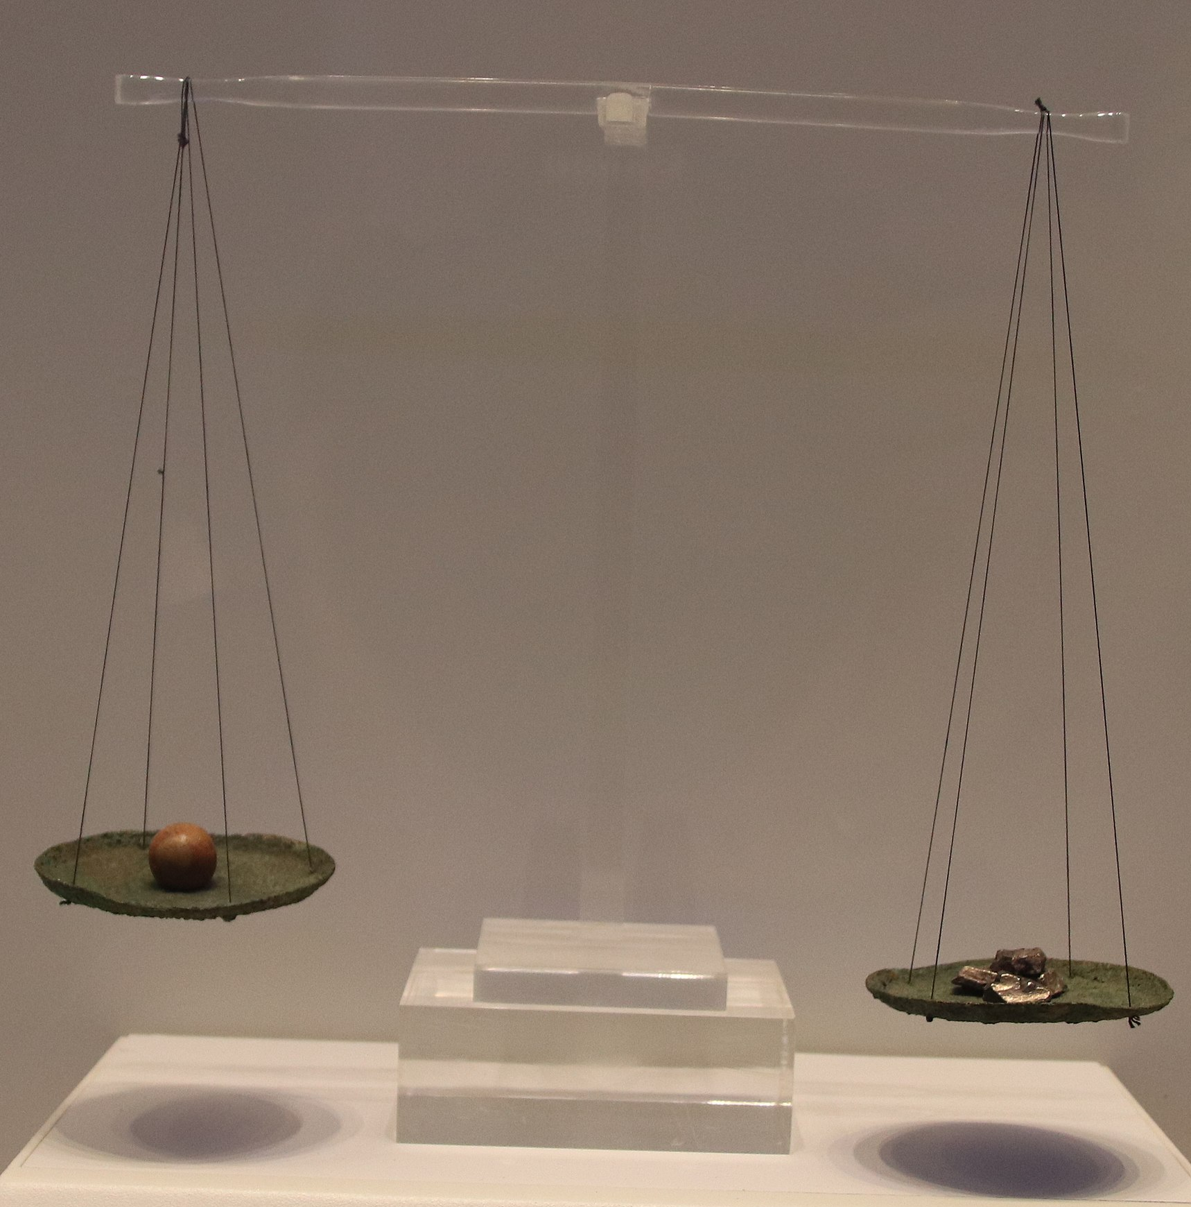

Usage:
Weights were placed in one pan, while the items to be weighed were placed in the other. When the rod was parallel to the ground, then the items in the two pans were of equal weight.

Translation:
“Balance scales” may be rendered in some languages as “tool for weighing” or “instrument for knowing how much something weighs.” The translator should avoid using an anachronistic word for modern types of scales, such as a spring scale or a hydraulic scale.
Balance scales (Image generated by ChatGPT using OpenAI technology)Weights (and also measures of volume) from different time periods have been uncovered in various archaeological sites. The weights generally were made of stone, were spherical in shape, and were identified by having their names engraved on them. Because of their rustic manufacture, they were not “accurate” or “just” in a precise modern sense. However, they served as normative standards in a given period and region, although they differed according to time and place. For this reason the equivalents in terms of modern weights are only approximate.
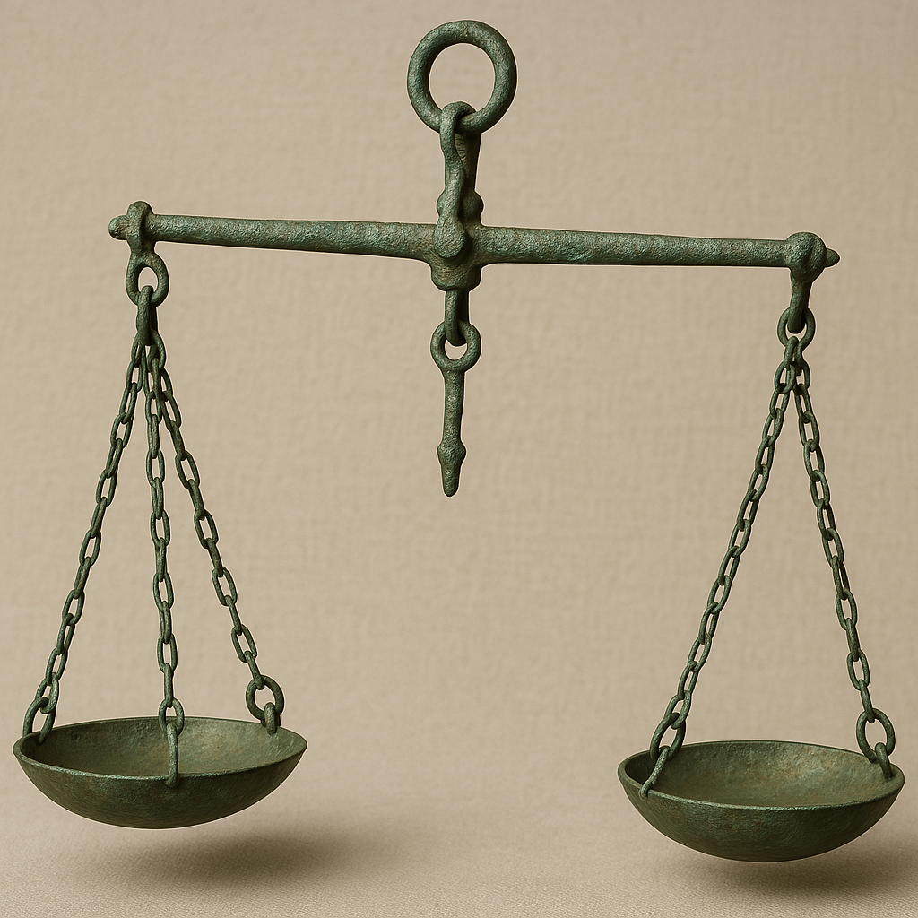
Because the ancient scale compared the relative weights of two objects, in the intertestamental period it became a symbol for considering the relative value or right and wrong of two activities or choices. Compare the English idiom “weigh his actions.” This figurative usage appears in SIR 1:22; SIR 21:25; SIR 28:25; and to a slightly lesser extent in DAN 5:27. Translators will often prefer to abandon the physical object and translate according to the meaning; compare GNT at SIR 21:25, which reads “the wise will consider the consequences of what they say.” Similarly, at SIR 1:22, instead of the literal text “a man’s anger tips the scale to his ruin” (RSV), GNT has “it [anger] can bring about your downfall.”

Stone weights

1.6.2 Stone weights

References:Hebrew אֶבֶן (’even)LEV 19:36, DEU 25:13, DEU 25:13, DEU 25:15, 2SA 14:26, PRO 11:1, PRO 16:11, PRO 20:10, PRO 20:10, PRO 20:23, PRO 20:23, MIC 6:11Greek σταθμίον (stathmion)SIR 42:4

Description and usage:
Stone weights (© Chamberi, CC BY-SA 3.0, via Wikimedia Commons)Stones of various sizes and weights were used on balance scales to determine the price of produce being sold (see 1.6.1 Balance scales<REALIA:1.6.1>). The stones were usually marked with their weights.
<image: 2Q==>

Translation:
In most of the references above, the weights are a means of determining the amount to be paid for something; that is, they are a tool for conducting business dealings. So in some of the passages the reference to weights may be left implied; for example, in PRO 16:11CEV has “The LORD doesn’t like it when we cheat in business.”
While the Hebrew word ’even literally means “stone,” in the references listed above, where the translator decides to indicate the physical object, it will normally be best to translate ’even as “weight.”

Money, coins

1.6.3 Money, coins

References:Hebrew כֶּסֶף (kesef)GEN 13:2, GEN 17:13, GEN 17:23, GEN 17:27, GEN 20:16, GEN 23:9, GEN 23:13, GEN 23:15, GEN 23:16, GEN 23:16, GEN 24:35, GEN 31:15, GEN 37:28, GEN 42:25, GEN 42:27, GEN 42:28, GEN 42:35, GEN 42:35, GEN 43:12, GEN 43:12, GEN 43:15, GEN 43:18, GEN 43:21, GEN 43:21, GEN 43:22, GEN 43:22, GEN 43:23, GEN 44:1, GEN 44:2, GEN 44:8, GEN 44:8, GEN 45:22, GEN 47:14, GEN 47:14, GEN 47:15, GEN 47:15, GEN 47:16, GEN 47:18, EXO 12:44, EXO 21:11, EXO 21:21, EXO 21:32, EXO 21:34, EXO 21:35, EXO 22:6, EXO 22:16, EXO 22:24, EXO 25:3, EXO 30:16, EXO 35:5, EXO 35:24, EXO 38:25, EXO 38:27, LEV 5:15, LEV 22:11, LEV 25:37, LEV 25:50, LEV 25:51, LEV 27:3, LEV 27:6, LEV 27:6, LEV 27:15, LEV 27:16, LEV 27:18, LEV 27:19, NUM 3:48, NUM 3:49, NUM 3:50, NUM 3:51, NUM 18:16, NUM 22:18, NUM 24:13, NUM 31:22, DEU 2:6, DEU 2:6, DEU 2:28, DEU 2:28, DEU 8:13, DEU 14:25, DEU 14:25, DEU 14:26, DEU 17:17, DEU 21:14, DEU 22:19, DEU 22:29, DEU 23:20, JOS 6:19, JOS 6:24, JOS 7:21, JOS 7:21, JOS 7:22, JOS 7:24, JOS 22:8, JDG 5:19, JDG 9:4, JDG 16:5, JDG 16:18, JDG 17:2, JDG 17:2, JDG 17:3, JDG 17:3, JDG 17:4, JDG 17:4, JDG 17:10, 1SA 2:36, 1SA 9:8, 2SA 8:11, 2SA 18:11, 2SA 18:12, 2SA 21:4, 2SA 24:24, 1KI 7:51, 1KI 10:22, 1KI 10:27, 1KI 10:29, 1KI 15:15, 1KI 15:18, 1KI 15:19, 1KI 16:24, 1KI 20:3, 1KI 20:5, 1KI 20:7, 1KI 20:39, 1KI 21:2, 1KI 21:6, 1KI 21:15, 2KI 5:5, 2KI 5:22, 2KI 5:23, 2KI 5:26, 2KI 6:25, 2KI 6:25, 2KI 7:8, 2KI 12:5, 2KI 12:5, 2KI 12:5, 2KI 12:5, 2KI 12:8, 2KI 12:9, 2KI 12:10, 2KI 12:11, 2KI 12:11, 2KI 12:12, 2KI 12:14, 2KI 12:16, 2KI 12:17, 2KI 12:17, 2KI 15:19, 2KI 15:20, 2KI 15:20, 2KI 16:8, 2KI 18:14, 2KI 18:15, 2KI 20:13, 2KI 22:4, 2KI 22:7, 2KI 22:9, 2KI 23:33, 2KI 23:35, 2KI 23:35, 2KI 23:35, 1CH 18:11, 1CH 19:6, 1CH 21:22, 1CH 21:24, 1CH 29:3, 1CH 29:7, 2CH 1:15, 2CH 1:17, 2CH 5:1, 2CH 9:14, 2CH 9:27, 2CH 15:18, 2CH 16:2, 2CH 16:3, 2CH 17:11, 2CH 21:3, 2CH 24:5, 2CH 24:11, 2CH 24:11, 2CH 24:14, 2CH 25:6, 2CH 25:24, 2CH 27:5, 2CH 32:27, 2CH 34:9, 2CH 34:14, 2CH 34:17, 2CH 36:3, EZR 1:4, EZR 2:69, EZR 3:7, EZR 8:25, EZR 8:26, EZR 8:28, EZR 8:30, EZR 8:33, NEH 5:4, NEH 5:10, NEH 5:11, NEH 5:15, NEH 7:70, NEH 7:71, EST 3:9, EST 3:11, EST 4:7, JOB 3:15, JOB 22:25, JOB 27:16, JOB 27:17, JOB 28:15, JOB 31:39, PSA 15:5, PSA 68:31, PSA 105:37, PSA 119:72, PRO 2:4, PRO 3:14, PRO 7:20, PRO 8:10, PRO 8:19, PRO 10:20, PRO 16:16, PRO 22:1, ECC 2:8, ECC 5:9, ECC 5:9, ECC 7:12, ECC 10:19, SNG 8:11, ISA 2:7, ISA 7:23, ISA 13:17, ISA 39:2, ISA 43:24, ISA 46:6, ISA 52:3, ISA 55:1, ISA 55:1, ISA 55:2, ISA 60:9, JER 32:9, JER 32:9, JER 32:10, JER 32:25, JER 32:44, JER 52:19, LAM 5:4, EZK 7:19, EZK 7:19, EZK 28:4, EZK 38:13, DAN 11:38, DAN 11:43, HOS 2:10, HOS 3:2, JOL 4:5, AMO 2:6, AMO 8:6, MIC 3:11, NAM 2:10, ZEP 1:11, ZEP 1:18, HAG 2:8, ZEC 6:11, ZEC 9:3, ZEC 11:12, ZEC 11:13, ZEC 14:14Greek ἀργύριον (argurion)MAT 25:18, MAT 25:27, MAT 26:15, MAT 27:3, MAT 27:6, MAT 27:9, MAT 28:12, MAT 28:15, MRK 14:11, LUK 9:3, LUK 19:15, LUK 19:23, LUK 22:5, ACT 3:6, ACT 7:16, ACT 8:20, ACT 19:19, ACT 20:33, 1PE 1:18, TOB 1:14, TOB 4:1, TOB 4:20, TOB 5:2, TOB 5:3, TOB 5:19, TOB 5:19, TOB 9:2, TOB 10:2, TOB 10:10, TOB 12:3, JDT 2:18, JDT 5:9, JDT 8:7, ESG 3:9, ESG 3:11, SIR 28:24, SIR 29:10, SIR 40:25, SIR 47:18, SIR 51:25, SIR 51:28, BAR 1:6, BAR 1:10, BAR 1:10, BAR 3:17, BAR 3:18, LJE 1:9, LJE 1:57, 1MA 1:23, 1MA 2:18, 1MA 3:29, 1MA 3:31, 1MA 3:41, 1MA 4:23, 1MA 6:1, 1MA 8:3, 1MA 8:26, 1MA 8:28, 1MA 10:40, 1MA 10:42, 1MA 10:60, 1MA 11:24, 1MA 13:15, 1MA 13:16, 1MA 13:17, 1MA 13:18, 1MA 15:26, 1MA 15:31, 1MA 16:11, 1MA 16:19, 2MA 3:11, 2MA 4:8, 2MA 4:19, 2MA 4:24, 2MA 10:20, 2MA 10:21, 2MA 12:43, 3MA 3:28, 1ES 1:34, 1ES 2:4, 1ES 2:6, 1ES 4:18, 1ES 4:19, 1ES 5:44, 1ES 5:53, 1ES 8:13, 1ES 8:14, 1ES 8:16, 1ES 8:19, 1ES 8:55, 1ES 8:56, 1ES 8:57, 1ES 8:59, 1ES 8:61Greek ἄργυρος (arguros)MAT 10:9Greek κέρμα (kerma)JHN 2:15Greek νόμισμα (nomisma)MAT 22:19, 1MA 15:6Greek κόμμα (komma)1MA 15:6Greek χαλκός (chalkos)MAT 10:9, MRK 6:8, MRK 12:41, LJE 1:34Greek χρῆμα (chrēma)MRK 10:23, LUK 18:24, ACT 4:37, ACT 8:18, ACT 8:20, ACT 24:26, SIR 21:8, SIR 29:5, SIR 29:6, SIR 31:3, SIR 33:20, SIR 34:20, SIR 37:6, SIR 40:13, SIR 40:26, SIR 46:19, 1MA 14:32, 2MA 1:14, 2MA 3:6, 2MA 3:7, 2MA 3:7, 2MA 4:1, 2MA 4:23, 2MA 4:27, 2MA 4:45, 2MA 8:25, 3MA 2:32, 4MA 3:20, 4MA 4:3, 4MA 4:4, 4MA 4:6, 4MA 4:10

Description:
Jewish and Roman coins (© Salisbury and South Wiltshire Museum, Katie Hinds - Wikimedia Commons)Before the time of the Persians, money took the form of unstamped pieces of a precious metal such as silver or gold. Coins were only invented in the eighth century B.C., and they did not come into common use in the land of Israel until near the end of the Old Testament period. Coins were small disks made of various kinds of metal. They were stamped or minted with words, symbols, likenesses of leaders, and so on, as a means of identifying their origin and relative values.
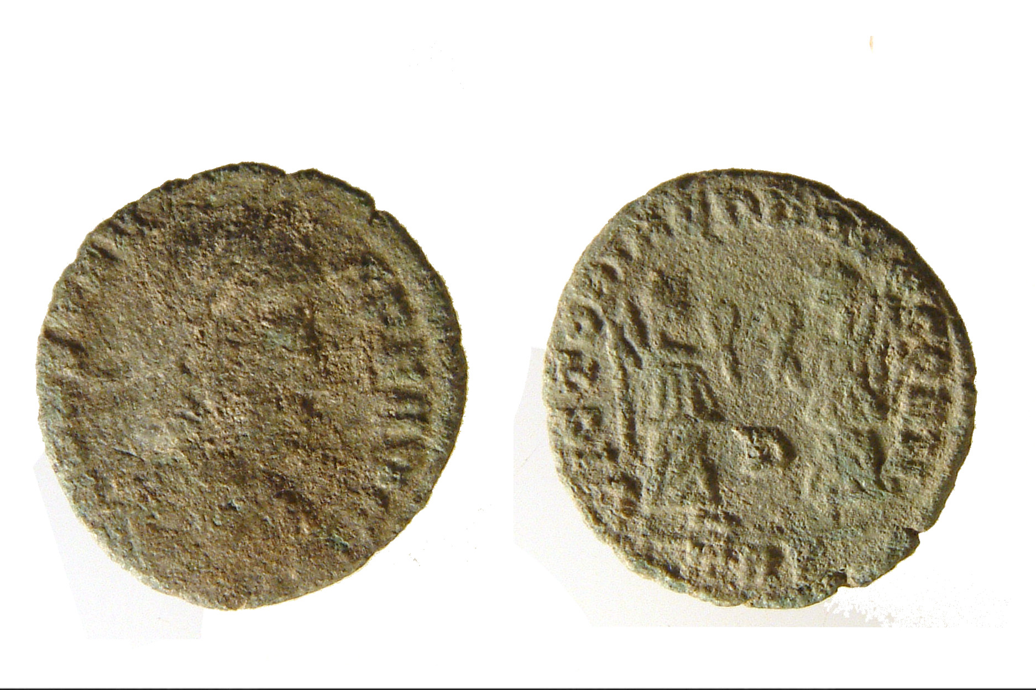

Translation:
Only in a few later writings of the Old Testament (1CH 29:7; EZR 2:69; NEH 5:15; NEH 7:70; NEH 7:71; NEH 7:72) are actual coins in view. It will be necessary in translation to avoid the anachronism of having coins in the narrative at a time when they still had not been invented. While many translations may be technically correct to say “pieces of money,” avoiding the anachronistic mention of “coins,” this is perhaps not the best solution; the average reader will not understand “pieces of money” as meaning anything other than “coins.” In this case it may be better to stay with the literal expression “pieces of silver.” A translation should never use a word that indicates paper money, which did not exist in biblical times.
Where a generic term is lacking for the means of payment locally in use (such as certain seashells in some cultures), a generic plural of a commonly accepted local coin may be possible.
Part of the Greek text of 1MA 15:6 is literally “to make your own coinage” (an activity usually reserved for a sovereign power). GNT “to mint your own coins” takes advantage of a special word in English for this operation. Not all languages have a word for coining or minting money. It is possible to follow the Greek fairly literally and make good sense in many cases. A possible model is “to produce your own coins.”

Bank, table

1.6.4 Bank, table

References:Greek τράπεζα (trapeza)MAT 21:12, MRK 11:15, LUK 19:23, JHN 2:15

Description:
Moneychanger or banker at a table (O.Mustafin, CC0, via Wikimedia Commons)A small table was used by people for conducting money transactions. This was most likely a table at which someone could sit, not a low table where people reclined to eat (see 5.7 Table for eating<REALIA:5.7>).
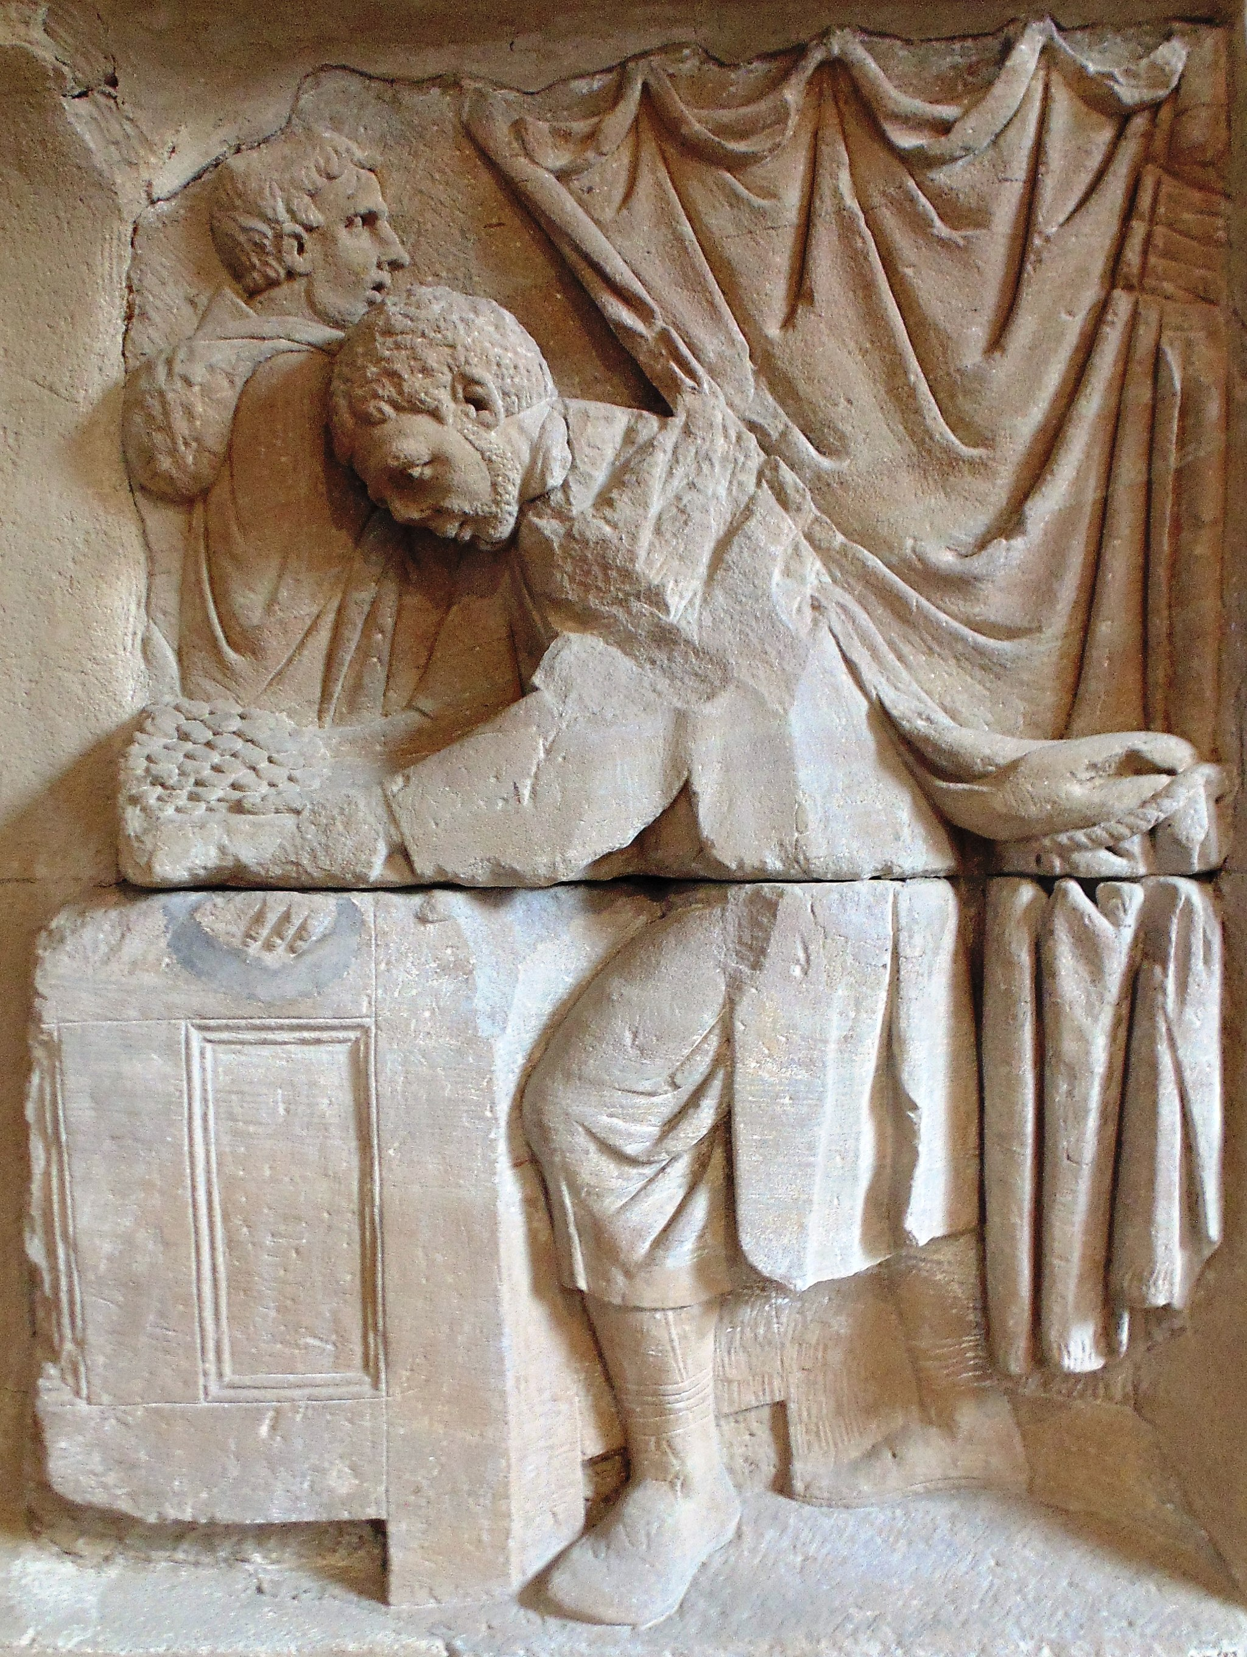

Translation:
When Jesus confronted the moneychangers in the Temple (MAT 21:12; MRK 11:15; JHN 2:15), he literally overturned the tables where they were transacting business. Just as the English word “bank” comes from a word for table or “bench,” so also in Greek the word trapeza came to mean a place for financial dealings. In LUK 19:23 the master asks the servant why he had not put the money “on a table.” Some translations have “in[to] the bank” (RSV, GNT), while others say “on deposit” (NIV, REB).

