Resource: Human-made Things in the Bible
Human-made Things in the Bible © United Bible Societies, 2025. Adapted from: The Works of Their Hands: Man-made Things in the Bible, by Ray Pritz © 2009 United Bible Societies. This work is licensed under Creative Commons Attribution-ShareAlike 4.0 International (https://creativecommons.org/licenses/by-sa/4.0/).

Human-made Things in the Bible

Royalty

1.10 Royalty

Throne

1.10.1 Throne

References:Hebrew כִּסֵּא (kise’, kiseh)GEN 41:40, EXO 11:5, EXO 12:29, DEU 17:18, JDG 3:20, 1SA 2:8, 2SA 3:10, 2SA 7:13, 2SA 7:16, 2SA 14:9, 1KI 1:13, 1KI 1:17, 1KI 1:20, 1KI 1:24, 1KI 1:27, 1KI 1:30, 1KI 1:35, 1KI 1:37, 1KI 1:37, 1KI 1:46, 1KI 1:47, 1KI 1:47, 1KI 1:48, 1KI 2:4, 1KI 2:12, 1KI 2:19, 1KI 2:19, 1KI 2:24, 1KI 2:33, 1KI 2:45, 1KI 3:6, 1KI 5:19, 1KI 7:7, 1KI 8:20, 1KI 8:25, 1KI 9:5, 1KI 9:5, 1KI 10:9, 1KI 10:18, 1KI 10:19, 1KI 10:19, 1KI 16:11, 1KI 22:10, 1KI 22:19, 2KI 10:3, 2KI 10:30, 2KI 11:19, 2KI 13:13, 2KI 15:12, 2KI 25:28, 2KI 25:28, 1CH 17:12, 1CH 17:14, 1CH 22:10, 1CH 28:5, 1CH 29:23, 2CH 6:10, 2CH 6:16, 2CH 7:18, 2CH 9:8, 2CH 9:17, 2CH 9:18, 2CH 9:18, 2CH 18:9, 2CH 18:18, 2CH 23:20, EST 1:2, EST 5:1, JOB 26:9, JOB 36:7, PSA 9:5, PSA 9:8, PSA 11:4, PSA 45:7, PSA 47:9, PSA 89:5, PSA 89:15, PSA 89:30, PSA 89:37, PSA 89:45, PSA 93:2, PSA 94:20, PSA 97:2, PSA 103:19, PSA 122:5, PSA 122:5, PSA 132:11, PRO 16:12, PRO 20:8, PRO 20:28, PRO 25:5, PRO 29:14, ISA 6:1, ISA 9:6, ISA 14:9, ISA 14:13, ISA 16:5, ISA 22:23, ISA 47:1, ISA 66:1, JER 1:15, JER 3:17, JER 13:13, JER 14:21, JER 17:12, JER 17:25, JER 22:2, JER 22:4, JER 22:30, JER 29:16, JER 33:17, JER 33:21, JER 36:30, JER 43:10, JER 49:38, JER 52:32, JER 52:32, LAM 5:19, EZK 1:26, EZK 1:26, EZK 10:1, EZK 26:16, EZK 43:7, JON 3:6, HAG 2:22, ZEC 6:13, ZEC 6:13Aramaic כָּרְסֵא (korse’)DAN 5:20, DAN 7:9, DAN 7:9Greek δίφρος (difros)JDT 11:19Greek θρόνος (thronos)MAT 5:34, MAT 19:28, MAT 19:28, MAT 23:22, MAT 25:31, LUK 1:32, LUK 1:52, LUK 22:30, ACT 2:30, ACT 7:49, COL 1:16, HEB 1:8, HEB 4:16, HEB 8:1, HEB 12:2, REV 1:4, REV 2:13, REV 3:21, REV 3:21, REV 4:2, REV 4:2, REV 4:3, REV 4:4, REV 4:4, REV 4:4, REV 4:5, REV 4:5, REV 4:6, REV 4:6, REV 4:6, REV 4:9, REV 4:10, REV 4:10, REV 5:1, REV 5:6, REV 5:7, REV 5:11, REV 5:13, REV 6:16, REV 7:9, REV 7:10, REV 7:11, REV 7:11, REV 7:15, REV 7:15, REV 7:17, REV 8:3, REV 11:16, REV 12:5, REV 13:2, REV 14:3, REV 16:10, REV 16:17, REV 19:4, REV 19:5, REV 20:4, REV 20:11, REV 20:12, REV 21:3, REV 21:5, REV 22:1, REV 22:3, JDT 1:12, JDT 9:3, ESG 5:1, ESG 5:1, ESG 8:12, WIS 5:23, WIS 6:21, WIS 7:8, WIS 9:4, WIS 9:10, WIS 9:12, WIS 18:15, SIR 1:8, SIR 10:14, SIR 24:4, SIR 40:3, SIR 47:11, BAR 5:6, 1MA 2:57, 1MA 7:4, 1MA 10:52, 1MA 10:53, 1MA 10:55, 1MA 11:52, 4MA 17:18, ODA 3:8, PSS 2:19, PSS 17:6Latin thronus2ES 8:21

Description:
Relief of Darius sitting on his throne in Persepolis (© درفش کاویانی, CC BY-SA 3.0, via Wikimedia Commons)The throne was a relatively large and elaborate seat upon which a ruler sat. It could be made of stone or wood or even other substances such as precious metals and ivory. It usually had a back and often armrests on the sides. The throne of Solomon is described in 1KI 10:19; 1KI 10:20 and 2CH 9:18; 2CH 9:19 as being elevated and approached by stairs. See 3.1.7 Stairs, steps<REALIA:3.1.7>.
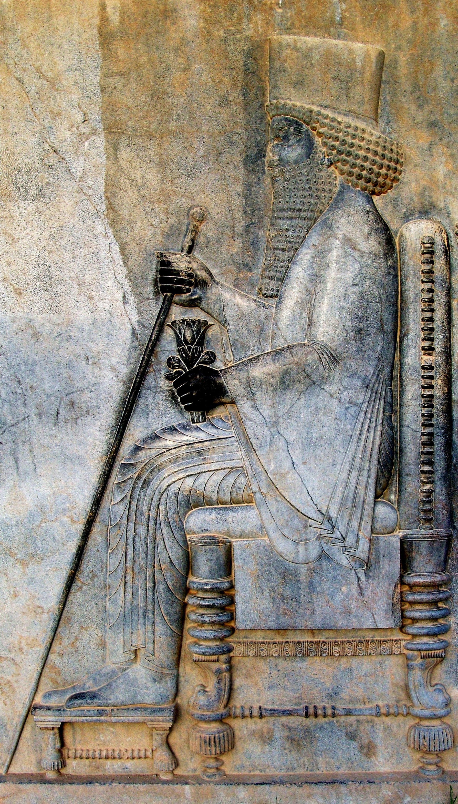

Usage:
On official occasions the ruler sat on the throne. This could be for the reception of foreign dignitaries, the passing of judgment, or the making and declaration of major decisions regarding the nation.

Translation:
“Throne” may be rendered “great chair,” “important seat,” or “king’s chair.” On the other hand, a description of the “throne” as a place of judging or of decision making may be the rendering, for example, “chair from which the ruler gives orders,” “seat of decision making for a ruler,” or “seat of judging.”
The Greek word thronos refers only to a throne, but the Hebrew words kise’ and kiseh are the normal words for a seat (see 5.9 Chair, seat<REALIA:5.9>). When the seat of a king is in view, then the proper translation of these Hebrew words is “throne.”

Crown

1.10.2 Crown

References:Hebrew כֶּתֶר (kether)EST 1:11, EST 2:17, EST 6:8Hebrew נֵזֶר (nezer)2SA 1:10, 2KI 11:12, 2CH 23:11, PSA 89:40, PSA 132:18, PRO 27:24, ZEC 9:16Hebrew עטר (‘atar (verb))PSA 8:6, SNG 3:11Hebrew עֲטָרָה (‘atarah)2SA 12:30, 1CH 20:2, EST 8:15, PSA 21:4, SNG 3:11, JER 13:18, EZK 16:12, EZK 21:31, ZEC 6:11, ZEC 6:14Greek διάδημα (diadēma)REV 12:3, REV 13:1, REV 19:12, ESG 1:11, ESG 2:17, ESG 8:15, WIS 5:16, WIS 18:24, SIR 11:5, SIR 47:6, 1MA 1:9, 1MA 6:15, 1MA 8:14, 1MA 11:13, 1MA 11:13, 1MA 11:54, 1MA 12:39, 1MA 13:32, 1ES 4:30Greek στέφανος, στεφανόω (stefanos, stefanoō (verb))MAT 27:29, MRK 15:17, JHN 19:2, JHN 19:5, HEB 2:7, HEB 2:9, REV 4:4, REV 4:10, REV 6:2, REV 9:7, REV 12:1, REV 14:14, SIR 40:4, SIR 45:12, 1MA 10:20, 1MA 10:29, 1MA 11:35, 1MA 13:37, 1MA 13:39, 2MA 14:4

Description and usage:
King wearing a crown (© CNG Wikimedia Commons)
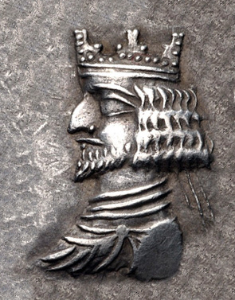
Double crown uniting the scorpion-shaped crown of Lower Egypt and the bottle-shaped crown of Upper Egypt (© Einsamer Schütze, via Wikimedia Commons)The crown was a type of headgear worn by a king or queen as a sign of the royal office.
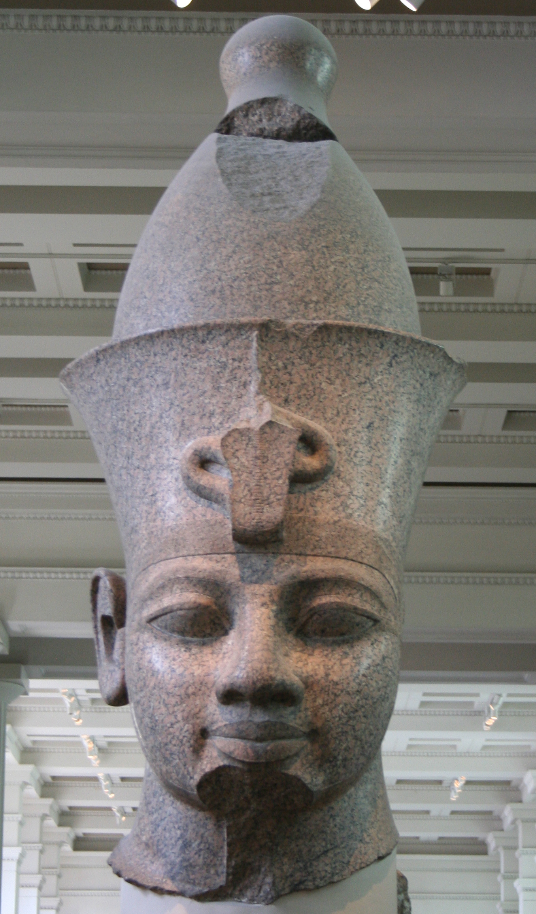

Translation:
The “crown” may be described as “symbol of his/her power, worn on his/her head.”
Crown of thorns (© Sgconlaw - Wikimedia Commons)In some passages the crown serves only as a symbol of the office of king or queen. In those cultures where royalty (or the office of the supreme leader) is indicated by another symbol, this may be substituted for “crown.” Thus, for example, EST 2:17 might read “he gave her the royal seal and made her queen in place of Vashti.” Similarly, PSA 21:4 might read “you seat him on the chief’s stool” or “you make him chief.”
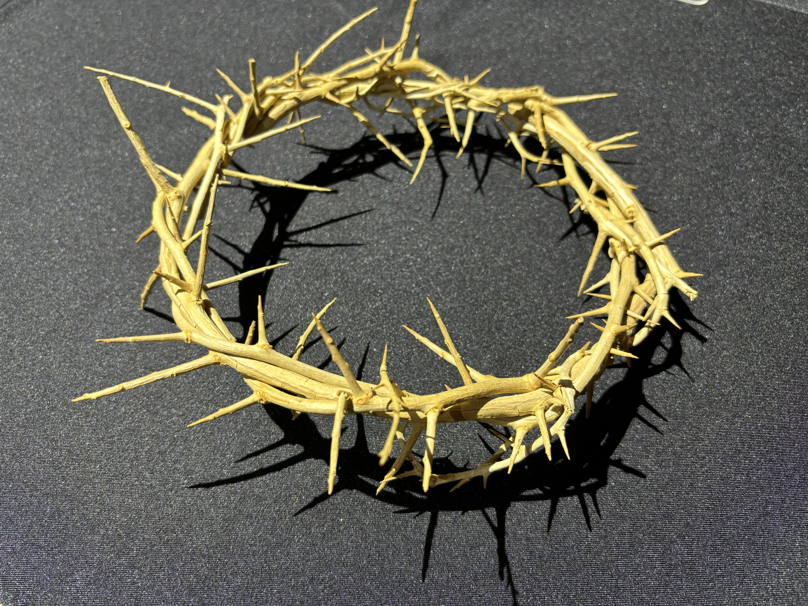
In some passages (JOB 19:9; JOB 31:36; PRO 12:4; PRO 16:31; PRO 17:6; LAM 5:16) it is unclear from the context if the Hebrew word ‘atarah refers to a crown or a wreath (see 6.8 Wreath, crown<REALIA:6.8>).
RSV renders 1MA 11:13 as “Then Ptolemy entered Antioch and put on the crown of Asia. Thus he put two crowns upon his head, the crown of Egypt and that of Asia.” This literal rendering can create a rather silly picture in the mind of the reader. The crowns, of course, simply represent the authority held by Ptolemy in the two regions mentioned here. CEV has avoided the image of a king trying to balance two crowns on his head by saying “Ptolemy went to the city of Antioch, where he crowned himself king—both of Syria and of Egypt.” CEV ’s rendering, however, gives the mis­impression that he became king of Syria and Egypt simultaneously. A better model is “Ptolemy went to the city of Antioch, where he crowned himself king. This meant that he now ruled over both Egypt and Syria.”
It should be noted that the “crown of thorns” placed on Jesus was a wreath made of thorny branches (MAT 27:29; MRK 15:17; JHN 19:2; JHN 19:5). The action may be described as “put a circle of thorns on his head” or “wove thorn branches together into a wreath [or, circle] and put them on his head.”
For stefanos as a wreath, see 6.8 Wreath, crown<REALIA:6.8>.

Scepter

1.10.3 Scepter

References:Hebrew חקק (mchoqeq)GEN 49:10, NUM 21:18, PSA 60:9, PSA 108:9Hebrew מַטֶּה (mateh)PSA 110:2, JER 48:17Hebrew מַקֵּל (maqel)JER 48:17Hebrew שֵׁבֶט (shevet)GEN 49:10, NUM 24:17, JDG 5:14, PSA 45:7, PSA 45:7, PSA 125:3, ISA 14:5, EZK 19:11, EZK 19:14, AMO 1:5, AMO 1:8, ZEC 10:11Hebrew שַׁרְבִיט (sharvit)EST 4:11, EST 5:2, EST 5:2, EST 8:4Greek ῥάβδος (rhabdos)HEB 1:8, HEB 1:8, ESG 5:2Greek σκῆπτρον (skēptron)ESG 4:17, WIS 6:21, WIS 7:8, WIS 10:14, SIR 35:21, LJE 1:12

Description and usage:
Head of a scepter (Gary Todd, Israel Museum, CC0, via Wikimedia Commons)The scepter was a decorated rod, often made at least partially of a precious metal, symbolizing the authority of the ruler. The ruler held the scepter when he was engaged in certain aspects of his office. See also 1.2.4 Rod, club, shepherd’s staff<REALIA:1.2.4>.
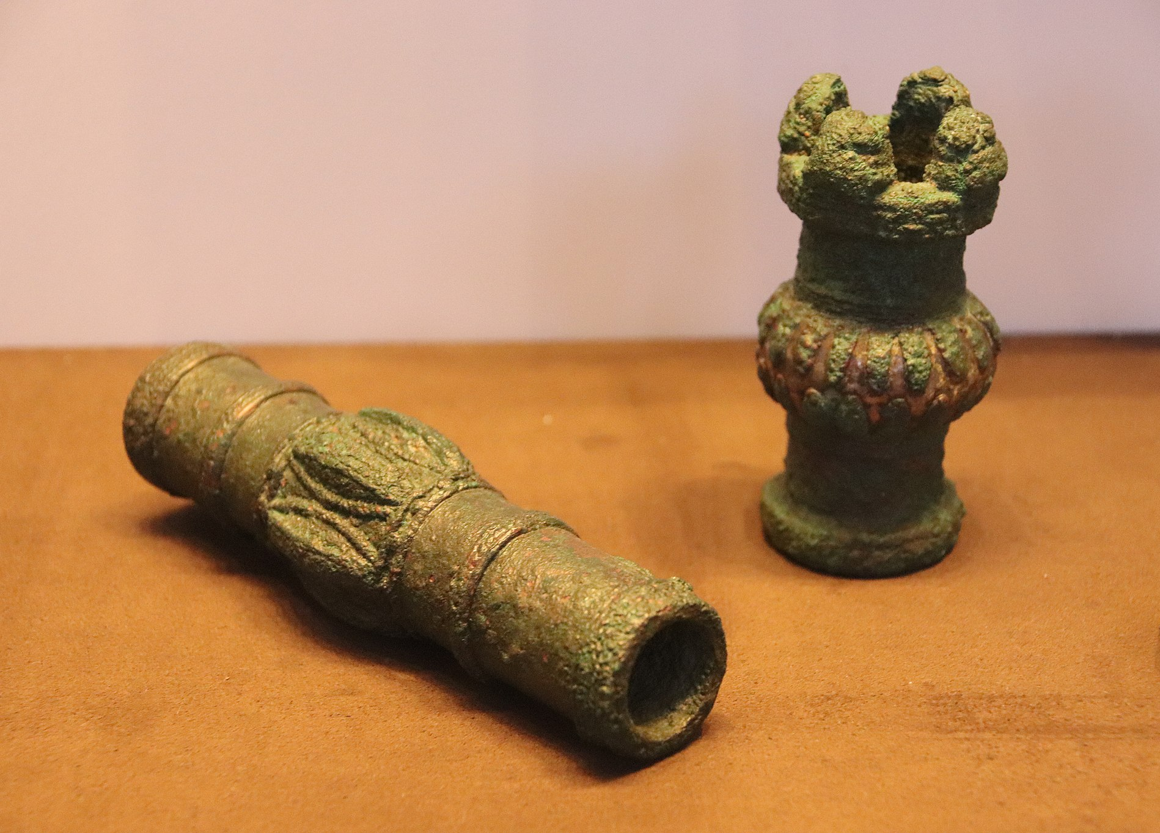

Translation:
In languages where a chief’s authority is symbolized by an object associated with him (such as a cane, stool, or scepter), such symbols of authority can often be used in translation; for example, PSA 45:7 may be rendered “Your ceremonial staff shows that you rule your people fairly.”
The Hebrew words mateh and maqel are parallel to each other in JER 48:17. It is not always necessary to reproduce the parallelism with two similar words; for example, for the last half of this verse RSV has “How the mighty scepter is broken, the glorious staff,” but GNT says “Its powerful rule has been broken; its glory and might are no more.” This passage is metaphorical, so the focus here is not on the scepter as a physical object but on authority.

Anointing horn, anointing flask

1.10.4 Anointing horn, anointing flask

References:Hebrew שֶׁמֶן (pak shemen)1SA 10:1, 2KI 9:1, 2KI 9:3Hebrew קֶרֶן (qeren)1SA 16:1, 1SA 16:13, 1KI 1:39

Description:
Ram's horn (© Olve Utne, CC BY-SA 2.5, via Wikimedia Commons)The anointing horn/flask was a small container for holding olive oil. It was made of an animal horn or other material. The horn usually had to be hollowed out.
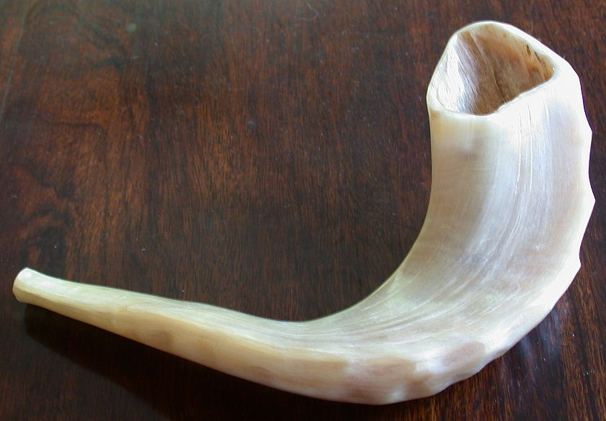

Usage:
The ceremony for installing a person in the office of king or priest included pouring olive oil over his head (see 1.10.5 Anointing oil<REALIA:1.10.5>). The oil was kept in and poured from the anointing horn/flask, used only for this special ceremony.

Translation:
The Hebrew word qeren refers to an animal horn, while the word pak simply alludes to a container, such as a vial or flask or a jar with a narrow neck. NCV renders qeren in 1SA 16:1 as “container.” A word should be chosen which indicates a container with a small volume, one from which a liquid may be poured, and with the possibility of being closed.

Anointing oil

1.10.5 Anointing oil

References:Hebrew יִצְהָר (yitshar)ZEC 4:14Hebrew שֶׁמֶן, מִשְׁחָה (shemen mishchah)EXO 25:6, EXO 29:7, EXO 29:21, EXO 30:25, EXO 30:25, EXO 30:31, EXO 31:11, EXO 35:8, EXO 35:15, EXO 35:28, EXO 37:29, EXO 39:38, EXO 40:9, LEV 8:2, LEV 8:10, LEV 8:12, LEV 8:30, LEV 10:7, LEV 21:10, LEV 21:12, NUM 4:16Greek ἔλαιον (elaion)LUK 7:46, HEB 1:9, SIR 45:15

Description and usage:
Plain olive oil was used to anoint kings and sometimes prophets to dedicate them for their tasks.
The preparation of a special perfumed oil is commanded in EXO 30:23; EXO 30:24; EXO 30:25; EXO 30:26; EXO 30:27; EXO 30:28; EXO 30:29; EXO 30:30; EXO 30:31; EXO 30:32; EXO 30:33. It was for anointing the priests as well as the Tabernacle and furniture in the Tabernacle. It set them aside as “holy.” It had an olive oil base mixed with a variety of aromatic spices.
See also 1.15.1 Oil, ointment<REALIA:1.15.1> and 9.3 Olive oil<REALIA:9.3>.

Translation:
The anointing of a king was primarily a religious act, not a political one.

