Resource: Human-made Things in the Bible
Human-made Things in the Bible © United Bible Societies, 2025. Adapted from: The Works of Their Hands: Man-made Things in the Bible, by Ray Pritz © 2009 United Bible Societies. This work is licensed under Creative Commons Attribution-ShareAlike 4.0 International (https://creativecommons.org/licenses/by-sa/4.0/).

Human-made Things in the Bible

Leather

1.13 Leather

References:Hebrew עוֹר (‘or)GEN 3:21, GEN 27:16, EXO 22:26, EXO 25:5, EXO 25:5, EXO 26:14, EXO 26:14, EXO 29:14, EXO 34:29, EXO 34:30, EXO 34:35, EXO 35:7, EXO 35:7, EXO 35:23, EXO 35:23, EXO 36:19, EXO 36:19, EXO 39:34, EXO 39:34, LEV 4:11, LEV 7:8, LEV 8:17, LEV 9:11, LEV 11:32, LEV 13:2, LEV 13:2, LEV 13:3, LEV 13:3, LEV 13:4, LEV 13:4, LEV 13:5, LEV 13:6, LEV 13:7, LEV 13:8, LEV 13:10, LEV 13:11, LEV 13:12, LEV 13:12, LEV 13:18, LEV 13:20, LEV 13:21, LEV 13:22, LEV 13:24, LEV 13:25, LEV 13:26, LEV 13:27, LEV 13:28, LEV 13:30, LEV 13:31, LEV 13:32, LEV 13:34, LEV 13:34, LEV 13:35, LEV 13:36, LEV 13:38, LEV 13:39, LEV 13:39, LEV 13:43, LEV 13:48, LEV 13:48, LEV 13:49, LEV 13:49, LEV 13:51, LEV 13:51, LEV 13:52, LEV 13:53, LEV 13:56, LEV 13:57, LEV 13:58, LEV 13:59, LEV 15:17, LEV 16:27, NUM 4:6, NUM 4:8, NUM 4:10, NUM 4:11, NUM 4:12, NUM 4:14, NUM 19:5, NUM 31:20, 2KI 1:8, JOB 2:4, JOB 2:4, JOB 7:5, JOB 10:11, JOB 18:13, JOB 19:20, JOB 19:20, JOB 19:26, JOB 30:30, JOB 40:31, JER 13:23, LAM 3:4, LAM 4:8, LAM 5:10, EZK 37:6, EZK 37:8, MIC 3:2, MIC 3:3Hebrew תַּחַשׁ (tachash)EZK 16:10Greek βυρσεύς (burseus)ACT 9:43, ACT 10:6, ACT 10:32Greek δερμάτινος (dermatinos)MAT 3:4, MRK 1:6

Description:
A tanner working with leather (Deutsche Fotothek, Public domain, via Wikimedia Commons)Leather was the skin or hide of an animal prepared by special processes to remove the hair and to keep it from decaying or becoming brittle. The person who prepares leather is called a leather worker or tanner.
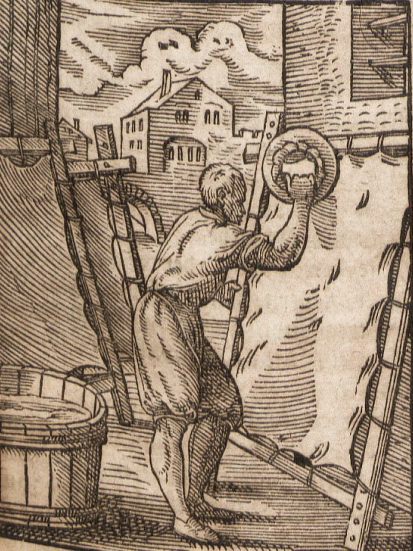

Usage:
Leather had many uses, which included making clothing parts, such as belts and sandals. It was also used to make containers for liquids, such as water and wine. Sometimes it was used for making straps for harnessing animals and other binding activities.

Translation:
Some languages will have a special word for “leather,” but many will use the same word as for the “skin” of an animal.
The Hebrew word tachash refers to an aquatic animal, the dugong (see All Creatures Great and Small, pages 42–43). It is only mentioned in Scripture with reference to its skin, so it is usually accompanied by the Hebrew word ‘or. In EZK 16:10 the word ‘or is omitted, but tachash there means the fine tanned leather made from the skin of that animal.

