Resource: Human-made Things in the Bible
Human-made Things in the Bible © United Bible Societies, 2025. Adapted from: The Works of Their Hands: Man-made Things in the Bible, by Ray Pritz © 2009 United Bible Societies. This work is licensed under Creative Commons Attribution-ShareAlike 4.0 International (https://creativecommons.org/licenses/by-sa/4.0/).

Human-made Things in the Bible

Dagger

2.4 Dagger

Reference:Greek ἐγχειρίδιον (egcheiridion)LJE 1:13

Description and usage:
Sword (dagger) (© Unknown - Wikimedia Commons)The dagger was a short stabbing weapon with a pointed blade. It was held easily in one hand and could be concealed without difficulty.
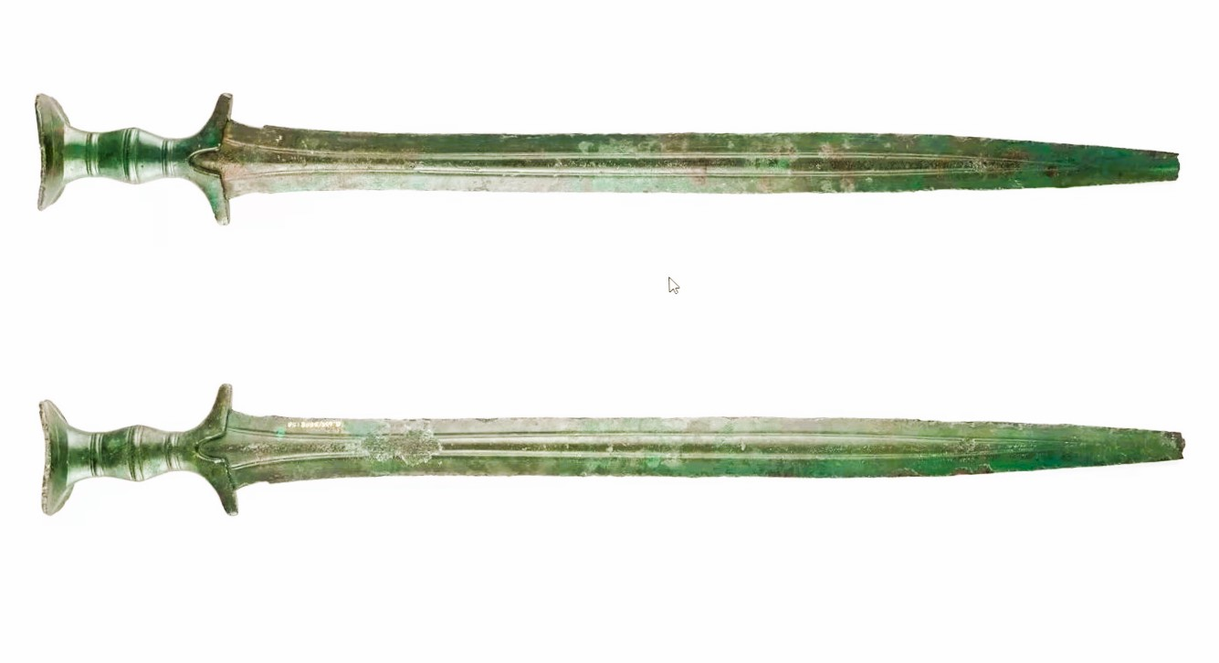

Translation:
The dagger was smaller than the short sword and in most cultures will be comparable to a pointed knife.

