Resource: Human-made Things in the Bible
Human-made Things in the Bible © United Bible Societies, 2025. Adapted from: The Works of Their Hands: Man-made Things in the Bible, by Ray Pritz © 2009 United Bible Societies. This work is licensed under Creative Commons Attribution-ShareAlike 4.0 International (https://creativecommons.org/licenses/by-sa/4.0/).

Human-made Things in the Bible

Spear, lance

2.5 Spear, lance

References:Hebrew חֲנִית (chanith)1SA 13:19, 1SA 13:22, 1SA 17:7, 1SA 17:7, 1SA 17:45, 1SA 17:47, 1SA 18:10, 1SA 18:11, 1SA 19:9, 1SA 19:10, 1SA 19:10, 1SA 20:33, 1SA 21:9, 1SA 22:6, 1SA 26:8, 1SA 26:12, 1SA 26:16, 1SA 26:22, 1SA 26:22, 2SA 1:6, 2SA 2:23, 2SA 2:23, 2SA 21:19, 2SA 23:7, 2SA 23:18, 2SA 23:21, 2SA 23:21, 2SA 23:21, 2KI 11:10, 1CH 11:11, 1CH 11:20, 1CH 11:23, 1CH 11:23, 1CH 11:23, 1CH 12:35, 1CH 20:5, 2CH 23:9, JOB 39:23, JOB 41:18, PSA 35:3, PSA 46:10, PSA 57:5, ISA 2:4, MIC 4:3, NAM 3:3, HAB 3:11Hebrew רֹמַח (romach)NUM 25:7, JDG 5:8, 1KI 18:28, 1CH 12:9, 1CH 12:25, 2CH 11:12, 2CH 14:7, 2CH 25:5, 2CH 26:14, NEH 4:7, NEH 4:10, NEH 4:15, JER 46:4, EZK 39:9, JOL 4:10Hebrew שֵׁבֶט (shevet)2SA 18:14Greek γαῖσος (gaisos)JDT 9:7Greek δεξιολάβος (dexiolabos)ACT 23:23Greek δορά, δόρυ (dora, doru)JDT 7:10, JDT 11:2, ESG 8:12, SIR 29:13, 3MA 3:15, 3MA 5:43, 3MA 6:5Greek κάμαξ (kamax)2MA 5:3Greek κέντρον (kentron)4MA 14:19Greek λόγχη (logchē)JHN 19:34, 2MA 5:2, 2MA 15:11Greek σιβύνη (sibunē (zibunē))JDT 1:15Latin framea2ES 13:9, 2ES 13:28

Description:
The spear was a long, straight rod with a sharp end used for piercing by thrusting. Its circumference was less than the grip of a man’s hand, and its length varied from the height of a man to much longer. It was normally made of wood with a metal head or point (see 2.5.1 Spearhead<REALIA:2.5.1>). The butt of the spear was also covered with a pointed piece of metal (see 2SA 2:23) and was used to stick the spear in the ground or to drive oxen or horses as a goad.
See the illustration at 2.3.1 Sheath, scabbard<REALIA:2.3.1>.

Usage:
In battle the spear was held in the middle and thrust at the enemy. Only rarely was it intended for throwing (see 2.6 Javelin<REALIA:2.6>).

Translation:
Where possible, translators should choose a word or phrase that indicates that this weapon was held and thrust (much like a knife on the end of a stick) rather than thrown.
The phrase “lifted up his spear” occurs in 2SA 23:18 and 1CH 11:11. GNT gives the correct meaning with “fought with his spear.”
The meaning of the Greek word dexiolabos in ACT 23:23 is uncertain. Most translations have “spearmen” (RSV, NIV), “foot soldiers with spears” (CEV), “men with spears” (NCV), or “light-armed troops” (REB).

Spearhead

2.5.1 Spearhead

References:Hebrew לֶהָבָה (lehavah)1SA 17:7Hebrew קַיִן (qayin)2SA 21:16

Description and usage:
Bronze spearhead from Iran, Luristan, ca 1000–550 BCE (Los Angeles County Museum of Art www.lacma.org, Public domain, via Wikimedia Commons)The spearhead was a piece of metal, usually iron or bronze, attached to the end of the spear (see 2.5 Spear, lance<REALIA:2.5>). It was either placed over the end of the spear shaft like a sleeve or wedged into a split at the end of the spear shaft and secured by tying it with a cord. The spearhead was sharpened to a point.
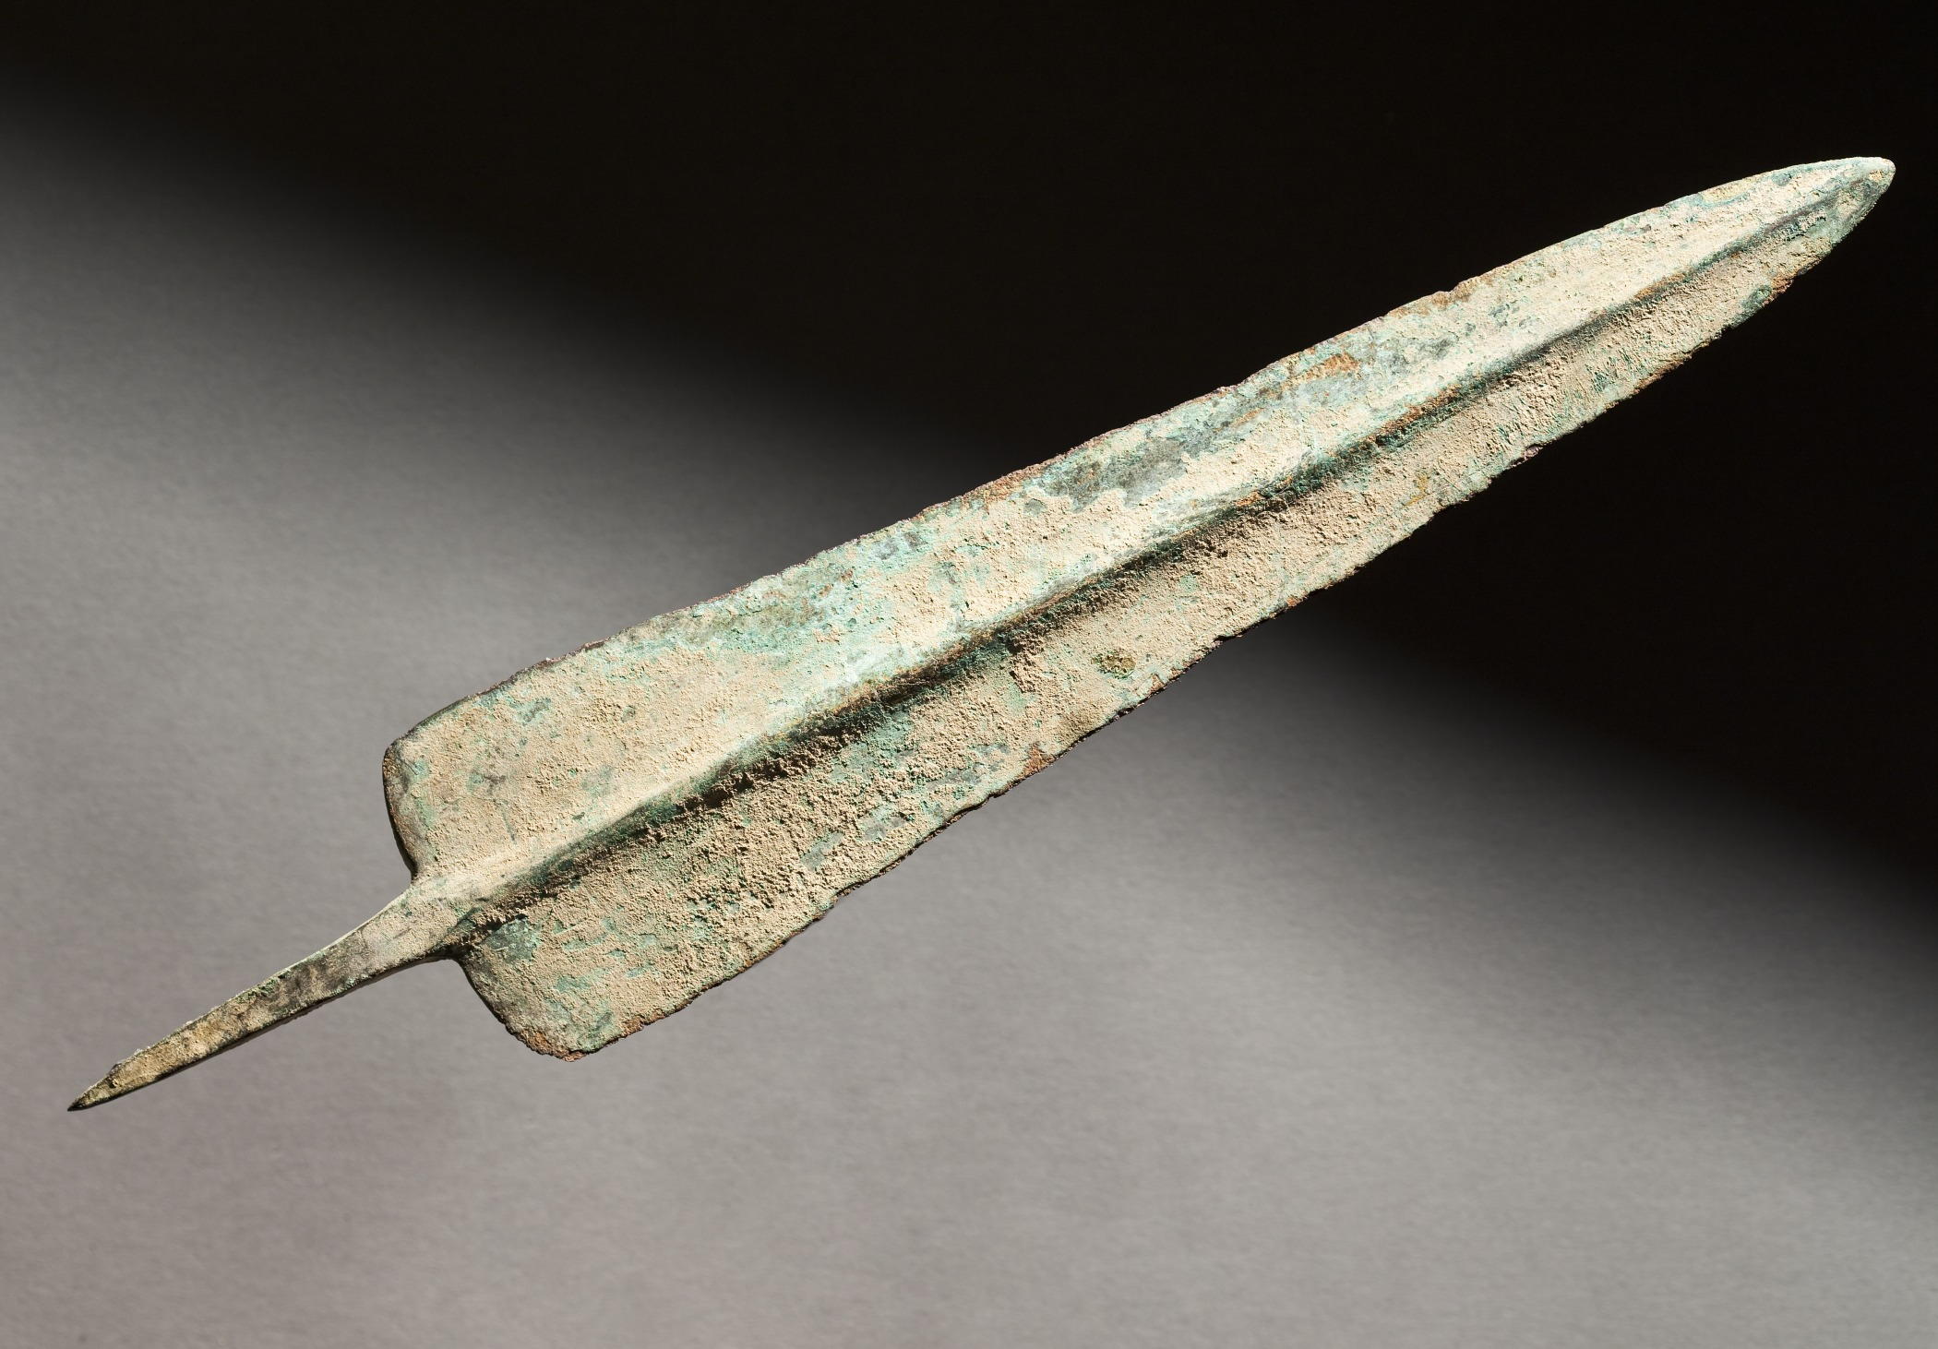

Translation:
In both of the references the spearhead is mentioned because of its exceptional size (about 7 kilograms, 15–16 pounds). The spearhead of an average soldier weighed much less. It is possible, but less likely, that the Hebrew word qayin in 2SA 21:16 refers to the entire spear, including its iron head.

