Resource: Human-made Things in the Bible
Human-made Things in the Bible © United Bible Societies, 2025. Adapted from: The Works of Their Hands: Man-made Things in the Bible, by Ray Pritz © 2009 United Bible Societies. This work is licensed under Creative Commons Attribution-ShareAlike 4.0 International (https://creativecommons.org/licenses/by-sa/4.0/).

Human-made Things in the Bible

Javelin

2.6 Javelin

References:Hebrew כִּידוֹן (kidon)JOS 8:18, JOS 8:18, JOS 8:26, 1SA 17:6, 1SA 17:45, JOB 39:23, JOB 41:21, JER 6:23, JER 50:42Hebrew שִׁרְיָה (shiryah)JOB 41:18Greek ὕσσος (hussos)JHN 19:29

Description and usage:
Drawing of a javelin, or spear, used for hunting and fighting (© Unknown - Wikimedia Commons)The javelin was a type of short spear or large arrow (see 2.14.2 Arrow<REALIA:2.14.2>). It was lighter than the spear and, unlike the spear, was suited for throwing at the enemy from a standing position or while riding on a horse or in a chariot. Javelins were made of wood or reed. Like the spear, the javelin had a metal head or point fixed in the same way as a spearhead (see 2.5.1 Spearhead<REALIA:2.5.1>). It often had a cord wrapped around its middle and looped over the finger of the thrower. As the javelin was released, the cord unwound, spinning the javelin and giving it greater stability, accuracy, and distance.
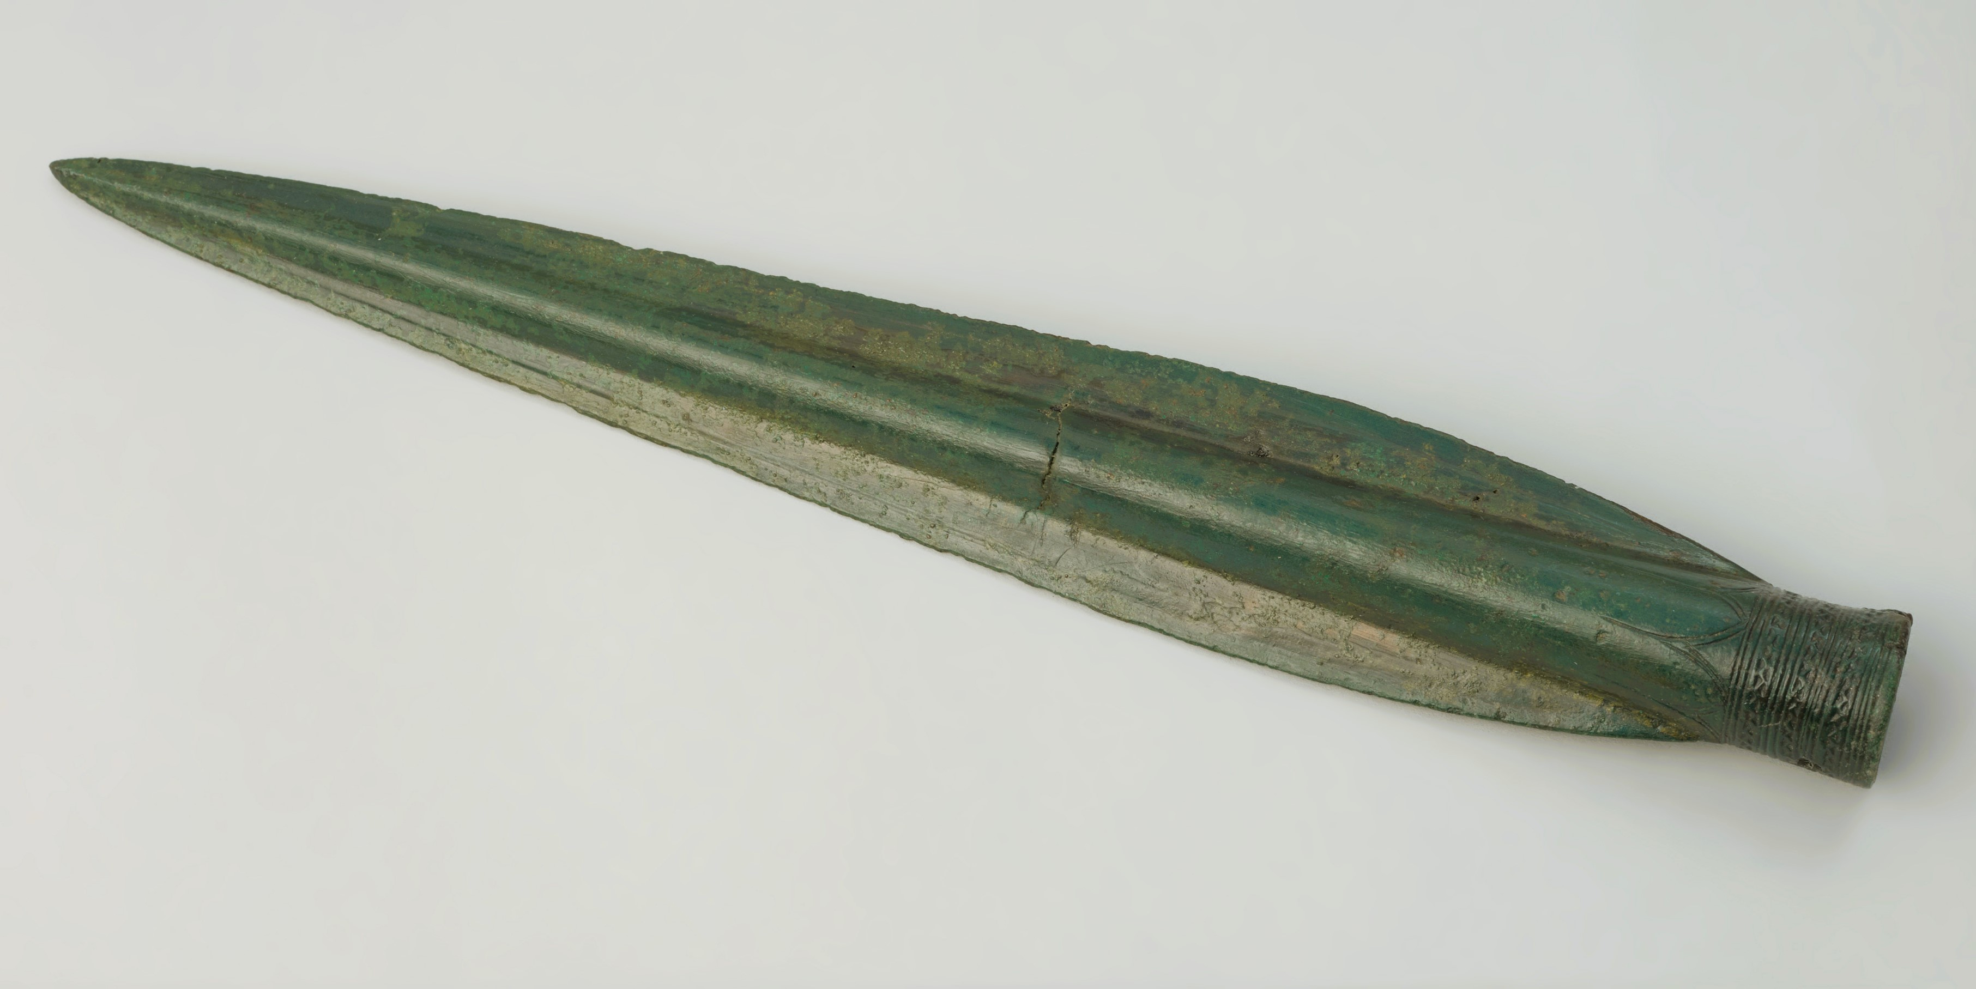

Translation:
“Javelin” may be rendered “throwing spear” or “light spear.”
Roland de Vaux suggests that the Hebrew word kidon refers to a long sword or type of scimitar. This interpretation has been followed by GECL, CEV and NJB in some of the passages listed above. REB has “sabre” at JOB 41:21, but it shortens the weapon considerably at JOS 8:26 with “dagger.” Most translations, however, prefer “javelin,” “spear,” or “lance.”
The Hebrew word shiryah in JOB 41:18 refers to a weapon, but it has not been definitely identified. Many translations have “javelin” (RSV, NIV), GNT says “lance,” and NLT uses “pointed shaft.”
In JHN 19:29 the Greek word hussos is a variant reading that is accepted by some scholars (but rejected by most) instead of the better-attested hussōpos (“hyssop”).

