Resource: Human-made Things in the Bible
Human-made Things in the Bible © United Bible Societies, 2025. Adapted from: The Works of Their Hands: Man-made Things in the Bible, by Ray Pritz © 2009 United Bible Societies. This work is licensed under Creative Commons Attribution-ShareAlike 4.0 International (https://creativecommons.org/licenses/by-sa/4.0/).

Human-made Things in the Bible

Battle-axe

2.8 Battle-axe

Reference:Hebrew סגר (sgor)PSA 35:3

Description and usage:
Double-headed battle axe (Jebulon, CC0, via Wikimedia Commons)The battle-axe had a handle about half the length of a man’s body on which was mounted a metal blade sharpened on opposing sides. A soldier could use it in close combat and swing it in two directions without changing his grip on it. The illustration shows one possible shape of the blade.
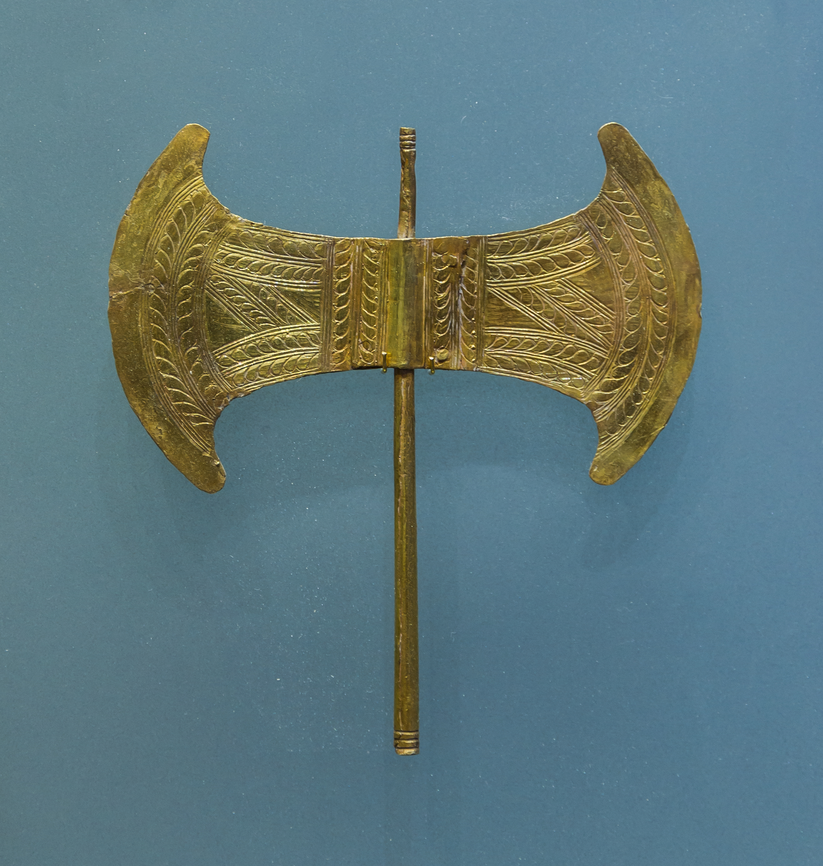

Translation:
The Hebrew word sgor looks like the imperative form of the verb meaning “close, shut off,” so the Septuagint understood it to mean “capture, make a prisoner.” Many translations take it to be a second weapon with the sword mentioned just before it, and most have rendered it “javelin” (RSV, NJPSV). However, A Handbook on Psalms (page 329) points out that there is evidence from Qumran that the sgor was a kind of axe used in war. Several translations (GNT, NASB, ITCL) have accepted this meaning. NJB, citing the Qumran information, has “pike,” which was a long thrusting spear. This Handbook recommends “battle-axe.”

