Resource: Human-made Things in the Bible
Human-made Things in the Bible © United Bible Societies, 2025. Adapted from: The Works of Their Hands: Man-made Things in the Bible, by Ray Pritz © 2009 United Bible Societies. This work is licensed under Creative Commons Attribution-ShareAlike 4.0 International (https://creativecommons.org/licenses/by-sa/4.0/).

Human-made Things in the Bible

Shields

2.10 Shields

A shield has been defined as “a device to serve as a barrier between the body of a soldier and the weapon of his enemy.”

Large shield

2.10.1 Large shield

References:Hebrew צִנָּה (tsinah)1SA 17:7, 1SA 17:41, 1KI 10:16, 1KI 10:16, 1CH 12:9, 1CH 12:25, 1CH 12:35, 2CH 9:15, 2CH 9:15, 2CH 11:12, 2CH 14:7, 2CH 25:5, PSA 5:13, PSA 35:2, PSA 91:4, JER 46:3, EZK 23:24, EZK 26:8, EZK 38:4, EZK 39:9Greek ἀσπιδίσκη (aspidiskē)1MA 4:57Greek ἀσπίς (aspis)JDT 9:7, WIS 5:19, SIR 29:13, SIR 37:5, 1MA 6:39, 1MA 14:24, 1MA 15:18, 1MA 15:20, 2MA 5:3, 2MA 15:11Greek κάλυμμα (kalumma)1MA 4:6, 1MA 6:2Greek θυρεός (thureos)EPH 6:16

Description:
Large shields held by soldiers at the lion hunt of Ashurbanipal (Room 10a, British Museum) (© Johnbod, CC BY-SA 4.0, via Wikimedia Commons)The large shield was a long, oblong shield. It was about the height of a man since it was intended to protect the entire body. It could be made of wood, metal, leather stretched over wood, or even plaited strips of wood or reeds.
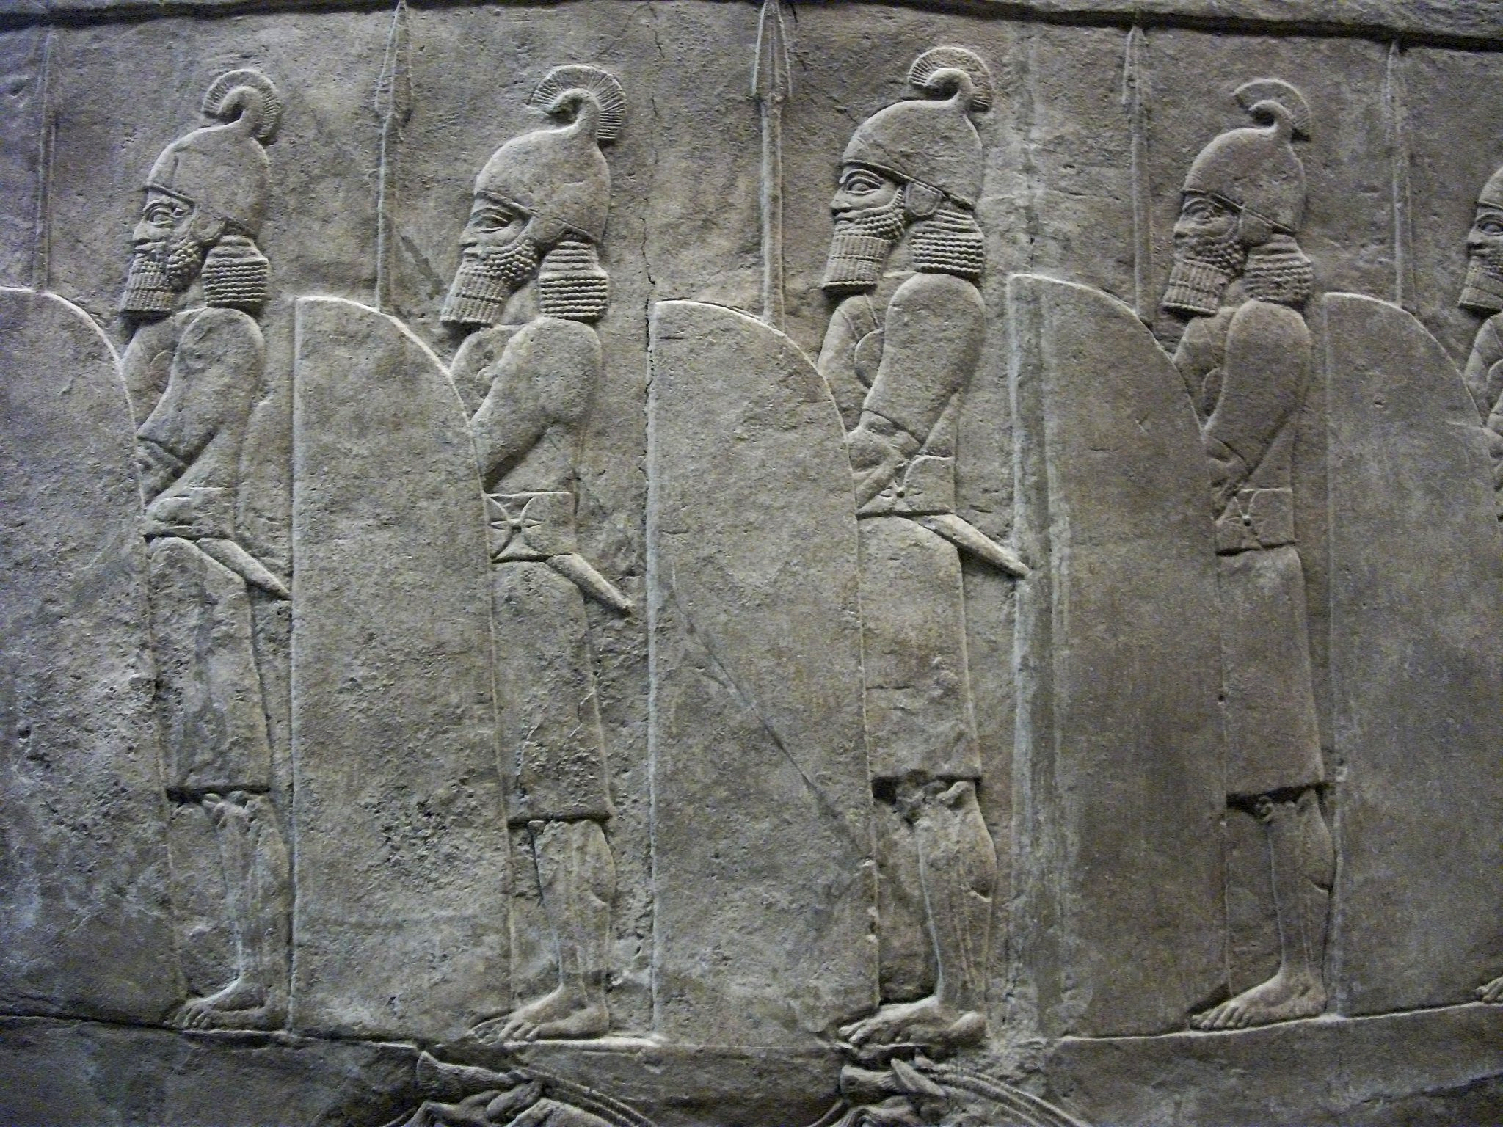

Usage:
This shield was held with one hand by means of straps attached to its back. A warrior who held his sword in his right hand would hold his shield with his left hand, and vice versa. The shield was held between the warrior and his opponent and was used to ward off blows from swords, spears or clubs, as well as to stop any missiles such as arrows, stones, or javelins. In the story of David fighting the giant Goliath (1SA 17:0), a servant stood in front of Goliath holding the giant’s shield.

Translation:
In some languages “shield” is rendered “protection a person carries when he fights” or “protection carried to prevent blows from the enemy.” In passages where “shield” is used figuratively, it is possible to preserve the element of protection while avoiding translating the actual piece of armor; for example, “his faithfulness is a shield and buckler” (PSA 91:4 in RSV) may be rendered “God keeps his promises and will protect and defend you.”
The Hebrew word tsinah is sometimes used metaphorically of God as protector (see PSA 5:13 and PSA 91:4 and the discussion at 2.10.2 Small shield, buckler<REALIA:2.10.2>).
In EZK 26:8 the Hebrew word tsinah indicates a special large shield, known technically as a mantelet (see 2.19.8 Mantelet<REALIA:2.19.8>), which was held above or in front of soldiers engaged in siege activities. While the Hebrew word is singular, such cover was normally made of many such shields. So for the last part of this verse, GNT has “make a solid wall of shields against you” and CEV says “set up rows of shields around you.”
In the Septuagint the Greek word kalumma refers to the veil or a cloth covering furniture in the Tabernacle. In 1MA 4:6 almost all translations render it as some piece of protective “armor” (RSV, CEV). In 1MA 6:2 some render it “shields” (RSV, CEV), while NAB and Goldstein prefer “helmets.”

Small shield, buckler

2.10.2 Small shield, buckler

References:Hebrew מָגֵן (magen)GEN 15:1, DEU 33:29, JDG 5:8, 2SA 1:21, 2SA 1:21, 2SA 22:3, 2SA 22:31, 2SA 22:36, 1KI 10:17, 1KI 10:17, 1KI 14:26, 1KI 14:27, 2KI 19:32, 1CH 5:18, 2CH 9:16, 2CH 9:16, 2CH 12:9, 2CH 12:10, 2CH 14:7, 2CH 17:17, 2CH 23:9, 2CH 26:14, 2CH 32:5, 2CH 32:27, NEH 4:10, JOB 15:26, JOB 41:7, PSA 3:4, PSA 7:11, PSA 18:3, PSA 18:31, PSA 18:36, PSA 28:7, PSA 33:20, PSA 35:2, PSA 47:10, PSA 59:12, PSA 76:4, PSA 84:10, PSA 84:12, PSA 89:19, PSA 115:9, PSA 115:10, PSA 115:11, PSA 119:114, PSA 144:2, PRO 2:7, PRO 6:11, PRO 24:34, PRO 30:5, SNG 4:4, ISA 21:5, ISA 22:6, ISA 37:33, JER 46:3, JER 46:9, EZK 23:24, EZK 27:10, EZK 38:4, EZK 38:5, EZK 39:9, NAM 2:4Hebrew עֲגָלָה (‘agalah)PSA 46:10Hebrew שֶׁלֶט (shelet)2SA 8:7, 2KI 11:10, 1CH 18:7, 2CH 23:9, SNG 4:4, JER 51:11, EZK 27:11Hebrew שֶׁמֶשׁ (shemesh)PSA 84:12, ISA 54:12

Description:
Soldiers with round shields (Neo-Assyrian Bas-Relief of Lion Hunt, Assyrian Gallery, British Museum) (Gary Todd, British Museum, CC0, Flickr)Like the larger shield, this shield could be made of wood (sometimes covered with leather) or metal. It varied in shape but was usually round. Wooden shields were often reinforced by metal spikes or by being covered with metal plates.
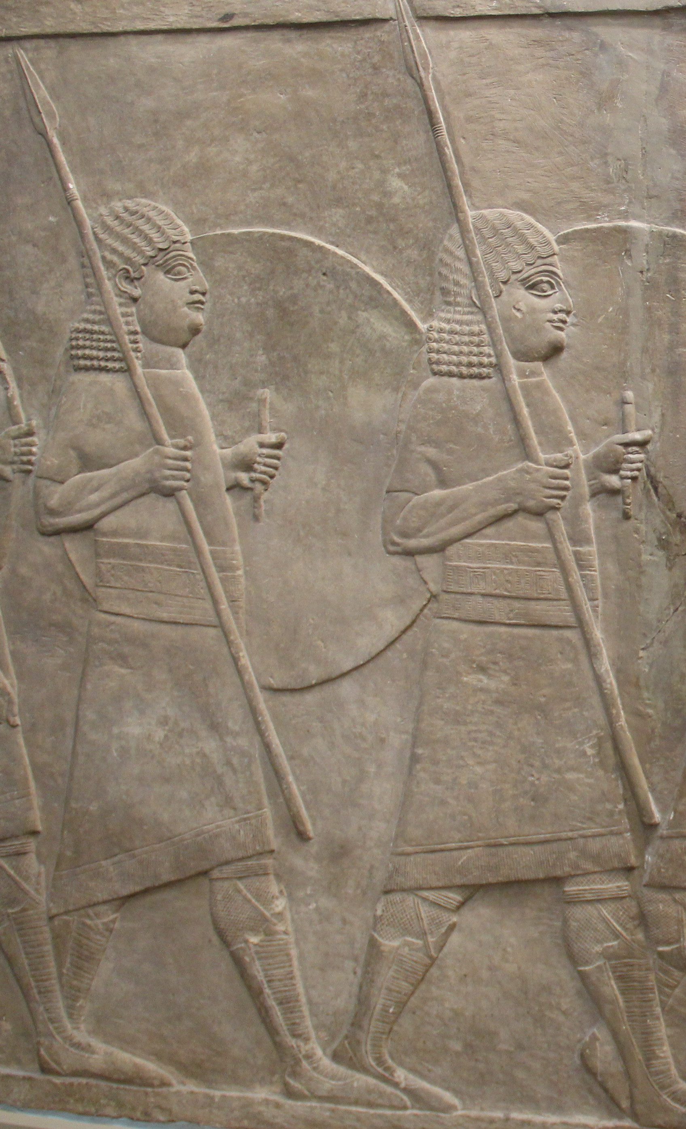

Usage:
See 2.10.1 Large shield<REALIA:2.10.1>.

Translation:
See 2.10.1 Large shield<REALIA:2.10.1>. 2SA 1:21 and ISA 21:5 speak of oiling the shield. Shields that were covered with leather were oiled periodically to keep the leather from cracking. Oiling also preserved metal shields by keeping them from rusting. Where the idea of oiling a shield may be obscure to the readers, translators may wish to follow the example of GNT for the last part of ISA 21:5, where it has “Prepare your shields!” (similarly NCV). Another possible model is CEV “Grab your shields” or even GECL “to arms!”
In many passages, particularly in the Psalms, God is figuratively likened to a shield. Where such a comparison might be misunderstood, it may be replaced with a description of God as protector or defender; for example, in GEN 15:1NCV renders the literal clause “I am your shield” as “I will defend you.” It is also possible to expand the translation in such cases; for example, in 2SA 22:3 the Hebrew word rendered “my shield” by RSV becomes “He protects me like a shield” in GNT. Such figurative references are found in GEN 15:1; DEU 33:29; 2SA 22:3; 2SA 22:31; 2SA 22:36; PSA 3:4; PSA 7:11; PSA 18:3; PSA 18:31; PSA 18:36; PSA 28:7; PSA 33:20; PSA 59:12; PSA 84:10; PSA 84:12; PSA 89:19; PSA 115:9; PSA 115:10; PSA 115:11; PSA 119:114; PSA 144:2; PRO 2:7; PRO 30:5.
PSA 46:10: Some translations render the Hebrew word ‘agaloth as “chariots,” but most scholars agree that “chariots” cannot be meant and that “shields” is more likely. The word ‘agaloth is related to the Hebrew word for “round,” and this makes it likely that the smaller, round shield is intended. Ancient shields were most commonly made of wood and leather, and frequently rubbed with olive oil. As a result they would burn easily. Where shields are known only to be made of metal, it may be helpful to include a note explaining how shields can be set on fire.
The Hebrew word shemesh, which normally means “sun,” also carries the meaning of a round shield that formed part of the protection at the top of a city wall (see the illustration at 2.19.3 Firing platform, siege tower<REALIA:2.19.3>). Thus, the phrase “sun and shield” (RSV) in PSA 84:10 speaks of two types of shield. Most modern translations wrongly retain “sun,” but compare NJB, which has “rampart and shield.” NJPSV gives “bulwark” in the margin. “Protector and glorious king” in GNT keeps the idea of “sun” in “glorious king,” but it reverses the order as it is found in the Hebrew.

