Resource: Human-made Things in the Bible
Human-made Things in the Bible © United Bible Societies, 2025. Adapted from: The Works of Their Hands: Man-made Things in the Bible, by Ray Pritz © 2009 United Bible Societies. This work is licensed under Creative Commons Attribution-ShareAlike 4.0 International (https://creativecommons.org/licenses/by-sa/4.0/).

Human-made Things in the Bible

Breastplate, chest protector

2.12 Breastplate, chest protector

References:Hebrew שִׁרְיוֹן (shiryan)1KI 22:34, 2CH 18:33, ISA 59:17Greek θώραξ (thorax)EPH 6:14, 1TH 5:8, REV 9:9, REV 9:9, REV 9:17, WIS 5:18, SIR 43:20, 1MA 3:3, 1MA 6:2, 1MA 6:43

Description and usage:
Chest protector (Image generated by ChatGPT using OpenAI technology)The breastplate was a piece of armor covering the chest (and sometimes the back) to protect it against blows and arrows. It was normally made of metal or thick leather reinforced with metal. It covered the chest from the neck to the waist and was held on by straps around the back.
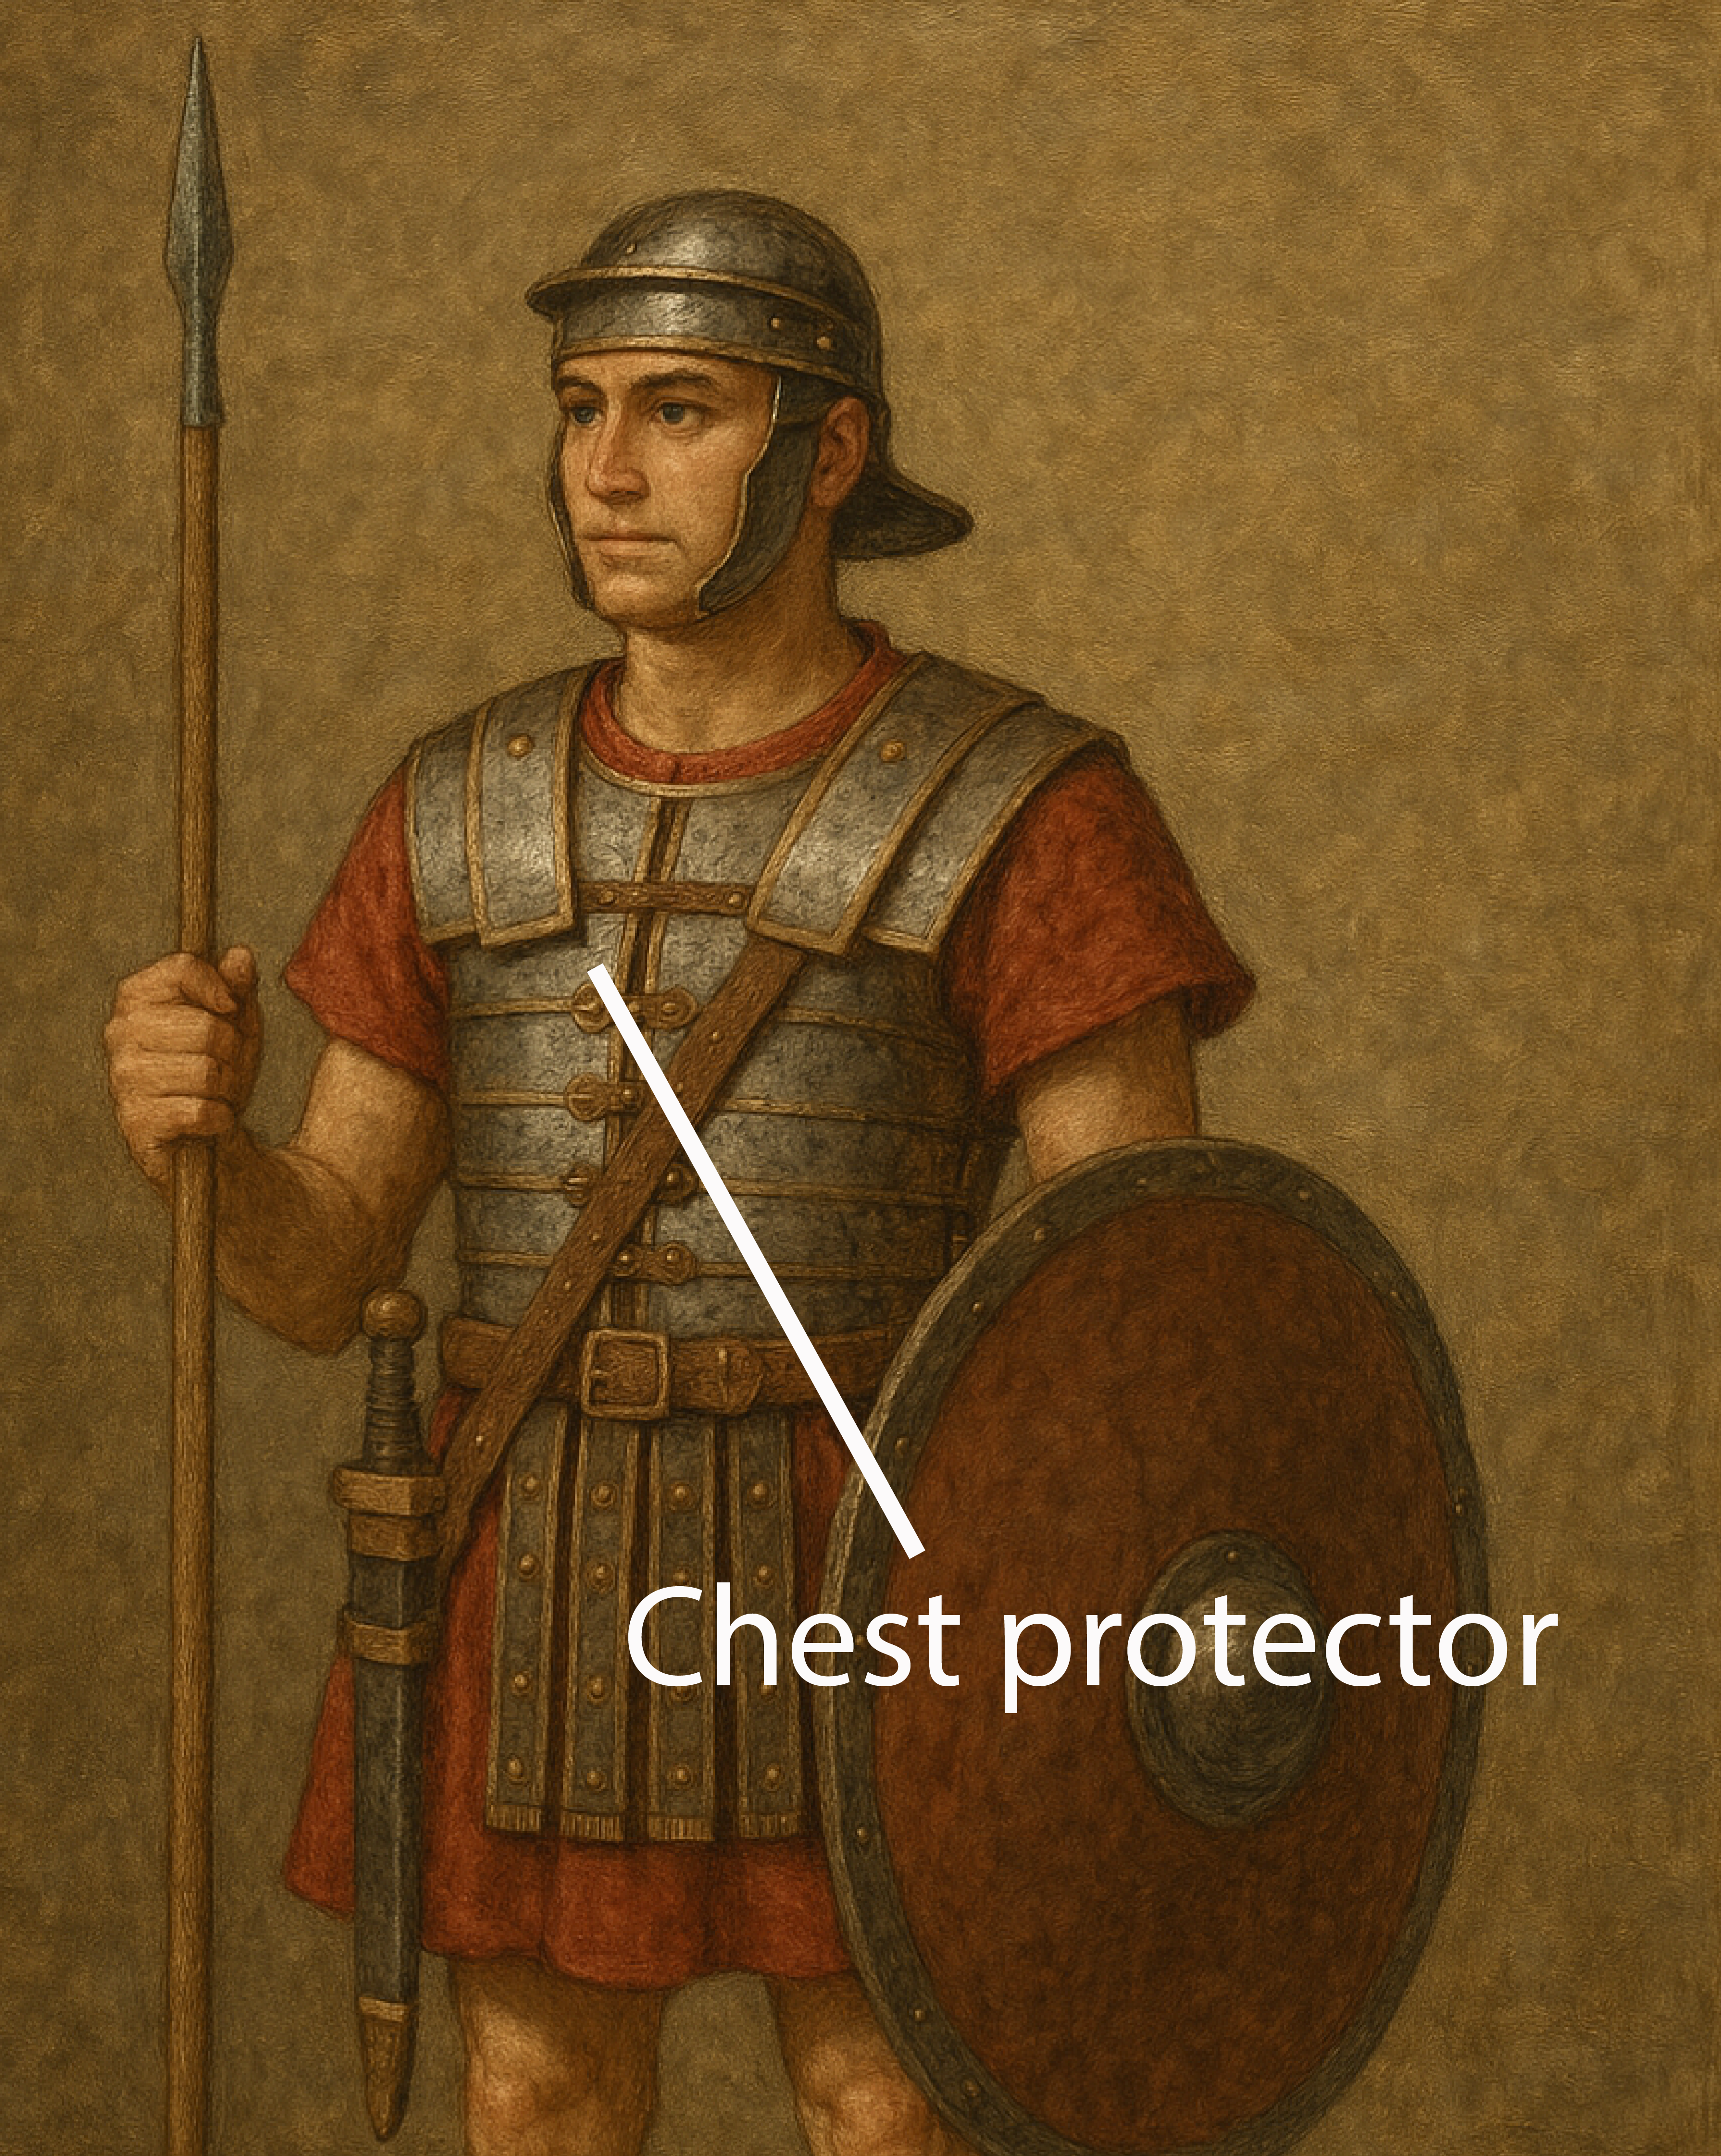

Translation:
The use of the word “breastplate” in EPH 6:14 and 1TH 5:8 is figurative to indicate the protective values of certain Christian virtues (compare WIS 5:18). So it is possible to translate the figurative meaning as follows: “We must protect ourselves, like with armor, with faith and love” (1TH 5:8 b in SPCL) and “the protection of right living on your chest” (EPH 6:14 c in NCV).
In REV 9:9 the breastplates are worn by the horses. Warhorses sometimes wore breast shields to protect them from the enemy’s spears and swords. For the first half of this verse, RSV has “they had scales like iron breastplates.” NJB is better with “They had body-armour like iron breastplates.” SPCL translates “Their bodies were covered with a kind of iron armor.” Another possible rendering is “Their bodies were covered with what looked like pieces of metal used to protect the chests of people.”

