Resource: Human-made Things in the Bible
Human-made Things in the Bible © United Bible Societies, 2025. Adapted from: The Works of Their Hands: Man-made Things in the Bible, by Ray Pritz © 2009 United Bible Societies. This work is licensed under Creative Commons Attribution-ShareAlike 4.0 International (https://creativecommons.org/licenses/by-sa/4.0/).

Human-made Things in the Bible

Wooden tower on elephant

2.16 Wooden tower on elephant

Reference:Greek πύργος, ξύλινος (purgos xulinos)1MA 6:37

Description and usage:
War elephants (Bernard Picart, Public domain, via Wikimedia Commons)In ancient warfare, elephants were sometimes used almost like a tank in modern warfare. The animal was so large that it frightened opposing soldiers and could hardly be withstood by an individual soldier. Sometimes a kind of wooden tower or box was placed on the back of the elephant as an elevated firing platform for soldiers. The whole heavy apparatus was strapped on the elephant with straps (called mēchanē in this verse) that went under the animal’s belly and perhaps around its neck and even under its tail. NJB renders these straps as “girths.”
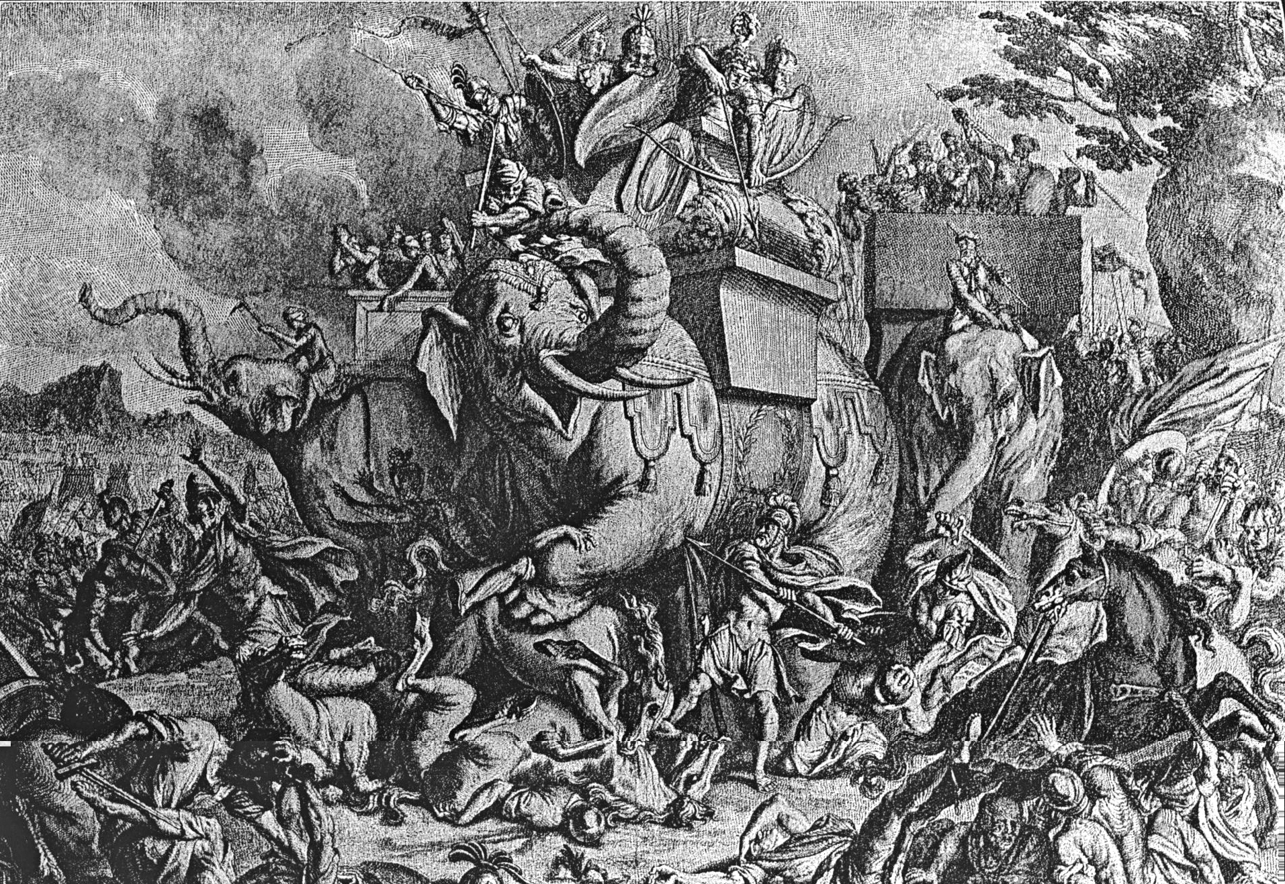

Translation:
In 1MA 6:37 the actual number of soldiers on each platform is in doubt. The Greek text has “thirty” or “thirty-two,” which would be too many even for a large elephant. Rahlfs emends the text to read “four” (followed by RSV), while GNT, NJB, and TOB have “three.” The Norwegian Bible (NOB) has “two.” The normal number of soldiers on an elephant, according to Charles, was three or four, and translators will normally have one of these numbers and perhaps include a footnote.

