Resource: Human-made Things in the Bible
Human-made Things in the Bible © United Bible Societies, 2025. Adapted from: The Works of Their Hands: Man-made Things in the Bible, by Ray Pritz © 2009 United Bible Societies. This work is licensed under Creative Commons Attribution-ShareAlike 4.0 International (https://creativecommons.org/licenses/by-sa/4.0/).

Human-made Things in the Bible

Well

3.8 Well

References:Hebrew בְּאֵר (b’er)GEN 14:10, GEN 14:10, GEN 16:14, GEN 21:19, GEN 21:25, GEN 21:30, GEN 24:11, GEN 24:20, GEN 26:15, GEN 26:18, GEN 26:19, GEN 26:20, GEN 26:21, GEN 26:22, GEN 26:25, GEN 26:32, GEN 29:2, GEN 29:2, GEN 29:2, GEN 29:3, GEN 29:3, GEN 29:8, GEN 29:10, EXO 2:15, NUM 20:17, NUM 21:16, NUM 21:16, NUM 21:17, NUM 21:18, NUM 21:22, JDG 9:21, 2SA 17:18, 2SA 17:19, 2SA 17:21, PSA 55:24, PSA 69:16, PRO 5:15, PRO 23:27, SNG 4:15Hebrew בֹּאר (bo’r)2SA 23:15Hebrew בּוֹר (bor)DEU 6:11, 1SA 19:22, 2SA 3:26, 1CH 11:17, 1CH 11:18Hebrew בַּיִר (bayir)JER 6:7Greek πηγή (pēgē)JHN 4:6, JHN 4:6, JHN 4:14Greek φρέαρ (frear)LUK 14:5, JHN 4:11, JHN 4:12

Description and usage:
(Image generated by ChatGPT using OpenAI technology)The well was a deep construction, often walled with stone, at the bottom of which was a pool of water. Wells were dug as deep as was necessary to reach usable water, sometimes more than 50 meters (165 feet) deep. For the difference between a well and a cistern, see 3.9 Cistern<REALIA:3.9>.
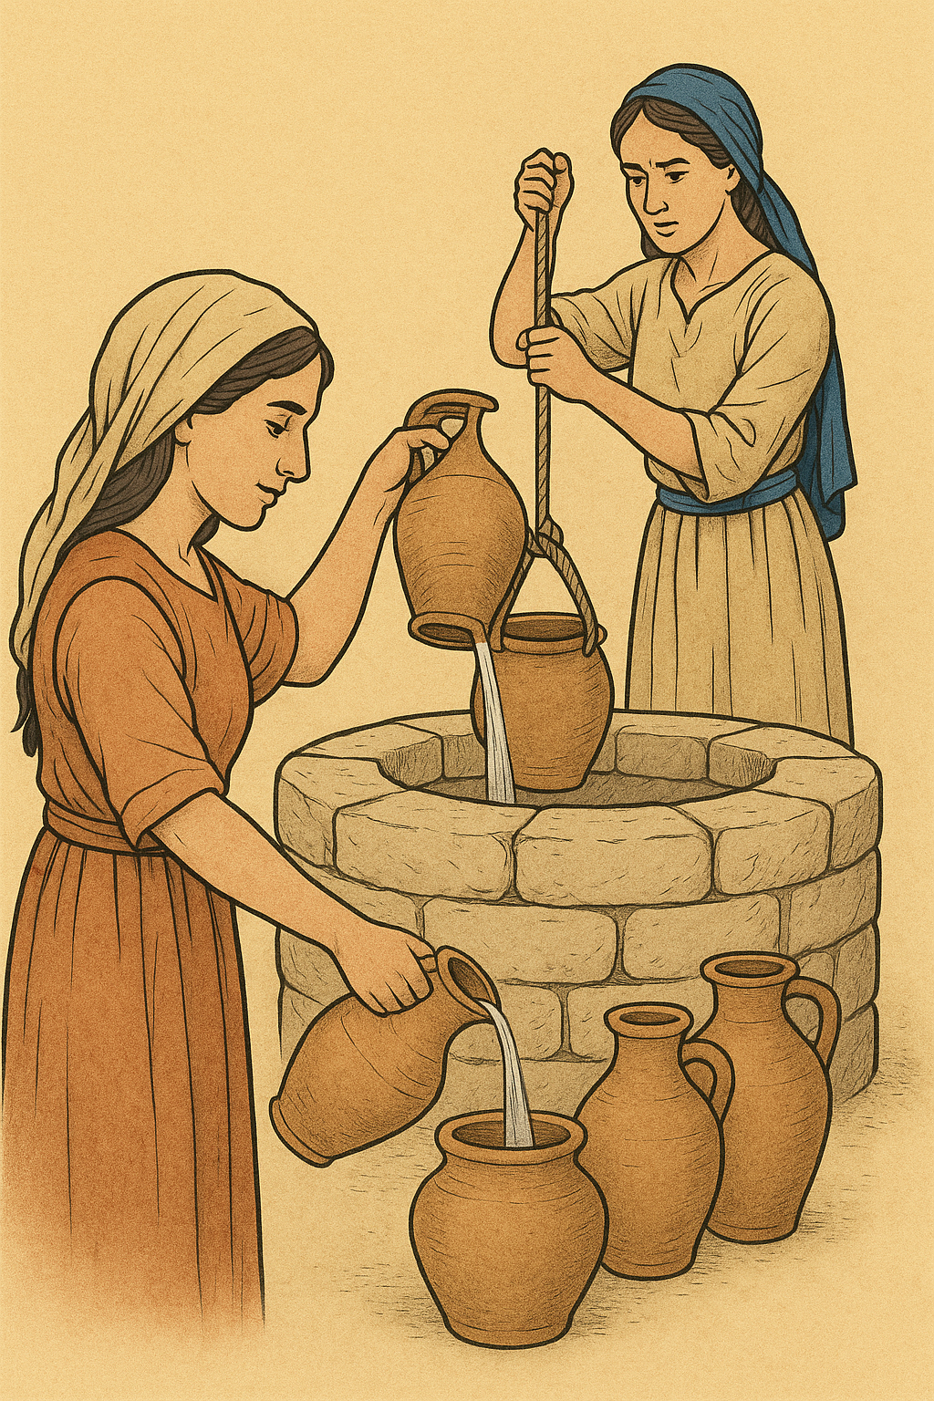

Translation:
Wells varied widely in construction, depending on the topography. In some cases a “well” was little more than a walled-in spring, and in fact the Greek word pēgē may indicate either a well or a spring, although most often it indicates a natural water source rather than a man-made one. In JHN 4:0pēgē is used interchangeably with frear, a word that refers to something dug or carved from rock. At JHN 4:14 most translations render pēgē as “spring,” although KJV and NASB have “well.” Most translations render pēgē as “well” in verse 6 and as “spring” in verse 14. A Handbook on The Gospel of John (page 111) offers a suggestion of how both are possible in a single context.
The Hebrew words given above all indicate holes that have been dug. Hebrew uses separate words for natural springs, which, of course, were not made by people. Because the Greek word frear indicates a hole that has been dug or carved out, it is not always possible to tell whether it indicates a cistern or a well.
PRO 5:15: The context of this verse indicates that the words “well” and “cistern” are used figuratively of a man’s wife. So GNT translates “Be faithful to your own wife and give your love to her alone.” CEV preserves the imagery by saying “You should be faithful to your wife, just as you take water from your own well” (similarly NCV). Compare also FRCL: “Your wife is like a spring of pure water. Drink from that source!” (similarly ITCL).
LUK 14:5: Any common term for “well,” “pond,” “fountain,” or “cistern” is acceptable here, provided that falling into it implies the danger of drowning.

