Resource: Human-made Things in the Bible
Human-made Things in the Bible © United Bible Societies, 2025. Adapted from: The Works of Their Hands: Man-made Things in the Bible, by Ray Pritz © 2009 United Bible Societies. This work is licensed under Creative Commons Attribution-ShareAlike 4.0 International (https://creativecommons.org/licenses/by-sa/4.0/).

Human-made Things in the Bible

Courtyard, court

3.20 Courtyard, court

References:Hebrew חָצֵר (chatser)EXO 8:9, EXO 27:9, EXO 27:9, EXO 27:12, EXO 27:13, EXO 27:16, EXO 27:17, EXO 27:18, EXO 27:19, EXO 35:17, EXO 35:17, EXO 35:18, EXO 38:9, EXO 38:9, EXO 38:15, EXO 38:16, EXO 38:17, EXO 38:18, EXO 38:18, EXO 38:20, EXO 38:31, EXO 38:31, EXO 38:31, EXO 39:40, EXO 39:40, EXO 40:8, EXO 40:8, EXO 40:33, EXO 40:33, LEV 6:9, LEV 6:19, NUM 3:26, NUM 3:26, NUM 3:37, NUM 4:26, NUM 4:26, NUM 4:32, 2SA 17:18, 1KI 6:36, 1KI 7:8, 1KI 7:9, 1KI 7:12, 1KI 7:12, 1KI 8:64, 2KI 20:4, 2KI 21:5, 2KI 23:12, 1CH 23:28, 1CH 28:6, 1CH 28:12, 2CH 4:9, 2CH 7:7, 2CH 20:5, 2CH 23:5, 2CH 24:21, 2CH 29:16, 2CH 33:5, NEH 3:25, NEH 8:16, NEH 8:16, NEH 13:7, EST 1:5, EST 2:11, EST 4:11, EST 5:1, EST 5:2, EST 6:4, EST 6:4, EST 6:5, PSA 65:5, PSA 84:3, PSA 84:11, PSA 92:14, PSA 96:8, PSA 100:4, PSA 116:19, PSA 135:2, ISA 1:12, ISA 62:9, JER 19:14, JER 26:2, JER 32:2, JER 32:8, JER 32:12, JER 33:1, JER 36:10, JER 36:20, JER 37:21, JER 37:21, JER 38:6, JER 38:13, JER 38:28, JER 39:14, JER 39:15, EZK 8:7, EZK 8:16, EZK 9:7, EZK 10:3, EZK 10:4, EZK 10:5, EZK 40:14, EZK 40:17, EZK 40:17, EZK 40:19, EZK 40:20, EZK 40:23, EZK 40:27, EZK 40:28, EZK 40:31, EZK 40:32, EZK 40:34, EZK 40:37, EZK 40:44, EZK 40:47, EZK 41:15, EZK 42:1, EZK 42:3, EZK 42:3, EZK 42:6, EZK 42:7, EZK 42:8, EZK 42:9, EZK 42:10, EZK 42:14, EZK 43:5, EZK 44:17, EZK 44:17, EZK 44:19, EZK 44:19, EZK 44:21, EZK 44:27, EZK 45:19, EZK 46:1, EZK 46:20, EZK 46:21, EZK 46:21, EZK 46:21, EZK 46:21, EZK 46:21, EZK 46:21, EZK 46:22, EZK 46:22, ZEC 3:7Hebrew עֲזָרָה (‘azarah)2CH 4:9, 2CH 4:9, 2CH 6:13Greek αὐλαῖος (aulaios)2MA 14:41Greek αὐλή (aulē)MAT 26:3, MAT 26:58, MAT 26:69, MRK 14:54, MRK 14:66, MRK 15:16, LUK 11:21, LUK 22:55, JHN 18:15, REV 11:2, TOB 2:9, TOB 2:9, ESG 1:1, ESG 2:11, ESG 4:2, LJE 1:17, 1MA 4:38, 1MA 4:48, 1MA 9:54, 1MA 11:46, 3MA 2:27, 3MA 5:10, 3MA 5:46, 1ES 9:1Greek περιβολή (peribolē)SIR 50:11Aramaic תְּרַע (tera‘)DAN 2:49

Description:
Courtyard of a house (Daderot, CC0, via Wikimedia Commons)The courtyard was an open area enclosed by structures within a building complex, such as the Temple, a palace, or even a house.
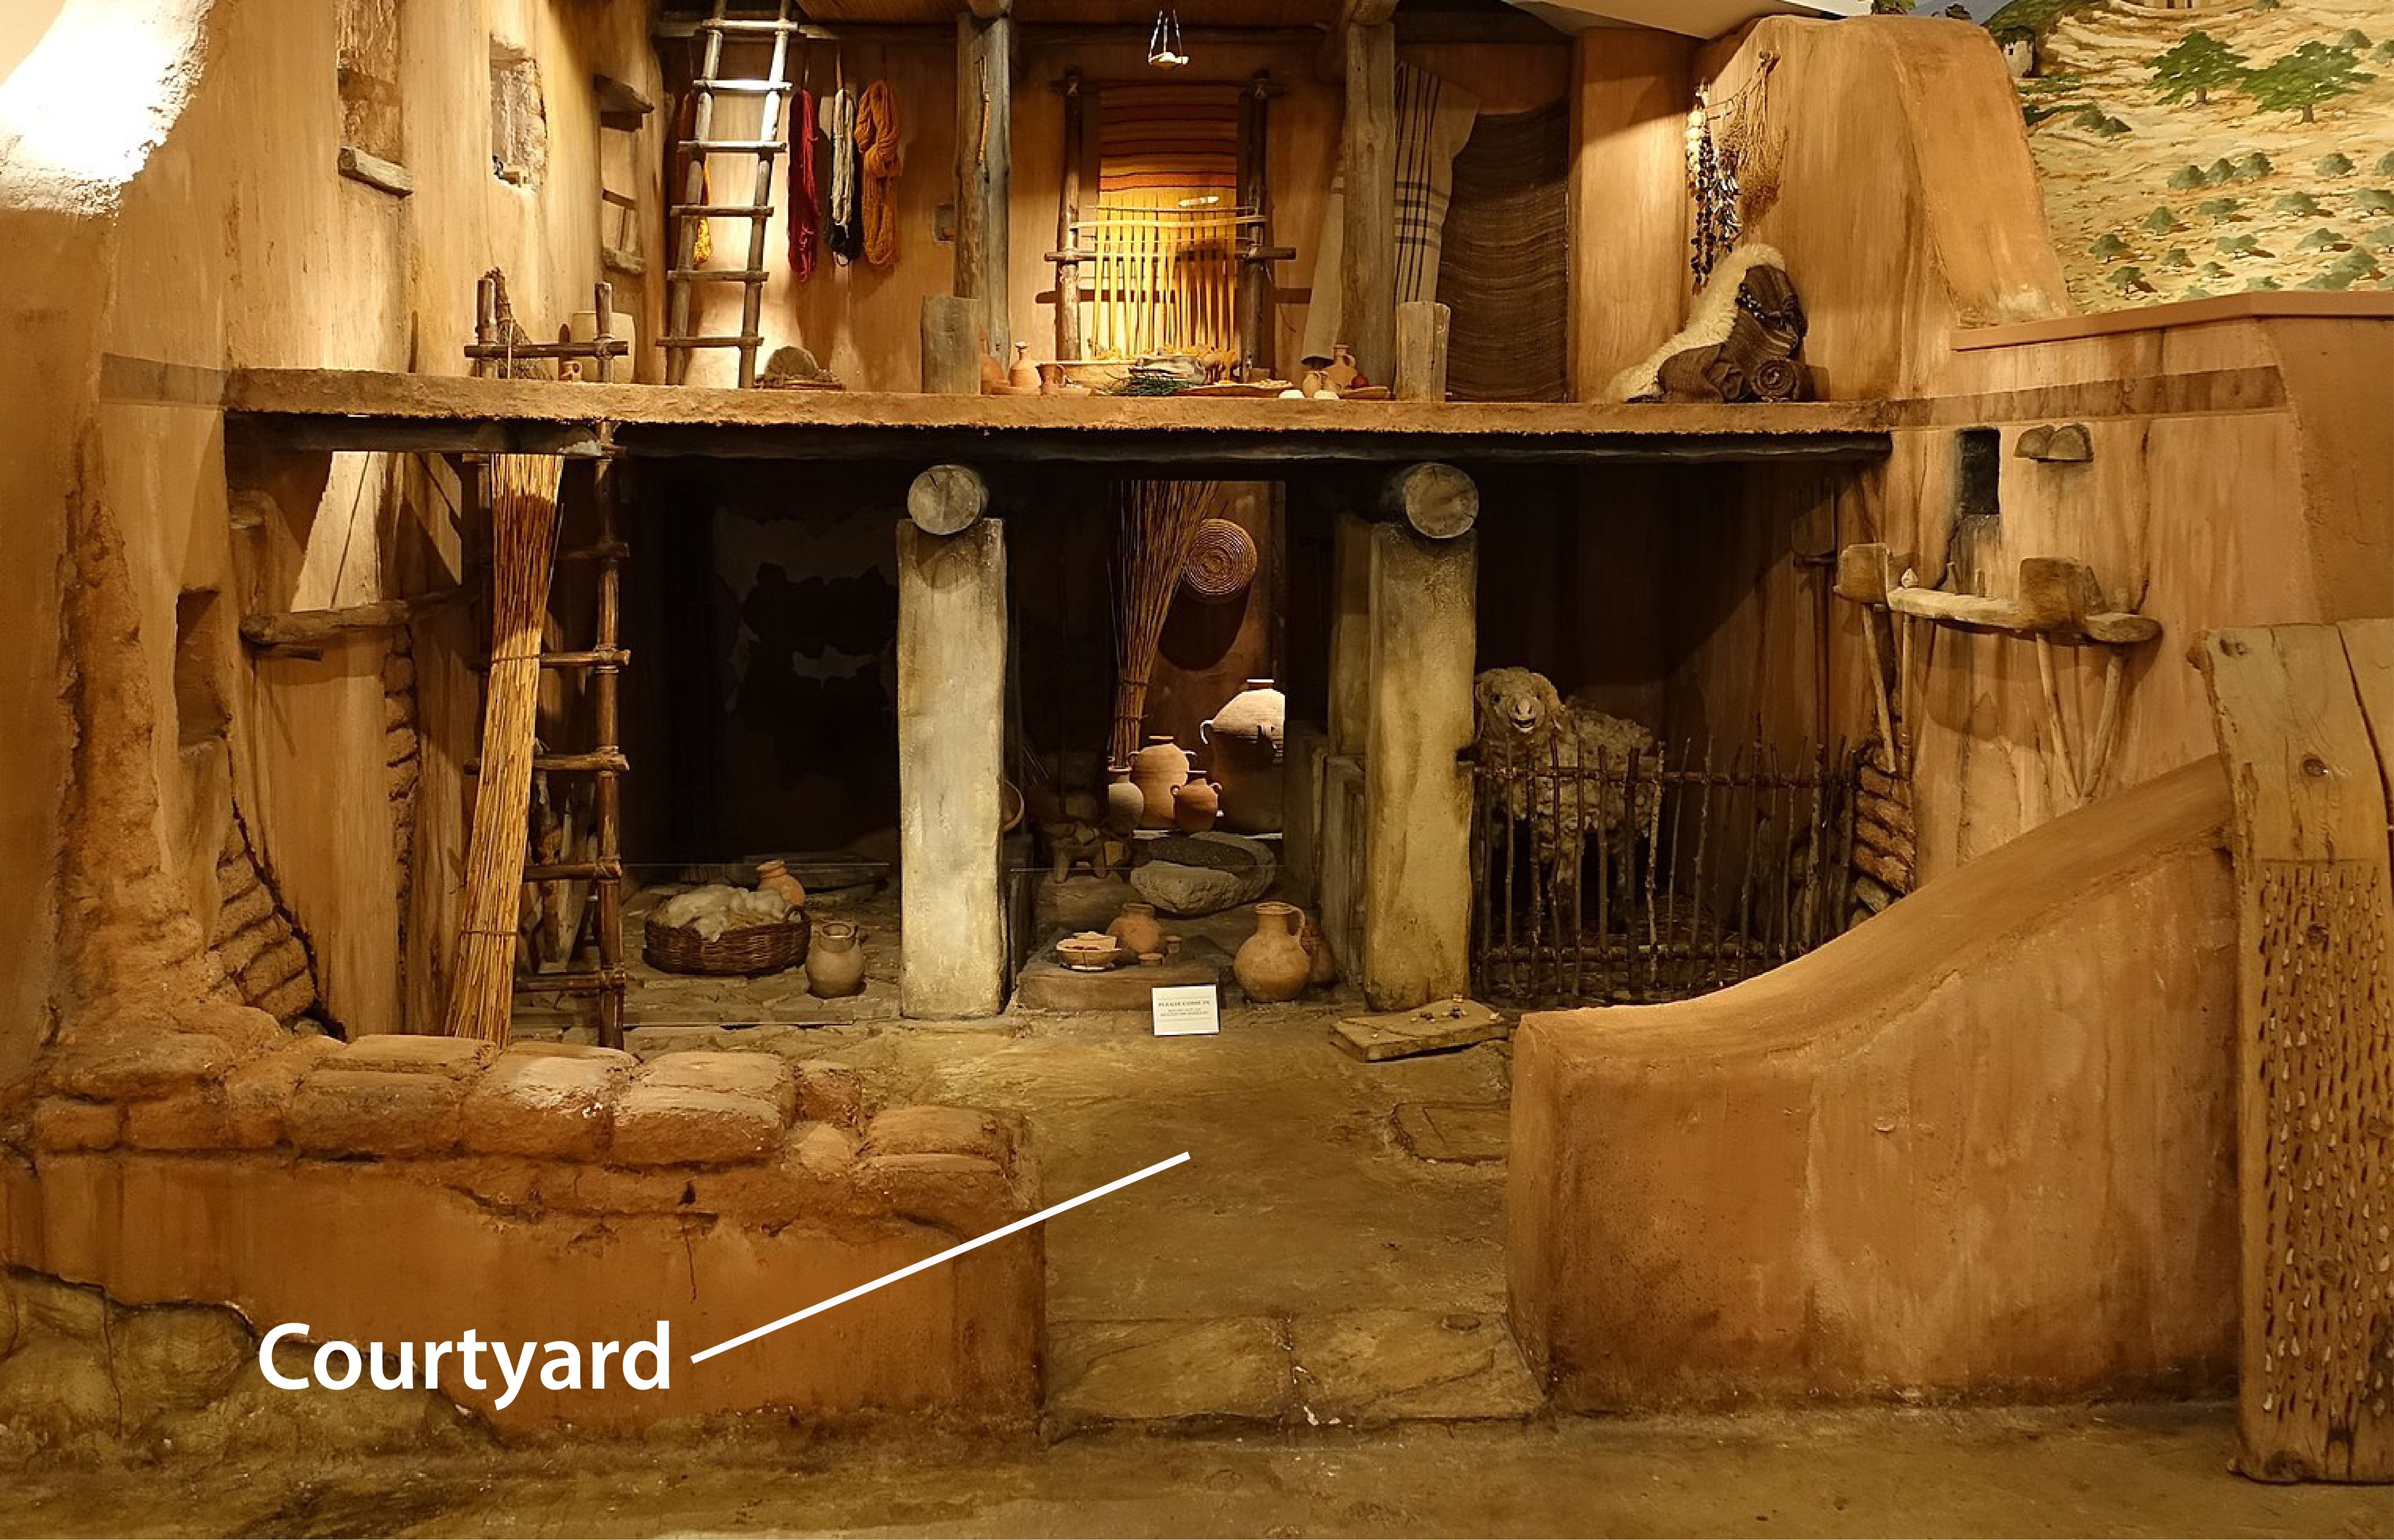

Translation:
As in English, so also in the biblical languages the words for “court” indicate both the physical courtyard and also the place of residence or activity of a king.
Temple courtyard (© Ariely, CC BY 3.0, via Wikimedia Commons)A number of times in the Old Testament, particularly in the Psalms, we encounter a phrase like “the courts of the LORD,” “your courts,” or “my courts.” In these places the word “courts” is a metonym for the Tabernacle or the Temple, and where necessary it may be translated as such. For example, in PSA 65:5GNT has “your sanctuary” and CEV says “your temple.” The translator should avoid using a word that indicates a court of law.
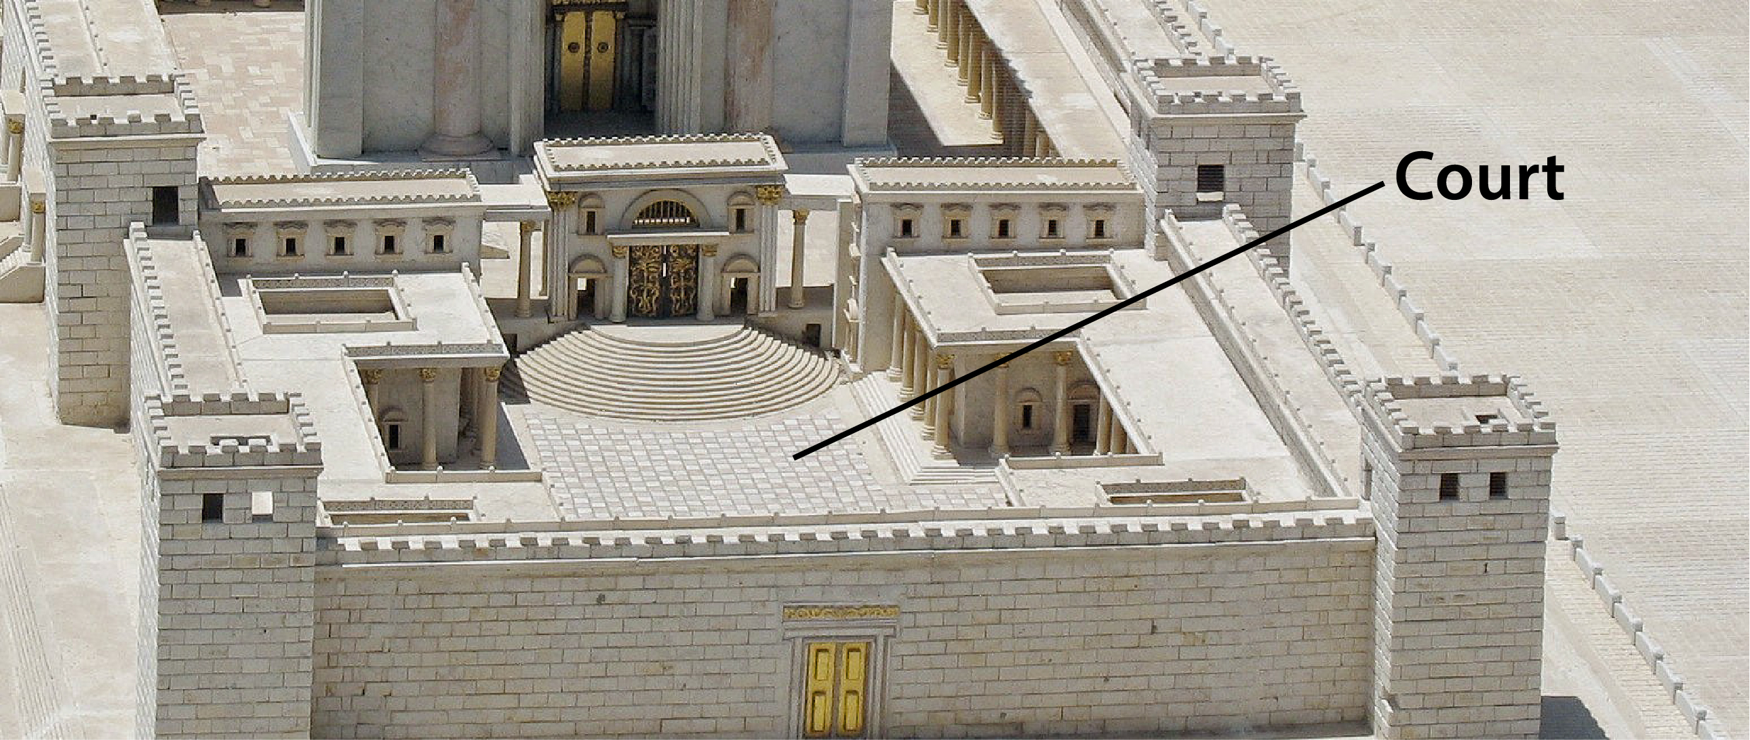
In some places the Greek word aulē refers to the courtyard of a private house. It has this meaning in MAT 26:3 and LUK 11:21, so CEV renders it “home” in these passages.
REV 11:2: “The court outside the temple” (RSV) was known as the Court of the Gentiles, for that is where they could assemble. They could not get closer to the inner sanctuary, however. In this passage this court and its people stand for the unbelievers, who will not be spared the disasters to come. Another way of expressing the initial clause in this verse is “But do not measure the open spaces with walls around them outside the Temple.”

Pavement, The Pavement

3.20.1 Pavement, The Pavement

References:Hebrew לְבֵנָה (lvenah)EXO 24:10Hebrew מַלְבֵּן (malben)JER 43:9Hebrew רִצְפָה (ritsfah)2CH 7:3, EST 1:6, EZK 40:17, EZK 40:17, EZK 40:18, EZK 40:18, EZK 42:3Greek λιθόστρωτον (lithostrōton)JHN 19:13Greek ἔδαφος (edafos)SIR 11:5, SIR 20:18, BEL 1:19, 3MA 2:22, 4MA 6:7

Description and usage:
Roman pavement, Petra (© High Contrast, CC BY 3.0 DE, via Wikimedia Commons)Pavement was an area paved with flat blocks of stone to form a courtyard (not a road). “The Pavement” was the name given to the inner courtyard of the Roman fortress of Antonia, which bordered the northwest corner of the Temple complex in Jerusalem.
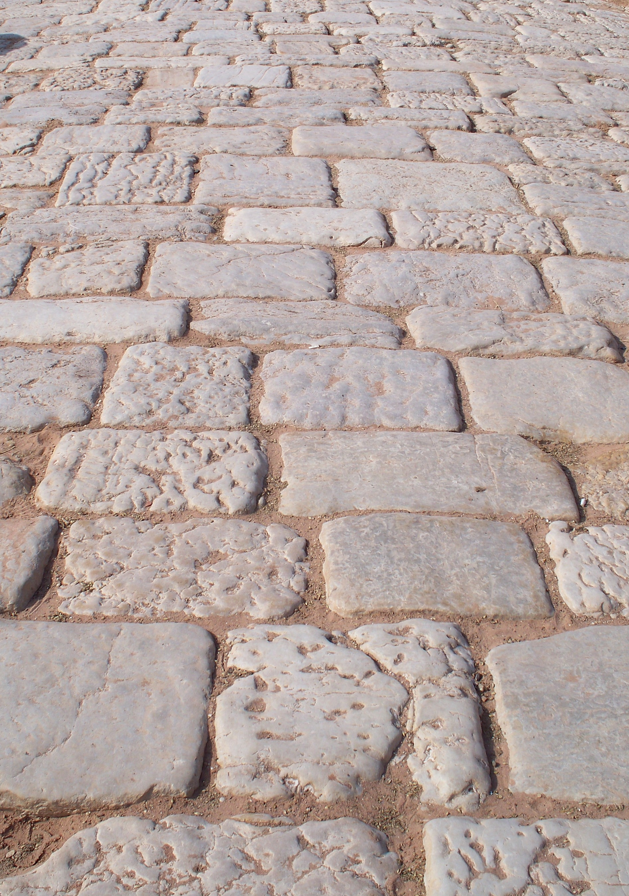

Translation:
JER 43:9: The Hebrew word malben occurs elsewhere with the meaning of “brick mold” or “brickkiln” (see the discussion and references at 1.8.1 Brick mold, brickkiln<REALIA:1.8.1>). Here it seems to indicate the material from which the pavement is made; NIV, NCV, and CEV all render it “brick pavement.” Jeremiah is told to hide the stones “in the melet of the malben.” The Hebrew word melet occurs only here, and its meaning is uncertain. Translations usually render it as some material in which the bricks would be set, for example, “clay” (NRSV, NIV, NCV), “mortar” (RSV, GNT), or “cement” (REB). CEV avoids finding a specific material and focuses instead on the location, saying “underneath the brick pavement.”
JHN 19:13: In some languages translators may render “The Pavement” as “the court covered with large blocks of flat stone” or “the stone-paved courtyard.”
The Greek word edafos does not refer to a specific place or even to a particular kind of construction. Thus it may be translated with a generic term such as “floor” or even “ground.”

