Resource: Human-made Things in the Bible
Human-made Things in the Bible © United Bible Societies, 2025. Adapted from: The Works of Their Hands: Man-made Things in the Bible, by Ray Pritz © 2009 United Bible Societies. This work is licensed under Creative Commons Attribution-ShareAlike 4.0 International (https://creativecommons.org/licenses/by-sa/4.0/).

Human-made Things in the Bible

High Priest’s clothing

4.5 High Priest’s clothing
This model shows what the high priest's garments may have looked like (© Ray Pritz by United Bible Societies)The High Priest’s clothing consisted of eight items. First he put on, as an undergarment, a pair of linen shorts. Over these he wore the tunic, a kind of long shirt, and then he wrapped a sash around his waist. Over all of this, he put on a long blue robe. Next came the ephod, which was a kind of apron with its own belt and shoulder straps. Between the straps and the belt of the ephod was a jeweled breastpiece. The biblical description does not make it clear if the shoulder straps of the ephod reached all the way to the waist in the front (as shown in the illustration at the right), or if the breastpiece with its cords formed the bridge between the shoulder straps and the top of the ephod at the waist. Tied around his forehead was a gold plate, and on top of his head he wore a sort of turban.

The precise identification of the various articles of clothing is very difficult. In some cases the exact meaning is unknown. The translator should try to visualize the whole outfit and then formulate it in a way that is meaningful to the readers. Footnotes may be necessary in order to emphasize the fact that the full set of clothing mentioned here was special and reserved for the High Priest. Some of this clothing was also worn by the other priests. The practice of transliterating the Hebrew terminology should be avoided if at all possible, but if no other solution can be found, a footnote or glossary explanation will definitely be required.

Undergarment, breeches, shorts

4.5.1 Undergarment, breeches, shorts

References:Hebrew מִכְנָסַיִם (miknasayim)EXO 28:42, EXO 39:28, LEV 6:3, LEV 16:4, EZK 44:18Greek περισκελής (periskelēs)SIR 45:8

Description and usage:
The undergarment of the high priest (© Ben P L, CC BY 2.0, via Wikimedia Commons)The shorts were an undergarment for the lower body. The references above indicate that it was made of linen (see 1.5.3.7 Linen<REALIA:1.5.3.7>). While this garment was in common use, it is mentioned only in reference to the High Priest and his fellow priests. It was to be worn next to their skin, under their priestly garments.
<image: 2Q==>

Translation:
The closest natural equivalent for “shorts” in the receptor language should be used. Some languages differentiate between undergarments worn by men and those worn by women. In all of the references listed above, a word for men’s undergarments should be chosen.

Tunic, shirt

4.5.2 Tunic, shirt

References:Hebrew כֻּתֹּנֶת (kutoneth)EXO 28:4, EXO 28:39, EXO 28:40, EXO 29:5, EXO 29:8, EXO 39:27, EXO 40:14, LEV 8:7, LEV 8:13, LEV 10:5, LEV 16:4, EZR 2:69, NEH 7:69, NEH 7:71Greek χιτών (chitōn)MRK 14:63

Description and usage:
Priest wearing a tunic (Image generated by ChatGPT using OpenAI technology)The tunic was another undergarment worn by the High Priest and his fellow priests. It went over the shorts, but from the waist up it was next to the skin, and over top of it went the robe. It was a kind of shirt and probably had long sleeves and reached nearly to the ankles. It was woven of linen. It was probably pulled over the head and was held in place by a sash wound around the waist. See also 6.3 Shirt, tunic<REALIA:6.3>.
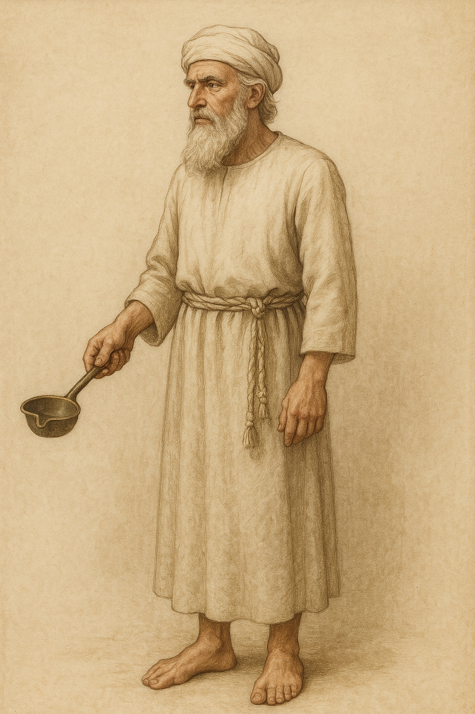

Translation:
In ordinary usage the Hebrew word kutoneth refers to an everyday article of clothing worn by men and women alike and was probably a sort of “shirt.” The RSV rendering “coat” (EXO 28:4) is misleading since this piece of clothing was not an outer garment but one worn underneath other clothing and next to the body. Kutoneth has often been translated “tunic” (NIV, NEB, NAB, NJB). “Shirt” (GNT, CEV) will be the closest equivalent in many languages. According to EXO 28:4, the tunic was “embroidered” (GNT). For translating the word “embroidered,” see 1.5.3.11 Embroidered cloth, needlework<REALIA:1.5.3.11>.

Robe

4.5.3 Robe

References:Hebrew מִדָּה (midah)PSA 133:2Hebrew מְעִיל (m‘il)EXO 28:4, EXO 28:31, EXO 28:34, EXO 29:5, EXO 39:22, EXO 39:23, EXO 39:24, EXO 39:25, EXO 39:26, LEV 8:7, 1SA 2:19, 1SA 15:27, 1SA 18:4, 1SA 24:5, 1SA 24:12, 1SA 24:12, 1SA 28:14, 2SA 13:18, 1CH 15:27, EZR 9:3, EZR 9:5, JOB 1:20, JOB 2:12, JOB 29:14, PSA 109:29, ISA 59:17, ISA 61:10, EZK 26:16Greek ἔνδυμα (enduma)WIS 18:24Greek ἱμάτιον (himation)MAT 26:65Greek περιστολή (peristolē)SIR 45:7Greek ποδήρης (podērēs)WIS 18:24, SIR 45:8Greek στολή (stolē)SIR 45:10, SIR 50:11, 1MA 10:21

Description:
The robe of the High Priest was worn on top of the tunic and thus was a kind of jacket or overshirt. It was woven of light blue wool thread. It was a long garment, hanging down to the ankles. It is not clear whether it had sleeves or not, nor whether it was open or closed in the front. Somewhat like a Latin American poncho, it may even have been a rectangular piece of cloth with a hole in the middle for the head. Around the hem of the robe were sewn alternating golden bells (see 4.5.3.1 Jinglet, bell<REALIA:4.5.3.1>) and pomegranates made of woven threads. The robe was held in place by the ephod, which was worn over it. See the illustrations at 4.5 High Priest’s clothing<REALIA:4.5> and 4.5.4 Ephod<REALIA:4.5.4>.

Translation:
This garment is sometimes called “the robe of the ephod” (so RSV in EXO 28:31; EXO 29:5; EXO 39:22). This means simply that the ephod was worn over it.

Jinglet, bell

4.5.3.1 Jinglet, bell

References:Hebrew פַּעֲמֹן (pa‘amon)EXO 28:33, EXO 28:34, EXO 28:34, EXO 39:25, EXO 39:25, EXO 39:26, EXO 39:26Greek κώδων (kōdōn)SIR 45:9

Description and usage:
Bells and jinglets on the high priest's garments (© Ben P L, CC BY 2.0, via Wikimedia Commons)Jinglets were small platelets of metal. Their exact size and shape are not known. They were sewn to the hem of the High Priest’s robe (see 4.5.3 Robe<REALIA:4.5.3>). As he walked or moved, they knocked together making a jingling or tinkling sound.
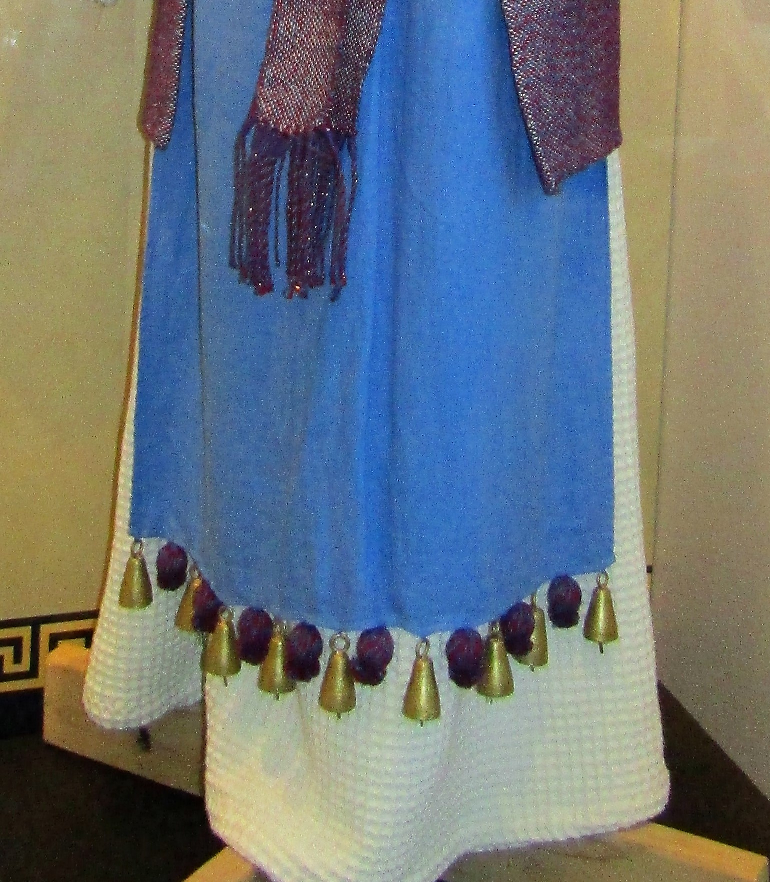

Translation:
Bells as we know them today, with a bell shape containing a ringing clapper, were not known at the time of Exodus and are probably not intended. Nevertheless, almost all the modern translations consulted render the Hebrew word pa‘amon as “bells” (for example, RSV and NIV). Where a word for jingling platelets exists and is commonly understood, it should be used. Otherwise translators may use “bells,” since they have the same function and are not very different in form. Where “bells” are not known, it will be necessary to find some sort of ornamentation, made of pieces of metal (perhaps coins) or even shells, which makes a sound when the clothing is moved.

Ephod

4.5.4 Ephod

References:Hebrew אֵפֹד, אֲפֻדָּה (’efod, ’afudah)EXO 25:7, EXO 28:4, EXO 28:6, EXO 28:8, EXO 28:12, EXO 28:15, EXO 28:25, EXO 28:26, EXO 28:27, EXO 28:27, EXO 28:28, EXO 28:28, EXO 28:28, EXO 28:31, EXO 29:5, EXO 29:5, EXO 29:5, EXO 35:9, EXO 35:27, EXO 39:2, EXO 39:5, EXO 39:7, EXO 39:8, EXO 39:18, EXO 39:19, EXO 39:20, EXO 39:20, EXO 39:21, EXO 39:21, EXO 39:21, EXO 39:22, LEV 8:7, LEV 8:7, NUM 34:23, JDG 8:27, JDG 17:5, JDG 18:14, JDG 18:17, JDG 18:18, JDG 18:20, 1SA 2:18, 1SA 2:28, 1SA 14:3, 1SA 21:10, 1SA 22:18, 1SA 23:6, 1SA 23:9, 1SA 30:7, 1SA 30:7, 2SA 6:14, 1CH 15:27, ISA 30:22, HOS 3:4Greek ἐπωμίς (epōmis)SIR 45:8

Description and usage:
A drawing of the clothing of the high priest (Image generated by ChatGPT using OpenAI technology)The ephod of the High Priest was a kind of apron or vest with shoulder straps and a belt. The belt was an integral part of the ephod; it was wrapped around the waist and tied either in the front or the back (see also the discussion below). The top of the ephod was at about the bottom of the ribcage. According to a tradition preserved by Josephus (Antiquities III 7, 5), the ephod had a length of one cubit (about 50 centimeters or 20 inches). This would mean that it extended approximately to the middle of the upper leg. The dimensions of the ephod are not given in Scripture.
<image: Z>
In order to gain a better picture of the structure of this ephod, it is helpful to consider it together with the breastpiece (see 4.5.5 Sacred pocket, breastpiece<REALIA:4.5.5>). According to one interpretation, the shoulder straps of the ephod were attached in the back and in the front of the ephod, and the breastpiece was attached to these straps in the front by gold rings. This is demonstrated in the illustration at 4.5 High Priest’s clothing<REALIA:4.5>. According to another interpretation, the shoulder straps of the ephod did not reach the belt at the top of the ephod. The space between the end of the straps and the belt (about 25 centimeters or 10 inches) was taken up by the breastpiece. On the four corners of the breastpiece were sewn gold rings. The lower two rings were tied with a blue thread to corresponding rings in the belt of the ephod. The upper rings of the breastpiece were connected to the ends of the shoulder straps by means of small gold chains. On the end of each shoulder strap was a kind of clasp consisting of a precious stone in a gold setting. Engraved on these stones were the names of the twelve tribes of Israel. It was to these devices that the other ends of the gold chains were attached. See the illustrations here and 4.5.5 Sacred pocket, breastpiece<REALIA:4.5.5>.

Translation:
“Ephod” is a transliteration of the Hebrew word ’efod and is perhaps the most difficult piece of the priestly clothing to translate. In some languages there will be a word for an item of clothing corresponding in design (if not in purpose) to the ephod. However, in some cases the word may not be usable because it designates something used only by women. In other cases a word for a workman’s apron may be inappropriate because its primary purpose is to protect the clothing. This was not the purpose of the ephod, which was the most elaborate and expensive item in the High Priest’s wardrobe. Almost all English versions transliterate ’efod, but Mft has simply “apron” and AT translates “[sacred] apron.” In other languages it may be possible to say “priestly apron.”
In EXO 28:8 and EXO 39:5RSV has the phrase “the skilfully woven band.” This band or belt seems to have been made with the same material as the ephod and attached to its corners so that it could be tied. The use of the singular does not necessarily mean that there was only one belt. The term may have been used in a collective sense. The Hebrew word here simply means “girdle,” “waistband,” or “belt.” The idea of “skilfully woven” is therefore omitted in NJB and NEB as well as in many non-English versions, and may also be left out of the receptor-language rendering. NJB has “The waistband on the ephod.”
Other meanings of ’efod: In a number of the passages listed above, the word ’efod describes something other than an item of the High Priest’s clothing. In most (some would say all) cases it still indicates an item of clothing, probably a kind of vest or apron tied around the upper abdomen. See 1SA 2:18; 1SA 22:18; 2SA 6:14; and 1CH 15:27, where the Hebrew phrase ’efod bad is used; this phrase is literally “linen ephod” or “cloth ephod.” The renderings of GNT at 1SA 2:18 (“sacred linen apron”) and 2SA 6:14 (“linen cloth around his waist”) may serve as models.
JDG 8:27: The exact nature of the “ephod” made by Gideon remains uncertain. Because he collected a large quantity of gold before he made it, many have thought it to be a kind of “idol” (GNT, International Children’s Bible, Mft). However, even here it is possible that a copy of the priestly apron is intended; gold was a major component of the priestly garment, and some of Gideon’s gold could have been used to pay the skilled workers to make the ephod. NCV says “holy vest,” but most versions simply have the transliteration “ephod” (for example, RSV and NIV). If no explanation is given, however, the average reader will probably associate it with the object of the same name first mentioned in Exodus. It seems best, then, to decide between “idol/image/statue” and “priestly apron”; or, if “ephod” is kept, to include a footnote indicating the possible meanings. The TOB note on this verse is a good model: “The ephod may designate here either a receptacle for the sacred lots, used for divination, or the statue of a god.”
In JDG 17:5; JDG 18:14; JDG 18:18; JDG 18:18; JDG 18:20; and HOS 3:4, the ephods mentioned may well have been sacred clothing similar in purpose and perhaps in form to the ephod of the High Priest. However, both Micah’s ephod in Judges and the one mentioned in HOS 3:4 were not the High Priest’ ephod. These ephods are associated in their contexts with illicit worship.

Sacred pocket, breastpiece

4.5.5 Sacred pocket, breastpiece

References:Hebrew חֹשֶׁן (choshen)EXO 25:7, EXO 28:4, EXO 28:15, EXO 28:22, EXO 28:23, EXO 28:23, EXO 28:24, EXO 28:26, EXO 28:28, EXO 28:28, EXO 28:29, EXO 28:30, EXO 29:5, EXO 35:9, EXO 35:27, EXO 39:8, EXO 39:9, EXO 39:15, EXO 39:16, EXO 39:17, EXO 39:19, EXO 39:21, EXO 39:21, LEV 8:8, LEV 8:8

Description and usage:
(Image generated by ChatGPT using OpenAI technology)The breastpiece was a piece of embroidered cloth worn by the High Priest over the center of his chest. It formed a bridge between the shoulder straps of the ephod and its belt (see the description of its attachment to the ephod at 4.5.4 Ephod<REALIA:4.5.4>).

The breastpiece was rectangular, twice as long as it was wide, but it was doubled so that it was square. Its dimensions are given as two spans by one span. When it was folded it was a square, one span on each side. (The span is usually considered to have been about half a cubit [compare EZK 43:13, EZK 43:17 ], which equals about 25 centimeters [10 inches].) The fold was at the bottom, and this formed a kind of pocket. In this pocket were kept the Urim and Thummim (see 4.9.1 Urim and Thummim<REALIA:4.9.1>).
Mounted on the breastpiece in gold settings were four rows of three (or three rows of four) precious stones each. On each of the twelve different stones was engraved a name of one of the tribes of Israel.

Translation:
It may not be easy to find a single term appropriate to translate the Hebrew word choshen. The English word “breastplate” gives the mistaken impression that it was made of metal or other hard substance. Die Bibel: Einheitsübersetzung (BE) has “lot pouch,” which focuses on the function of the breastpiece in holding the Urim and Thummim. It may also be translated “sacred pouch” (Mft), “chest covering” (NCV), or “pocket over the heart.” The Hebrew phrase choshen mishpat (“breastpiece of judgment” in RSV) in EXO 28:15 is rendered “pouch of judgment” (TOT), “judicial pouch” (Mft), “breastpiece of decision” (NJPSV, NAB), and “breastpiece for making decisions” (NIV). CEV has “breastpiece for the high priest to use in learning what I want my people to do.”

Sash, cloth belt

4.5.6 Sash, cloth belt

References:Hebrew אַבְנֵט (’avnet)EXO 28:4, EXO 28:39, EXO 28:40, EXO 29:9, EXO 39:29, LEV 8:7, LEV 8:13, LEV 16:4Hebrew חגר (chagar)EXO 29:9, LEV 8:7, LEV 8:7, LEV 8:13, LEV 16:4

Description:
The sash was a long cloth belt that was wrapped several times around the waist of the High Priest over the tunic (see 4.5.2 Tunic, shirt<REALIA:4.5.2>). His fellow priests also wore sashes. According to EXO 39:29, the High Priest’s sash was embroidered of four kinds of thread. According to post-biblical Jewish tradition, it was 32 cubits (about 16 meters or 53 feet) long. Even if the tradition exaggerates the length, it was probably long enough to be wound around the waist several times before being tied. See the illustration at 4.5.4 Ephod<REALIA:4.5.4>.

Translation:
In modern English the word “girdle” (RSV) for this belt is misleading. In addition to its purely functional use as a long embroidered sash that was wrapped around the midsection, it also seems to have had a symbolic meaning as a sign of the priesthood. Many English versions use the word “sash,” but in some languages it may be necessary to say “broad band.” In LEV 8:7 it should be carefully distinguished from “the skilfully woven band of the ephod” (RSV; GNT “its finely woven belt”), mentioned later in this verse (see 4.5.4 Ephod<REALIA:4.5.4>).
See also the discussion at 6.6 Waistband, sash, belt<REALIA:6.6>.

Forehead plate, forehead ornament

4.5.7 Forehead plate, forehead ornament

References:Hebrew צִיץ (tsits)EXO 28:36, EXO 39:30, LEV 8:9Greek στέφανος (stefanos)SIR 45:12

Description:
(Image generated by ChatGPT using OpenAI technology)The High Priest was commanded to wear a kind of headband on his forehead just below the level of his turban. It was made of two materials. In the front was a thin piece of gold beaten into the form of a narrow band. On this plate were inscribed the words “Consecrated [or, Dedicated/Holy] to the LORD).” Through the ends of this band were threaded blue ribbons or threads. These were tied at the back of the head holding the band against the forehead.
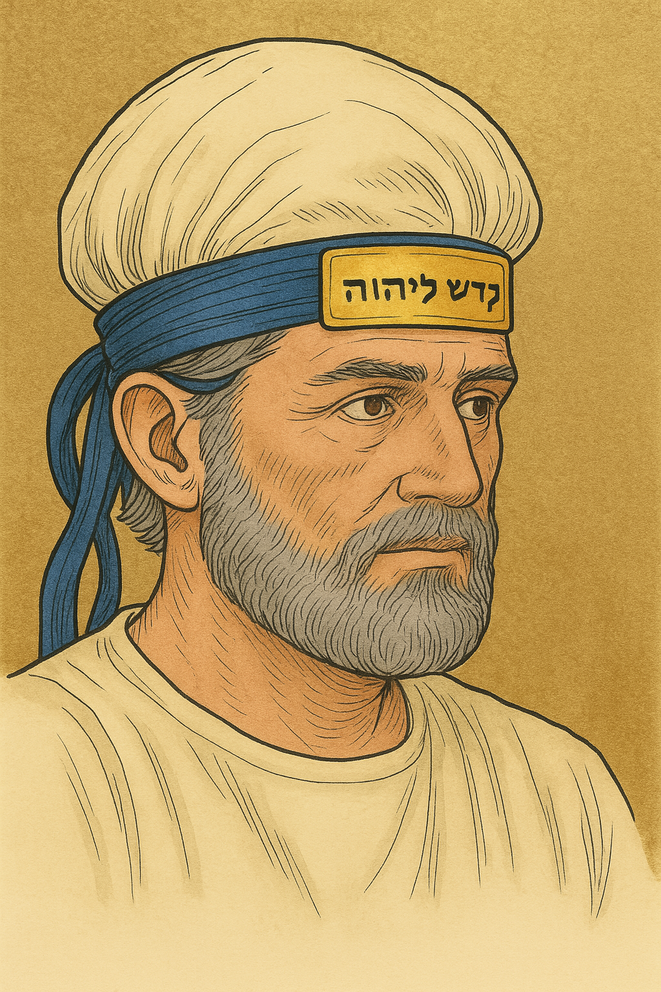

Translation:
Ten English translations of EXO 28:36 that were consulted had eight different renderings of the Hebrew word tsits. Something like CEV “narrow strip” or GECL “small plate” will probably be best. Another possibility is “gold headband.”
LEV 8:9 has the literal expression “the golden flower, the holy crown.” In the first phrase “flower” renders the Hebrew word tsits. This word may mean “blossom” or “flower,” as in NUM 17:23 (verse 23 in Hebrew), or “shining thing.” When it is used with the qualifying word “golden,” many English versions understand it in the sense of “plate” (for example, RSV and NIV). FRCL, however, translates “the golden jewel in the form of a flower.” NJB has simply “the golden flower.” However, these words in Hebrew are in apposition with the phrase “the holy crown” and are explained by it. “The holy crown” was clearly not a crown in the sense of a sign of royalty. The Hebrew word translated “crown” may also mean “consecration,” and the whole expression probably indicates that the golden plate was a symbol of the High Priest’s dedication to God. It has been suggested that the meaning of the second phrase may be rendered by an expression such as “the sign showing that Aaron was given over to [or, consecrated to] God.” A possible model for translating the whole expression is “the golden object showing that he was dedicated to God.”

Turban, headdress

4.5.8 Turban, headdress

References:Hebrew מִגְבָּעָה (migba‘ah)EXO 28:40, EXO 29:9, EXO 39:28, LEV 8:13Hebrew מִצְנֶפֶת (mitsnefeth)EXO 28:4, EXO 28:37, EXO 28:37, EXO 28:39, EXO 29:6, EXO 29:6, EXO 39:28, EXO 39:31, LEV 8:9, LEV 8:9, LEV 16:4Hebrew פְּאֵר (p’er)EXO 39:28, EZK 44:18Hebrew צָנִיף (tsanif)ZEC 3:5, ZEC 3:5Greek κίδαρις (kidaris)JDT 4:15, SIR 45:12

Description:
The turban was a headpiece formed by winding a long piece of cloth many times around the top of the head. It may have been wound permanently and put on and taken off like a hat. See the illustration at 6.7 Headdress, turban, hat<REALIA:6.7>.

Translation:
In some languages there may be a very general word for anything worn on the head. If such a term must be used to describe the High Priest’s headdress, it may be necessary to include a footnote explaining that such a headpiece symbolized the authority of the High Priest.
The Hebrew words migba‘ah and p’er (literally “beauty” or “decoration”) refer to the headgear of the normal priests. In form their headgear was like the headdress worn by the High Priest, although slightly less elaborate. It will usually be possible to use the same word for both.
In EXO 39:28 the words migba‘ah and p’er are combined to describe the caps of the ordinary priests. Since both words are used elsewhere to describe a single piece of headwear, different approaches have been tried here in translation. Most translations have a single word, such as “caps” (RSV, GNT) or “headbands” (NIV, NCV). Others take the word p’er to be a modifier of migba‘ah, saying “decorated turbans” (NJPSV), “decorated caps” (NASB), “beautiful turbans” (GW), or “fancy caps” (CEV). REB treats the two words (in reverse order) as two different items, saying “the tall headdresses and their bands.”

