Resource: Human-made Things in the Bible
Human-made Things in the Bible © United Bible Societies, 2025. Adapted from: The Works of Their Hands: Man-made Things in the Bible, by Ray Pritz © 2009 United Bible Societies. This work is licensed under Creative Commons Attribution-ShareAlike 4.0 International (https://creativecommons.org/licenses/by-sa/4.0/).

Human-made Things in the Bible

Burial and mourning

4.8 Burial and mourning

Tomb, grave

4.8.1 Tomb, grave

References:Hebrew בַּיִת (bayith)ISA 14:18Hebrew גָּדִישׁ (gadish)JOB 21:32Hebrew צְרִיחַ (tsriach)1SA 13:6Hebrew קְבוּרָה (qvurah)GEN 35:20, GEN 35:20, GEN 47:30, DEU 34:6, 1SA 10:2, 2KI 9:28, 2KI 21:26, 2KI 23:30, 2CH 26:23, ECC 6:3, ISA 14:20, JER 22:19, EZK 32:23, EZK 32:24Hebrew קֶבֶר (qever)GEN 23:4, GEN 23:6, GEN 23:6, GEN 23:9, GEN 23:20, GEN 49:30, GEN 50:5, GEN 50:13, EXO 14:11, NUM 19:16, NUM 19:18, JDG 8:32, JDG 16:31, 2SA 2:32, 2SA 3:32, 2SA 4:12, 2SA 17:23, 2SA 19:38, 2SA 21:14, 1KI 13:22, 1KI 13:30, 1KI 13:31, 1KI 14:13, 2KI 13:21, 2KI 22:20, 2KI 23:6, 2KI 23:16, 2KI 23:16, 2KI 23:17, 2CH 16:14, 2CH 21:20, 2CH 24:25, 2CH 28:27, 2CH 32:33, 2CH 34:4, 2CH 34:28, 2CH 35:24, NEH 2:3, NEH 2:5, NEH 3:16, JOB 3:22, JOB 5:26, JOB 10:19, JOB 17:1, JOB 21:32, PSA 5:10, PSA 88:6, PSA 88:12, ISA 14:19, ISA 22:16, ISA 22:16, ISA 53:9, ISA 65:4, JER 5:16, JER 8:1, JER 20:17, JER 26:23, EZK 32:22, EZK 32:23, EZK 32:25, EZK 32:26, EZK 37:12, EZK 37:12, EZK 37:13, EZK 37:13, EZK 39:11, NAM 1:14Greek μνῆμα (mnēma)MRK 5:5, LUK 8:27, LUK 23:53, LUK 24:1, ACT 2:29, ACT 7:16, REV 11:9Greek μνημεῖον (mnēmeion)GEN 23:6, GEN 23:6, GEN 23:9, GEN 35:20, GEN 35:20, GEN 49:30, GEN 50:5, GEN 50:13, ISA 22:16, ISA 22:16, ISA 26:19, EZK 39:11, MAT 8:28, MAT 23:29, MAT 27:52, MAT 27:53, MAT 27:60, MAT 27:60, MAT 28:8, MRK 5:2, MRK 6:29, MRK 15:46, MRK 15:46, MRK 16:2, MRK 16:3, MRK 16:5, MRK 16:8, LUK 11:44, LUK 11:47, LUK 23:55, LUK 24:2, LUK 24:9, LUK 24:12, LUK 24:22, LUK 24:24, JHN 5:28, JHN 11:17, JHN 11:31, JHN 11:38, JHN 12:17, JHN 19:41, JHN 19:42, JHN 20:1, JHN 20:1, JHN 20:2, JHN 20:3, JHN 20:4, JHN 20:6, JHN 20:8, JHN 20:11, JHN 20:11, ACT 13:29, WIS 10:7Greek τάφος (tafos)MAT 23:27, MAT 23:29, MAT 27:61, MAT 27:64, MAT 27:66, MAT 28:1, ROM 3:13, TOB 4:4, TOB 4:17, TOB 6:15, TOB 8:10, TOB 8:18, WIS 19:3, SIR 30:18, 1MA 2:70, 1MA 9:19, 1MA 13:27, 1MA 13:30, 2MA 5:10, 2MA 12:39, 3MA 6:31, 1ES 1:29Latin monumentum2ES 2:16Latin sepulchrum2ES 2:23, 2ES 5:35

Description and usage:
Tomb with niches, with wall painting of man playing a flute and woman playing a harp (Beit Guvrin) (© Carole Raddato from FRANKFURT, Germany, CC BY-SA 2.0, via Wikimedia Commons)The tomb was a construction for the burial of the dead. Since much of the land of Israel, especially in the hilly regions, has little topsoil, tombs were often hewn out of bedrock. In some cases natural caves were used for burial. The entrance to a tomb was closed with a stone (see 4.8.1.1 Stone for closing a tomb<REALIA:4.8.1.1>).
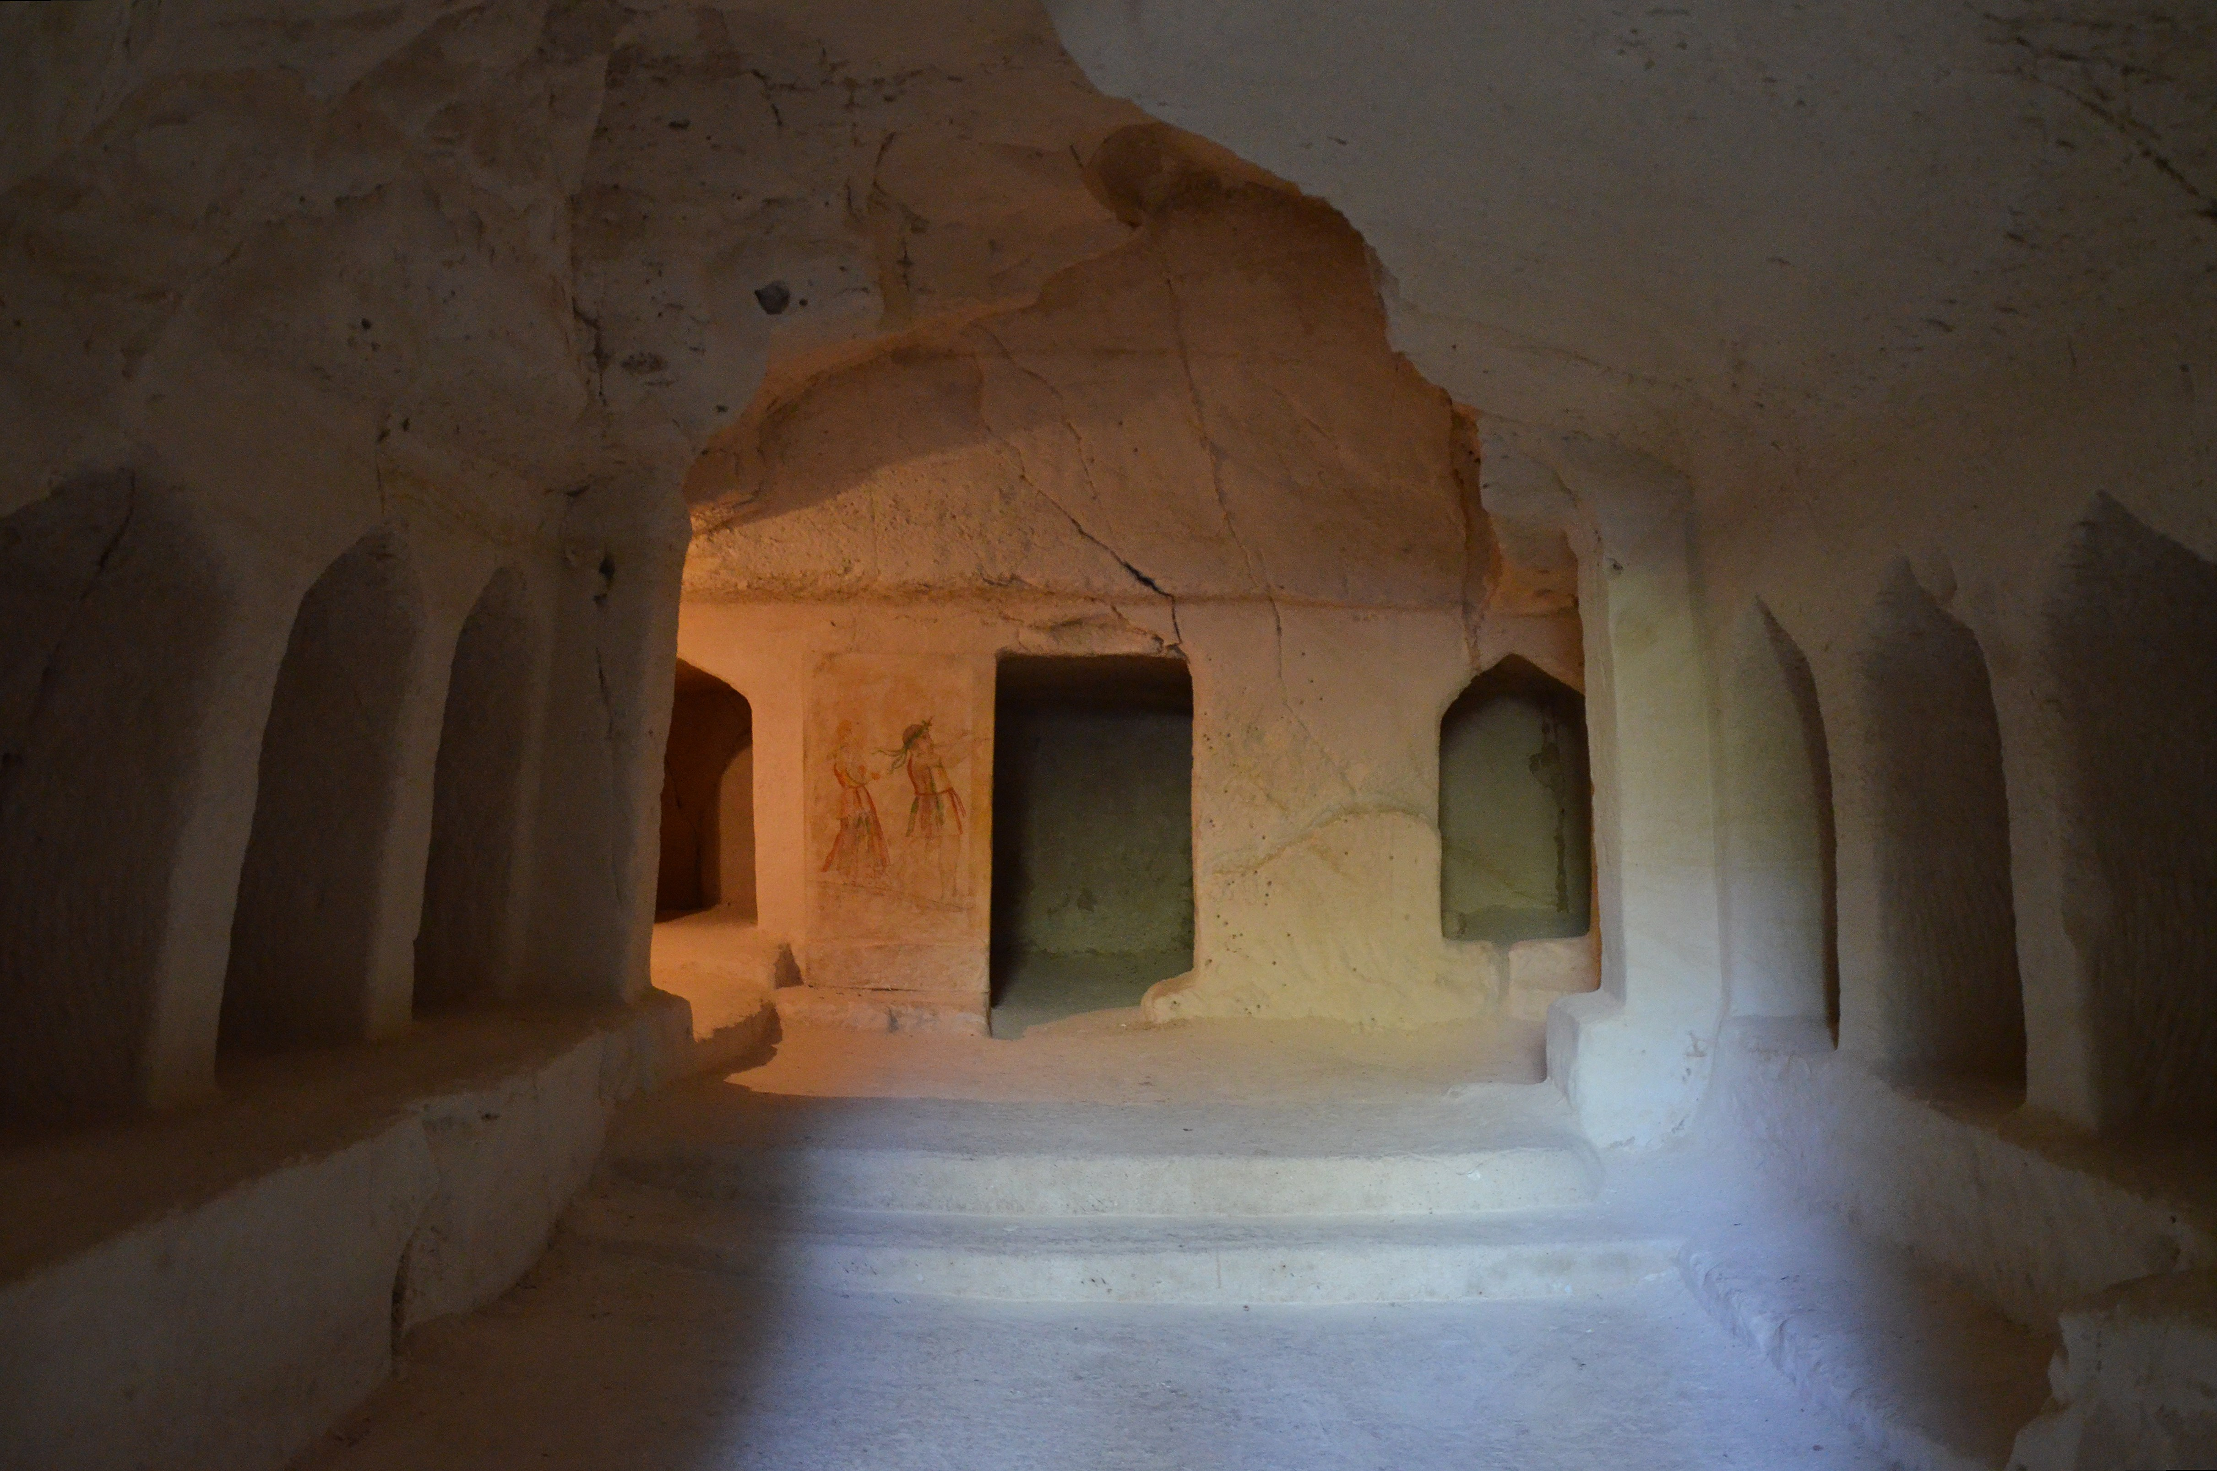

Translation:
Death is a universal experience, and all languages and cultures have words to express the disposal of a dead body. In a number of languages it is important to distinguish clearly between a grave (a hole in the ground in which a corpse is placed) and a tomb (a construction built above the surface of the ground for housing one or more corpses). In some contexts, however, it may be better to use a more generic expression, for example, “places where people are buried” or “places where corpses are placed.”
In some passages the word “grave” is used as a symbol for death. Translators should consider whether the physical burial place is in focus or rather the fact that a person has died. In the latter case, it may be better to use a term indicating “death.” This will be true especially in poetic passages. For example, JOB 3:22 is literally “who rejoicing unto joy are glad when they find a grave,” but GNT has “They are not happy till they are dead and buried.” JOB 5:26 is literally “You will come to the grave at an old age,” but GNT says “you will live to a ripe old age.”
Certain verses speak of “graves” in the plural. Here it will often be appropriate to use a word like “graveyard” (GNT in JOB 21:32) or “cemetery.”
In the upper levels of Israelite society burial was often done in two stages. In the first stage the body was either laid on a kind of shelf inside a burial chamber or it was placed in a large box called a sarcophagus (“flesh eater”) in English. After about a year, when the flesh had rotted, the bones were moved to a designated place in the chamber. By New Testament times the bones were being placed into an ossuary (“bone box”). These practices gave rise to two expressions in the Hebrew language: “he lay down with his fathers” and “he was gathered to his fathers.” In 2CH 16:14, the place where the body was laid out (mishkav in Hebrew) is referred to in the burial of King Asa of Judah. Some translations render the word as “bier” (RSV, NIV; see 4.8.4 Bier, coffin<REALIA:4.8.4>), but the structure of the verse indicates that Asa’s body was taken into the tomb and laid in its permanent place, that is, on a shelf in the tomb. The rendering of NJPSV gives the sense better with “resting-place.”
1SA 13:6: The meaning of the Hebrew word tsrichim in this verse is uncertain. Some versions understand it to mean “tombs” (RSV, CEV, GECL, ITCL). These would be cave-like structures hewn out of the rock. Others use a more generic term, such as “pits” (GNT, NIV) or “vaults” (NJB). Some have thought this word is related to a Hebrew word meaning “stronghold” or “tower” in JDG 9:46, JDG 9:49, but this meaning does not seem to fit the context here.
In MAT 23:29 the Greek word mnēmeion may also be understood as referring to monuments built as memorials to people who have died. Here it may be translated “monuments to the dead.” This is also its meaning in LUK 11:47. The Latin word monumentum in 2ES 2:16 may be understood in the same way.
In MRK 5:2 it is important to avoid a term that would designate merely graves, for the demoniac who met Jesus was not living down in graves in the ground, but had found some habitation either in burial caves or in tombs constructed above ground.

Stone for closing a tomb

4.8.1.1 Stone for closing a tomb

References:Greek λίθος (lithos)MAT 27:60, MAT 27:66, MAT 28:2, MRK 15:46, MRK 16:3, MRK 16:4, LUK 24:2, JHN 11:39, JHN 11:41, JHN 20:1

Description and usage:
Round stone for sealing a tomb entrance (© Ian Scott, CC BY-SA 2.0, via Wikimedia Commons)A large, heavy stone was used to close the entrance to a cave or tomb cut out of the rock.
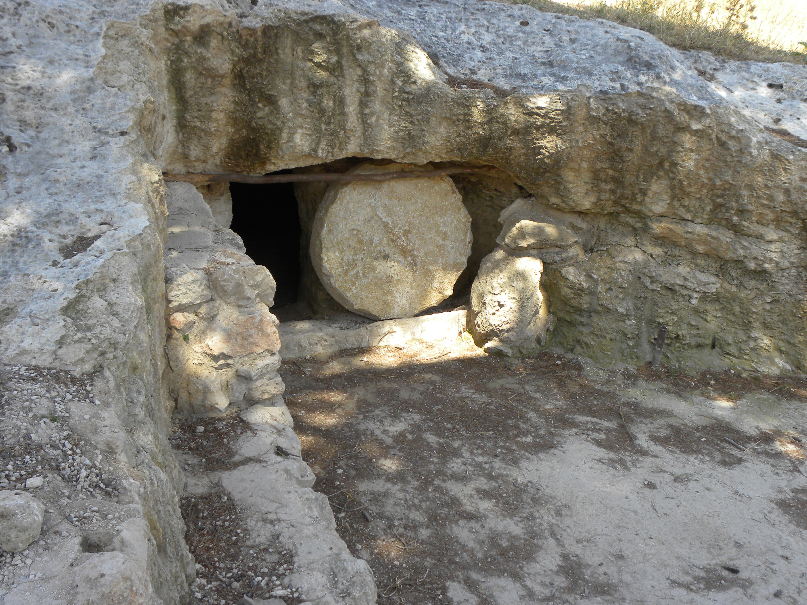

Translation:
Two different methods were used to close tombs with stones, and it is unclear from the Gospels which method is described in the accounts of Jesus’ burial. In one method the stone was cylindrical. It sat on its side in a channel the same width as the stone, and it was pushed sideways until it covered the mouth of the tomb. By the second method the entrance to the tomb was reached by going down a short incline. The stone was spherical and was rolled down the incline until it plugged the tomb entrance.
JHN 11:39; JHN 11:39; JHN 11:41: The place where Lazarus was buried is described as a cave with a stone placed at the entrance. In JHN 11:38 the Greek phrase that GNT renders “at the entrance” is ambiguous. It may mean “on it,” in which case the shaft of the burial tomb was vertical. Or it may mean “against it,” in which case the shaft was horizontal. Commentators are divided in their opinions, but the weight of evidence seems to favor a horizontal cave. In either case, the purpose of the stone was primarily to keep animals from entering the tomb and devouring the body. “A stone placed at the entrance” (GNT) may often be best translated “a stone covering the opening to the cave” or “a large stone covering the hole of the cave.” Note that the text does not state here, as in the case of Jesus’ burial, that the stone was “rolled” in front of the entrance.

Burial mound

4.8.2 Burial mound

Reference:Greek χειμών (cheimōn)SIR 21:8

Description and usage:
A pile of stones sometimes marks a burial site (© ניסים טבקה Pikiwiki Israel, CC BY 2.5, via Wikimedia Commons)The burial mound was a pile of stones placed over the place of burial. Its purpose was to mark the burial site and to prevent animals from digging up the body.
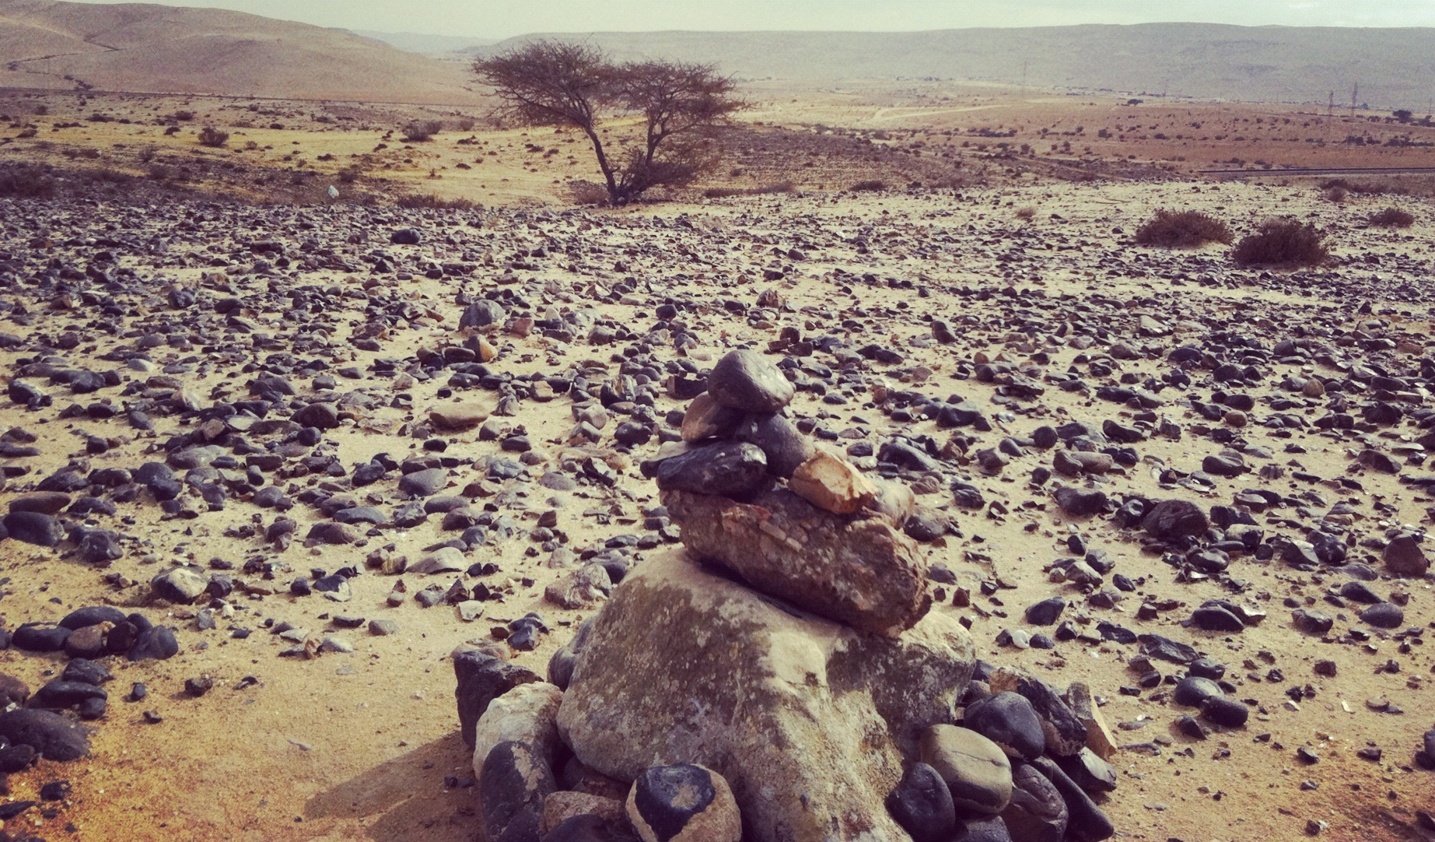

Translation:
Since the “burial mound” was just another kind of tomb, GNT has simply “tomb” in SIR 21:8. There is a textual variation in this verse. Some manuscripts have “for the winter” instead of “for his burial mound” (RSV). Most translations use a word for “tomb” and add a footnote giving the alternate reading (so GNT).

Body preparation

4.8.3 Body preparation

Burial cloth, shroud, grave clothes: See 1.5.3.7 Linen<REALIA:1.5.3.7>.

Embalming oils

4.8.3.1 Embalming oils

References:Greek ἀλόη (aloē)JHN 19:39Greek ἄρωμα (arōma)MRK 16:1, LUK 23:56, LUK 24:1, JHN 19:40Greek μύρον (muron)LUK 23:56Greek σμύρνα (smurna)JHN 19:39

Description and usage:
Embalming oils were aromatic oils or salves used especially in preparing a dead body for burial in a way that it would be preserved. See also 10.6.1.1 Myrrh<REALIA:10.6.1.1>.

Translation:
In 2CH 16:14 we find the Hebrew expression bsamim uznim mruqachim in the context of the burial of King Asa of Judah. The text says that spices and aromatic oils were placed in the tomb (CEV “the tomb was filled with spices and sweet-smelling oils”). There is no reason to assume that Asa’s body was embalmed (like Jacob’s body in GEN 50:2; GEN 50:3), although GNT comes close with “They used spices and perfumed oils to prepare his body for burial.”
In LUK 23:56 translators may use a descriptive phrase to render the Greek word muron, for example, “perfumed oil for preserving the body” or “… to keep the body from rotting.”
Ingredients mentioned in the New Testament for embalming oils are “myrrh” (smurna in Greek) and “aloes” (aloē in Greek). Most translators borrow terms for these ingredients and then use some kind of marginal note to explain the nature of their substance.

Bier, coffin

4.8.4 Bier, coffin

References:Hebrew אֲרוֹן (’aron)GEN 50:26Hebrew מִטָּה (mitah)2SA 3:31Greek σορός (soros)LUK 7:14

Description and usage:
Stone coffins or ossuaries in the garden of Dominus Flevit on the Mount of Olives (© Deror Avi, CC BY-SA 3.0, via Wikimedia Commons)The bier was a board on which a body was carried to its place of burial, and the coffin was a box in which a body was placed for burial.
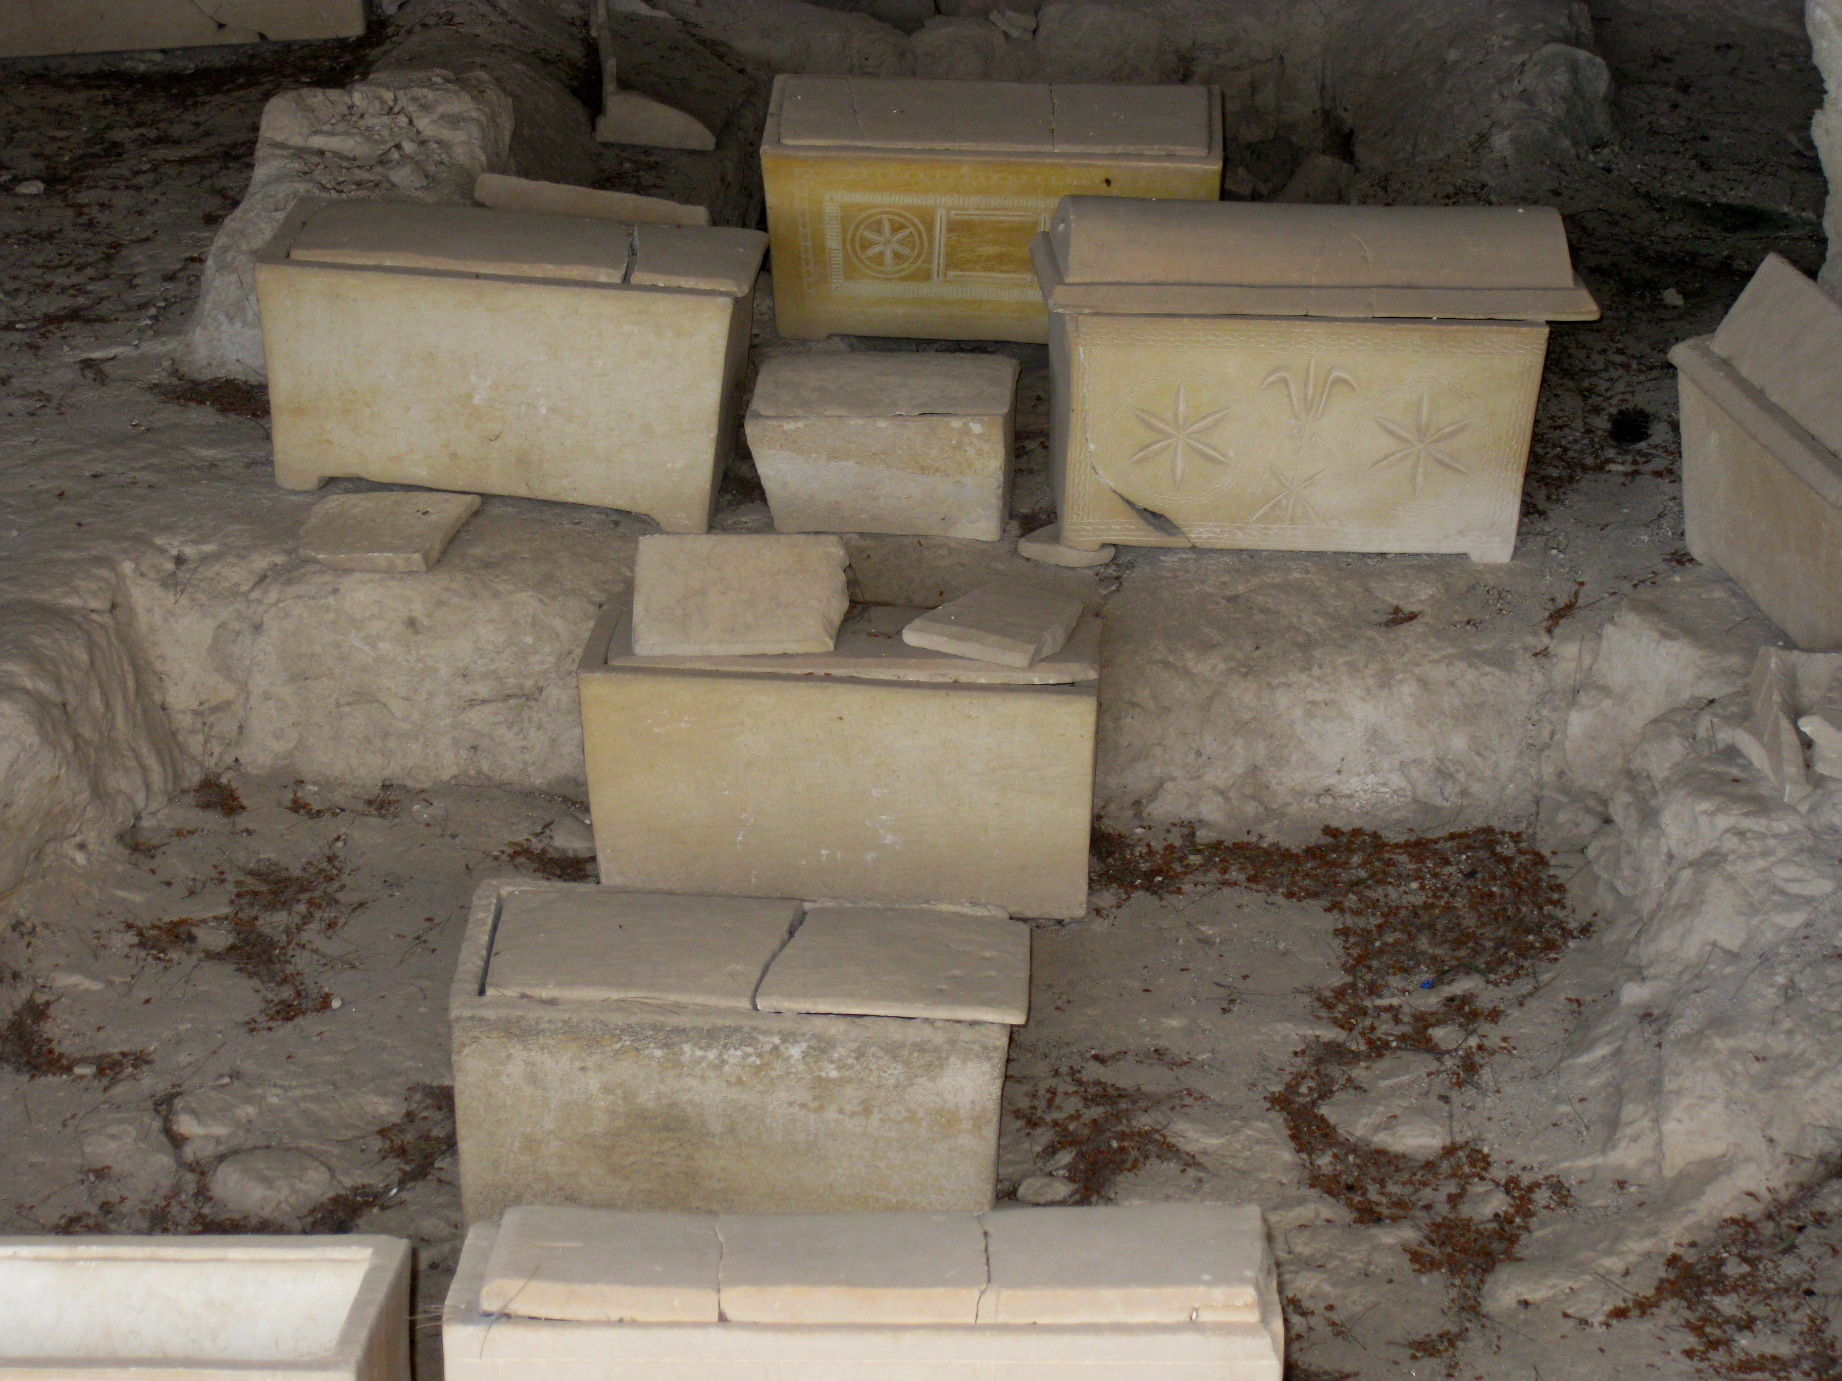

Translation:
In GEN 50:26 the Hebrew word ’aron is literally “box,” but it means “coffin” in this context.
In 2SA 3:31 the Hebrew word mitah is literally “bed.” The context, however, makes it clear that the object is serving as a bier or, less likely, a coffin.
LUK 7:14: In this verse some translations render the Greek word soros as “coffin” (GNT, NCV). This word can also refer to a “bier,” and that is its more probable meaning here. In some languages it may be necessary to use a descriptive expression, for example, “board on which the body was being carried” or “box in which the body lay.”

Sackcloth, mourning clothes

4.8.5 Sackcloth, mourning clothes

References:Hebrew בֶּגֶד, אֵבֶל (bigdey ’evel)2SA 14:2Hebrew שַׂק (saq)GEN 37:34, 2SA 3:31, 2SA 21:10, 1KI 20:31, 1KI 20:32, 1KI 21:27, 1KI 21:27, 2KI 6:30, 2KI 19:1, 2KI 19:2, 1CH 21:16, NEH 9:1, EST 4:1, EST 4:2, EST 4:3, EST 4:4, JOB 16:15, PSA 30:12, PSA 35:13, PSA 69:12, ISA 3:24, ISA 15:3, ISA 20:2, ISA 22:12, ISA 37:1, ISA 37:2, ISA 50:3, ISA 58:5, JER 4:8, JER 6:26, JER 48:37, JER 49:3, LAM 2:10, EZK 7:18, EZK 27:31, DAN 9:3, JOL 1:8, JOL 1:13, AMO 8:10, JON 3:5, JON 3:6, JON 3:8Greek σάκκος (sakkos)MAT 11:21, LUK 10:13, REV 6:12, REV 11:3, JDT 4:10, JDT 4:11, JDT 4:12, JDT 4:14, JDT 8:5, JDT 9:1, JDT 10:3, ESG 4:1, ESG 4:2, ESG 4:3, ESG 4:4, BAR 4:20, 1MA 2:14, 1MA 3:47, 2MA 3:19, 2MA 10:25Latin saccus2ES 16:2

Description and usage:
Sackcloth was a coarse dark material made of goat or camel hair. It was worn next to the skin as a sign of mourning or repentance (2KI 6:30).

Translation:
Customs associated with mourning vary greatly in different cultures, and in some the clothing or lack of clothing is not relevant. In most languages “sackcloth” is described as “coarse cloth” and sometimes as “heavy cloth.” It will often be best to clarify the relation between these clothes and mourning; for example, “clothes that show someone is mourning for the dead.”
In some languages there may exist an equivalent symbol of mourning, such as body painting, smearing ashes over the face or chest, carrying objects such as bags symbolizing a needy widow’s mourning, or wearing a cord of mourning around the neck. There are dangers as well as advantages in such a cultural translation. Particular aspects of the Israelite culture are lost, and there may be undesirable meanings associated with the local practice. Whenever this is done, all of its ramifications should be checked carefully. Generally it will be preferable to use the Israelite custom, with a footnote explaining its meaning or providing the equivalent custom. A footnote might read “Mourning clothes were coarse pieces of cloth sewed together from woven goat or camel hair.”
2SA 14:2 does not specifically mention sackcloth but speaks of “mourning clothes.” It was the Jewish custom to tear the outer garment as a sign of despair or sadness. However, this verse indicates something more than just tearing the clothing. For the literal clause “put on mourning clothes,” CEV and NCV have “Put on funeral clothes.” Where no special custom is known, or where a known one would be inappropriate for the context of this story, it may be possible to expand this clause to “Go and put on special clothes that will make David think you are sad because someone has died.”
JOB 16:15: The first half of this verse is literally “I have sewed sackcloth upon my skin” (so RSV). This may suggest that Job will wear the sackcloth permanently, or that he wears it next to his skin. GNT “I mourn and wear clothes made of sackcloth” avoids expressing either suggestion. GECL, however, translates “The mourning clothes are my second skin,” which implies that Job will wear them all the time. This line may be rendered “I have put mourning clothes on my body,” “I have dressed myself in the clothes of those who mourn for the dead,” or “I wear the rough cloth of those who are in mourning.”
In some passages the wearing of sackcloth is not an act of mourning because of death but rather an expression of sorrow and penitence. See, for example, ISA 58:5; DAN 9:3; JON 3:6.
MAT 11:21: The last part of this verse is literally “they would have repented long ago in sackcloth and ashes” (so RSV; see also LUK 10:13). Instead of retaining the reference to putting on “sackcloth and ashes,” some translations have said simply “long ago they would have shown to everyone that they were turning from their sins.” However, translators should try to retain these cultural actions in the text, since they were a common aspect of biblical culture.

