Resource: Human-made Things in the Bible
Human-made Things in the Bible © United Bible Societies, 2025. Adapted from: The Works of Their Hands: Man-made Things in the Bible, by Ray Pritz © 2009 United Bible Societies. This work is licensed under Creative Commons Attribution-ShareAlike 4.0 International (https://creativecommons.org/licenses/by-sa/4.0/).

Human-made Things in the Bible

Basin, washbasin

5.16 Basin, washbasin

References:Hebrew סַף (saf)EXO 12:22, EXO 12:22, 2SA 17:28Hebrew סִיר, רַחַץ (sir rachats)PSA 60:10, PSA 108:10Greek νιπτήρ (niptēr)JHN 13:5

Description and usage:
(Image generated by ChatGPT using OpenAI technology)The basin was a large bowl, normally made of clay. It had several uses; commonly it held water and was used for washing the hands, face, and feet.
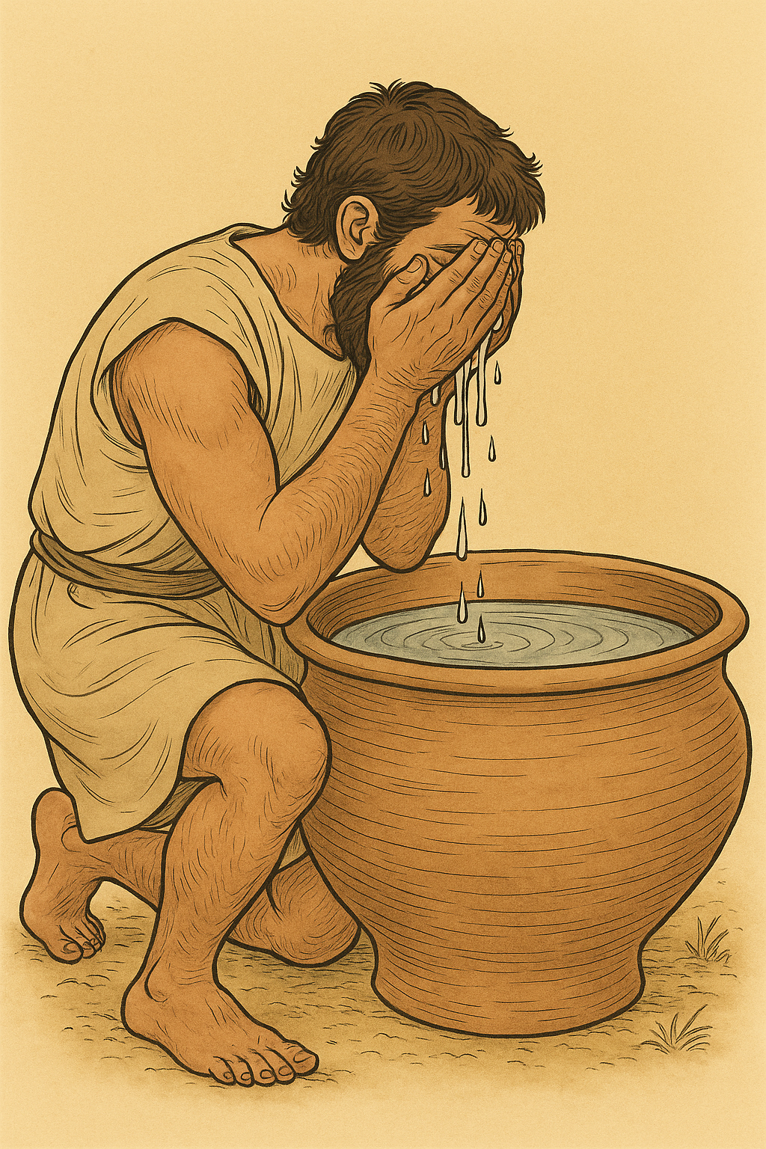

Translation:
JHN 13:5: The word niptēr does not appear elsewhere in Greek literature; its meaning is uncertain, but most translations have “basin,” “washbasin,” or “bowl.” It can be argued that the word means “pitcher” or “jug,” since in the Ancient Near East, people’s feet were not generally washed in a basin of standing water but by pouring water over the feet from a pitcher. With this understanding the picture in JHN 13:5 would be as follows: The disciples were on cushions, reclining on their left sides, and using their right hands to reach into the dishes that were on the table, or tables, placed in front of them. Jesus poured water into “the pitcher” (the Greek text has the definite article “the,” suggesting that it was a particular vessel used specifically for that purpose) and then went around behind the disciples, where their feet were stretched out behind them. There he poured water from the pitcher over their feet and dried them with the towel (see 10.4 Towel<REALIA:10.4>) wrapped around his waist.

