Resource: Human-made Things in the Bible
Human-made Things in the Bible © United Bible Societies, 2025. Adapted from: The Works of Their Hands: Man-made Things in the Bible, by Ray Pritz © 2009 United Bible Societies. This work is licensed under Creative Commons Attribution-ShareAlike 4.0 International (https://creativecommons.org/licenses/by-sa/4.0/).

Human-made Things in the Bible

Shirt, tunic

6.3 Shirt, tunic

References:Hebrew כֻּתֹּנֶת (kutoneth)GEN 3:21, GEN 37:3, GEN 37:23, GEN 37:23, GEN 37:31, GEN 37:31, GEN 37:32, GEN 37:32, GEN 37:33, EXO 28:4, EXO 28:39, EXO 28:40, EXO 29:5, EXO 29:8, EXO 39:27, EXO 40:14, LEV 8:7, LEV 8:13, LEV 10:5, LEV 16:4, 2SA 13:18, 2SA 13:19, 2SA 15:32, EZR 2:69, NEH 7:69, NEH 7:71, JOB 30:18, SNG 5:3, ISA 22:21Hebrew סָדִין (sadin)JDG 14:12, JDG 14:13, PRO 31:24, ISA 3:23Aramaic פטישׁ (ptash)DAN 3:21Greek χιτών (chitōn)MAT 5:40, MAT 10:10, MRK 6:9, LUK 3:11, LUK 6:29, LUK 9:3, JHN 19:23, JHN 19:23, ACT 9:39, JUD 1:23, JDT 14:19, LJE 1:30, 2MA 4:38, 2MA 12:40, 4MA 9:11

Description:
(Image generated by ChatGPT using OpenAI technology)The tunic was a long, close-fitting garment worn next to the skin under the outer cloak or coat. It was usually made of wool but could also be of other materials, such as linen. It often had sleeves. It was a simple garment, made of two equal halves, front and back, sewn together with holes left for the head and arms (see also 4.5.2 Tunic, shirt<REALIA:4.5.2>).
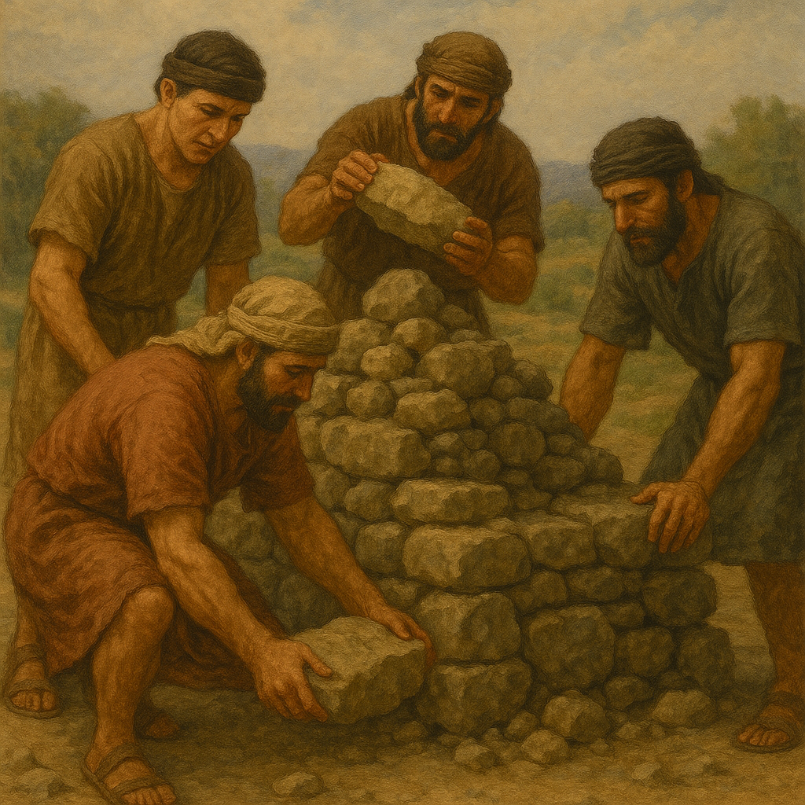

Usage:
The tunic was worn by both sexes. Usually a loincloth (see 6.4 Loincloth<REALIA:6.4>) was worn under this garment. The tunic was worn under the robe, but it could also be worn without the robe when a person was engaged in physical activity (similar to the T-shirt in modern Western culture).

Translation:
For the Hebrew word kutoneth in GEN 3:21, Nouvelle Bible de Jérusalem has “tunics.” However, most translations choose not to be so specific and render this piece of clothing made from animal skins as “garments” (RSV, NIV, NJPSV) or “clothes” (GNT, CEV, FRCL, GECL).
GEN 37:0 and 2SA 13:18; 2SA 13:19 speak literally of “a long robe with sleeves” (RSV). However, the Hebrew for “with sleeves” could be rendered “of many colors.” Translations vary. In GEN 37:3GNT says “a long robe with full sleeves” and adds the following footnote: “or decorated robe.” The point of the story is that Jacob favored Joseph above his brothers and so honored him with a special gift. CEV has “a fancy coat” and then gives the following two options in a footnote: “Or ‘a coat of many colors’ or ‘a coat with long sleeves.’ ”
Some commentators and translations understand the Hebrew word sadin to refer to a simple linen sheet; for example, in JDG 14:12; JDG 14:13GNT has “a piece of fine linen.” Most, however, understand it as a piece of clothing made of linen (see 1.5.3.7 Linen<REALIA:1.5.3.7> and 1.5.3.13 Linen cloth, sheet<REALIA:1.5.3.13>). The type of clothing here in the versions varies widely from “linen wraps” (NASB) to “linen shirts” (NCV). In most cases translators may use a general expression such as “linen clothes” or “linen shirts.”
DAN 3:21: In this verse the writer uses four terms for articles of clothing worn by the three men being thrown into the blazing furnace. The precise meaning of these articles of clothing is uncertain and not very important; the writer uses this list (as he uses other lists elsewhere) for rhetorical effect. What is important is to use words indicating that the men were fully clothed, and that their dress included inner garments, outer garments, and something worn on the head. CEV ’s rendering of these articles of clothing is helpful: “with all of their clothes still on, including their turbans.”
In MAT 5:40 and LUK 6:29 the Greek word chitōn refers to an essential garment; therefore translators should avoid the use of a term referring to a garment that is considered a luxury in the receptor culture. In some languages it will be difficult in these verses to distinguish between this garment and the outer garment (see 6.2 Outer garment, cloak, mantle, robe<REALIA:6.2>). If there are terms that distinguish between the outer and inner garments, they can usually be used, as GNT has used “coat” and “shirt.” Otherwise, translators may use descriptive phrases; for example, the word chitōn may be rendered “clothing you wear under your outer wrap [or, near your body]” or “clothing that covers the outer clothing.” However, to help readers realize the difference in value of the two garments, something Jesus’ hearers would have understood immediately, translators may prefer to say “your garment that is of little value” and “your outer garment that is more valuable.”
JHN 19:23: This verse notes that Jesus’ tunic was woven in one piece, without a seam. The technique for making such a garment in the ancient period is uncertain, but this does not mean that the garment was unique or particularly expensive.

