Resource: Human-made Things in the Bible
Human-made Things in the Bible © United Bible Societies, 2025. Adapted from: The Works of Their Hands: Man-made Things in the Bible, by Ray Pritz © 2009 United Bible Societies. This work is licensed under Creative Commons Attribution-ShareAlike 4.0 International (https://creativecommons.org/licenses/by-sa/4.0/).

Human-made Things in the Bible

Animal skin

6.5 Animal skin

References:Hebrew עוֹר (‘or)GEN 3:21, GEN 27:16, EXO 22:26, EXO 25:5, EXO 25:5, EXO 26:14, EXO 26:14, EXO 29:14, EXO 34:29, EXO 34:30, EXO 34:35, EXO 35:7, EXO 35:7, EXO 35:23, EXO 35:23, EXO 36:19, EXO 36:19, EXO 39:34, EXO 39:34, LEV 4:11, LEV 7:8, LEV 8:17, LEV 9:11, LEV 11:32, LEV 13:2, LEV 13:2, LEV 13:3, LEV 13:3, LEV 13:4, LEV 13:4, LEV 13:5, LEV 13:6, LEV 13:7, LEV 13:8, LEV 13:10, LEV 13:11, LEV 13:12, LEV 13:12, LEV 13:18, LEV 13:20, LEV 13:21, LEV 13:22, LEV 13:24, LEV 13:25, LEV 13:26, LEV 13:27, LEV 13:28, LEV 13:30, LEV 13:31, LEV 13:32, LEV 13:34, LEV 13:34, LEV 13:35, LEV 13:36, LEV 13:38, LEV 13:39, LEV 13:39, LEV 13:43, LEV 13:48, LEV 13:48, LEV 13:49, LEV 13:49, LEV 13:51, LEV 13:51, LEV 13:52, LEV 13:53, LEV 13:56, LEV 13:57, LEV 13:58, LEV 13:59, LEV 15:17, LEV 16:27, NUM 4:6, NUM 4:8, NUM 4:10, NUM 4:11, NUM 4:12, NUM 4:14, NUM 19:5, NUM 31:20, 2KI 1:8, JOB 2:4, JOB 2:4, JOB 7:5, JOB 10:11, JOB 18:13, JOB 19:20, JOB 19:20, JOB 19:26, JOB 30:30, JOB 40:31, JER 13:23, LAM 3:4, LAM 4:8, LAM 5:10, EZK 37:6, EZK 37:8, MIC 3:2, MIC 3:3Greek δέρμα (derma)HEB 11:37Greek μηλωτή (mēlōtē)HEB 11:37

Description:
(Image generated by ChatGPT using OpenAI technology)The hide or skin of an animal could be tanned or untanned. It could be tanned with the hair or wool left on or after the hair or wool had been removed.
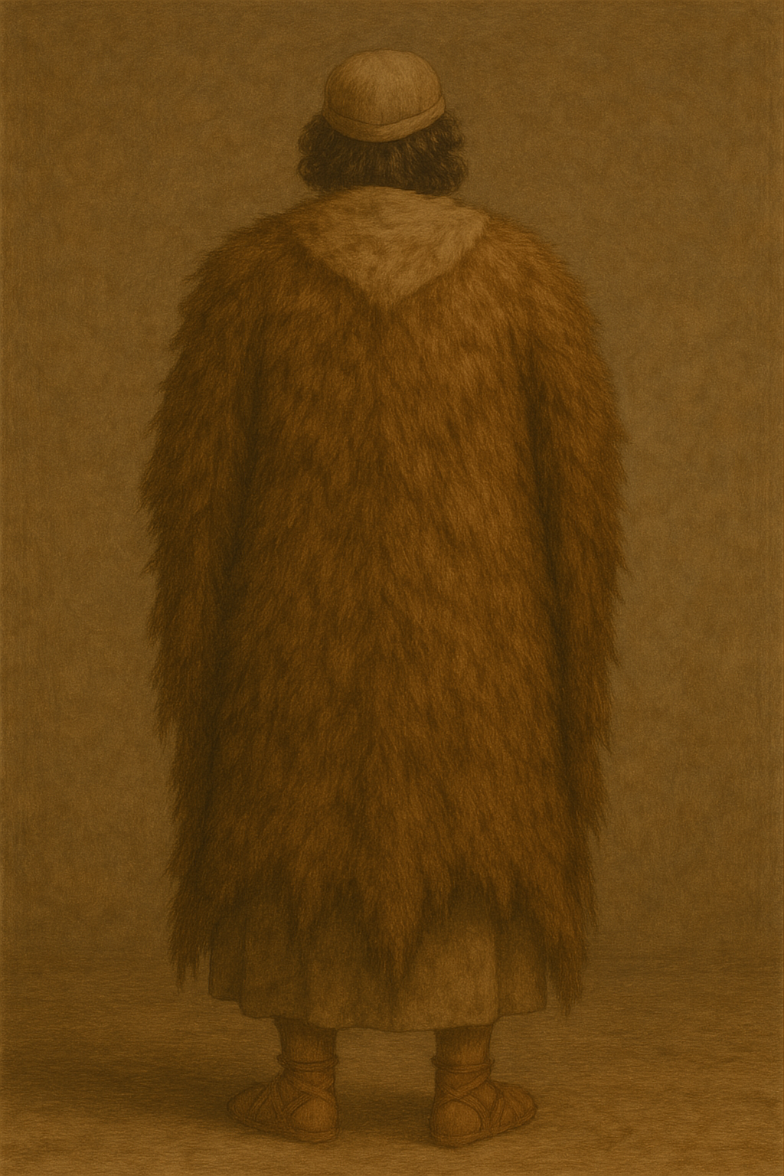

Usage:
Animal skins served many purposes, including their use as a rough kind of outer clothing.

Translation:
In a number of languages it is important to distinguish clearly between tanned and untanned skins or hides. Furthermore, translators must often make a distinction between a skin that still has the hair on it and one that does not. In HEB 11:37 the likelihood is that these skins were tanned and still retained the hair as extra protection. While the Greek here has two words for “skins” (derma and mēlōtē), most translations use only one word for “skins” and name the two animals from which the skins came by saying “skins of sheep and/or goats” (RSV, GNT). NIV says “sheepskins and goatskins.”
The passages listed above with the Hebrew word ‘or do not refer specifically to clothing but rather to tanned animal hides for unspecified usage. In these passages most translations use a general word for “leather.” Where such a word is lacking, it may be necessary to use a descriptive phrase, such as “dried animal skin.”

