Resource: Human-made Things in the Bible
Human-made Things in the Bible © United Bible Societies, 2025. Adapted from: The Works of Their Hands: Man-made Things in the Bible, by Ray Pritz © 2009 United Bible Societies. This work is licensed under Creative Commons Attribution-ShareAlike 4.0 International (https://creativecommons.org/licenses/by-sa/4.0/).

Human-made Things in the Bible

Veil

6.12 Veil

References:Hebrew מַסְוֶה (masweh)EXO 34:33, EXO 34:34, EXO 34:35Hebrew מִסְפָּחָה (mispachah)EZK 13:18, EZK 13:21Hebrew צַמָּה (tsamah)SNG 4:1, SNG 4:3, SNG 6:7, ISA 47:2Hebrew צָעִיף (tsa‘if)GEN 24:65, GEN 38:14, GEN 38:19Hebrew רְדִיד (rdid)SNG 5:7, ISA 3:23Hebrew רְעָלָה (r‘alah)ISA 3:19Greek κάλυμμα (kalumma)2CO 3:13, 2CO 3:14, 2CO 3:15, 2CO 3:16

Description and usage:
Wedding dress and veil (Beit Jebrin, northwest of Hebron) (© Trjames, CC BY-SA 3.0, via Wikimedia Commons)The veil was a thin piece of cloth worn over the face. The material would be sufficiently thin that the wearer would be able to see through it if it covered the eyes (unlike the illustration here), but others would find it difficult to recognize the facial features through the veil.
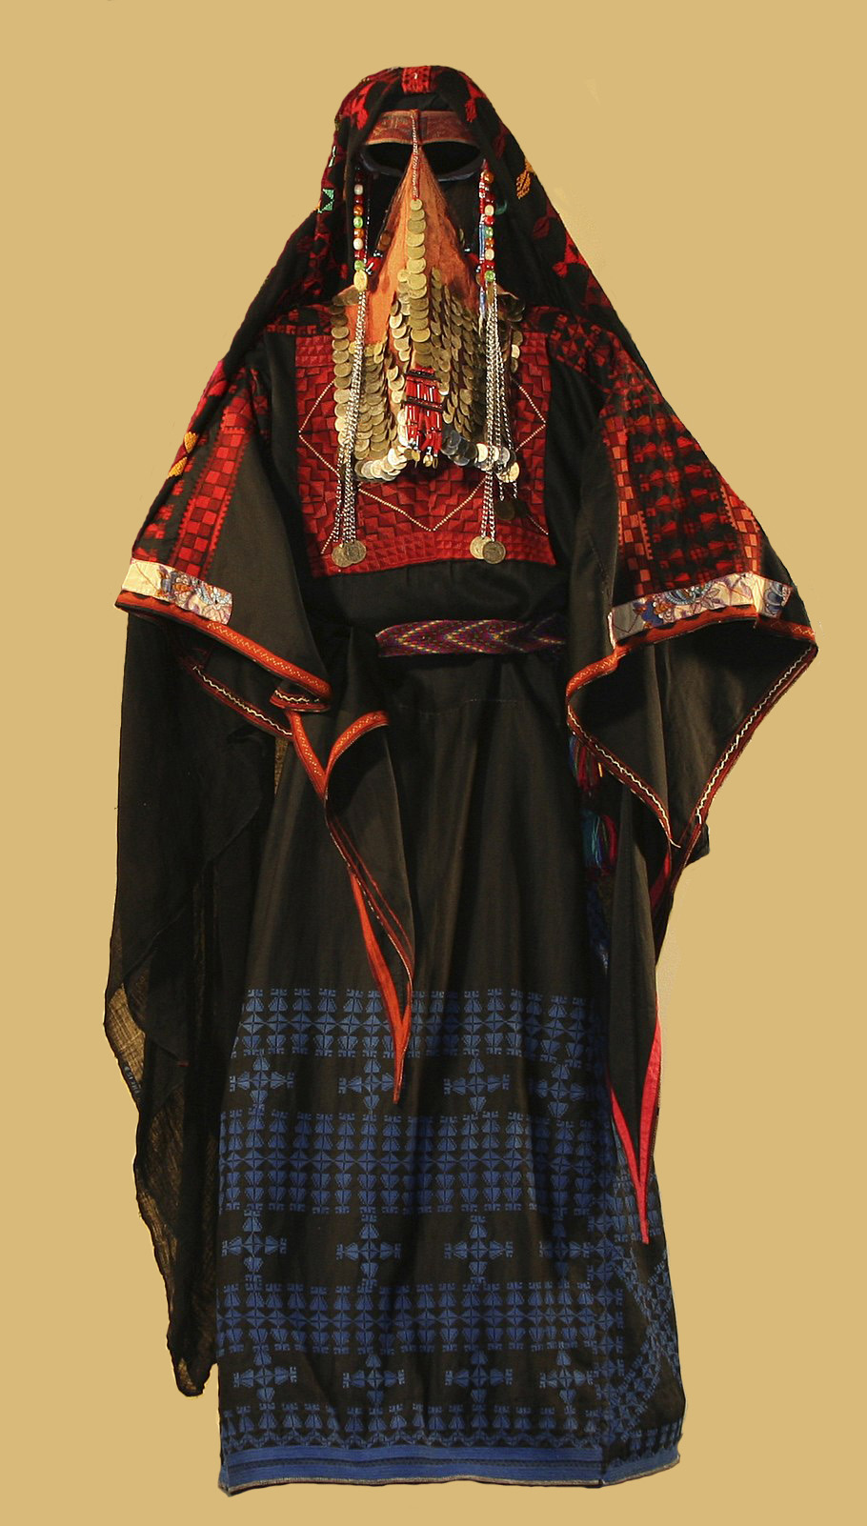

Translation:
Where a word is lacking in a language for “veil,” a descriptive phrase may be used, such as “thin cloth to hide the face.” It may be necessary to expand the translation a little to convey the meaning; compare NCV at GEN 38:14, where it renders the second clause as “covered her face with a veil to hide who she was.”
Translators should be aware that it is only by historical accident that, in older English translations, the word “veil” was used also for the curtain that divided the Holy Place from the Most Holy Place (see 3.14.1.6 Curtain, veil, drape<REALIA:3.14.1.6>). No attempt should be made to render them identically in the receptor language.
EZK 13:18; EZK 13:21: The Hebrew word mispachah refers to a long veil, almost a sheath, reaching from the head to the feet.
The Hebrew word rdid in SNG 5:7 and ISA 3:23 probably refers to a long veil, covering more than just the face. Both the mispachah and the rdid were similar to the niqab or burqah worn by some Muslim women.

