Resource: Human-made Things in the Bible
Human-made Things in the Bible © United Bible Societies, 2025. Adapted from: The Works of Their Hands: Man-made Things in the Bible, by Ray Pritz © 2009 United Bible Societies. This work is licensed under Creative Commons Attribution-ShareAlike 4.0 International (https://creativecommons.org/licenses/by-sa/4.0/).

Human-made Things in the Bible

Wristband, magic charm

6.14 Wristband, magic charm

References:Hebrew כֶּסֶת (keseth)EZK 13:18, EZK 13:20

Description:
Bands of cloth worn on the wrist were thought to have protective power (© Osama Shukir Muhammed Amin FRCP(Glasg), CC BY-SA 4.0, via Wikimedia Commons)The wristband was a strip of sewn cloth worn on the wrist.
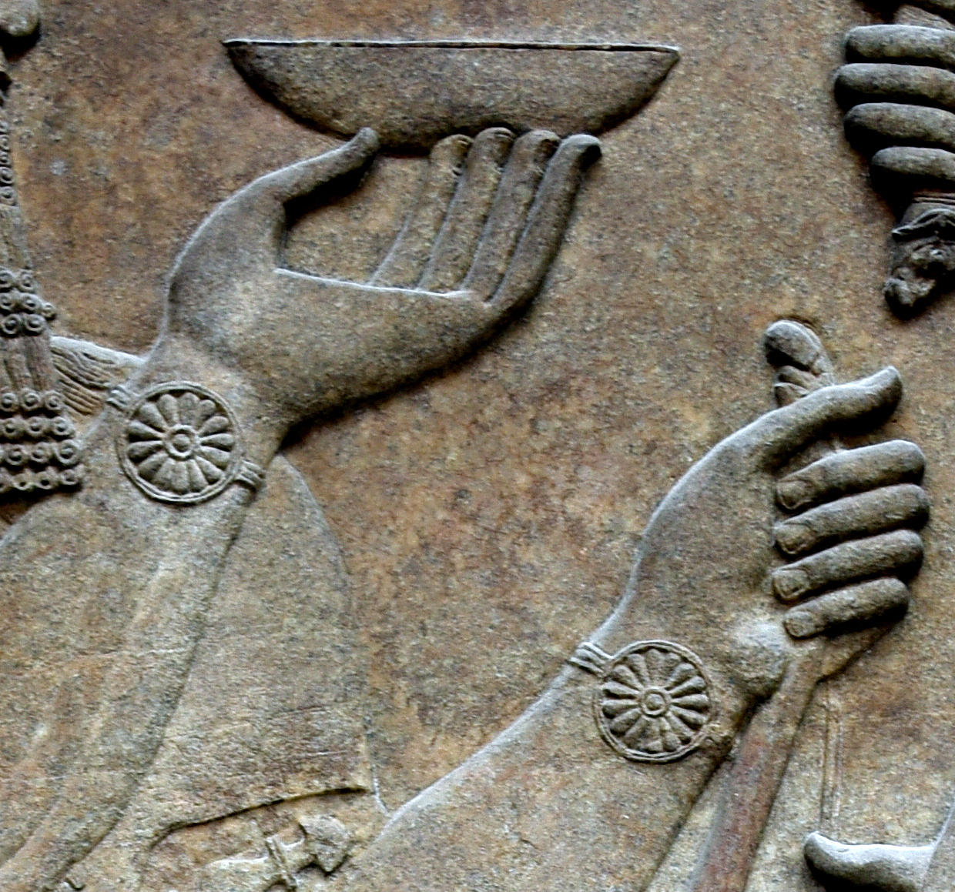

Translation:
The context of EZK 13:18; EZK 13:20 indicates that these bands of cloth were used in magic rituals. An exact equivalent may be available in some languages. Where no equivalent exists, a descriptive phrase may be used. GNT calls them “magic wristbands,” while both CEV and NCV say “magic charms.” According to verse 18, they were sewn on “all the joints of the hands,” which is taken by all translations consulted to mean the wrists and not the elbows, as noted in the Hebrew lexicon by Brown, Driver, and Briggs under the word ’atsil.

