Resource: Human-made Things in the Bible
Human-made Things in the Bible © United Bible Societies, 2025. Adapted from: The Works of Their Hands: Man-made Things in the Bible, by Ray Pritz © 2009 United Bible Societies. This work is licensed under Creative Commons Attribution-ShareAlike 4.0 International (https://creativecommons.org/licenses/by-sa/4.0/).

Human-made Things in the Bible

Cart, wagon

8.2 Cart, wagon

References:Hebrew גַּלְגַּל (galgal)EZK 23:24, EZK 26:10Hebrew עֲגָלָה (‘agalah)GEN 45:19, GEN 45:21, GEN 45:27, GEN 46:5, NUM 7:3, NUM 7:3, NUM 7:6, NUM 7:7, NUM 7:8, 1SA 6:7, 1SA 6:7, 1SA 6:8, 1SA 6:10, 1SA 6:11, 1SA 6:14, 1SA 6:14, 2SA 6:3, 2SA 6:3, 1CH 13:7, 1CH 13:7, PSA 46:10, ISA 5:18, ISA 28:27, ISA 28:28, AMO 2:13Hebrew צָב, עֲגָלָה (tsav, ‘egloth tsav)NUM 7:3, NUM 7:3, ISA 66:20Greek ἅμαξα (hamaxa)JDT 15:11, SIR 33:5Greek καρρον (karron)1ES 5:53Greek ῥέδη (rhedē)REV 18:13

Description and usage:
Drawing of a wagon model (© Deutsche Bibelgesellschaft, Stuttgart by United Bible Societies)The wagon was a two or four-wheeled carriage or cart used for travel or the transport of loads. Such vehicles were usually made of wood. They were pulled by draft animals, usually oxen, donkeys, or horses. These animals were attached to a long pole that was in turn attached to the front of the wagon. The upper section of the wagon was often formed by crossed wooden bars in the shape of a cage.
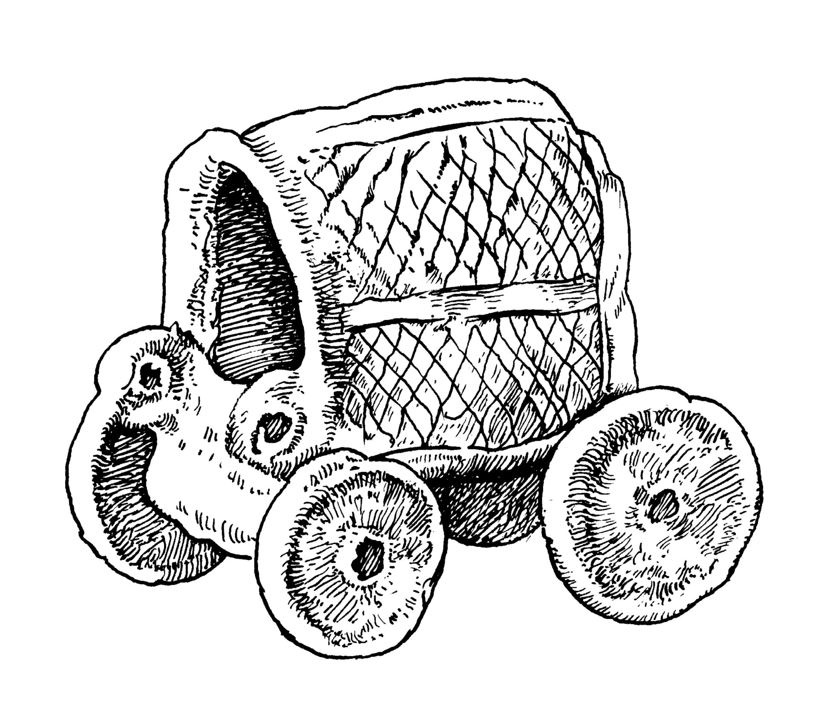

Translation:
Wagons and carts in the Bible were always pulled by animals. Translators should avoid any word for “wagon” that indicates a vehicle propelled by an engine.
(Image generated by ChatGPT using OpenAI technology)NUM 7:3: The meaning of the Hebrew phrase ‘egloth tsav here is uncertain. Most translators and commentators say something like “covered wagons” (RSV, REB). These would be wagons as described above with a cloth covering the items carried in each wagon. Such a wagon might resemble a tortoise or turtle, which is a meaning of the Hebrew word tsav.
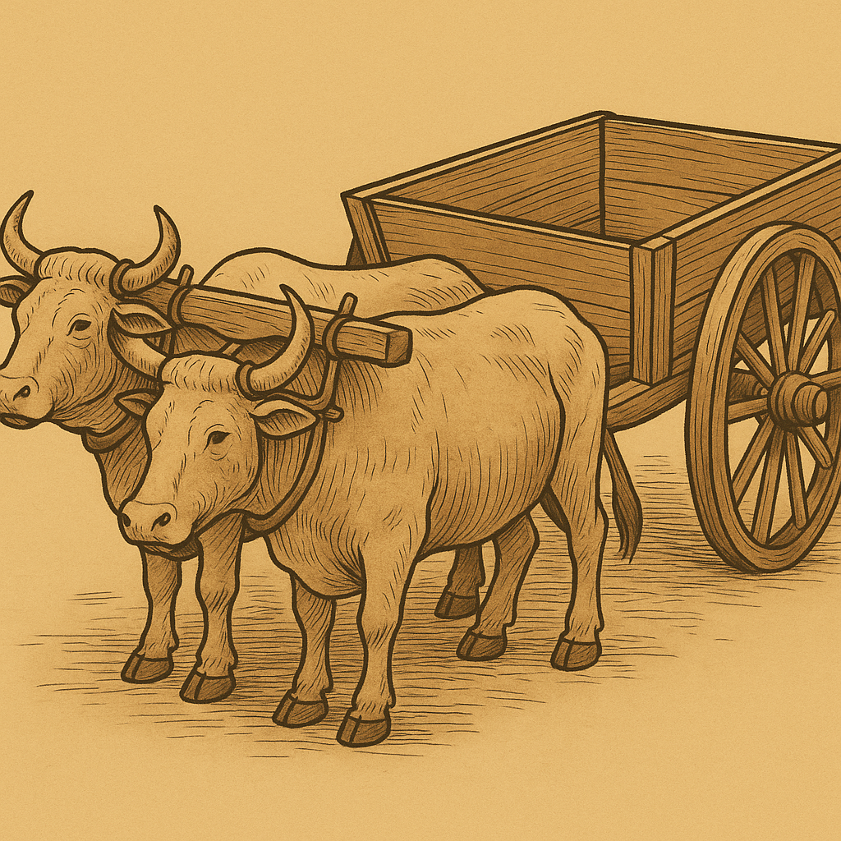
EZK 23:24; EZK 26:10: The Hebrew word galgal is literally “wheel.” In the context of these verses, it is clear that this is a metonym for a vehicle with wheels, that is, a cart or wagon.
1ES 5:53: In this verse some Greek manuscripts have the word chara (“joy”), which makes no sense in this context. One manuscript has the word karron, meaning “wagon” as described above.

