Resource: Human-made Things in the Bible
Human-made Things in the Bible © United Bible Societies, 2025. Adapted from: The Works of Their Hands: Man-made Things in the Bible, by Ray Pritz © 2009 United Bible Societies. This work is licensed under Creative Commons Attribution-ShareAlike 4.0 International (https://creativecommons.org/licenses/by-sa/4.0/).

Human-made Things in the Bible

Wheel

8.3 Wheel

References:Hebrew אוֹפַן (’ofan)EXO 14:25, 1KI 7:30, 1KI 7:32, 1KI 7:32, 1KI 7:32, 1KI 7:33, 1KI 7:33, PRO 20:26, ISA 28:27, EZK 1:15, EZK 1:16, EZK 1:16, EZK 1:16, EZK 1:19, EZK 1:19, EZK 1:20, EZK 1:20, EZK 1:21, EZK 1:21, EZK 3:13, EZK 10:6, EZK 10:9, EZK 10:9, EZK 10:9, EZK 10:9, EZK 10:10, EZK 10:10, EZK 10:12, EZK 10:12, EZK 10:13, EZK 10:16, EZK 10:16, EZK 10:19, EZK 11:22, NAM 3:2Hebrew גַּלְגַּל (galgal)ISA 5:28, JER 47:3, EZK 10:2, EZK 10:6, EZK 10:13, DAN 7:9Hebrew גִּלְגָּל (gilgal)ISA 28:28Greek τροχός (trochos)SIR 33:5

References:

Axle:Hebrew יָד (yad)1KI 7:32, 1KI 7:33Hebrew סֶרֶן (seren)1KI 7:30Greek ἄξων (axōn)SIR 33:5

References:

Wheel hub:Hebrew חִשּׁוּר (chishur)1KI 7:33

References:

Wheel spoke:Hebrew חִשּׁוּק (chishuq)1KI 7:33

References:

Wheel rim:Hebrew גַּב (gav)1KI 7:33, EZK 1:18, EZK 1:18

Description:
Hub, spoke, and rim of a wheel (Gary Todd, Public domain, Flickr)The wheel was a ring or round disk with a rod (the axle) running through its center or hub. Wheels were made of wood and sometimes partly of metal. They could be a solid piece of wood (see the illustrations at 8.2 Cart, wagon<REALIA:8.2>) or a central hub connected by several spokes to an outer rim. The axle normally extended from one side of the vehicle to the other side, with a wheel attached to each end of the axle.
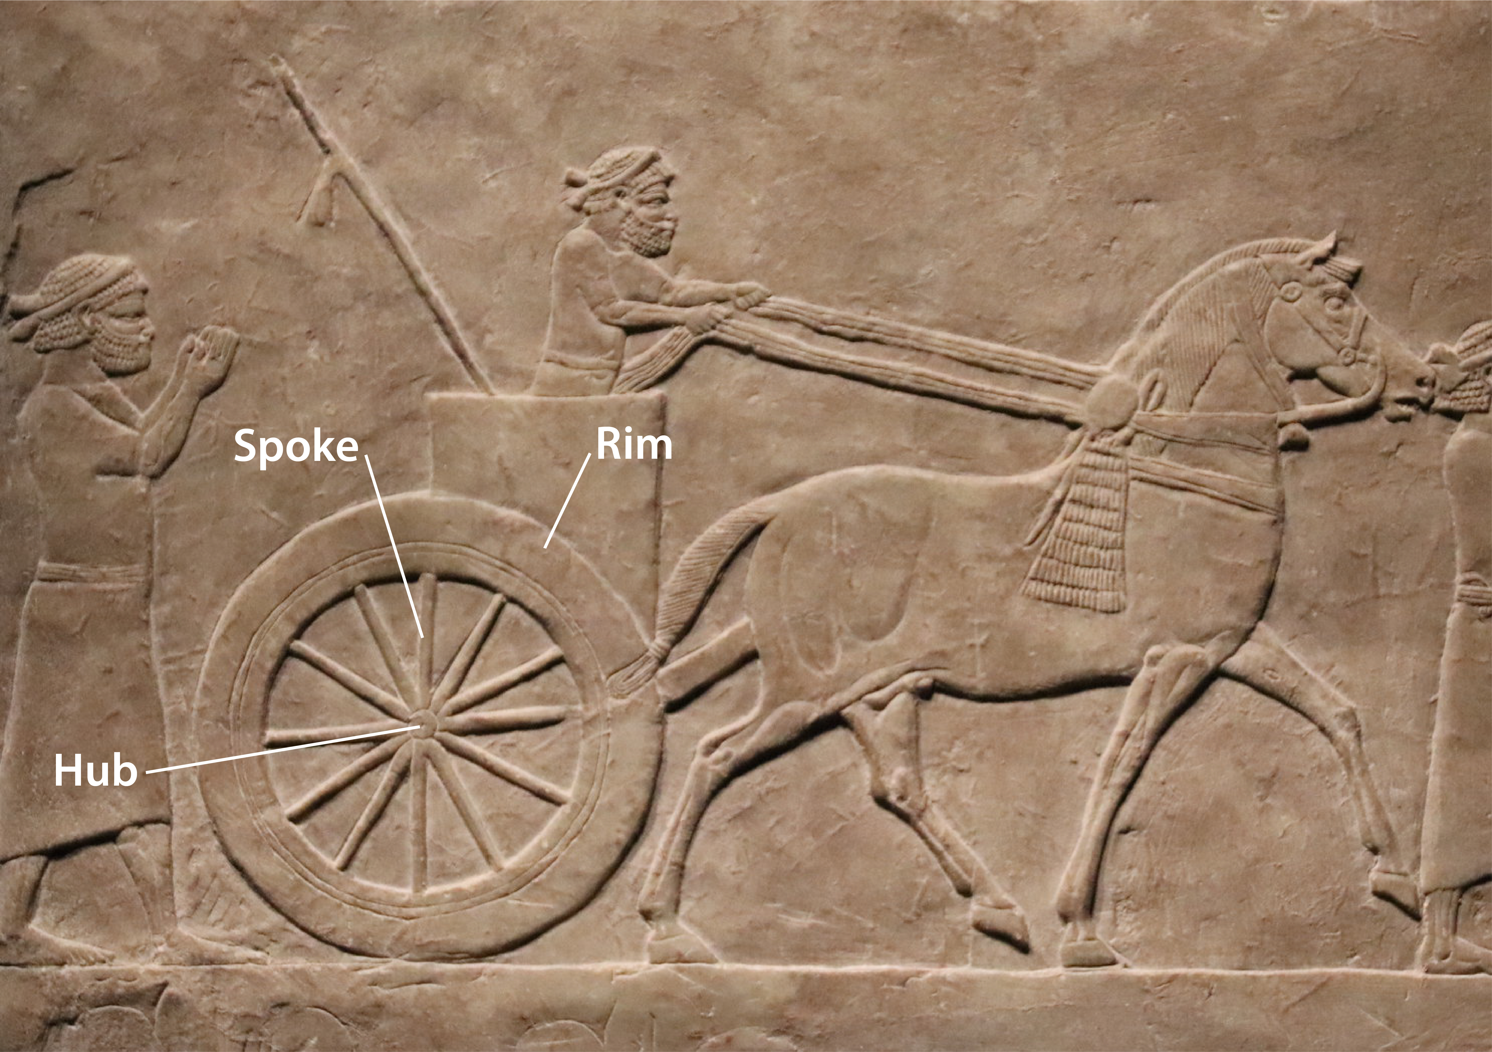

Translation:
The axle holds the wheels in place so that they can turn freely (Cyclopaedia of Biblical, Theological and Ecclesiastical Literature, Harper 1888, Public domain)The “wheels” mentioned in EZK 1:15; EZK 1:16; EZK 1:17; EZK 1:18; EZK 1:19; EZK 1:20; EZK 1:21 and EZK 10:6; EZK 10:7; EZK 10:8; EZK 10:9; EZK 10:10; EZK 10:11; EZK 10:12; EZK 10:13; EZK 10:14; EZK 10:15; EZK 10:16; EZK 10:17; EZK 10:18; EZK 10:19 may not refer to devices on which a vehicle rolls. These “wheels” may be understood as some sort of spinning disks, for which a language may have a separate word. Jewish tradition interprets this image as a vehicle on which the LORD is seated, and these are the wheels of the vehicle.
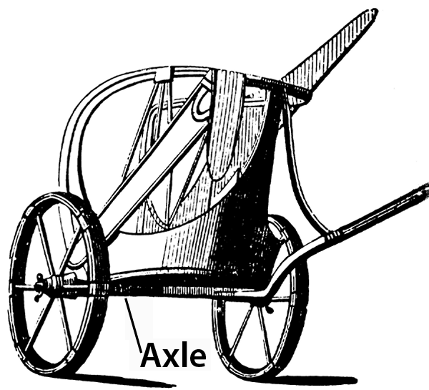
While most languages will have a word for “axle,” NAB renders SIR 33:5 accurately without reference to this piece on which the wheel turns: “Like the wheel of a cart is the mind of a fool; his thoughts revolve in circles.”

