Resource: Human-made Things in the Bible
Human-made Things in the Bible © United Bible Societies, 2025. Adapted from: The Works of Their Hands: Man-made Things in the Bible, by Ray Pritz © 2009 United Bible Societies. This work is licensed under Creative Commons Attribution-ShareAlike 4.0 International (https://creativecommons.org/licenses/by-sa/4.0/).

Human-made Things in the Bible

Money

11.6 Money

The relative values of monetary units mentioned in the New Testament may best be understood in their relationship to the denarius, which was equivalent to one day’s wages for a common laborer:
Talent = 6,000 denarii; MAT 18:24; MAT 25:15; MAT 25:16; MAT 25:20; MAT 25:20; MAT 25:20; MAT 25:20; MAT 25:22; MAT 25:22; MAT 25:22; MAT 25:24; MAT 25:25; MAT 25:28; MAT 25:28
Mina = 1,000 denarii; LUK 19:13; LUK 19:16; LUK 19:16; LUK 19:18; LUK 19:18; LUK 19:20; LUK 19:24; LUK 19:24; LUK 19:25
Stater = 4 denarii; MAT 17:27
Didrachma = 2 denarii; MAT 17:24; MAT 17:24
Denarius (also Drachma) = ONE DAY’S WAGE; MAT 18:28; MAT 20:2; MAT 20:9; MAT 20:10; MAT 20:13; MAT 22:19; MRK 6:37; MRK 12:15; MRK 14:5; LUK 7:41; LUK 10:35; LUK 15:8; LUK 15:8; LUK 15:9; LUK 20:24; JHN 6:7; JHN 12:5; REV 6:6; REV 6:6
Assarion = 1/16 denarius; MAT 10:29; LUK 12:6
Kodrantes = 1/64 denarius; MAT 5:26; MRK 12:42
Lepton = 1/128 denarius; MRK 12:42; LUK 12:59; LUK 21:2

For a general discussion of translating terms related to money, see 1.6.3 Money, coins<REALIA:1.6.3>.
maneh: See 11.2.2 Mina<REALIA:11.2.2>, “Mina.”
talanton: See 11.2.3 Talent<REALIA:11.2.3>, “Talent.”
peres: See 11.1.4 Peres, Parsin<REALIA:11.1.4>, “Peres, Parsin.”

Qsitah

11.6.1 Qsitah

References:Hebrew קְשִׂיטָה (qsitah)GEN 33:19, JOS 24:32, JOB 42:11

The precise meaning of the Hebrew word qsitah is unknown. REB takes it to mean “sheep,” but gives “piece[s] of money” as an alternate rendering. It is misleading with such obscure words to try to be too precise. Good models at JOB 42:11 are “some silver” (CEV), “a piece of silver” (NCV), and perhaps “some money” (GNT). In all three places where it occurs, it seems to be something that has a fairly significant value. The word “coin” is anachronistic in these three passages, and most translations have “piece[s] of silver.”

Greek coins

11.6.2 Greek coins
argurion, see 1.6.3 Money, coins<REALIA:1.6.3>.

Assarion

11.6.2.1 Assarion

References:Greek ἀσσάριον (assarion)MAT 10:29, LUK 12:6

The Greek words assarion, kodrantēs and lepton (11.6.2.2 Kodrantes<REALIA:11.6.2.2> and 11.6.2.3 Lepton<REALIA:11.6.2.3>) refer to small coins. Each of these words may be rendered “very small coin,” “coin with very little value,” or “money that was not worth very much.” Generally the same word or phrase may be used for all three, except in MRK 12:42, where two lepta equal a kodrantēs.
For the assarion, translations generally choose a very low denomination coin in MAT 10:29; LUK 12:6, for example, “a penny” (so RSVGNT). The meaning of Jesus’ saying is well conveyed also by PV, which says “for almost nothing.”

Kodrantes

11.6.2.2 Kodrantes

References:Greek κοδράντης (kodrantēs)MAT 5:26, MRK 12:42
Tiberian quadrans or kodrantes, similar to a penny (© Kwo-Wei Peng by United Bible Societies)Kodrantes:
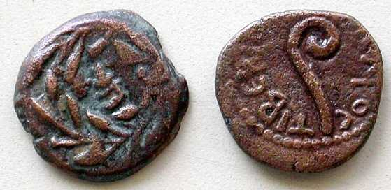
MAT 5:26: At the end of this verse most translations have something like “until you have paid the last penny” (NIV). It is also possible to express this well without naming a specific coin; for example, NCV and PV say “until you have paid everything you owe.” Some scholars think it more likely, however, more likely that this clause means “until you have paid off all the money the judge fined you [or, said you must pay].” Compare GNT, which reads “until you pay the last penny of your fine” (similarly GW).
MRK 12:42: At the end of this verse the Greek says literally “two lepta, which are a kodrantes.” Many translations expand “two lepta” somewhat to “two small copper coins” (NCV), and then indicate that they were worth very little by saying they were worth “a penny” (RSV), “a few cents” (NCV), “less than a cent” (GW), “about a penny” (GNT), or “of very low value” (SPCL). ITCL omits the second phrase, since the purpose of that phrase in the original text was to explain to Mark’s readers the value of the lesser known lepton.

Lepton

11.6.2.3 Lepton

References:Greek λεπτόν (lepton)MRK 12:42, LUK 12:59, LUK 21:2

See the comments under kodrantēs above, 11.6.2.2 Kodrantes<REALIA:11.6.2.2>.

Adarkon, darkmon

11.6.2.4 Adarkon, darkmon

References:Hebrew אֲדַרְכּוֹן (’adarkon)1CH 29:7, EZR 8:27Hebrew דַּרְכְּמוֹנִים (darkmonim)EZR 2:69, NEH 7:69, NEH 7:70, NEH 7:71

The ’adarkon /darkmon is a monetary unit of uncertain value.
According to some scholars, the ’adarkon and the darkmon are not the same coin, the former coin corresponding to the Persian daric and the latter one to the Greek drachma. In all of the passages listed above, however, it is possible that the reference is to a weight of gold and not to coins.
In 1CH 29:7 it does not seem necessary to retain the actual numbers nor to give the amounts with too much precision. GNT provides a good model with “190 tons of gold, 380 tons of silver, 675 tons of bronze, and 3,750 tons of iron.” The mention of coins in this verse is anachronistic, as coins did not make their first appearance until several hundred years after the time of David. It is possible that the writer of Chronicles has converted the amount of gold into a monetary unit contemporary with the time of writing.

Denarius

11.6.2.5 Denarius

References:Greek δηνάριον (dēnarion)MAT 18:28, MAT 20:2, MAT 20:9, MAT 20:10, MAT 20:13, MAT 22:19, MRK 6:37, MRK 12:15, MRK 14:5, LUK 7:41, LUK 10:35, LUK 20:24, JHN 6:7, JHN 12:5, REV 6:6, REV 6:6
The head of Emperor Tiberius on a denarius (© Kwo-Wei Peng by United Bible Societies)Because of the recent rapid inflation in the world and the considerable loss of buying power of coinage metals such as gold, silver and copper in comparison to ancient times, a number of translators have attempted in some measure to relate coinage to buying power, or perhaps better, to earning power. Thus, rather than translating “denarius” by some specific amount in a modern currency, it may be equated to a day’s wage. For example, in MRK 6:37 the literal expression “two hundred denarii” (RSV) is sometimes rendered “the equivalent of 200 days’ wages” or even “eight months of a laborer’s wages.” This will be a good solution in most cases with a couple of exceptions: (1) There are some passages where converting to work days will be unwieldy; for example, in MAT 18:28 the debt of the second servant is equivalent to about four months’ wages, which is a figure that people can grasp. However, the debt of the first servant was approximately equivalent to the wages of 1000 men for 20 years. It would be awkward to include this in translation. (2) There are still some cultures in the world where hiring day laborers is unknown because each person or family unit in the village does its own hunting and gathering or even farming. In such cultures “a day’s wage” may have little meaning.
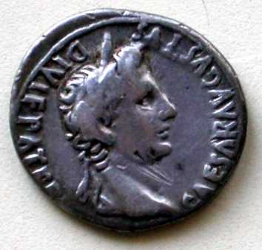
When calculating the number of days’ wages, translators should not forget that, unlike other peoples in the ancient world, Jews did not work one day out of seven. Thus a work week consisted of six work days, and about 25 days made up one work month. The 100 denarii of MAT 18:28 equaled four months’ salary and not three months, as stated in some common-language translations.

Drachma

11.6.2.6 Drachma

References:Greek δραχμή (drachmē)LUK 15:8, LUK 15:8, LUK 15:9, TOB 5:15, 2MA 4:19, 2MA 10:20, 2MA 12:43, 3MA 3:28

The drachma had the same value as the denarius, that is, a day’s wage. See the comments under dēnarion above, 11.6.2.6 Drachma<REALIA:11.6.2.6>.
LUK 15:8; LUK 15:8; LUK 15:9: While the amount the woman has lost here may not seem like a lot since it is only one day’s wage, it should not be represented in translation as insignificant. This would be against the whole point of the parable. The word “silver,” which appears in many translations (so RSVGNT), is only implied in the word “drachma” (which was a silver coin). Including this piece of information in translation can help to indicate that the coins were not of low value.

Didrachma

11.6.2.7 Didrachma

References:Greek δίδραχμον (didrachmon)MAT 17:24, MAT 17:24

MAT 17:24; MAT 17:24: Here the Greek word didrachma (rendered “the half-shekel tax” in RSV) refers to the tax which, according to EXO 30:13, was required of every male Jew from the age of twenty onward.
A half-shekel from Tyre (© Kwo-Wei Peng by United Bible Societies)It is not the amount of the half-shekel tax that is really important in this verse, but rather the nature of it, as seen in GNT, which says “the Temple tax.” Translators can say “the tax all the men [or, all Jewish men] paid for the Temple expenses” or “the tax paid to support the Temple.”
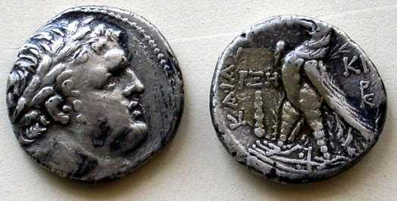
Some translators have wanted to give some indication of the amount of money here and have said “the tax of money of half a shekel” or even “the money called a half-shekel that people had to pay to the Temple.” It is also possible to indicate in a footnote that this was about half the wages a laborer would earn in a day. But this is marginal information and does not need to be specified in the text. Another rendering some have used is “the small amount of money people had to pay to support the Temple.” But translators should be careful not to make the expression too cumbersome. Nor should they give more emphasis to the amount of money than to its function. The Temple tax was paid once a year.

Stater

11.6.2.8 Stater

References:Greek στατήρ (statēr)MAT 17:27

The statēr was a silver coin worth two didrachma or approximately four denarii. In MAT 17:27 it may be rendered “a coin.” A footnote might be added: “Literally, ‘a stater,’ a silver coin worth four drachmas, the exact amount needed for two people to pay the Temple tax.”

