Resource: Human-made Things in the Bible
Human-made Things in the Bible © United Bible Societies, 2025. Adapted from: The Works of Their Hands: Man-made Things in the Bible, by Ray Pritz © 2009 United Bible Societies. This work is licensed under Creative Commons Attribution-ShareAlike 4.0 International (https://creativecommons.org/licenses/by-sa/4.0/).

Human-made Things in the Bible

Hunting

1.4 Hunting

Trap, snare

1.4.1 Trap, snare

References:Hebrew חֶבֶל (chevel)JOB 18:10, PSA 140:6Hebrew יקשׁ (yaqash (verb))DEU 7:25, PSA 124:7, PSA 141:9, PRO 6:2, ECC 9:12, ISA 8:15, ISA 28:13, JER 50:24Hebrew יָקוֹשׁ (yaqush)PSA 91:3, PRO 6:5, JER 5:26, HOS 9:8Hebrew מוֹקֵשׁ (moqesh)EXO 10:7, EXO 23:33, EXO 34:12, DEU 7:16, JOS 23:13, JDG 2:3, JDG 8:27, 1SA 18:21, 2SA 22:6, JOB 34:30, JOB 40:24, PSA 18:6, PSA 64:6, PSA 69:23, PSA 106:36, PSA 140:6, PSA 141:9, PRO 12:13, PRO 13:14, PRO 14:27, PRO 18:7, PRO 20:25, PRO 22:25, PRO 29:6, PRO 29:25, ISA 8:14, AMO 3:5Hebrew מָזוֹר (mazor)OBA 1:7Hebrew מַלְכֹּדֶת (malkodeth)JOB 18:10Hebrew נקשׁ (naqash (verb))DEU 12:30, 1SA 28:9, PSA 9:17, PSA 38:13Hebrew פַּח (pach)JOS 23:13, JOB 18:9, JOB 22:10, PSA 69:23, PSA 91:3, PSA 119:110, PSA 124:7, PSA 124:7, PSA 140:6, PSA 141:9, PSA 142:4, PRO 7:23, PRO 22:5, ECC 9:12, ISA 8:14, ISA 24:17, ISA 24:18, JER 18:22, JER 48:43, JER 48:44, HOS 5:1, HOS 9:8, AMO 3:5, AMO 3:5Hebrew צַמִּים (tsamim)JOB 18:9Hebrew קושׁ (qosh (verb))ISA 29:21Hebrew שְׂבָכָה (svakah)JOB 18:8Hebrew שׁוּחָה (shuchah)PRO 22:14, PRO 23:27, JER 18:20Hebrew שַׁחַת (shachath)PSA 7:16, PSA 9:16, PSA 35:7, PRO 26:27, JER 5:26, EZK 19:4, EZK 19:8Hebrew שִׁיחָה (shichah)PSA 57:7, PSA 119:85, JER 18:22Greek βόθρος (bothros)SIR 12:16Greek βρόχος (brochos)1CO 7:35Greek θήρα (thēra)ROM 11:9Greek σκάνδαλον (skandalon)ROM 11:9, WIS 14:11, 1MA 5:4

Description and usage:
Included in this entry are a wide variety of devices used to trap and catch animals and birds.

Translation:
JOB 18:8; JOB 18:9; JOB 18:10 uses six different words for various kinds of traps. The present discussion will follow the wording of RSV:
“Net” (resheth; see 1.4.2 Net<REALIA:1.4.2>): The net usually ensnared its quarry by entangling the feet, although the one mentioned here seems to be large enough to hold the entire person.
“Pitfall” (svakah): This word indicates a network of branches and twigs which covers and hides a hole or pit. When the quarry steps on this network, its weight breaks through, and it falls into the pit and is trapped.
“Trap” (pach): This is a general word for a device used to trap animals or especially birds. Here it is explicitly identified as a trap that catches the bird by its foot (literally “heel”).
“Snare” (tsamim): This word may refer to some kind of woven material or mesh that entangles the feet.
“Rope” (chevel): This most likely refers to a hidden noose that is attached at the other end to a bent bough or small tree that springs upright and tightens the noose around the victim when the trap is sprung.
“Trap” (malkodeth): This is a general word for any kind of trap.
Because of the repetition in these three verses, some translations are considerably condensed. NCV reduces the six words for traps to only three different words: “(8) Their feet will be caught in a net when they walk into its web. (9) A trap will catch them by the heel and hold them tight. (10) A trap for them is hidden on the ground, right in their path.” CEV condenses these verses even further: “(8) Before they know it, (9) they are trapped in a net, (10) hidden along the path.” See also the lengthy discussion on these verses in A Handbook on The Book of Job, pages 339–340.
For the Hebrew word mazor in OBA 1:7, see the comments in A Handbook on The Books of Obadiah, Jonah, and Micah, page 15.
In ROM 11:9 the Greek words thēra and skandalon are treated as having literal meanings, whereas the passage as a whole is figurative. The three words there for various kinds of traps (including pagis; see 1.4.2 Net<REALIA:1.4.2>) would all seem to be completely parallel in structure and meaning. As a result, in a number of languages the three terms are reduced often to two, for example, “snare” and “trap.” If there are three different kinds of traps, then, of course, three terms can be used. In some cases, however, it may be preferable to use words to express the acts of catching and trapping as in GNT, which has “May they be caught and trapped at their feasts; may they fall, may they be punished!”
Hook: See 1.3.2 Hook<REALIA:1.3.2>.

Net

1.4.2 Net

References:Hebrew חֵרֶם (cherem)ECC 7:26, MIC 7:2Hebrew מִכְמָר (mikmar)ISA 51:20Hebrew מָצוֹד (matsod (see )ECC 7:26Hebrew מְצוּדָה (mtsudah)PSA 66:11, EZK 12:13, EZK 17:20Hebrew רֶשֶׁת (resheth)JOB 18:8, PSA 9:16, PSA 10:9, PSA 25:15, PSA 31:5, PSA 35:7, PSA 35:8, PSA 57:7, PSA 140:6, PRO 1:17, PRO 29:5, LAM 1:13, EZK 12:13, EZK 17:20, EZK 19:8, HOS 5:1, HOS 7:12Greek παγίς (pagis)LUK 21:35, ROM 11:9, 1TI 3:7, 1TI 6:9, 2TI 2:26, TOB 14:10, TOB 14:10, WIS 14:11, SIR 9:3, SIR 9:13, SIR 27:20, SIR 27:26, SIR 27:29, SIR 51:2, 1MA 1:35, 1MA 5:4

Description:
Men trapping deer in a net (Relief from the lion hunt of king Ashurbanipal, Northern Palace, Nineveh, Room S, panels 17–18, c. 645–635 BCE) (© Zunkir, CC BY-SA 4.0, via Wikimedia Commons)The net was a mesh or very loose fabric made of string.
<image: Z>

Usage:
The net was a hunting tool. It was put in places where a bird or animal might fly or run into it and become entangled. Nets could also be used actively in hunting, that is, the hunter stalked the prey, and when he got close enough, he threw the net over his quarry.

Translation:
Since snares or traps for capturing birds or animals are almost universal, there should be no difficulty involved in obtaining an appropriate term. In many contexts, however, it cannot be certain if the net spoken of is for hunting animals or for hunting birds. In languages where no distinction is required, a generic term for “net” may be used. Where a distinction must be made, the context should be checked carefully. The following breakdown indicates which passages refer to nets for animals (including human beings), which ones refer to nets for birds, and which ones are unclear:
Animals: PSA 9:16; PSA 35:7; PSA 35:8; PRO 29:5; ISA 51:20; LAM 1:13; EZK 12:13; EZK 17:20; EZK 19:8; 1TI 3:7; [SIR 9:13; SIR 27:20, SIR 27:26, SIR 27:29; 1MA 1:35; 1MA 5:4 ]
Birds: PRO 1:17; HOS 7:12
Unclear: JOB 18:8; PSA 10:9; PSA 25:15; PSA 31:5; PSA 57:7; PSA 140:6; ECC 7:26; HOS 5:1; LUK 21:35; ROM 11:9; 1TI 6:9; 2TI 2:26; [TOB 14:10; WIS 14:11; SIR 9:3; SIR 51:2 ]
In LUK 21:35 it is not so much the physical object that is in focus but rather the unexpected nature of the event; however, the object is usually retained in translation.
In cases where the text is speaking figuratively, it may be possible to avoid using the figure of a net, especially where such a reference would be misleading; for example, in MIC 7:2 d NCV says “everyone is trying to trap someone else.”

Cage

1.4.3 Cage

References:Hebrew סוּגַר (sugar)EZK 19:9Greek κάρταλλος (kartallos)SIR 11:30

Description and usage:
Doves in a cage, awaiting to be sold in the temple and to be used as sacrifice (Image generated by ChatGPT using OpenAI technology)The cage was a kind of basket, woven loosely of cane or sticks. It had a top or door that could be closed. When a bird or other prey was caught alive, it was confined in the cage. Sometimes the basket itself served as a kind of trap.
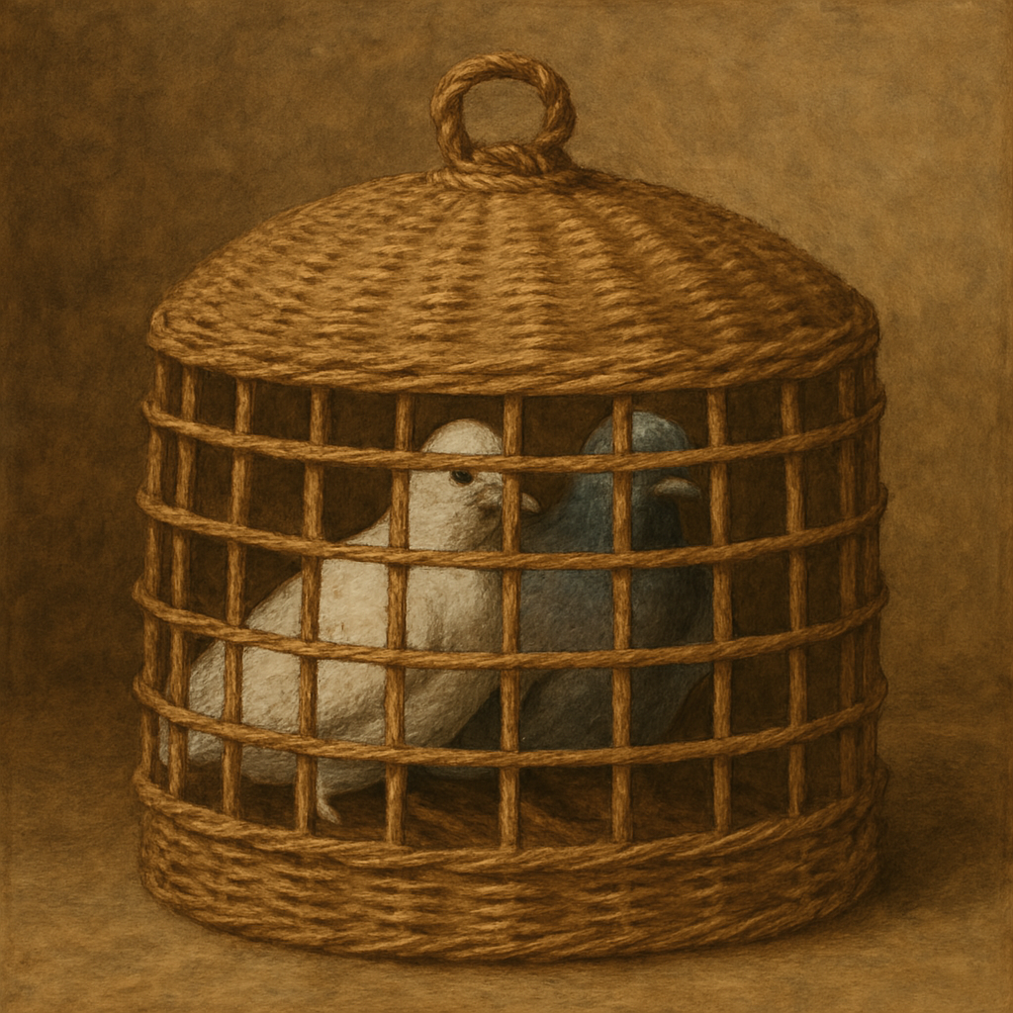

Translation:
The Hebrew word sugar in EZK 19:9 probably refers to a kind of wooden collar put on prisoners (see 1.1.1 Yoke<REALIA:1.1.1>). However, perhaps because the prophet pictures Judah’s king as a captured lion here, most translations render it “cage.” A few translations (GECL, ITCL) have “collar” or “yoke.” NJB has “shackled.”
Sometimes a captive bird could be used as a lure to capture a larger animal. The bird was tied inside the basket. When the prey entered the basket to take the bait, the basket was closed upon it by some device. It is presumably this interpretation of SIR 11:30 that has caused GNT to render the first half of this verse as “A proud person is a decoy to lure you into danger.” Other translations omit the element of the lure; for example, the New American Bible (NAB) has “Though he seem like a bird confined in a cage” (similarly ITCL).

