Resource: Human-made Things in the Bible
Human-made Things in the Bible © United Bible Societies, 2025. Adapted from: The Works of Their Hands: Man-made Things in the Bible, by Ray Pritz © 2009 United Bible Societies. This work is licensed under Creative Commons Attribution-ShareAlike 4.0 International (https://creativecommons.org/licenses/by-sa/4.0/).

Human-made Things in the Bible

Scribes

1.7 Scribes

Scroll, book

1.7.1 Scroll, book

References:Hebrew מְגִלָּה (mgilah)EZR 6:2, JER 36:6, JER 36:14, JER 36:14, JER 36:21, JER 36:23, JER 36:25, JER 36:29, JER 36:32, EZK 3:1, EZK 3:2, EZK 3:3, ZEC 5:1, ZEC 5:2Hebrew מְגִלָּה, סֵפֶר (mgilath sefer)PSA 40:8, JER 36:2, JER 36:4, EZK 2:9Hebrew סֵפֶר (sefer)GEN 5:1, EXO 17:14, EXO 24:7, EXO 32:32, EXO 32:33, NUM 5:23, NUM 21:14, DEU 17:18, DEU 24:1, DEU 24:3, DEU 28:58, DEU 28:61, DEU 29:19, DEU 29:20, DEU 29:26, DEU 30:10, DEU 31:24, DEU 31:26, JOS 1:8, JOS 8:31, JOS 8:34, JOS 10:13, JOS 18:9, JOS 23:6, JOS 24:26, 1SA 10:25, 2SA 1:18, 2SA 11:14, 2SA 11:15, 1KI 11:41, 1KI 14:19, 1KI 14:29, 1KI 15:7, 1KI 15:23, 1KI 15:31, 1KI 16:5, 1KI 16:14, 1KI 16:20, 1KI 16:27, 1KI 21:8, 1KI 21:8, 1KI 21:8, 1KI 21:9, 1KI 21:11, 1KI 22:39, 1KI 22:46, 2KI 1:18, 2KI 5:5, 2KI 5:6, 2KI 5:6, 2KI 5:7, 2KI 8:23, 2KI 10:1, 2KI 10:2, 2KI 10:6, 2KI 10:7, 2KI 10:34, 2KI 12:20, 2KI 13:8, 2KI 13:12, 2KI 14:6, 2KI 14:15, 2KI 14:18, 2KI 14:28, 2KI 15:6, 2KI 15:11, 2KI 15:15, 2KI 15:21, 2KI 15:26, 2KI 15:31, 2KI 15:36, 2KI 16:19, 2KI 19:14, 2KI 20:12, 2KI 20:20, 2KI 21:17, 2KI 21:25, 2KI 22:8, 2KI 22:8, 2KI 22:10, 2KI 22:11, 2KI 22:13, 2KI 22:13, 2KI 22:16, 2KI 23:2, 2KI 23:3, 2KI 23:21, 2KI 23:24, 2KI 23:28, 2KI 24:5, 1CH 9:1, 2CH 16:11, 2CH 17:9, 2CH 20:34, 2CH 24:27, 2CH 25:4, 2CH 25:26, 2CH 27:7, 2CH 28:26, 2CH 32:17, 2CH 32:32, 2CH 34:14, 2CH 34:15, 2CH 34:15, 2CH 34:16, 2CH 34:18, 2CH 34:21, 2CH 34:21, 2CH 34:24, 2CH 34:30, 2CH 34:31, 2CH 35:12, 2CH 35:27, 2CH 36:8, NEH 7:5, NEH 8:1, NEH 8:3, NEH 8:5, NEH 8:8, NEH 8:18, NEH 9:3, NEH 12:23, NEH 13:1, EST 1:22, EST 2:23, EST 3:13, EST 6:1, EST 8:5, EST 8:10, EST 9:20, EST 9:25, EST 9:30, EST 9:32, EST 10:2, JOB 19:23, JOB 31:35, PSA 69:29, PSA 139:16, ECC 12:12, ISA 29:11, ISA 29:11, ISA 29:11, ISA 29:12, ISA 29:12, ISA 29:12, ISA 29:18, ISA 30:8, ISA 34:4, ISA 34:16, ISA 37:14, ISA 39:1, ISA 50:1, JER 3:8, JER 25:13, JER 29:1, JER 29:25, JER 29:29, JER 30:2, JER 32:10, JER 32:11, JER 32:12, JER 32:12, JER 32:14, JER 32:14, JER 32:14, JER 32:16, JER 32:44, JER 36:8, JER 36:10, JER 36:11, JER 36:13, JER 36:18, JER 36:32, JER 45:1, JER 51:60, JER 51:63, DAN 1:4, DAN 1:17, DAN 9:2, DAN 12:1, DAN 12:4, NAM 1:1, MAL 3:16Greek βιβλαρίδιον (biblaridion)REV 10:2, REV 10:9, REV 10:10Greek βιβλίον (biblion)MAT 19:7, MRK 10:4, LUK 4:17, LUK 4:17, LUK 4:20, JHN 20:30, JHN 21:25, GAL 3:10, 2TI 4:13, HEB 9:19, HEB 10:7, REV 1:11, REV 5:1, REV 5:2, REV 5:3, REV 5:4, REV 5:5, REV 5:8, REV 5:9, REV 6:14, REV 10:8, REV 13:8, REV 17:8, REV 20:12, REV 20:12, REV 20:12, REV 21:27, REV 22:7, REV 22:9, REV 22:10, REV 22:18, REV 22:18, REV 22:19, REV 22:19, TOB 7:14, TOB 12:20, ESG 9:20, ESG 10:2, SIR 1:1, SIR 1:1, SIR 1:1, SIR 50:27, BAR 1:1, BAR 1:3, BAR 1:14, 1MA 1:44, 1MA 1:56, 1MA 1:57, 1MA 3:48, 1MA 12:9, 1MA 14:23, 1MA 16:24, 2MA 2:13, 2MA 2:23, 1ES 1:12, 1ES 1:31, 1ES 2:16, 1ES 9:45Greek βίβλος (biblos)MAT 1:1, MRK 12:26, LUK 3:4, LUK 20:42, ACT 1:20, ACT 7:42, ACT 19:19, PHP 4:3, REV 3:5, REV 20:15, TOB 1:1, SIR 1:1, SIR 24:23, BAR 1:3, BAR 4:1, 2MA 6:12, 2MA 8:23, 1ES 1:31, 1ES 1:40, 1ES 5:48, 1ES 7:6, 1ES 7:9Greek κεφαλίς (kefalis)HEB 10:7Greek τόμος (tomos)1ES 6:22Latin liber2ES 1:1, 2ES 6:20, 2ES 12:37, 2ES 14:44

Description:
Scrolls (© Kadumago - Wikimedia Commons)The scroll was a long strip of writing material made by sewing together sheets of papyrus or parchment. This strip was then rolled up from one end or from both ends to form one or two cylinders. Usually the ends of the scroll were attached to sticks, around which the scroll was rolled. An unrolled scroll was often about 10 meters (33 feet) in length. It stood approximately 23–25 centimeters (9–10 inches) high. See also the illustration at 1.7.2 Ink<REALIA:1.7.2>.
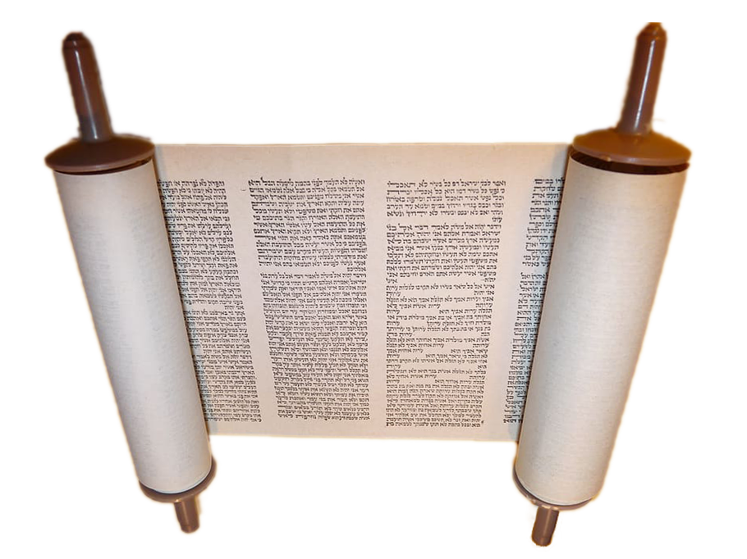

Usage:
Man reading a scroll (Image generated by ChatGPT using OpenAI technology)A scroll was a convenient means to store a large amount of written text in a relatively small space. The text was written in parallel columns, usually on one side of the scroll.
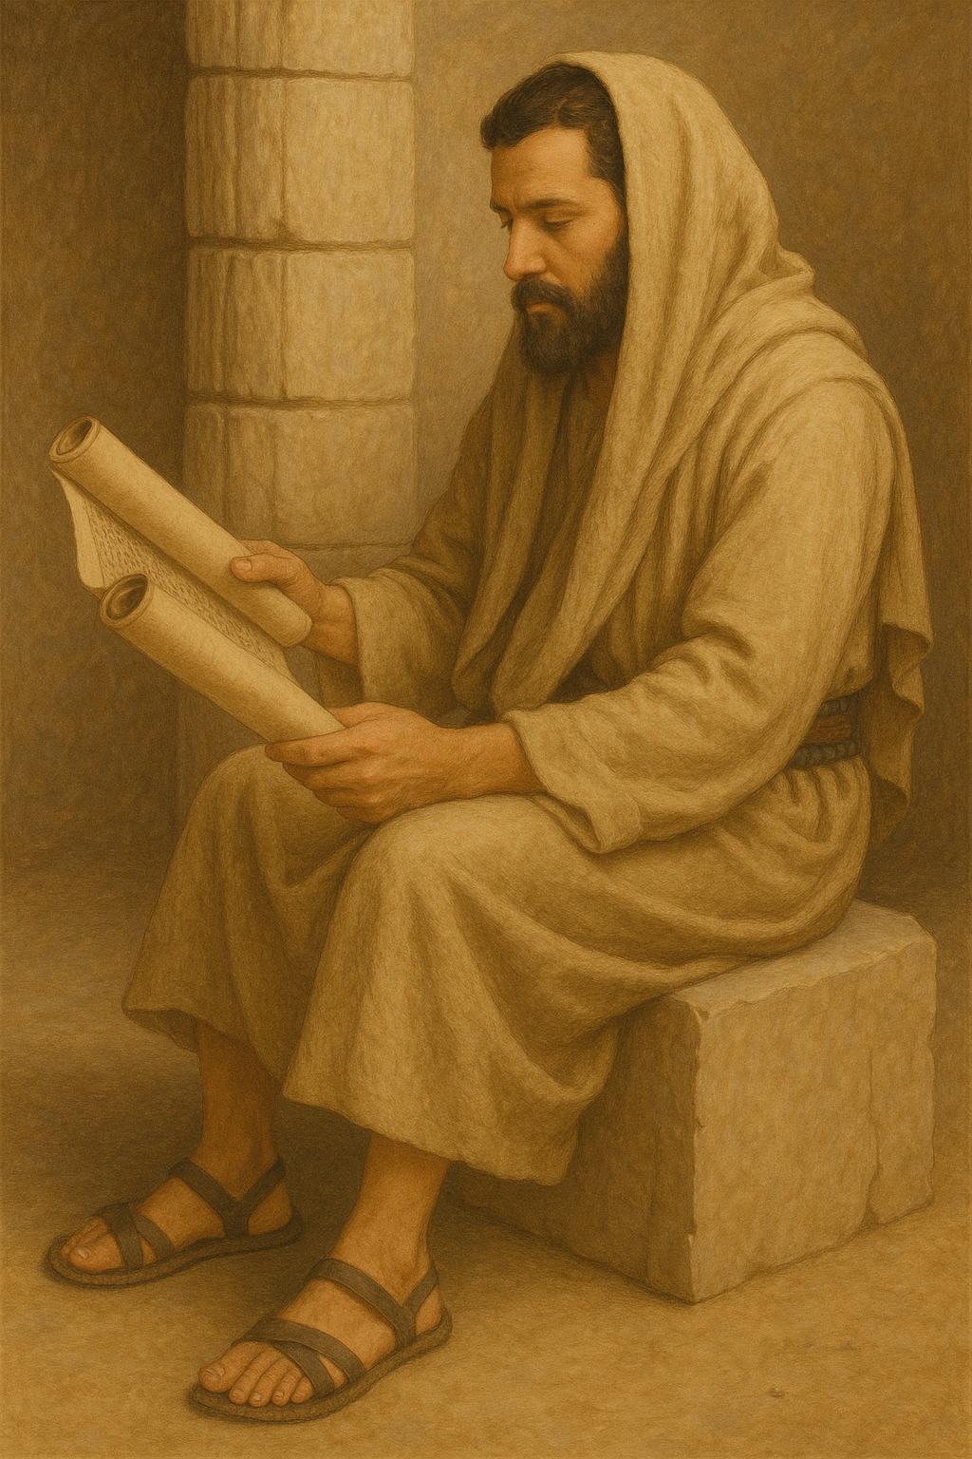

Translation:
In the case of practically all terms for documents (for example, “letter,” “book,” “scroll”), the meaning involves not only the object on which the writing is done, but also the contents of the writing. In some languages a distinction must be made between these two aspects of such objects, and translators must make certain that the particular expression used in a receptor language will at least include the contents and not refer merely to the materials on which the words were written.
Scrolls varied in length but otherwise there was little difference between the physical construction of a short document and a long one. Thus, for example, the Hebrew word sefer may indicate a longer document (“book”), or it can also designate something shorter, which may best be translated “letter,” “writing,” or even “document”; for example, GNT renders it “papers” in DEU 24:1 and “letter” in 2KI 5:6.
Exceptionally long books might be written on more than one scroll. The Greek word kefalis in HEB 10:7 refers to one such section or scroll of a book.
The codex, or bound book with individual pages, only came into use in the first century B.C. and in common use only a century or two later. Thus, all references to books in the Old Testament, in the Deuterocanon, and probably in the New Testament are to scrolls. Nevertheless, the closest equivalent in most languages for “scroll” is the term used today for “book,” and this will normally be the proper translation.
In ISA 29:11; ISA 29:12 the Hebrew verb yada’ (“know”) occurs with the word sefer to indicate the ability to read and should be translated “knows how to read” (GNT) or “can read” (RSV). In DAN 1:4 the word sefer may indicate either “literature/writings” (NRSV, SPCL, REB) or the ability “to read and write” (GNT). In some languages the idea of literature may be unfamiliar, but there will probably be some way of talking about “written things,” and this may be the nearest equivalent available.
TOB 7:14: On the scroll in this passage were written the terms of agreement between a man and a woman entering into marriage. Almost all cultures know some means by which two parties agree to a marriage. If this is a written document, then the name for that document may be used.

Ink

1.7.2 Ink

References:Hebrew דְּיוֹ (dyow)JER 36:18Greek μέλας (melas)2CO 3:3, 2JN 1:12, 3JN 1:13

Description:
A scribe copying Scripture with a reed pen (© Ray Pritz by United Bible Societies)Ink was a dark liquid used in writing or marking. Because it was difficult to store liquids for any length of time in the dry conditions of the Middle East, ink was sometimes made from black charcoal carbon. This was mixed with gum or oil and then dried. When the scribe was ready to write, he dipped his pen tip in water and then rubbed it on the ink block. The water dissolved a small amount of the carbon, forming the ink.
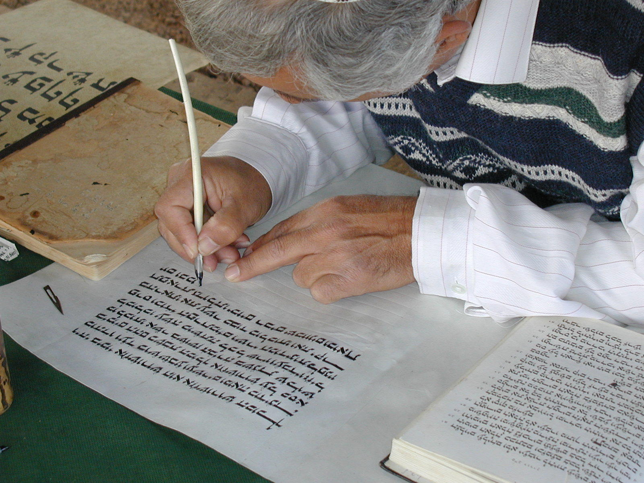

Translation:
The use of ink is so universal at the present time that some term or expression for it is almost inevitable in all languages. In some cases the equivalent is a descriptive phrase, for example, “black stain” or “writing mark.”

Pen

1.7.3 Pen

References:Hebrew עֵט, סֹפֵר (‘et sofer)PSA 45:2, JER 8:8Greek κάλαμος (kalamos)3JN 1:13, 3MA 4:20

Description:
The pen was a reed especially cut for making marks with ink on writing material. It was about 20 centimeters (8 inches) long and was sharpened on one end and split to form a nib. Sometimes it could be made of a rush cut at an angle and then frayed to form a fine brush.

Usage:
See 1.7.2 Ink<REALIA:1.7.2>.

Writing case

1.7.4 Writing case

References:Hebrew קֶסֶת, סֹפֵר (qeseth sofer)EZK 9:2, EZK 9:3, EZK 9:11

Description:
Pens in a case (Wood, ivory, paint, ca. 1635–1458 BCE, Second Intermediate Period–Early New Kingdom, Egypt, Thebes, Asasif) (Metropolitan Museum of Art, CC0, via Wikimedia Commons)The writing case was a small box, usually made of wood, for carrying several pens (1.7.2) and sometimes a cake of dried ink (1.7.4). Inside the case, in addition to several reed pens, there were receptacles where the ink was mixed at the time of writing. A person generally carried this case by hanging it from his belt. Sometimes the object for mixing the ink had the shape of a palette, with two circular hollows for two colors of ink, and was carried by hanging it from a cord.
<image: Z>

Translation:
Writing case and pen (Image generated by ChatGPT using OpenAI technology)The closest equivalent in many languages for “writing case” would be “pencil case,” but this could sound anachronistic. It is also possible to render it with a descriptive phrase, such as “a small box in which he carried pens” or “… in which he carried writing instruments.”
<image: 9k=>

Stylus

1.7.5 Stylus

References:Hebrew חֶרֶט (cheret)ISA 8:1Hebrew עֵט, בַּרְזֶל (‘et barzel)JOB 19:24, JER 17:1

Description and usage:
Tablet and stylus (© Deutsche Bibelgesellschaft, Stuttgart by United Bible Societies)The stylus was a short, sharp piece of iron.
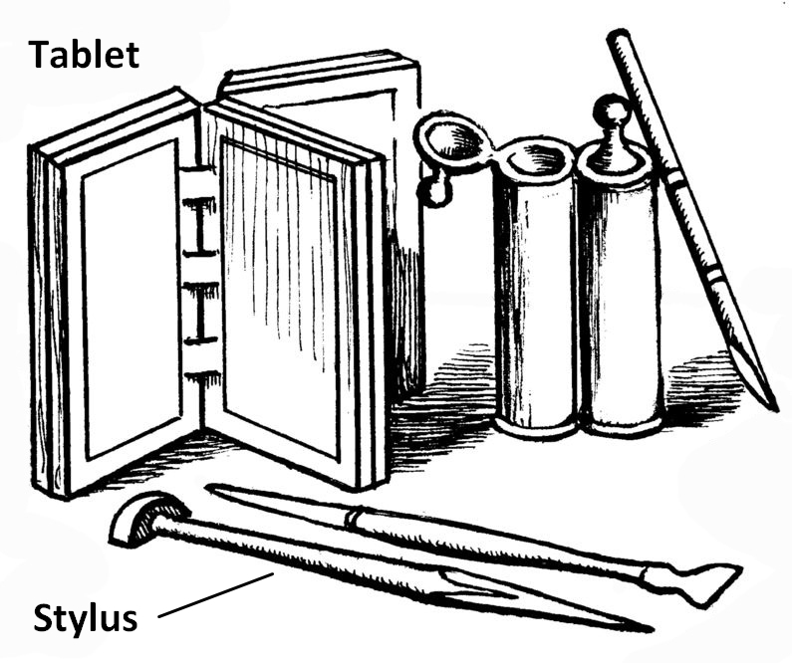
It was held in the hand and the point was used to engrave marks, usually writing or drawing, on stone or metal.

Translation:
It is not clear if JOB 19:24 speaks of an engraving tool made of iron or of an iron surface on which the engraving took place. For the first half of this verse, HOTTP suggests “on tablets of iron and lead” or “with a stylus and lead [meaning melted lead placed into the spaces of the inscription].”
The Hebrew phrase cheret ’enosh in ISA 8:1 has been the subject of much debate. Some translations choose to preserve the implement used (KJV “man’s pen”; NIV “ordinary pen”; NJB “ordinary stylus”), while others prefer a rendering that focuses on the words being written (RSV “common characters”; CEV “big clear letters”; NLT “clearly write”).

Writing tablet, tablet of brass/bronze

1.7.6 Writing tablet, tablet of brass/bronze

References:Hebrew גִּלָּיוֹן (gilayon)ISA 8:1Hebrew לוּחַ (luach)EXO 24:12, EXO 31:18, EXO 31:18, EXO 32:15, EXO 32:15, EXO 32:16, EXO 32:16, EXO 32:19, EXO 34:1, EXO 34:1, EXO 34:1, EXO 34:4, EXO 34:4, EXO 34:28, EXO 34:29, DEU 4:13, DEU 5:22, DEU 9:9, DEU 9:9, DEU 9:10, DEU 9:11, DEU 9:11, DEU 9:15, DEU 9:17, DEU 10:1, DEU 10:2, DEU 10:2, DEU 10:3, DEU 10:3, DEU 10:4, DEU 10:5, 1KI 8:9, 2CH 5:10, PRO 3:3, PRO 7:3, ISA 30:8, JER 17:1, HAB 2:2Greek δέλτος (deltos)1MA 8:22, 1MA 14:18, 1MA 14:26, 1MA 14:48Greek πινακίδιον (pinakidion)LUK 1:63Latin buxus2ES 14:24

Description:
Wax writing tablet (Metropolitan Museum of Art, CC0, MMA)The writing tablet was a small, flat board, normally made of wood. It was coated on one side with a thin layer of wax. A pointed stick or stylus was used to make marks and letters in the wax layer for short messages. After use, the wax could be smoothed out and used again. Several tablets could be connected along one edge by cord in order to make a kind of book. See the illustration at 1.7.5 Stylus<REALIA:1.7.5>. It is possible that the Old Testament references are to tablets made of clay, metal or stone, on which words were scratched directly with a hard, pointed object.
<image: Z>
The tablets mentioned in 1 Maccabees were flat pieces of polished brass or bronze on which words were inscribed. The sizes of these tablets are unknown, but they would probably not have been very large.

Translation:
Translators should avoid a word that indicates a modern “tablet” of writing paper.
PRO 3:3; PRO 7:3; JER 17:1: The Hebrew word luach has a figurative meaning in these passages and may be rendered without reference to an actual writing tablet; for example, GNT renders PRO 7:3 b as “write it on your heart,” and ITCL has “guard them in your heart like a treasure.”
Although one or two of the references with the Greek word deltos speak of the tablets as containing “letters” (that is, correspondence), such tablets were not the normal medium for letters. According to 1MA 8:22, they were special memorial documents, intended “as a memorial of peace and alliance” (RSV). Some cultures may have special documents that are exchanged between people groups when they make treaties or alliances.

Paper

1.7.7 Paper

References:Greek χαρτηρία (chartēria)3MA 4:20Greek χάρτης (chartēs)2JN 1:12Latin carta2ES 15:2

Description and usage:
Paper was a material for writing on, made from the papyrus plant.

Translation:
The name of any material commonly used in the receptor culture for writing letters on may serve as a rendering for the word “paper” in 2JN 1:12.
In 2ES 15:2 the focus is not on the material on which the writing is done but on the writing itself. So for the literal text “cause them to be written on paper” (RSV), GNT has “have them written down.”

Parchment

1.7.8 Parchment

Reference:Greek μεμβράνα (membrana)2TI 4:13

Description:
Parchment was a sheet of specially prepared animal skin on which someone could write with pen and ink. The skins of sheep and goats were prepared by removing the hair, and then they were smoothed with lime.

Usage:
Parchment was frequently the medium used in making scrolls (see 1.7.1 Scroll, book<REALIA:1.7.1>).

Translation:
In 2TI 4:13 the reference may be to documents written on parchment or to blank sheets of parchment. It is probably best to understand Paul’s request at the end of this verse to be “bring the rolled-up books [scrolls], and especially the ones made from animal skins [leather].”

