Resource: Human-made Things in the Bible
Human-made Things in the Bible © United Bible Societies, 2025. Adapted from: The Works of Their Hands: Man-made Things in the Bible, by Ray Pritz © 2009 United Bible Societies. This work is licensed under Creative Commons Attribution-ShareAlike 4.0 International (https://creativecommons.org/licenses/by-sa/4.0/).

Human-made Things in the Bible

Sling

2.2 Sling

References:Hebrew מַרְגֵּמָה (margemah)PRO 26:8Hebrew קלע, קֶלַע, קַלָּע (qala‘ (verb or noun), qela‘)JDG 20:16, 1SA 17:40, 1SA 17:49, 1SA 17:50, 1SA 25:29, 2KI 3:25, 2CH 26:14, JOB 41:20, ZEC 9:15Greek σφενδόνη, σφενδονήτης (sfendonē, sfendonētēs)JDT 6:12, JDT 9:7, SIR 47:4, 1MA 6:51, 1MA 9:11

Description:
A sling with rounded sling stones (Assyrian Gallery, British Museum) (Gary Todd, worldhistorypics.weebly.com, CC0)The sling was a small rectangular or oval piece of leather or woven material with cords attached to the two ends. The leather or cloth was slightly smaller than a man’s hand, and the cords were about the length of an arm.
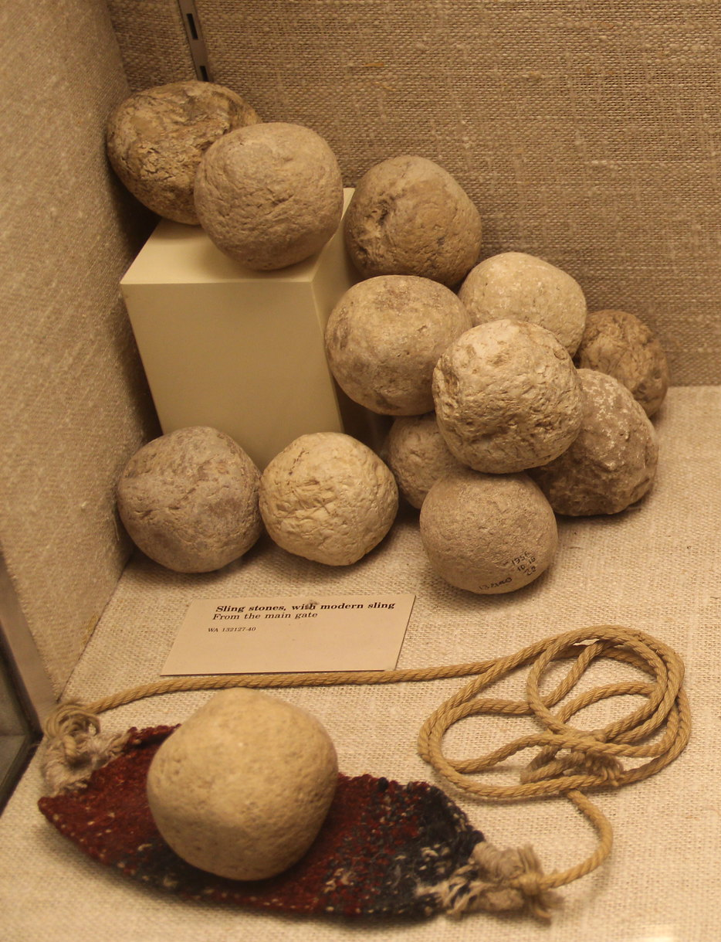

Usage:
Relief of Assyrian soldiers using slings (British Museum) (© Mike Peel (www.mikepeel.net)., CC BY-SA 4.0, via Wikimedia Commons)The sling was used to project a stone at high velocity at a target. The stone was placed in the pouch formed by the leather or cloth. The slinger grasped the ends of the cords and swung the stone in rapid circles. By releasing one of the cords at just the right moment, the pouch was opened and the stone was projected toward the target. Effective use of the sling required much practice.
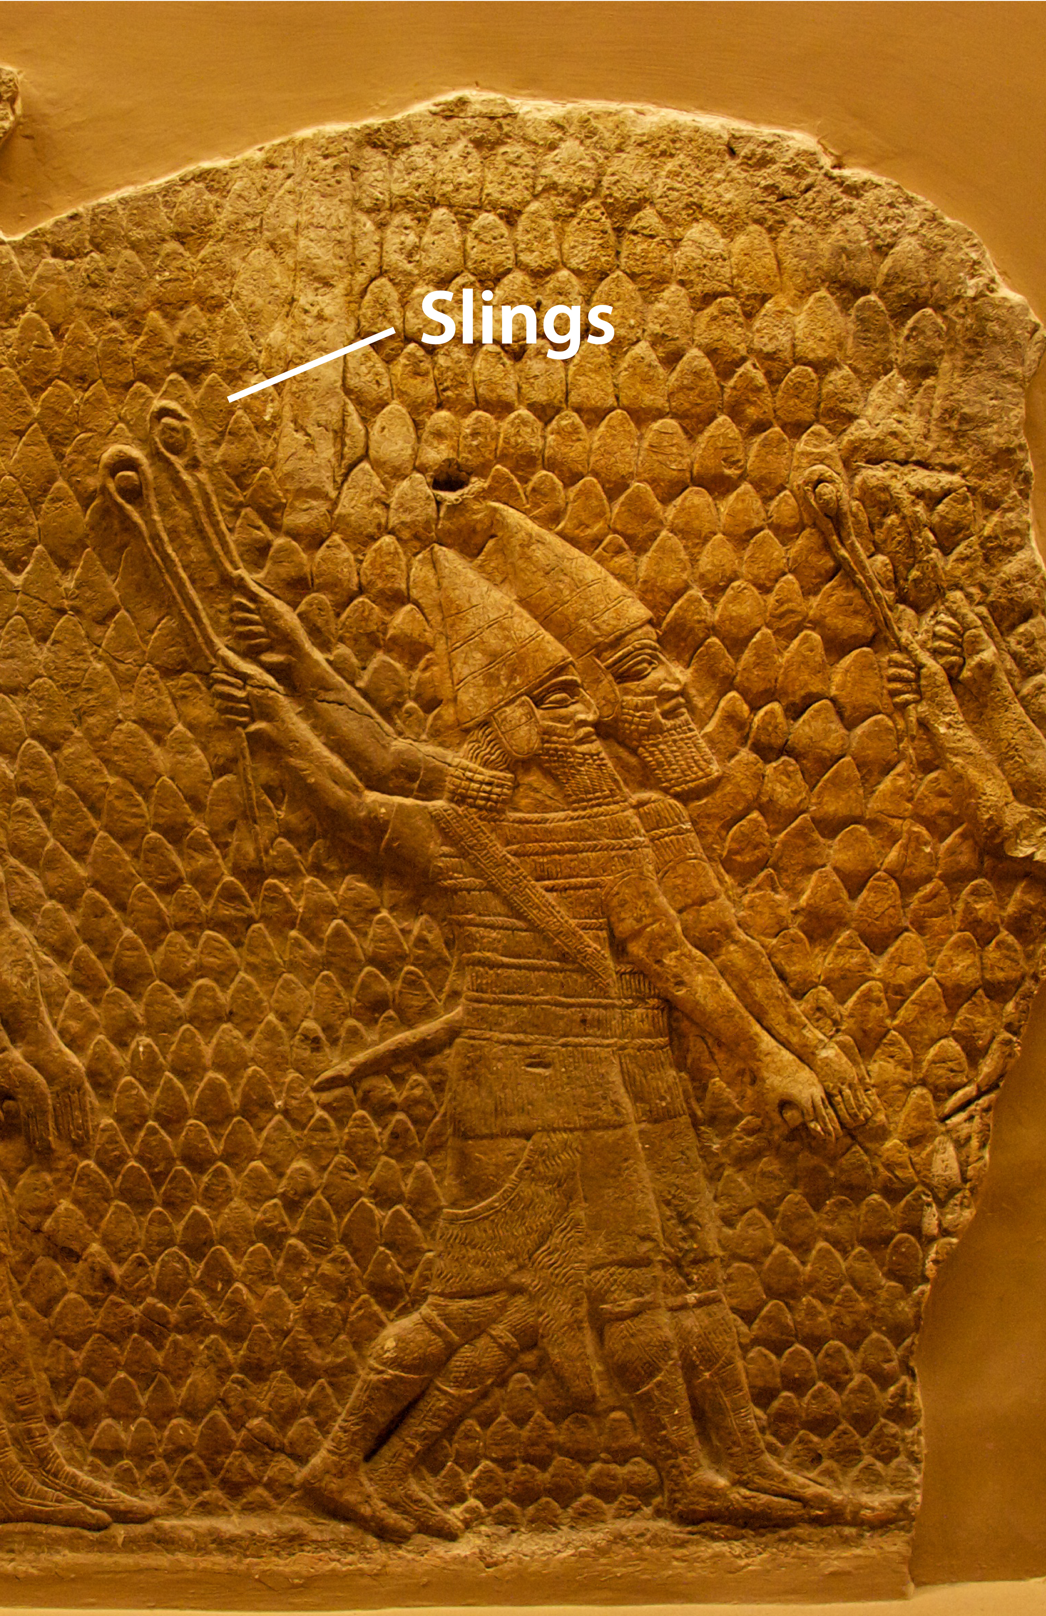

Translation:
If possible, translators should avoid using a word that will be under­stood as a modern slingshot or catapult made with pieces of rubber. In 2CH 26:14; JOB 41:28; and ZEC 9:15, the focus is actually on the stones and not on the weapon. In these passages the translator may avoid mentioning the sling; for example in JOB 41:28 b GNT has “rocks thrown at him are like bits of straw.”
The Greek word sfendonētēs in JDT 6:12 and 1MA 9:11 describes not the weapon but the person who uses it, the “slinger.” In JDT 6:12GNT says “who used a sling as a weapon.”
Where such a weapon is unknown, it may be possible to say “a special weapon for throwing stones.”

