Resource: Human-made Things in the Bible
Human-made Things in the Bible © United Bible Societies, 2025. Adapted from: The Works of Their Hands: Man-made Things in the Bible, by Ray Pritz © 2009 United Bible Societies. This work is licensed under Creative Commons Attribution-ShareAlike 4.0 International (https://creativecommons.org/licenses/by-sa/4.0/).

Human-made Things in the Bible

Sword

2.3 Sword

References:Hebrew חֶרֶב (cherev)GEN 3:24, GEN 27:40, GEN 31:26, GEN 34:25, GEN 34:26, GEN 48:22, EXO 5:3, EXO 5:21, EXO 15:9, EXO 17:13, EXO 18:4, EXO 20:25, EXO 22:23, EXO 32:27, LEV 26:6, LEV 26:7, LEV 26:8, LEV 26:25, LEV 26:33, LEV 26:36, LEV 26:37, NUM 14:3, NUM 14:43, NUM 19:16, NUM 20:18, NUM 21:24, NUM 22:23, NUM 22:29, NUM 22:31, NUM 31:8, DEU 13:16, DEU 13:16, DEU 20:13, DEU 28:22, DEU 32:25, DEU 32:41, DEU 32:42, DEU 33:29, JOS 5:2, JOS 5:3, JOS 5:13, JOS 6:21, JOS 8:24, JOS 8:24, JOS 10:11, JOS 10:28, JOS 10:30, JOS 10:32, JOS 10:35, JOS 10:37, JOS 10:39, JOS 11:10, JOS 11:11, JOS 11:12, JOS 11:14, JOS 13:22, JOS 19:47, JOS 24:12, JDG 1:8, JDG 1:25, JDG 3:16, JDG 3:21, JDG 3:22, JDG 4:15, JDG 4:16, JDG 7:14, JDG 7:20, JDG 7:22, JDG 8:10, JDG 8:20, JDG 9:54, JDG 18:27, JDG 20:2, JDG 20:15, JDG 20:17, JDG 20:25, JDG 20:35, JDG 20:37, JDG 20:46, JDG 20:48, JDG 21:10, 1SA 13:19, 1SA 13:22, 1SA 14:20, 1SA 15:8, 1SA 15:33, 1SA 17:39, 1SA 17:45, 1SA 17:47, 1SA 17:50, 1SA 17:51, 1SA 18:4, 1SA 21:9, 1SA 21:9, 1SA 21:10, 1SA 22:10, 1SA 22:13, 1SA 22:19, 1SA 22:19, 1SA 25:13, 1SA 25:13, 1SA 25:13, 1SA 31:4, 1SA 31:4, 1SA 31:5, 2SA 1:12, 2SA 1:22, 2SA 2:16, 2SA 2:26, 2SA 3:29, 2SA 11:25, 2SA 12:9, 2SA 12:9, 2SA 12:10, 2SA 15:14, 2SA 18:8, 2SA 20:8, 2SA 20:10, 2SA 23:10, 2SA 24:9, 1KI 1:51, 1KI 2:8, 1KI 2:32, 1KI 3:24, 1KI 3:24, 1KI 18:28, 1KI 19:1, 1KI 19:10, 1KI 19:14, 1KI 19:17, 1KI 19:17, 2KI 3:26, 2KI 6:22, 2KI 8:12, 2KI 10:25, 2KI 11:15, 2KI 11:20, 2KI 19:7, 2KI 19:37, 1CH 5:18, 1CH 10:4, 1CH 10:4, 1CH 10:5, 1CH 21:5, 1CH 21:5, 1CH 21:12, 1CH 21:12, 1CH 21:16, 1CH 21:27, 1CH 21:30, 2CH 20:9, 2CH 21:4, 2CH 23:14, 2CH 23:21, 2CH 29:9, 2CH 32:21, 2CH 34:6, 2CH 36:17, 2CH 36:20, EZR 9:7, NEH 4:7, NEH 4:12, EST 9:5, JOB 1:15, JOB 1:17, JOB 5:15, JOB 5:20, JOB 15:22, JOB 19:29, JOB 19:29, JOB 27:14, JOB 39:22, JOB 40:19, JOB 41:18, PSA 7:13, PSA 17:13, PSA 22:21, PSA 37:14, PSA 37:15, PSA 44:4, PSA 44:7, PSA 45:4, PSA 57:5, PSA 59:8, PSA 63:11, PSA 64:4, PSA 76:4, PSA 78:62, PSA 78:64, PSA 89:44, PSA 144:10, PSA 149:6, PRO 5:4, PRO 12:18, PRO 25:18, PRO 30:14, SNG 3:8, SNG 3:8, ISA 1:20, ISA 2:4, ISA 2:4, ISA 3:25, ISA 13:15, ISA 14:19, ISA 21:15, ISA 21:15, ISA 22:2, ISA 27:1, ISA 31:8, ISA 31:8, ISA 31:8, ISA 34:5, ISA 34:6, ISA 37:7, ISA 37:38, ISA 41:2, ISA 49:2, ISA 51:19, ISA 65:12, ISA 66:16, JER 2:30, JER 4:10, JER 5:12, JER 5:17, JER 6:25, JER 9:15, JER 11:22, JER 12:12, JER 14:12, JER 14:13, JER 14:15, JER 14:15, JER 14:16, JER 14:18, JER 15:2, JER 15:2, JER 15:3, JER 15:9, JER 16:4, JER 18:21, JER 18:21, JER 19:7, JER 20:4, JER 20:4, JER 21:7, JER 21:7, JER 21:9, JER 24:10, JER 25:16, JER 25:27, JER 25:29, JER 25:31, JER 26:23, JER 27:8, JER 27:13, JER 29:17, JER 29:18, JER 31:2, JER 32:24, JER 32:36, JER 33:4, JER 34:4, JER 34:17, JER 38:2, JER 39:18, JER 41:2, JER 42:16, JER 42:17, JER 42:22, JER 43:11, JER 43:11, JER 44:12, JER 44:12, JER 44:13, JER 44:18, JER 44:27, JER 44:28, JER 46:10, JER 46:14, JER 46:16, JER 47:6, JER 48:2, JER 48:10, JER 49:37, JER 50:16, JER 50:35, JER 50:36, JER 50:36, JER 50:37, JER 50:37, JER 51:50, LAM 1:20, LAM 2:21, LAM 4:9, LAM 5:9, EZK 5:1, EZK 5:2, EZK 5:2, EZK 5:12, EZK 5:12, EZK 5:17, EZK 6:3, EZK 6:8, EZK 6:11, EZK 6:12, EZK 7:15, EZK 7:15, EZK 11:8, EZK 11:8, EZK 11:10, EZK 12:14, EZK 12:16, EZK 14:17, EZK 14:17, EZK 14:21, EZK 16:40, EZK 17:21, EZK 21:8, EZK 21:9, EZK 21:10, EZK 21:14, EZK 21:14, EZK 21:16, EZK 21:17, EZK 21:19, EZK 21:19, EZK 21:19, EZK 21:20, EZK 21:24, EZK 21:25, EZK 21:33, EZK 21:33, EZK 23:10, EZK 23:25, EZK 23:47, EZK 24:21, EZK 25:13, EZK 26:6, EZK 26:8, EZK 26:9, EZK 26:11, EZK 28:7, EZK 28:23, EZK 29:8, EZK 30:4, EZK 30:5, EZK 30:6, EZK 30:11, EZK 30:17, EZK 30:21, EZK 30:22, EZK 30:24, EZK 30:25, EZK 31:17, EZK 31:18, EZK 32:10, EZK 32:11, EZK 32:12, EZK 32:20, EZK 32:20, EZK 32:21, EZK 32:22, EZK 32:23, EZK 32:24, EZK 32:25, EZK 32:26, EZK 32:27, EZK 32:28, EZK 32:29, EZK 32:30, EZK 32:31, EZK 32:32, EZK 33:2, EZK 33:3, EZK 33:4, EZK 33:6, EZK 33:6, EZK 33:26, EZK 33:27, EZK 35:5, EZK 35:8, EZK 38:4, EZK 38:8, EZK 38:21, EZK 38:21, EZK 39:23, DAN 11:33, HOS 1:7, HOS 2:20, HOS 7:16, HOS 11:6, HOS 14:1, JOL 4:10, AMO 1:11, AMO 4:10, AMO 7:9, AMO 7:11, AMO 7:17, AMO 9:1, AMO 9:4, AMO 9:10, MIC 4:3, MIC 4:3, MIC 5:5, MIC 6:14, NAM 2:14, NAM 3:3, NAM 3:15, ZEP 2:12, HAG 2:22, ZEC 9:13, ZEC 11:17, ZEC 13:7Hebrew מְכֵרָה (mkerah)GEN 49:5Hebrew פְּתִיחָה (pthichah)PSA 55:22Greek ἀκινάκης (akinakēs)JDT 13:6, JDT 16:9Greek μάχαιρα (machaira)MAT 10:34, MAT 26:47, MAT 26:52, MAT 26:52, MAT 26:52, MAT 26:55, MRK 14:43, MRK 14:47, MRK 14:48, LUK 21:24, LUK 22:36, LUK 22:38, LUK 22:49, LUK 22:52, JHN 18:10, JHN 18:11, ACT 12:2, ACT 16:27, ROM 8:35, ROM 13:4, GAL 6:17, HEB 4:12, HEB 11:34, HEB 11:37, REV 6:4, REV 13:10, REV 13:10, REV 13:14, ESG 3:13, SIR 28:18, BEL 1:25, 1MA 3:12, 1MA 4:6, 1MA 10:85, 2MA 5:2, 1ES 3:22, ODA 1:9, ODA 2:25, ODA 2:41, ODA 2:42Greek ξιφηφόρος (xifēforos)4MA 16:20Greek ξίφος (xifos)WIS 18:15, 2MA 12:22, 2MA 14:41Greek ῥομφαία (rhomfaia)LUK 2:35, REV 1:16, REV 2:12, REV 2:16, REV 6:8, REV 19:15, REV 19:21, JDT 1:12, JDT 2:27, JDT 7:14, JDT 8:19, JDT 9:2, JDT 11:10, JDT 16:4, WIS 5:20, SIR 21:3, SIR 22:21, SIR 26:28, SIR 39:30, SIR 40:9, SIR 46:2, BAR 2:25, SUS 1:59, 1MA 2:9, 1MA 3:3, 1MA 4:15, 1MA 4:33, 1MA 5:28, 1MA 5:51, 1MA 7:38, 1MA 7:46, 1MA 8:23, 1MA 9:73, 1MA 12:48, 2MA 15:15, 2MA 15:16, 1ES 1:50, 1ES 1:53, 1ES 4:23, 1ES 8:74, PSS 13:2, PSS 15:7Greek σίδηρος (sidēros)JDT 6:6, JDT 9:8Greek συγκεντέω (sugkenteō (verb))2MA 12:23Greek συνεκκεντέω (sunekkenteō (verb))2MA 5:26Latin gladius2ES 12:27, 2ES 12:28, 2ES 15:5, 2ES 15:15, 2ES 15:19, 2ES 15:35, 2ES 15:49, 2ES 15:57, 2ES 16:3, 2ES 16:22, 2ES 16:23Latin romphea2ES 15:15, 2ES 15:22, 2ES 15:41, 2ES 15:57, 2ES 16:32

Description and usage:
Straight sword (© Rama, Wikimedia Commons, CC BY-SA 2.0 FR, via Wikimedia Commons)The length and shape of swords varied widely in different periods and different nations. The basic concept, however, remained the same: the sword was a long, heavy knife made of metal, at first of bronze, and later of harder metals like iron. In earlier biblical times the blade tended to be more for cutting; it was curved similar to a sickle (see 1.1.6 Sickle<REALIA:1.1.6>), but it was sharpened only on the outside of the curve, unlike the sickle, which was sharpened on the inside of the curve. With this type of sword for cutting, no emphasis was placed on a point for piercing. In the later Old Testament period, swords were made more for piercing. These swords, which were as short as 30–40 centimeters (12–16 inches) at first, had relatively broad, pointed blades that were sharpened on both sides. By the time of the Israelite kings, the blades had become longer and relatively narrower.
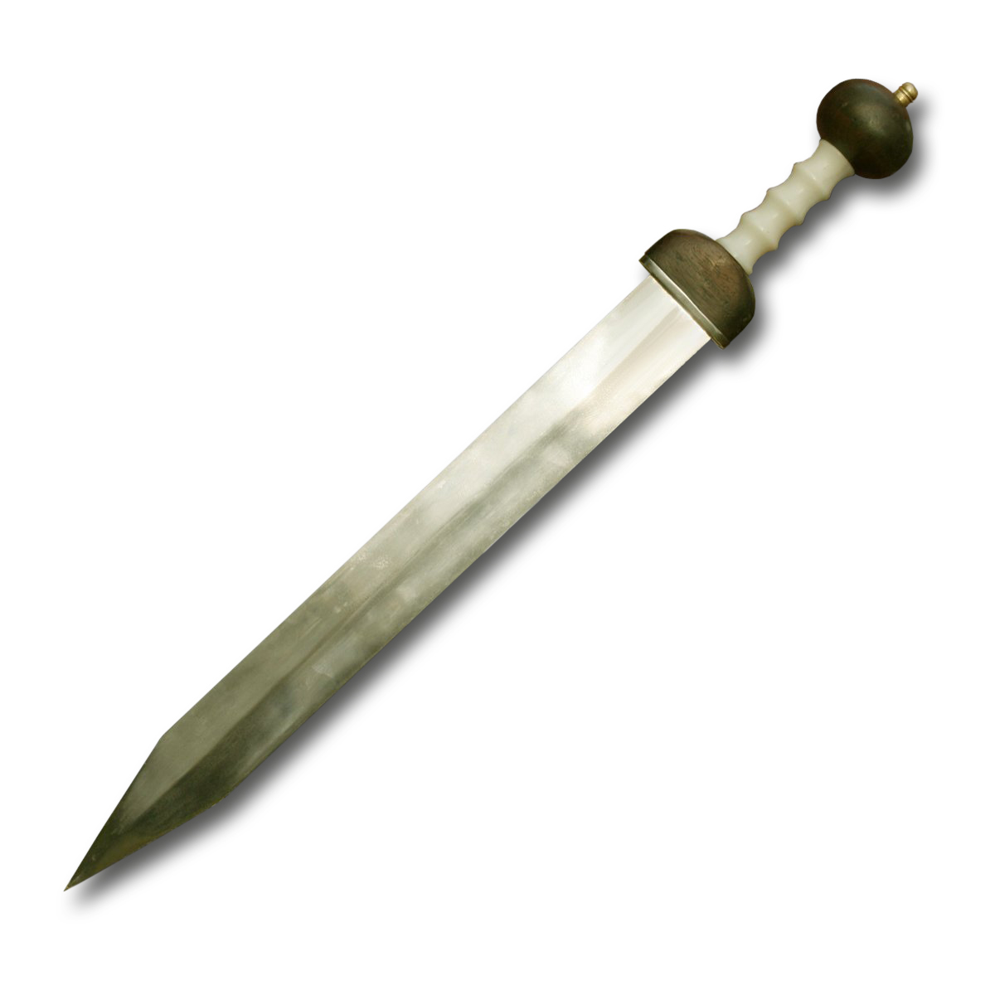

Translation:
An Assyrian curved, or sickle, sword (ca. 1307–1275 BCE) (Metropolitan Museum of Art, CC0, MMA)In a number of languages the term for “sword” is simply “large knife,” but in some regions it may be called “machete for killing” or “war knife.”
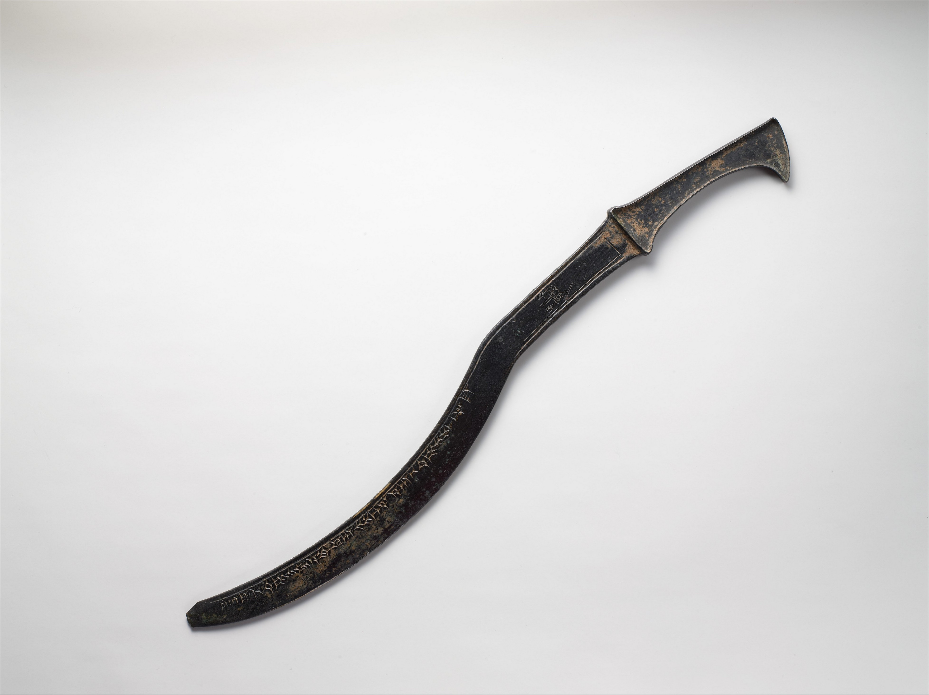
The Hebrew word cherev is a general term and does not specify whether the sword is long or short. Where a language makes a distinction, it will generally be best to translate it “short sword.” In the New Testament the Greek word machaira refers to a short sword and rhomfaia is a long sword. The phrase “with/by the edge of the sword” (occurring over 30 times with over half of them in Joshua and Judges) usually has in view the older, curved sword, which had only one edge. Normally it will not be necessary to render this expression literally, but it will be sufficient to say something like “with/by the sword.”
In many passages we find the phrase “die by the sword” or “slain by the sword” (for example, JOB 36:12; JER 5:12; JER 21:9; EZK 31:17; MAT 26:52). This is an idiomatic expression meaning to die a violent death. It normally (but not always; compare 1SA 2:33) means to die in war, and translators may often use an expression such as “killed in war” (GNT in JER 16:4) or “die in battle.” In such cases it usually indicates a non-heroic death; where a language has a special word or phrase for “die the death of a warrior,” the translator should not use that expression unless such a death is what is intended by the biblical text. In cases where death in warfare is not the meaning, one may say “die a violent death” or “killed by people.” One should not substitute a modern weapon for “sword”; for example, it would be anachronistic to say “shot to death.”
In some passages the word “sword” simply stands for warfare, for example, JER 5:12; ROM 8:35; REV 6:8. JOS 24:12 says literally “Then I sent the hornet before you and it drove out the two kings of the Amorites from before you, [but] not by your sword or your bow” (NASB). It may be preferable in some languages to translate the last part of this verse without naming the specific weapons: “Your weapons and strength had nothing to do with it.” It is also possible to translate this with both a positive and negative statement: “I defeated them for you. It was not your own strength and weapons that did it.”
The phrase “men who drew the sword” occurs in a number of passages (JDG 8:10; JDG 8:20 [6 times]; 2SA 24:9; 1CH 21:5). This is simply an idiomatic expression for “soldiers,” which is the GNT rendering in JDG 8:10.
The phrase “lift up the sword” occurs in ISA 2:4 and MIC 4:3 with the meaning “go into battle” or “go to war.” GNT gives the correct English equivalent by rendering the second to last line in each of these verses as “Nations will never again go to war.” In some languages a literal rendering of the idiom “to lift up the sword” will have quite a different meaning, such as “to surrender” or “to be victorious.” This is not the meaning of the text and should be avoided.
The Hebrew phrase cherev pifiyoth (PSA 149:6) or cherev piyoth (PRO 5:4) refers to a sword sharpened on both edges of the blade, that is, a “two-edged sword” (RSV; compare HEB 4:12; REV 1:16; REV 2:12; SIR 21:3). This is the straight sword of later Old Testament times and onward.
In GEN 49:5 the meaning of the Hebrew word mkerah is doubtful. Most translators connect Jacob’s words to the events described in GEN 34:25; GEN 34:26 and understand mkerah to be a kind of weapon, probably parallel to the “sword” (cherev in Hebrew) in those verses.
In PSA 55:22 the Hebrew word pthichoth refers to swords that are “drawn” (literally “open”), that is, ready for use. Thus, for the last line of this verse CEV has “and he was ready to attack with a sword.” Others prefer to use a simile; for example, GNT has “but they [his words] cut like sharp swords” and NCV says “… cut like knives.”
In LUK 2:35 the word “sword” is used figuratively for pain or anguish. Often translators can use a rather literal rendering. Sometimes it is preferable to shift to a simile; for example, the first half of this verse may be rendered “As for your soul, it will be as if a sword pierced it.” In some cases the equivalent expression does not need a term for “sword,” for example, “and you too shall be pierced to the heart” (NEB). It is also pos­sible to use a nonfigurative expression, for example, “you will experience anguish.” There is no implication here of a military death, and the translator should avoid the use of a term that might carry that implication.

Sheath, scabbard

2.3.1 Sheath, scabbard

References:Hebrew נָדָן (nadan)1CH 21:27Hebrew תַּעַר (ta‘ar)1SA 17:51, 2SA 20:8, JER 47:6, EZK 21:8, EZK 21:9, EZK 21:10, EZK 21:35Greek θήκη (thēkē)JHN 18:11

Description:
Body armor and weapons of a soldier (Image generated by ChatGPT using OpenAI technology)The sheath was a case or bag about the size and shape of a sword, used to cover and to carry the sword. It could be made of a variety of materials, usually leather, but also cloth, metal, or even wood. It was normally attached to a circular strap or belt that could be hung over the shoulder or tied around the waist. In later Old Testament times, when iron swords were too heavy for a belt alone, the sheath was attached to a combination of a belt and a shoulder strap.
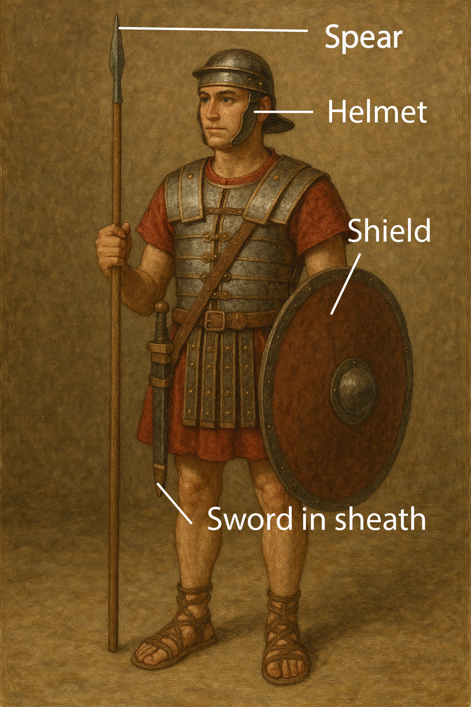

Usage:
The sheath covered the blade of a sword in order to protect the blade and to protect the person carrying the sword and those around him from being cut accidentally.

Translation:
In some languages “sheath” may be rendered “leather bag for a sword,” “covering for a sword,” or “something in which a sword is carried.”

