Resource: Human-made Things in the Bible
Human-made Things in the Bible © United Bible Societies, 2025. Adapted from: The Works of Their Hands: Man-made Things in the Bible, by Ray Pritz © 2009 United Bible Societies. This work is licensed under Creative Commons Attribution-ShareAlike 4.0 International (https://creativecommons.org/licenses/by-sa/4.0/).

Human-made Things in the Bible

Scale armor, coat of mail

2.13 Scale armor, coat of mail

References:Hebrew שִׁרְיוֹן, קַשְׂקֶשֶׂת (shiryon, shiryon qasqasim)1SA 17:5, 1SA 17:5, 1SA 17:38, 2CH 26:14, NEH 4:10Greek ἁλυσιδωτός (halusidōtos)1MA 6:35

Description and usage:
Detail of scale armor made of metal discs attached to each other (© MatthiasKabel, CC BY-SA 3.0, via Wikimedia Commons)Scale armor was a kind of vest or shirt covering the upper part of the body. It was made of several hundred small bronze scales or platelets overlapping each other and sewn on a cloth or leather base. The scales were thin and about 11 by 6 centimeters (4.5 by 2.5 inches). Such armor was lighter than a solid metal breastplate (see 2.12 Breastplate, chest protector<REALIA:2.12>) and was also more flexible, giving greater maneuverability. It was used especially by a soldier who could not carry a shield but still needed protection in battle (for example, a chariot driver).
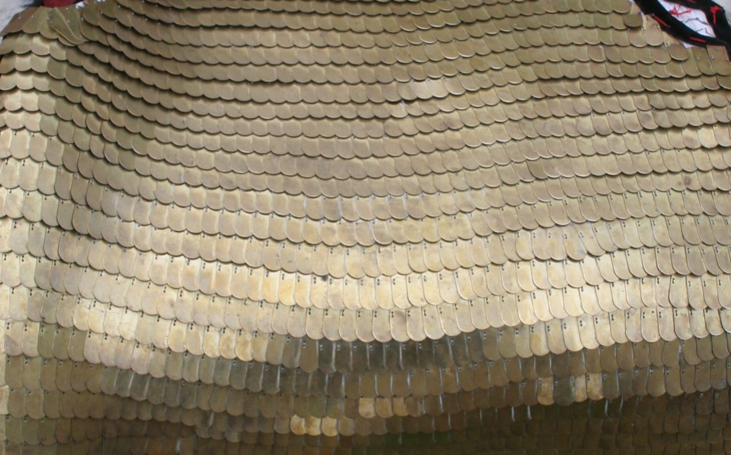

Translation:
Many languages will not have a specific term for such armor. In 1SA 17:5 both RSV and NRSV have the somewhat archaic term “coat of mail.” NIV has “scale armor,” and NCV says “coat of … armor.” Where body armor is unknown, translators may say “shirt covered with thin metal plates to protect the chest.”
King Ahab was killed when a stray arrow penetrated some weak spot in his armor (1KI 22:34; 2CH 18:33). The Hebrew word used to refer to this weak spot in the armor is deveq. RSV renders it “scale armor,” but it seems more likely that the word refers to a joint between two parts of the armor. GNT has “between the joints of his armor,” and CEV says “where two pieces of his armor joined.”

