Resource: Human-made Things in the Bible
Human-made Things in the Bible © United Bible Societies, 2025. Adapted from: The Works of Their Hands: Man-made Things in the Bible, by Ray Pritz © 2009 United Bible Societies. This work is licensed under Creative Commons Attribution-ShareAlike 4.0 International (https://creativecommons.org/licenses/by-sa/4.0/).

Human-made Things in the Bible

Archery

2.14 Archery

Bow

2.14.1 Bow

References:Hebrew קֶשֶׁת, קַשָּׁת (qesheth, qashath)GEN 9:13, GEN 9:14, GEN 9:16, GEN 21:16, GEN 21:20, GEN 27:3, GEN 48:22, GEN 49:24, JOS 24:12, 1SA 2:4, 1SA 18:4, 1SA 31:3, 2SA 1:18, 2SA 1:22, 2SA 22:35, 1KI 22:34, 2KI 6:22, 2KI 9:24, 2KI 13:15, 2KI 13:15, 2KI 13:16, 1CH 5:18, 1CH 8:40, 1CH 10:3, 1CH 12:2, 1CH 12:2, 2CH 14:7, 2CH 17:17, 2CH 18:33, 2CH 26:14, NEH 4:7, NEH 4:10, JOB 20:24, JOB 29:20, JOB 41:20, PSA 7:13, PSA 11:2, PSA 18:35, PSA 37:14, PSA 37:15, PSA 44:7, PSA 46:10, PSA 76:4, PSA 78:9, PSA 78:57, ISA 5:28, ISA 7:24, ISA 13:18, ISA 21:15, ISA 21:17, ISA 22:3, ISA 41:2, ISA 66:19, JER 4:29, JER 6:23, JER 9:2, JER 46:9, JER 49:35, JER 50:14, JER 50:29, JER 50:42, JER 51:3, JER 51:56, LAM 2:4, LAM 3:12, EZK 1:28, EZK 39:3, EZK 39:9, HOS 1:5, HOS 1:7, HOS 2:20, HOS 7:16, AMO 2:15, HAB 3:9, ZEC 9:10, ZEC 9:13, ZEC 10:4Greek τόξον (toxon)REV 6:2, JDT 9:7, WIS 5:21Latin arcus2ES 16:13

References:

Bowstring:Hebrew יֶתֶר (yether)JDG 16:7, JDG 16:8, JDG 16:9, JOB 30:11, PSA 11:2Hebrew מֵיתָר (meythar)PSA 21:13

References:

Archer:Hebrew ירה (yarah (verb))1SA 31:3, 2SA 11:24, 2SA 11:24, 1CH 10:3, 2CH 35:23Hebrew רַב (rav)JOB 16:13, PRO 26:10, JER 50:29Greek τοξότης (toxotēs)JDT 2:15, 1MA 9:11Latin sagittarius2ES 16:7, 2ES 16:16

Description:
Warrior shooting an arrow from a bow (Image generated by ChatGPT using OpenAI technology)The bow was an arch made of wood or other flexible material and bent by a string attached to its two ends. Ancient bows were of two types. The simpler and less effective was triangular in shape, with the wooden body of the bow formed from two straight pieces. Much stronger and more effective was the composite bow, which was constructed of alternating layers of material, mostly wood and animal horn glued together. Ancient bows varied in length between about 80 centimeters (30 inches) to over a meter (40 inches). The bowstring was normally made of spun linen or hemp.
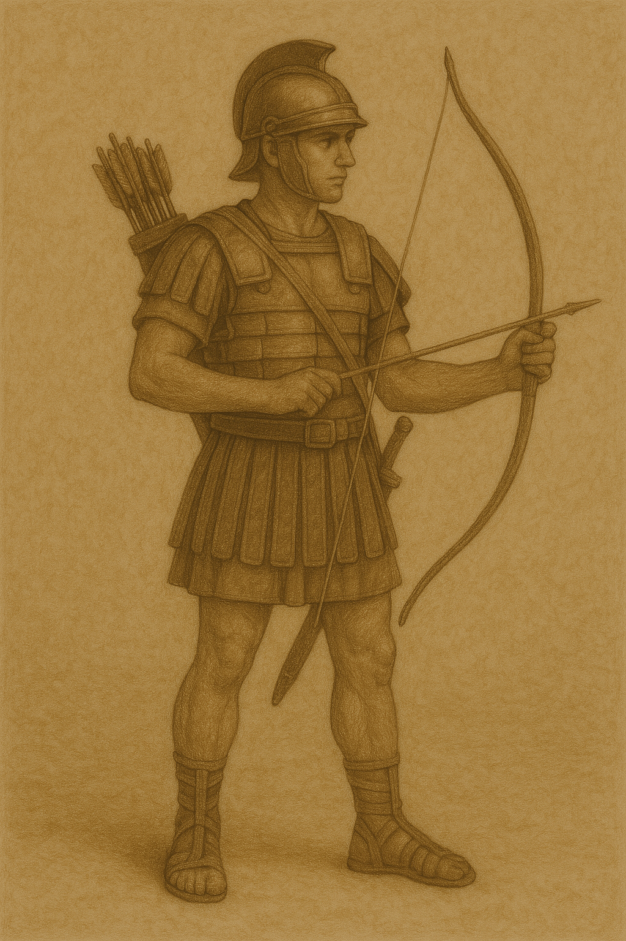

Usage:
Bowman bending his bow with his knee while the second man strings it (upper), and Egyptian soldiers stringing bows (lower) (© Deutsche Bibelgesellschaft, Stuttgart by United Bible Societies)The archer gripped the center of the wooden part of the bow in one hand and placed the notch that was cut into the back end of an arrow on the string. With the fingers of his other hand he gripped the string and the arrow and pulled back the arrow. When he released the arrow, it flew forward toward the target. In battle the object was to wound the enemy with the sharp point of the arrow. This weapon allowed the soldier to attack the enemy without coming into physical contact with him.
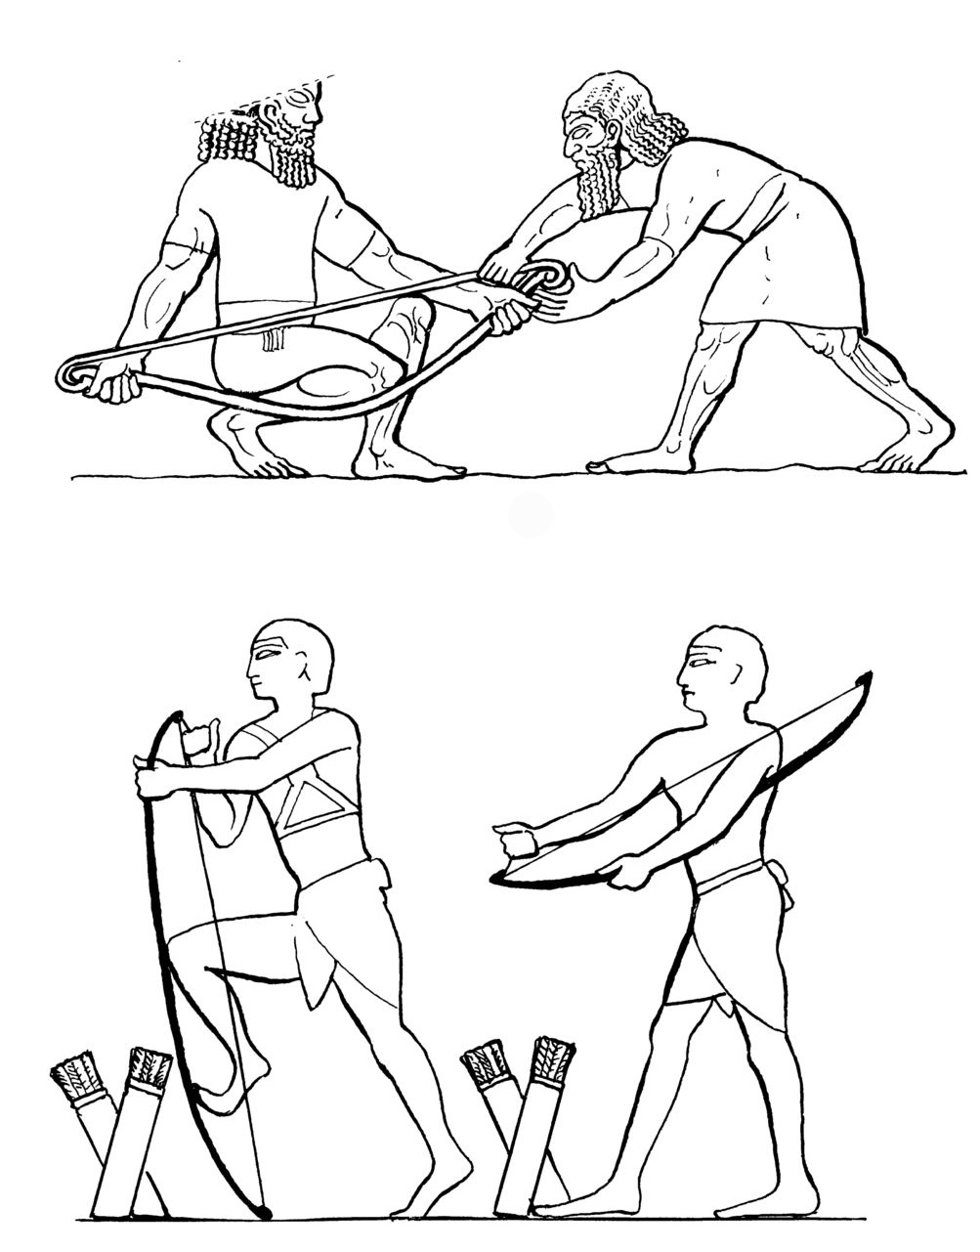

Translation:
Where bows and arrows are unknown, it may be necessary to say “weapon” or “weapon that shoots darts [or, missiles],” without specifying what kind of weapon it is, while carefully avoiding the implication that it is a gun that uses gunpowder and shoots bullets. The weapon should be recognized as useful in battle and operated by one person.
The phrase “bend the bow,” which occurs frequently (2SA 22:35; PSA 7:13; PSA 11:2; PSA 18:35; PSA 37:14; ISA 5:28; ISA 21:15; JER 9:2; JER 46:9; JER 50:14; JER 50:29; JER 51:3; LAM 2:4; LAM 3:12; ZEC 9:13), often does not refer to the drawing of the bowstring in order to shoot but rather to the method of bending the unstrung bow enough to slip the bowstring in place on the end of the bow. Composite bows in particular were very stiff and difficult to string. The underlying idea is preparing the bow for combat. Possible renderings for “bend the bow” are “string the bow” and “prepare the bow for use.” In JER 51:3 a NCV has “Don’t let the Babylonian soldiers prepare their bows to shoot.”
In some passages the word “bow” symbolizes warfare. See the discussion on JOS 24:12 at 2.3 Sword<REALIA:2.3>.
2SA 22:35; JOB 20:24; PSA 18:35: In JOB 20:24 a RSV says “a bronze arrow will strike him through.” “Bronze arrow” is literally “bow of bronze” in Hebrew. However, bows were not made of bronze, and a bronze bow would not shoot an arrow. The poet attributes to the bow the effect that is produced by the arrow. RSV has shifted to “bronze arrow,” but GNT has kept “bronze bow.” FRCL translates “bronze point,” that is, “bronze arrowhead.” This line may need to be adjusted to say “an arrow with a bronze point will hit him” or “an enemy will shoot an arrow with a bronze point into him.” If “bronze” is unknown, the translator may say “iron” or “metal.” De Vaux suggests that “bronze bow” indicates a kind of metal covering, which was used to strengthen some wooden bows. So “bronze bow” may be rendered “strongest bow” (GNT in 2SA 22:35 and PSA 18:35).
JER 9:2: RSV renders the first line of this verse as “They bend their tongue like a bow,” which will be obscure in many languages. CEV understands the bent bow to be the actual shooting of the arrows, so it restructures the first half of this verse, saying “Lies come from the mouths of my people, like arrows from a bow.” GNT understands the bent bow to indicate readiness for use but avoids the simile with “They are always ready to tell lies.”

Arrow

2.14.2 Arrow

References:Hebrew בֵּן, אַשְׁפָּה (ben ’ashpah)LAM 3:13Hebrew בֵּן, קֶשֶׁת (ben qesheth)JOB 41:20Hebrew חֵץ, חֵץִי (chets, chetsi)GEN 49:23, NUM 24:8, DEU 32:23, DEU 32:42, 1SA 17:7, 1SA 20:20, 1SA 20:21, 1SA 20:21, 1SA 20:22, 1SA 20:36, 1SA 20:36, 1SA 20:37, 1SA 20:37, 1SA 20:38, 2SA 22:15, 2KI 9:24, 2KI 13:15, 2KI 13:15, 2KI 13:17, 2KI 13:17, 2KI 13:18, 2KI 19:32, 1CH 12:2, 2CH 26:15, JOB 6:4, JOB 34:6, PSA 7:14, PSA 11:2, PSA 18:15, PSA 38:3, PSA 45:6, PSA 57:5, PSA 58:8, PSA 58:8, PSA 64:4, PSA 64:8, PSA 77:18, PSA 91:5, PSA 120:4, PSA 127:4, PSA 144:6, PRO 7:23, PRO 25:18, PRO 26:18, ISA 5:28, ISA 7:24, ISA 37:33, ISA 49:2, JER 9:7, JER 50:9, JER 50:14, JER 51:11, LAM 3:12, EZK 5:16, EZK 21:26, EZK 39:3, EZK 39:9, HAB 3:11, ZEC 9:14Hebrew מַטֶּה (mateh)HAB 3:9, HAB 3:14Hebrew רֶשֶׁף (reshef)PSA 76:4Greek βέλος (belos)EPH 6:16, WIS 5:12, SIR 19:12, SIR 26:12, 1MA 6:51, 2MA 5:3, 2MA 12:27, ODA 2:23, ODA 2:42Greek σχίζα (schiza)1MA 10:80Greek τόξευμα (toxeuma)2MA 10:30Latin sagitta2ES 16:7, 2ES 16:13, 2ES 16:16

Description:
Arrow (© Deutsche Bibelgesellschaft, Stuttgart by United Bible Societies)The arrow was a thin, straight rod made of reed or wood, about 50–70 centimeters (20–28 inches) in length. To one end of the arrow was attached a sharpened point, either of stone or metal. In the other end a notch was carved to fit on the string of the bow. The notched end was sometimes fitted with two or more feathers that helped stabilize the arrow in flight.

Usage:
See 2.14.1 Bow<REALIA:2.14.1>.

Translation:
The Hebrew word reshef normally refers to something fiery (for example, spark or lightning bolt; see JOB 5:7; PSA 78:48; SNG 8:6). In PSA 76:4 it is parallel with the word for “bow” and probably indicates some kind of burning arrow.
LAM 3:13: See the comments at 2.14.3 Quiver<REALIA:2.14.3>.
The Hebrew word mateh usually refers to a rod, club, or shepherd’s staff (see 1.2.4 Rod, club, shepherd’s staff<REALIA:1.2.4>), but in HAB 3:9 many translations render it “arrows” (RSV, GNT; supported by HOTTP and A Handbook on The Books of Nahum, Habakkuk, and Zephaniah). This verse is very unclear in Hebrew.

Quiver

2.14.3 Quiver

References:Hebrew אַשְׁפָּה (’ashpah)JOB 39:23, PSA 127:5, ISA 22:6, ISA 49:2, JER 5:16, LAM 3:13Hebrew תְּלִי (tli)GEN 27:3Greek φαρέτρα (faretra)SIR 26:12

Description and usage:
Bow with a quiver for holding the arrows (Image generated by ChatGPT using OpenAI technology)The quiver was a cylindrical leather container, closed on one end, for holding arrows. It was slightly shorter than the arrows it held. It was strapped to the back of the archer so that both hands were free to use the bow. It was large enough to hold 20–30 arrows.
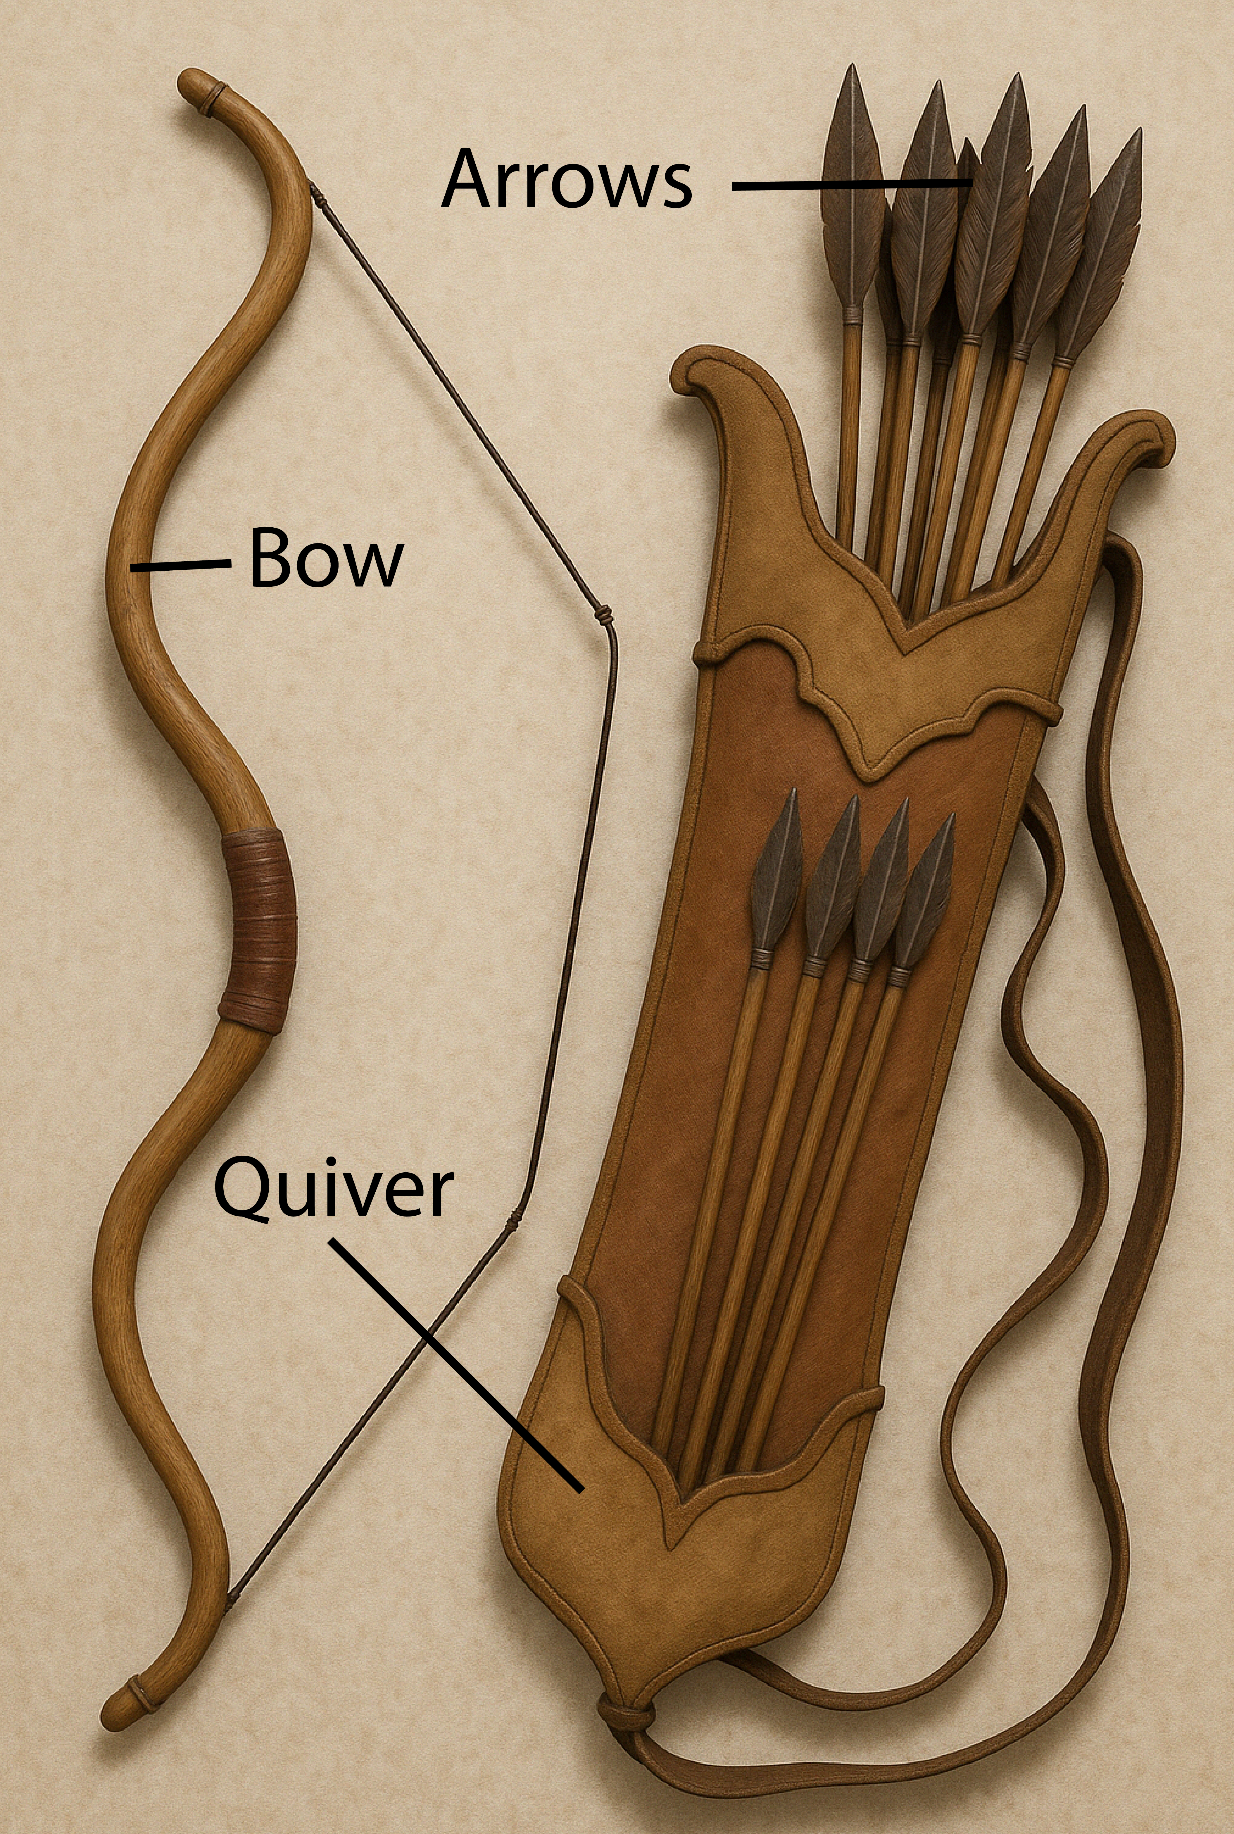

Translation:
“Quiver” may be rendered “container holding the arrows” or “arrow box.”
The following is adapted from A Handbook on Lamentations (page 81) on LAM 3:13: The Hebrew phrase bene ’ashpah (literally “sons of the quiver”) refers to arrows. The quiver as the container for the arrows is not central to the description of God’s attack here, and translators handle this expression in various ways; for example, GNT omits the word “quiver” as unnecessary when speaking of the action of “his arrows” (similarly FRCL “all his arrows” and GECL “Arrow after arrow”). However, translators who are translating into poetry may need to retain the word “quiver” by rendering the whole verse as follows: “His quiver gave [or, produced] arrows that he shot into my heart.”
In SIR 26:12 “quiver” is used in a euphemism for the female genitalia. The last half of this verse is literally “she will sit in front of every tent peg and open her quiver to the arrow” (NRSV). GNT says “She’ll spread her legs anywhere for any man who wants her.” Some translators may consider GNT ’s English euphemism to be too explicit. If possible, translators should look for an expression that indicates that the woman in the verse is promiscuous without being more explicit than the intended audience can tolerate. One possibility is “she is ready to have sex with anyone who comes along.” Where a suitable euphemism cannot be found, it may be necessary to keep a literal rendering and explain in a footnote that the imagery of the quiver and arrow is intended to portray sexual promiscuity.

