Resource: Human-made Things in the Bible
Human-made Things in the Bible © United Bible Societies, 2025. Adapted from: The Works of Their Hands: Man-made Things in the Bible, by Ray Pritz © 2009 United Bible Societies. This work is licensed under Creative Commons Attribution-ShareAlike 4.0 International (https://creativecommons.org/licenses/by-sa/4.0/).

Human-made Things in the Bible

Tent

3.2 Tent

References:Hebrew אהל (’ahal (verb))GEN 13:12, GEN 13:18, ISA 13:20Hebrew אֹהֶל (’ohel)GEN 4:20, GEN 9:21, GEN 9:27, GEN 12:8, GEN 13:3, GEN 13:5, GEN 18:1, GEN 18:2, GEN 18:6, GEN 18:9, GEN 18:10, GEN 24:67, GEN 25:27, GEN 26:25, GEN 31:25, GEN 31:33, GEN 31:33, GEN 31:33, GEN 31:33, GEN 31:33, GEN 31:34, GEN 33:19, GEN 35:21, EXO 18:7, LEV 14:8, NUM 11:10, NUM 16:26, NUM 16:27, NUM 19:14, NUM 19:14, NUM 19:14, NUM 19:18, NUM 24:5, DEU 1:27, DEU 5:30, DEU 11:6, DEU 16:7, JOS 3:14, JOS 7:21, JOS 7:22, JOS 7:22, JOS 7:23, JOS 7:24, JDG 4:11, JDG 4:17, JDG 4:18, JDG 4:20, JDG 4:21, JDG 5:24, JDG 6:5, JDG 7:13, JDG 7:13, JDG 8:11, 1SA 17:54, 2SA 6:17, 2SA 7:6, 2SA 16:22, 1KI 1:39, 2KI 7:7, 2KI 7:8, 2KI 7:8, 2KI 7:10, 1CH 4:41, 1CH 5:10, 1CH 15:1, 1CH 16:1, 1CH 17:5, 1CH 17:5, 2CH 1:4, 2CH 14:14, PSA 69:26, PSA 106:25, PSA 118:15, SNG 1:5, ISA 38:12, ISA 40:22, ISA 54:2, JER 6:3, JER 10:20, JER 10:20, JER 35:7, JER 35:10, JER 37:10, JER 49:29, LAM 2:4, DAN 11:45, HOS 12:10, HAB 3:7Hebrew מִשְׁכָּן (mishkan)NUM 24:5, PSA 78:28, SNG 1:8, ISA 54:2, JER 30:18, EZK 25:4Hebrew סֻכָּה (sukah)2SA 11:11, 1KI 20:12, 1KI 20:16Hebrew קֻבָּה (qubah)NUM 25:8Greek αὐλή (aulē)2MA 13:15Greek προσκήνιον (proskēnion)JDT 10:22Greek σκηνή (skēnē)HEB 11:9, JDT 3:3, JDT 5:22, JDT 6:10Greek σκῆνος (skēnos)2CO 5:1, 2CO 5:4, WIS 9:15Greek σκήνωμα (skēnōma)2PE 1:13, 2PE 1:14, JDT 2:26, JDT 9:8, JDT 10:18, JDT 14:7, JDT 15:1, 1MA 9:66, 2MA 10:6, 1ES 1:48, ODA 4:7Greek σκηνοποιός (skēnopoios (“tentmaker”))ACT 18:3

Description:
A bedouin tent in the Syrian desert (© yeowatzup, CC BY 2.0, via Wikimedia Commons)The tent was a portable dwelling of cloth and/or skins, held up by poles and secured to the ground by cords tied to stakes. Tents were normally made of cloth woven from the hair of goats.
<image: 9k=>

Usage:
Tents served as the regular dwelling of nomadic peoples. They could also be used as temporary shelter by soldiers in the field or perhaps by people moving from one permanent house to another.

Translation:
Nomad's tent (© Deutsche Bibelgesellschaft, Stuttgart by United Bible Societies)In a number of languages “tent” is rendered “house made of cloth.” Translators should avoid terms that would imply a temporary shelter used only on vacations or holidays. In Old Testament times such tents were permanent dwellings of nomadic groups and were moved from place to place as livestock were transferred from one pasture area to another.
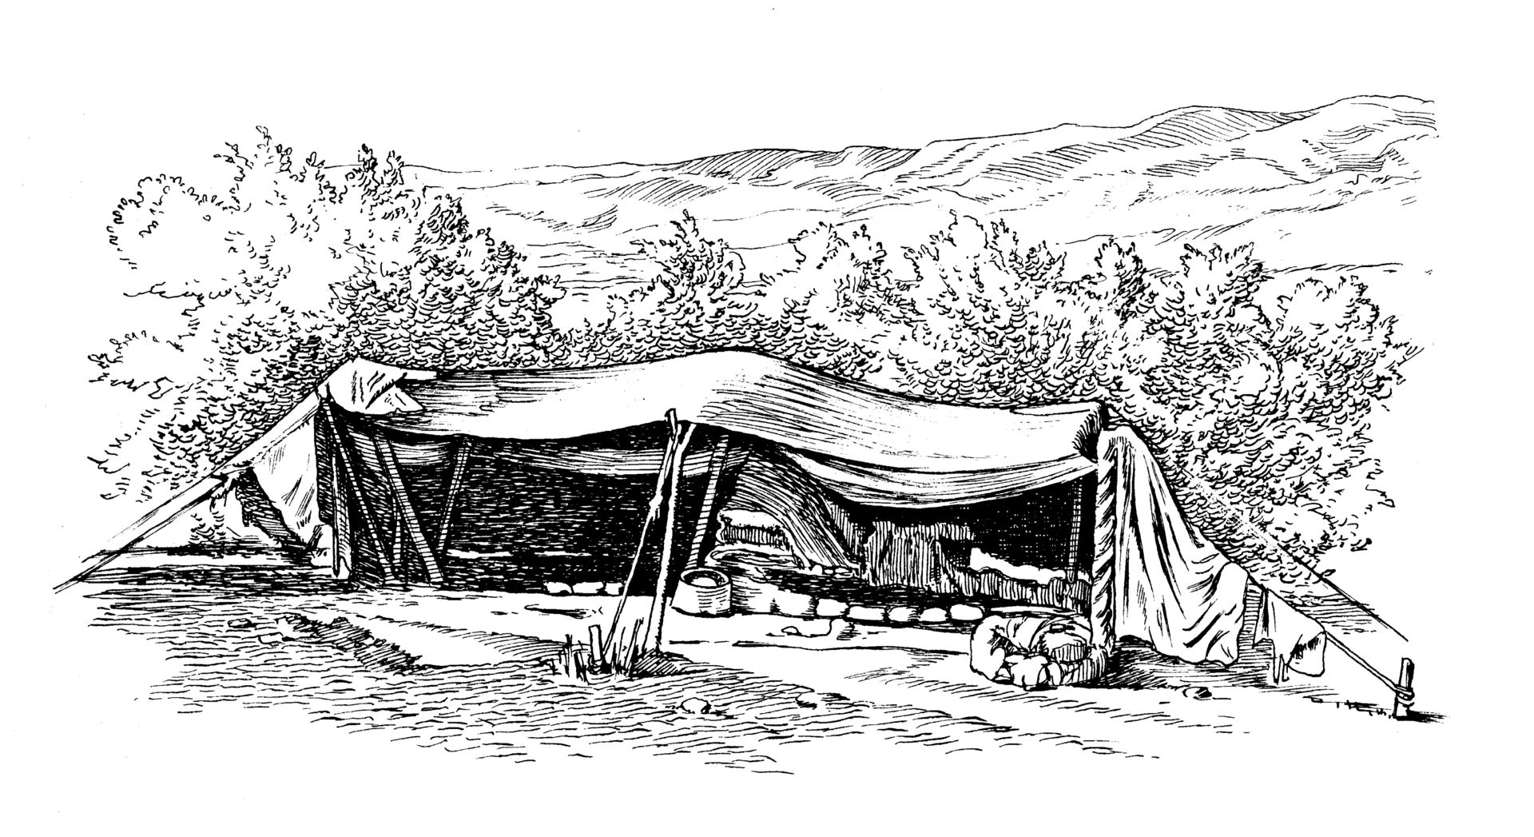
The Hebrew verb ’ahal means “to pitch a tent” (NIV), “to move a tent” (RSV, NASB), “to encamp, camp, set up camp” (GNT, TOB).
The word ’ohel serves in Hebrew to describe both dwellings used by nomads and tents used by soldiers on military campaigns (see also 3.15 Tent of Meeting and Tabernacle<REALIA:3.15>). Where a language distinguishes between the two, the context should be checked carefully. The following passages seem to refer to military tents: JDG 7:13; 1SA 17:54; 2KI 7:7; 2KI 7:8; 2KI 7:9; 2KI 7:10. It has also been suggested that, in ACT 18:3 Paul, Aquila and Priscilla made tents for military use, although the Greek word traditionally translated “tentmaker” more properly means “leather worker.”
It should be kept in mind that in Israel’s earlier history, many people lived in tents. The phrase “went to his tent” or “fled to their tents” often means simply “went home”; for example, 2KI 14:12 is literally “every man fled to his tent,” but, because the context tells us that they lived in houses, RSV says “every man fled to his home.”
The Hebrew word mishkan means “dwelling place” and is used most often for the Tabernacle in the wilderness (see 3.15.2 Tabernacle<REALIA:3.15.2>). In the passages listed above it refers specifically to a tent for people to live in (either as nomads or as soldiers). In NUM 24:5; ISA 54:2; and JER 30:18mishkan appears in poetic parallelism with a word for “tent.” In these places it will be best to use a general word meaning “dwelling place,” “residence.”
The meaning of the Hebrew word qubah in NUM 25:8 is uncertain. Many translations understand it to be a tent, perhaps with a high dome (GNT, NIV, KJV, NASB), while others take it to be a partition or room in a tent (RSV, NEB). Some translations (TOB, SPCL) believe it is a bedroom, but they give a footnote describing it to be a special tent dedicated to pagan religious rites, such as prostitution or divination. There seems no way to be certain which understanding is correct, so the translator will just need to choose one of them.
2MA 13:15: Originally the Greek word aulē referred to a courtyard and later to the court of a king. The context of this verse speaks of the part of the encampment where the king was located, so GNT says “the area near the king’s tent.” Most others have “the king’s pavilion” (RSV). At best the word “pavilion” will be obscure; at worst (in British English, for example) it could be misunderstood. Translators should follow GNT or say something like “the camp where Antiochus’ headquarters were located” (ITCL).
The Greek word proskēnion in JDT 10:22 refers to an area just inside the entrance to a tent. GNT renders it “outer part of the tent,” NJB has “entrance to the tent,” and NAB says “antechamber.”

Door of tent, dividing curtain

3.2.1 Door of tent, dividing curtain

References:Hebrew דֹּק (doq)ISA 40:22Hebrew יְרִיעָה (yri‘ah)PSA 104:2, SNG 1:5, ISA 54:2, JER 4:20, JER 10:20, JER 49:29, HAB 3:7Greek αὐλαία (aulaia)JDT 14:14

Description and usage:
Curtains divided different parts of a large tent.

Translation:
The Hebrew word yri‘ah is first used for the cloth strips that covered the Tabernacle (see 3.15.2.3.6.1 Linen cloth strips<REALIA:3.15.2.3.6.1>). In most of the passages listed above this word appears in parallelism with a word meaning “tent,” and for that reason it sometimes seems to be a metonym for tent (compare “the ark of God dwells in the yri‘ah ” in 2SA 7:2 with “the ark of the covenant of the LORD is under a yri‘ah ” in 1CH 17:1). In PSA 104:2 the visual imagery “stretched out the heavens like a yri‘ah ” comes from the curtains in the Tabernacle stretched out above the ark.
JDT 14:14 says “Bagoas went in and knocked at the door of the tent” (RSV). This will sound as strange in some languages as it does in English. NAB and NRSV try to solve the problem by changing “door” (aulaia in Greek) to “entry.” GNT goes even farther by rendering “Bagoas went in and clapped his hands in front of the sleeping quarters of the tent.” NJB is closer to the literal meaning of aulaia, saying “Bagoas went inside and struck the curtain dividing the tent.” The point of the story is that Bagoas thought Holofernes was in bed with Judith and made noise so as not to surprise them in an indecent position.

Tent peg, stake

3.2.2 Tent peg, stake

References:Hebrew יָתֵד (yathed)EXO 27:19, EXO 27:19, EXO 35:18, EXO 35:18, EXO 38:20, EXO 38:31, EXO 38:31, EXO 39:40, NUM 3:37, NUM 4:32, JDG 4:21, JDG 4:21, JDG 4:22, JDG 5:26, EZR 9:8, ISA 33:20, ISA 54:2, ZEC 10:4Greek πάσσαλος (passalos)SIR 14:24, SIR 26:12, SIR 27:2

Description and usage:
Peg, loop in rope (Source unknown)The tent peg was a shortened stick, pointed on one end. It was driven into the ground, and tent ropes were tied to it to anchor the tent in place. See the illustrations at 3.2 Tent<REALIA:3.2>.
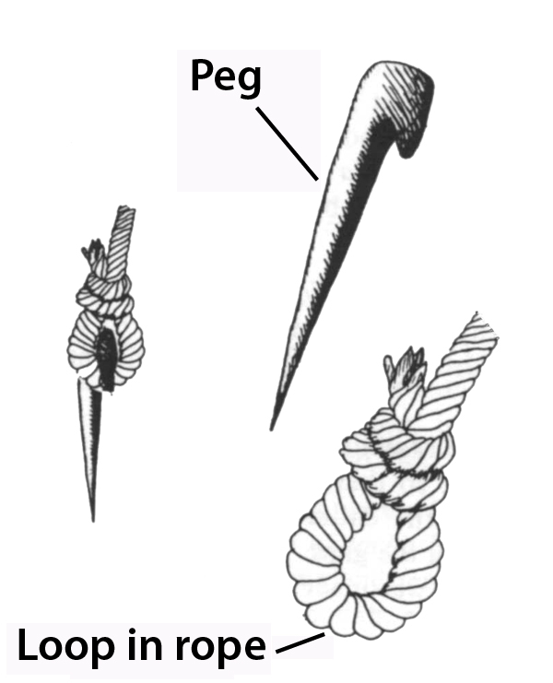

Translation:
The stakes of the Tabernacle, mentioned in Exodus and Numbers, were made of bronze. They were used to anchor the various coverings of the Tabernacle (see 3.15.2.3.6 Coverings<REALIA:3.15.2.3.6>) and also some of the standing posts (see 3.15.2.3.3 Upright beam, tenon, crosspiece, rung<REALIA:3.15.2.3.3>).
The tent stake provided security. It guaranteed that the tent would not fall nor be blown out of its place by winds. Thus it is sometimes a symbol of stability and security. This element of security may be reflected in translation in EZR 9:8 and ISA 33:20; for example, in EZR 9:8 the literal clause “to give us a tent peg within the place of his holiness” is rendered by RSV as “to give us a secure hold within his holy place,” and GNT has “live in safety in this holy place.”
Tent pegs (Don Ellens, The Tabernacle of Israel, Harris, Jones 1888, Public domain)or another sense of the Hebrew word yathed in JDG 16:14, see 1.5.3.5 Beater, batten, pin<REALIA:1.5.3.5>.
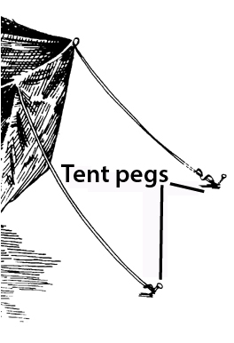
SIR 14:24: The Greek word passalos refers to a tent peg. The Hebrew version of Sirach has a word that, with a very slight emendation of part of one letter, could mean “tent cords” or “tent pegs.” With either reading, the basic meaning remains the same and is expressed well by GNT: “Camp as close to her house as you can get.” If translators wish to maintain the image of the tent and the house, they may say “he attaches his tent to the wall of her house.”

