Resource: Human-made Things in the Bible
Human-made Things in the Bible © United Bible Societies, 2025. Adapted from: The Works of Their Hands: Man-made Things in the Bible, by Ray Pritz © 2009 United Bible Societies. This work is licensed under Creative Commons Attribution-ShareAlike 4.0 International (https://creativecommons.org/licenses/by-sa/4.0/).

Human-made Things in the Bible

Boundary wall, fence

3.6 Boundary wall, fence

References:Hebrew גְּבוּל (gvul)EZK 40:12, EZK 40:12, EZK 43:13, EZK 43:17, EZK 43:20Hebrew גדר, גָּדֵר, גֶּדֶר, גְּדֵרָה, גְּדֶרֶת (gadar (verb), gader, geder, gderah, gdereth)NUM 22:24, NUM 22:24, EZR 9:9, JOB 19:8, PSA 62:4, PSA 80:13, PSA 89:41, PRO 24:31, ECC 10:8, ISA 5:5, JER 49:3, LAM 3:7, LAM 3:9, EZK 13:5, EZK 13:5, EZK 22:30, EZK 22:30, EZK 42:7, EZK 42:10, EZK 42:12, HOS 2:8, HOS 2:8, MIC 7:11, NAM 3:17Hebrew חוֹמָה (chomah)LAM 2:7, EZK 40:5, EZK 42:20Hebrew חַיִץ (chayits)EZK 13:10Hebrew מְסוּכָה, מְשֻׂכָה, מְשׂוּכָּה (msukah)PRO 15:19, ISA 5:5, MIC 7:4Hebrew קִיר (qir)PSA 62:4Hebrew שׂוך (suk (verb))JOB 1:10, HOS 2:8Hebrew שׁוּר, שׁוּרָה (shur, shurah)GEN 49:22, JOB 24:11Greek ἀνάλημμα (analēmma)SIR 50:2Greek μεσότοιχον (mesotoichon)EPH 2:14Greek τεῖχος (teichos)1MA 4:60, 1MA 6:7, 1MA 6:62, 1MA 9:54Greek τοῖχος (toichos)ACT 23:3, TOB 2:9, TOB 2:10, WIS 13:15, SIR 14:24, SIR 22:17, SIR 23:18, 1ES 6:8, ODA 10:5Greek φραγμός (fragmos)MAT 21:33, MRK 12:1, LUK 14:23, EPH 2:14, SIR 36:25

Description and usage:
Stone fences (© بدارين, CC BY-SA 4.0, via Wikimedia Commons)The fence was a structure for enclosing an area. Fences in the land of Israel were most often made of stone, less often (and only as a temporary structure) of sticks and brush.
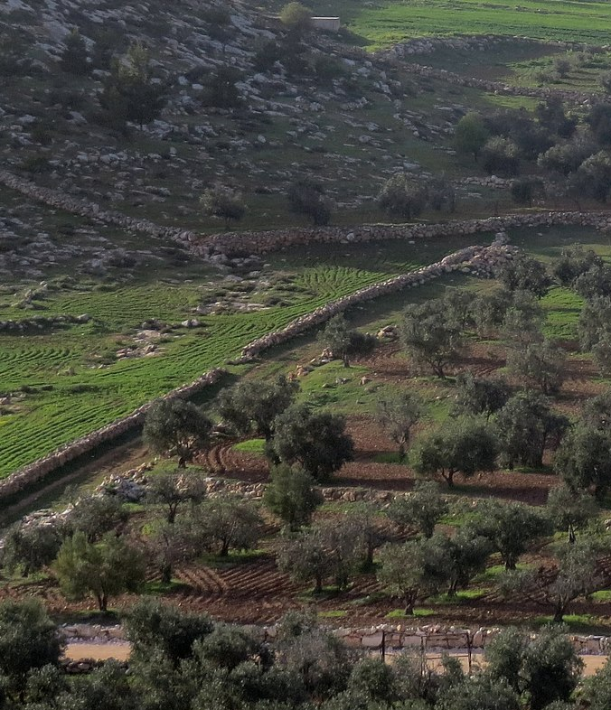

Translation:
In many societies there is some type of fence, wall, or barrier employed to surround fields. In some instances the fence may consist of piled up logs or sticks; in other instances it may be made of packed dirt or of laid-up stone. What is important, however, is not the form of the “fence,” but its function, and therefore translators may often use a descriptive expression, for example, “barrier to surround a field” or “barrier to keep animals out of the field.” Because stone was such a common material in the land of Israel, fences were usually made of loose stones. In many cultures such stone structures are called “walls,” not “fences.”
The Hebrew word gvul, which normally means “boundary” (see 3.7 Boundary marker<REALIA:3.7>), is used in several places in Ezekiel with a somewhat different meaning. In EZK 40:12 it seems to refer to a “low wall” (GNT), “railing” (CEV), or simply “barrier[s]” (RSV, NJPSV). In EZK 43:13; EZK 43:17; EZK 43:20 the word describes a kind of “rim” (RSV, NIV) around the base and different levels of the altar.
Some languages distinguish between the outer wall of a building and the inner walls that separate rooms. The Hebrew word chomah normally indicates an outer wall, specifically of a city (see 3.13.3.1 City wall, rampart, battlement<REALIA:3.13.3.1>). The references listed above are exceptional. The other Hebrew words can be used for both inner and outer walls, and the translator must decide the correct meaning from the context. The Greek word toichos refers to an inner wall. In translation the outer wall of a house may be called “side of a house,” and an inner wall may be referred to as “partition in a house.”
EZK 13:10: In this verse the Hebrew word chayits indicates a “divider,” a wall that is temporary and not very substantial. Translations attempt to indicate this by the addition of a modifier, such as “shaky” (CEV), “flimsy” (NIV, Living Bible [LB]), “weak” (NCV), “unstable” (SPCL), or “of loose stones” (GNT, GECL).
The Hebrew words shur and shurah have been understood in various ways. They literally mean “row.” This could mean a row of stones, so a wall or a fence. In GEN 49:22 most translations have “wall” (RSV, CEV, FRCL). However, in JOB 24:11RSV renders shurah as “olive rows.” As pointed out by A Handbook on The Book of Job, this not likely to be the meaning of the text. Olive trees in the Middle East are very often grown on specially prepared terraces. The terraces themselves are supported by retaining walls, which could be the meaning of shurah here. NRSV has abandoned the RSV rendering with “terraces” (also NIV). GECL says “garden,” and NASB has “walls.” GNT and CEV choose not to translate the word.
In EPH 2:14 the Greek words mesotoichon and fragmos are used figuratively of the Law, which constituted a barrier between Jews and Gentiles, “the wall of separation” (RSV). Here these words may be rendered “the wall to keep apart” or “the wall to divide.”

