Resource: Human-made Things in the Bible
Human-made Things in the Bible © United Bible Societies, 2025. Adapted from: The Works of Their Hands: Man-made Things in the Bible, by Ray Pritz © 2009 United Bible Societies. This work is licensed under Creative Commons Attribution-ShareAlike 4.0 International (https://creativecommons.org/licenses/by-sa/4.0/).

Human-made Things in the Bible

Oven

5.11 Oven

References:Hebrew תַּנּוּר (tanur)GEN 15:17, EXO 7:28, LEV 2:4, LEV 7:9, LEV 11:35, LEV 26:26, NEH 3:11, NEH 12:38, PSA 21:10, ISA 31:9, LAM 5:10, HOS 7:4, HOS 7:6, HOS 7:7, MAL 3:19Greek κλίβανος (klibanos)MAT 6:30, LUK 12:28

Description:
The oven was an implement for cooking food. Ovens were made of hardened clay or brick. They could vary in size and shape. An oven in an average home was roughly 50 centimeters (20 inches) in diameter. In the winter the oven could also serve the purpose of heating a small house. See also 1.11.1 Smelting furnace, kiln<REALIA:1.11.1>.
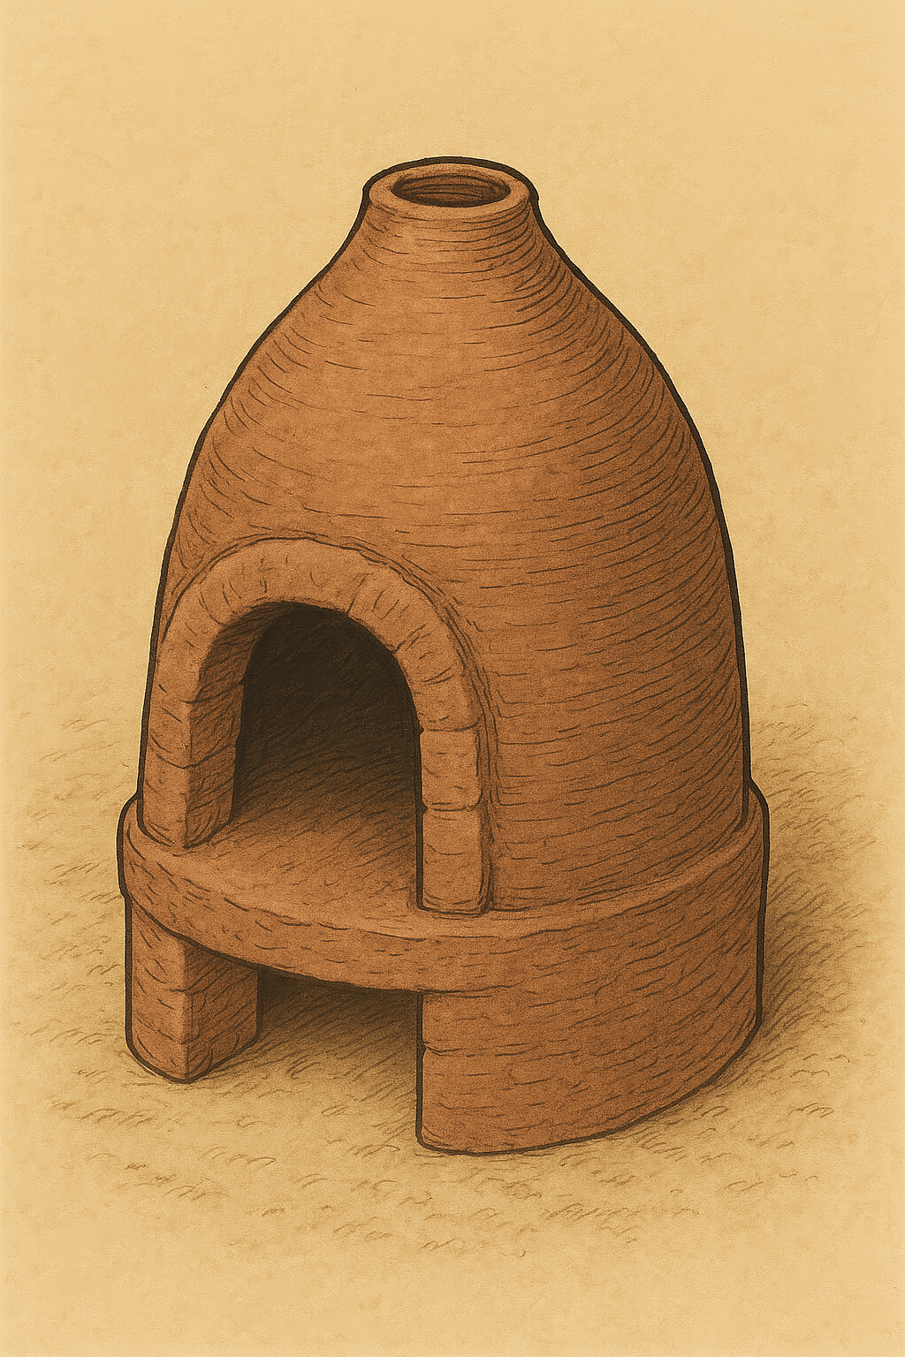

Translation:
All cultures know of devices for cooking food. The word “oven” may be rendered “place heated for baking bread” or “place for heating food.” It may be useful in some instances to employ a more extensive description in a glossary. However, this is rarely necessary since the function of an oven is far more important than its form. The difference between an oven and a smelting furnace (see 1.11.1 Smelting furnace, kiln<REALIA:1.11.1>) is primarily one of size rather than of basic design.
The Hebrew word tanur in GEN 15:17 seems to refer to a portable stove or fire pot, a kind of round earthenware bowl holding coals.
MAT 6:30; LUK 12:28: The point of the illustration in these verses is that God will take care of his people even more than he takes care of something like wild grass, which only serves as fuel for burning. So it is possible to omit mention of the instrument in which the grass is burned; for example, instead of “thrown into the oven” (RSV), NIV says “thrown into the fire,” and GECL has “burned up.” Such a translation will be especially appropriate for cultures where grass is not burned in an oven. The above comments should be considered also when translating MAL 3:19.

