Resource: Human-made Things in the Bible
Human-made Things in the Bible © United Bible Societies, 2025. Adapted from: The Works of Their Hands: Man-made Things in the Bible, by Ray Pritz © 2009 United Bible Societies. This work is licensed under Creative Commons Attribution-ShareAlike 4.0 International (https://creativecommons.org/licenses/by-sa/4.0/).

Human-made Things in the Bible

Other household items

5.21 Other household items

Needle

5.21.1 Needle

References:Greek βελόνη (belonē)LUK 18:25Greek ῥαφίς (rhafis)MAT 19:24, MRK 10:25

Description and usage:
Roman needles (National Museums Liverpool) (© Portable Antiquities Scheme, CC BY-SA 4.0, via Wikimedia Commons)The needle was a small, slender, and very smooth instrument, pointed on one end and with a hole at the other end. It was used to aid in passing thread through cloth in sewing. It could be made of metal, bone, or even a strong thorn.
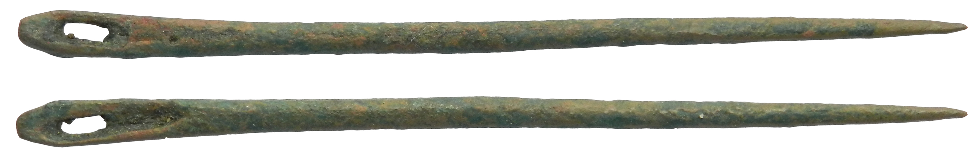

Translation:
There is no convincing evidence that the literal expression “eye of a needle” in MAT 19:24; MRK 10:25 and LUK 18:25 is a figurative name for a narrow gate. The reference to a camel passing through the eye of a needle is an example of rhetorical hyperbole. Here it is a purposeful exaggeration to point out the extreme difficulty of the event to which it is compared. It seems that Jesus chose the largest land animal known in Israel and the smallest man-made opening to express this difficulty. The hole in a needle is referred to differently in various languages, for example, “nostril of a needle,” “ear of a needle,” “mouth of a needle,” and even “anus of a needle.”

Broom

5.21.2 Broom

Reference:Hebrew מַטְאֲטֵא (mat’ate’)ISA 14:23

Description and usage:
(Image generated by ChatGPT using OpenAI technology)The broom was a longer or shorter stick to one end of which was attached some flexible material such as small branches. The broom was used to sweep dirt from the floor.
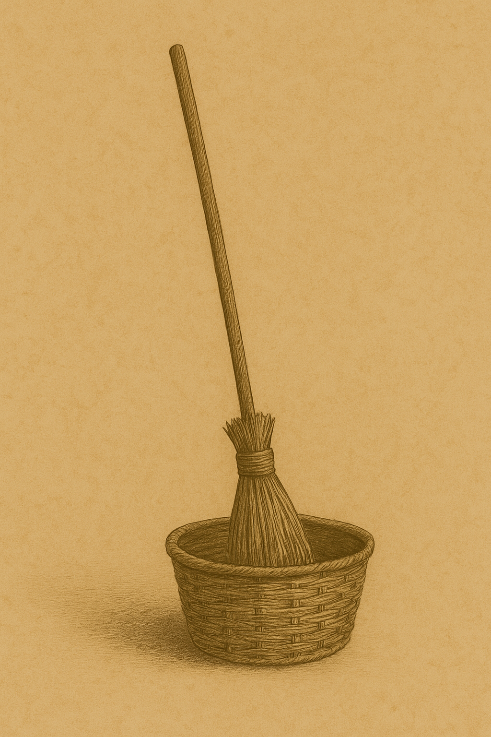

Translation:
The Hebrew word mat’ate’ appears only in ISA 14:23, although it is known from extra-biblical literature. In the Isaiah reference it is an instrument of destruction and judgment, and most translations render literally “broom of destruction” (RSV, NIV). Where an equivalent implement is not known, or where a destructive broom might seem too strange, translators may follow CEV, which renders the last half of the verse as “The LORD will sweep out the people.”

Peg (on a wall)

5.21.3 Peg (on a wall)

References:Hebrew יָתֵד (yathed)ISA 22:23, ISA 22:25, EZK 15:3

Description:
The peg was a short wooden stick, pointed on one end. It was pounded into a crack between stones that formed the wall of a house. It then served as a place to hang objects.

Translation:
In ISA 22:23; ISA 22:25 the wall peg is a symbol of stability. See the discussion at 3.2.2 Tent peg, stake<REALIA:3.2.2>.

Birthstool

5.21.4 Birthstool

Reference:Hebrew אָבְנַיִם (’ovnayim)EXO 1:16

Description and usage:
The birthstool was a special seat, perhaps made of two stones side by side with a space between them, on which a woman sat to give birth.

Translation:
The Hebrew word ’ovnayim literally means “pair of stones” or “double stone.” Lexicographers and commentators differ concerning its meaning in EXO 1:16. In JER 18:3 the same word refers to the potter’s wheel (see 1.5.1.1 Potter’s wheel<REALIA:1.5.1.1>). The dictionaries offer two probable meanings: (1) it may be a euphemism to refer to the genitals, so the second clause in EXO 1:16 may be rendered “you will look to see if the baby is a boy”); or (2) it may designate a birthstool because of a certain resemblance to the potter’s bench, so the same clause may be rendered “you will watch as they give birth.” The context allows either interpretation.
It is not necessary to give a literal translation; for the first half of this verse, compare GNT “When you help the Hebrew women give birth.” Where such a stool or chair is known, of course, it may be used here. NIV has “When you help the Hebrew women in childbirth and observe them on the delivery stool.” here. NIV has “When you help the Hebrew women in childbirth and observe them on the delivery stool.”

