Resource: Human-made Things in the Bible
Human-made Things in the Bible © United Bible Societies, 2025. Adapted from: The Works of Their Hands: Man-made Things in the Bible, by Ray Pritz © 2009 United Bible Societies. This work is licensed under Creative Commons Attribution-ShareAlike 4.0 International (https://creativecommons.org/licenses/by-sa/4.0/).

Human-made Things in the Bible

Apron

6.10 Apron

Reference:Greek σιμικίνθιον (simikinthion)ACT 19:12

Description and usage:
Leather apron (© MikiNikoloski, CC BY-SA 3.0, via Wikimedia Commons)The apron was a cloth or piece of leather wrapped by a workman around his waist or chest to protect his clothes.
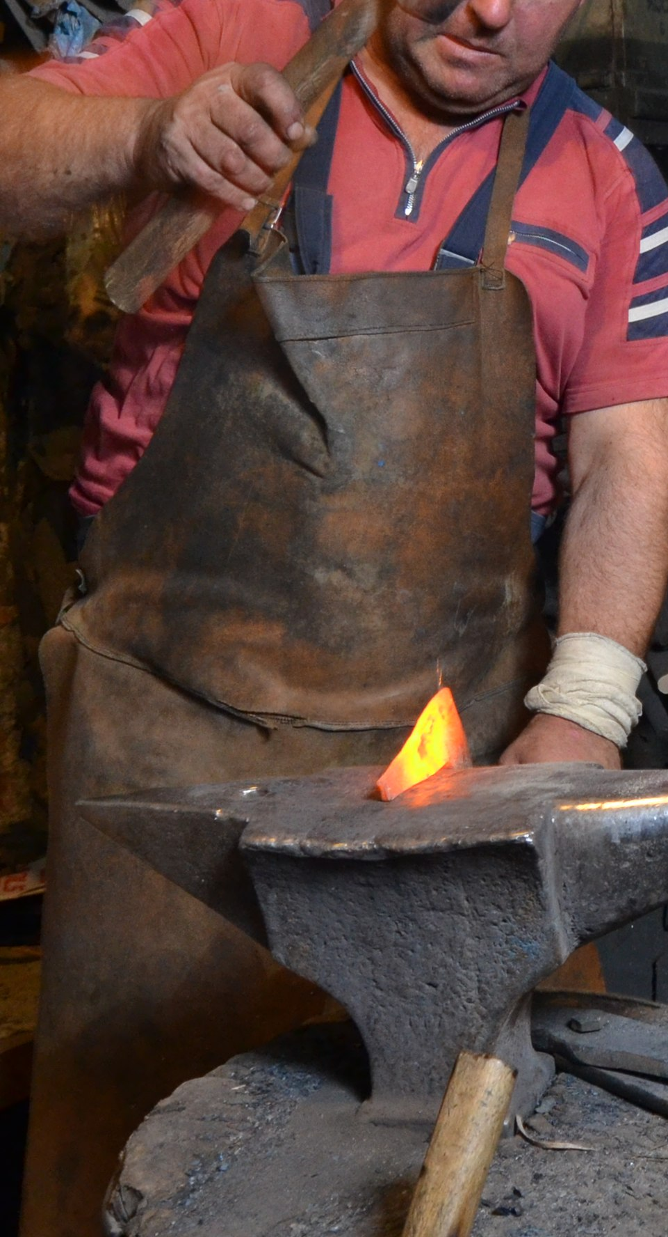

Translation:
In some languages “apron” may be rendered “workman’s cloth” or “work­man’s cloth to protect clothing.”
For the meaning of “ephod” as a kind of work apron, see 4.5.4 Ephod<REALIA:4.5.4>.

