Resource: Human-made Things in the Bible
Human-made Things in the Bible © United Bible Societies, 2025. Adapted from: The Works of Their Hands: Man-made Things in the Bible, by Ray Pritz © 2009 United Bible Societies. This work is licensed under Creative Commons Attribution-ShareAlike 4.0 International (https://creativecommons.org/licenses/by-sa/4.0/).

Human-made Things in the Bible

Jewelry, ornaments

10.5 Jewelry, ornaments

References:Hebrew חֲלִי, חֶלְיָה (chali, chelyah)PRO 25:12, SNG 7:2, HOS 2:15Hebrew כְּלִי (kli)GEN 24:53, GEN 24:53, EXO 3:22, EXO 3:22, EXO 11:2, EXO 11:2, EXO 12:35, EXO 12:35, EXO 35:22, NUM 31:50, NUM 31:51, PRO 20:15, ISA 61:10, EZK 16:17, EZK 16:39, EZK 23:26Hebrew עֲדִי (‘adi)EXO 33:4, EXO 33:5, EXO 33:6, 2SA 1:24, ISA 49:18, JER 2:32, JER 4:30, EZK 7:20, EZK 16:11, EZK 23:40Hebrew תּוֹר (tor)SNG 1:10, SNG 1:11Greek κόσμος (kosmos)1PE 3:3, JDT 10:4, SIR 6:30, SIR 21:21Greek χρυσίον (chrusion)1TI 2:9, 1PE 3:3, REV 17:4, REV 18:16, LJE 1:9

Description and usage:
Assorted jewelry (Metropolitan Museum of Art, Public domain, MMA)Jewelry was personal ornamentation worn on various parts of the body, often made with precious metals and gems. Items of jewelry could be worn on various parts of the head and face, around the neck, on all parts of the arms and fingers, and on the ankles. While jewelry was worn mostly by women, there were also certain items that were worn by men.
<image: Z>

Translation:
“Jewelry” may be rendered “things to make someone look beautiful” or “things with which someone tries to appear attractive.” “Gold jewelry” may be referred to as “pretty things made out of gold.”
The Hebrew word kli is actually a general term meaning “object” or “thing.” In the references above, a partial list is given of places where kli is usually accompanied by a modifier such as “gold” or “ornamental.” These occurrences may be taken as referring to jewelry in a generic sense and translated simply as “jewels” or “valuable objects.”
REV 17:4; REV 18:16: Instead of saying that the woman was “covered with gold ornaments, precious stones, and pearls” (REV 17:4 in GNT), it may be far more appropriate to say “she wore many gold ornaments, precious stones, and pearls” or “many gold ornaments, precious stones, and pearls were fastened to her clothes.” The Greek text in these two passages has no word for “jewelry” but only mentions the materials from which the jewelry was made. CEV may serve as a good model: “she wore jewelry made of gold, precious stones, and pearls.”
ISA 3:18–ISA 3:23
The list in these verses contains over 20 items, including jewelry and clothing. Many of the items occur only once in Scripture, and their exact meaning is unclear. In these verses some translations do not try to find separate words for each item of jewelry but rather use a general term for jewelry indicating where it is worn; for example, CEV has “When that day comes, I will take away from those women all the fine jewelry they wear on their ankles, heads, necks, ears, arms, noses, fingers, and on their clothes. I will remove their veils, their belts, their perfume, their magic charms, their royal robes, and all their fancy dresses, hats, and purses.”
There is an obvious connection to foreign cults in the origin of some of the jewelry. The “sun” and “moon” (referred to by the Hebrew words rendered “headbands” and “crescents” by RSV in verse 18) were worshiped in Semitic religions, and the “amulets” of verse 20 probably had their origin in a magical or religious function. However, just as this foreign religious connection was not specifically condemned in ISA 3:2; ISA 3:3, so it is not part of the focus here. The focus is on the false sense of power and pride that is going to be inverted because it is based on injustice.
The following comment by Watts in his commentary on Isaiah is worth quoting. “It is impossible now to gain a clear picture of the articles named … Fashion then as now changes rapidly and tends to name its articles in ways that defy rational definition. … Hartmann … has shown that LXX [the Septuagint] simply made a list of such articles from his own period to serve as a translation which many a translator has done in similar circumstances since then” (page 46).
The following discussion goes through the list item by item. Words in brackets are the translation of NRSV followed by that of GNT for each Hebrew word.

Verse 18
‘Akasim (“anklets,” “ornaments they wear on their ankles”): The “anklets” can refer to little chains or ornaments attached to shoes, legs, or ankles. A related Hebrew verb (translated “tinkling”) was used in ISA 3:16. See 10.5.2 Bracelet, armlet, anklet<REALIA:10.5.2> below.
Shvisim (“headbands,” “[ornaments] on their heads”) and saharonim (“crescents,” “[ornaments] on their necks”): The “headbands,” as the word is used in later Hebrew, were made of gold or wool thread and hung from a headpiece worn on top of the head. However, many scholars think that the word applies to sun-shaped, disk ornaments (that is, “little suns, sunettes”) and is intended as a pair with the moon-shaped ornaments, the “crescents.” This later interpretation is preferable. FRCL has “headbands” for the first word, but with a footnote saying “Or jewels in the shape of the sun.” For “crescents,” NCV has “necklaces shaped like the moon.” GECL has “suns and half-moons, which they wear on the neck.” Another possible rendering is “little pendants/jewels/ornaments [shaped like/in the shape of] the sun and half-moon.” We do not know where “little suns and half-moon ornaments” were hung since they could conceivably be added to footwear, hands, bracelets, necklaces, headgear, clothing, or to all of these places. Archaeologists have found necklaces with these ornaments. If they are translated as items hanging on necklaces then they should not be tightly grouped with “anklets.”

Verse 19
Ntifoth (“pendants,” combined by GNT with saharonim in verse 18): The “pendants” probably refer to tear-drop or drip-shaped ornaments since the root word in Hebrew is used with liquids like honey and wine, and is not a general word for “hanging.” TOB has a note saying “Literally drops, most likely pearls.” These “pendants” could be worn on a necklace made with pretty stones or glass. FRCL and NCV use “earrings.”
Sheroth (“bracelets,” “[ornaments] on their wrists”) For this Hebrew word, “bracelets” is not recommended as a translation. In later Hebrew, the word meant a neck-strap used for domesticated animals. It may be related to a word for “chain” and probably means “necklace” or “neck cord” here. If so, it would make a fitting pair with the bead-droplets immediately before it. Thus “beads and necklaces” or “droplets and neck cords” is preferred for the first two words in this verse.
R‘aloth (“scarfs,” “veils”): The last item in this verse is less problematic. The Hebrew word r‘aloth refers to cloth used to cover the face. NCV and GNT have “veils.” See 6.12 Veil<REALIA:6.12>.

Verse 20
P’erim (“headdresses,” “hats”): The word “headdresses” is a close approximation in English to the Hebrew word here. The word probably refers to head decorations, perhaps often with a flower motif, either as a hat, turban, or crown. NCV has “scarves,” and REB says “headbands.” General words for (fancy) hats or special sashes wrapped as headgear by women around their heads is good here, but note the “turbans” in verse 23. NJB has “diadems,” the ornamental head cover worn by queens and princesses. See also 6.6 Waistband, sash, belt<REALIA:6.6>.
Ts‘adoth (“armlets,” combined by GNT with the next three items as “the magic charms they wear on their arms and at their waists”): The “armlets,” which were metal bands of decoration worn on the arm, are known from 2SA 1:10 (see 10.5.2 Bracelet, armlet, anklet<REALIA:10.5.2> below). These may have signaled persons belonging to royalty or the ruling class, according to some interpretations based on ancient pictures from the Assyrian court. The root of the Hebrew word ts‘adoth refers to a “step, pace,” so some scholars have thought that these ornaments were originally anklets (NCV “ankle chains”; similarly NJB). However, “armlets” is recommended as less speculative than “anklets.” In Isaiah’s description here, they are women’s ornaments. FRCL has “little chains.”
Qishurim (“sashes”): The “sashes,” or girdles, refer to bindings used on outer garments. They could be decorated with beads. NCV opts for a longer descriptive phrase with “cloth belts worn around their waists.” REB has “necklaces.” (It may be worth mentioning that a translator should never list the same item twice within one inventory!) see also 6.6 Waistband, sash, belt<REALIA:6.6>.
Batey nefesh (“perfume boxes”): The Hebrew here is literally “life houses” and may refer to small cylinders that could hold written incantations. TOB explains that they were to provide a magic protection to those wearing them, and gives 1SA 25:29 as a possible reference. This interpretation is recommended, and the translator should use “talismans” (NJPSV) as a model, or follow the GNT. FRCL has a word that could be translated “magic medicine.” This item will form a semantic pair with the next one.
Lchashim (“amulets”): The Hebrew here is literally “whispered charms” and may refer to any kind of little article that is thought to carry magic power. FRCL has “good-luck charm.” The purpose of mentioning these items is not to condemn pagan magic directly but to expose the pride that is placed on wealth and power. So these amulets signify amoral, wealthy power.

Verse 21
Taba‘oth (“signet rings,” “rings they wear on their fingers”): As the renderings of NRSV and GNT indicate, it is possible to understand these rings either as signet rings (NIV, REB, NJPSV, NCV) or simply as decorative jewelry (GECL, SPCL, NASB, NJB); see the discussion under 10.2 Seal, signet ring, ring<REALIA:10.2>. The choice of the translator will be determined by considering Isaiah’s intended audience here, which is “the daughters of Zion” (ISA 3:16). Since it is unlikely that women wore “signet rings,” with the implication that they wielded authority, then “rings” or “finger rings” is the better rendering.
Nizmey ’af (“nose rings,” “[rings] in their noses”): “Nose rings” are an ornament that seems to be associated with women (GEN 24:47; EZK 16:12; HOS 2:15). Men may have worn similar rings in their ears (GEN 35:4). Some of these “nose rings” and earrings were associated with pagan cults (GEN 35:2; GEN 35:3; GEN 35:4). In some cultures for women to wear “nose rings” would appear to be a strange custom. If a literal translation would cause too much of a distraction, a translator may generalize and speak of jewelry worn on the head as opposed to that worn elsewhere on the body. See 10.5.1 Earring, nose ring<REALIA:10.5.1> below.

Verse 22
Machalatsoth (“festal robes,” “fine robes”): The meaning of this Hebrew word is uncertain. It may be connected with the word for “waist.” Perhaps these garments were fine coats with sleeves. Other possible meanings are “skirts,” “slips,” “underwear,” and “loincloths” (suggested by Sheffer, page 546). However, these last meanings do not fit as well with the next two words. “Fancy coats” may be the most probable meaning here. REB has “fine dresses” and NCV “fine robes.” NJB “party dresses” is an attempt to find a modern equivalent. See also 6.2 Outer garment, cloak, mantle, robe<REALIA:6.2>.
Ma‘atafoth (“mantles,” “gowns”): The “mantles” were probably outer garments that could be wrapped around the shoulders and over the head. Perhaps they were made of a heavier material than the next item. This is the only place where the word occurs in the Hebrew Bible. FRCL has “capes.”
Mitpachoth (“cloaks,” “cloaks”): The “cloaks” appear to be a specific covering worn by women. This Hebrew word also occurs in RUT 3:15. Women were able to cover their heads and shoulders with these garments. NJPSV gives a good model for translating this word in English with “shawls,” which is a covering normally used by women. They were sometimes used for carrying possessions, as in the Ruth example. See also 6.2 Outer garment, cloak, mantle, robe<REALIA:6.2>.
Charitim (“handbags, purses”): The last item in this verse is slightly different from the garments mentioned here. The “handbags” were bags used for carrying money or other small items. Perhaps these “purses” were grouped with shawls because both could be used for carrying things. See 10.1 Bag, sack, money bag, purse<REALIA:10.1>.

Verse 23
Gilyonim (“garments of gauze,” “revealing garments”): This Hebrew word probably refers to a thin, fine piece of cloth that can be seen through, so GNT has “revealing garments.” Some scholars have suggested that the word refers to “mirrors” (NCV, TOB) that could be carried in the purses of the previous verse. However, “fine cloth” is more probable.
Sdinim (“linen garments,” “linen handkerchiefs”): The “linen garments” were sheets of linen. They could be used to sit or recline on, or as curtains, or as clothing to wrap oneself in (“wrapper”). FRCL has “fine blouses.” “Linen handkerchiefs” is another possibility if it can be understood as a piece of clothing. See also 6.3 Shirt, tunic<REALIA:6.3>.
Tsnifoth (“turbans,” “scarves”): This Hebrew word refers to women’s head coverings. The head covering may have been able to serve as a veil as well. FRCL has “scarves.” One possible rendering is “fine clothes wound around the head,” unless such a description is too heavy or long-winded in the context of a description that aims at being comprehensive rather than precise and technical. See also 6.7 Headdress, turban, hat<REALIA:6.7>.
Rdidim (“veils,” “long veils they wear on their heads”): This Hebrew word probably refers to a veil of fine quality. It was able to cover the face. It probably refers to the same kind of veil as those mentioned in GEN 24:65 and GEN 38:14, GEN 38:19, but it is a different word, most likely referring to a garment of finer quality. See also 6.12 Veil<REALIA:6.12>.

Earring, nose ring

10.5.1 Earring, nose ring

References:Hebrew נֶזֶם (nezem)GEN 24:22, GEN 24:30, GEN 24:47, GEN 35:4, EXO 32:2, EXO 32:3, EXO 35:22, JDG 8:24, JDG 8:24, JDG 8:25, JDG 8:26, JOB 42:11, PRO 11:22, PRO 25:12, ISA 3:21, EZK 16:12, HOS 2:15Hebrew עָגִיל (‘agil)NUM 31:50, EZK 16:12Greek ἐνώτιον (enōtion)JDT 10:4

Description and usage:
Gold earrings (Metropolitan Museum of Art, Public domain, MMA)The earring was worn on the ear and the nose ring in the nose for decoration. They were small rings, usually made of silver or gold. They could have more or less elaborate decorative work attached to them.
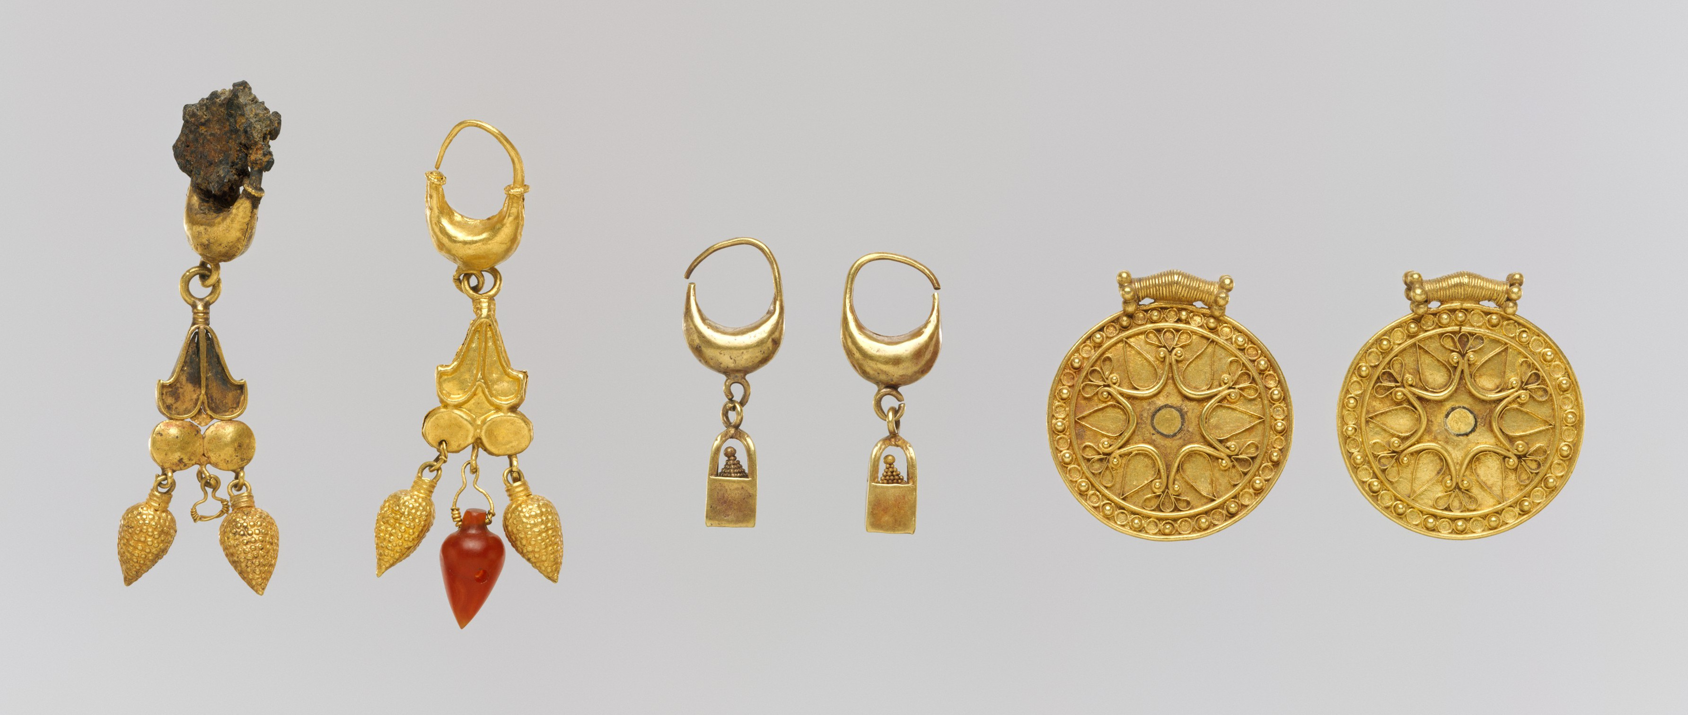

Translation:
The Hebrew word nezem refers to a ring that could be worn in the ear or in the nose. In either case, it was worn as decorative jewelry.
Nose rings (© Deutsche Bibelgesellschaft, Stuttgart by United Bible Societies)The Hebrew word ‘agil in EZK 16:12 clearly refers to an earring, and this is probably the case in NUM 31:50 also.
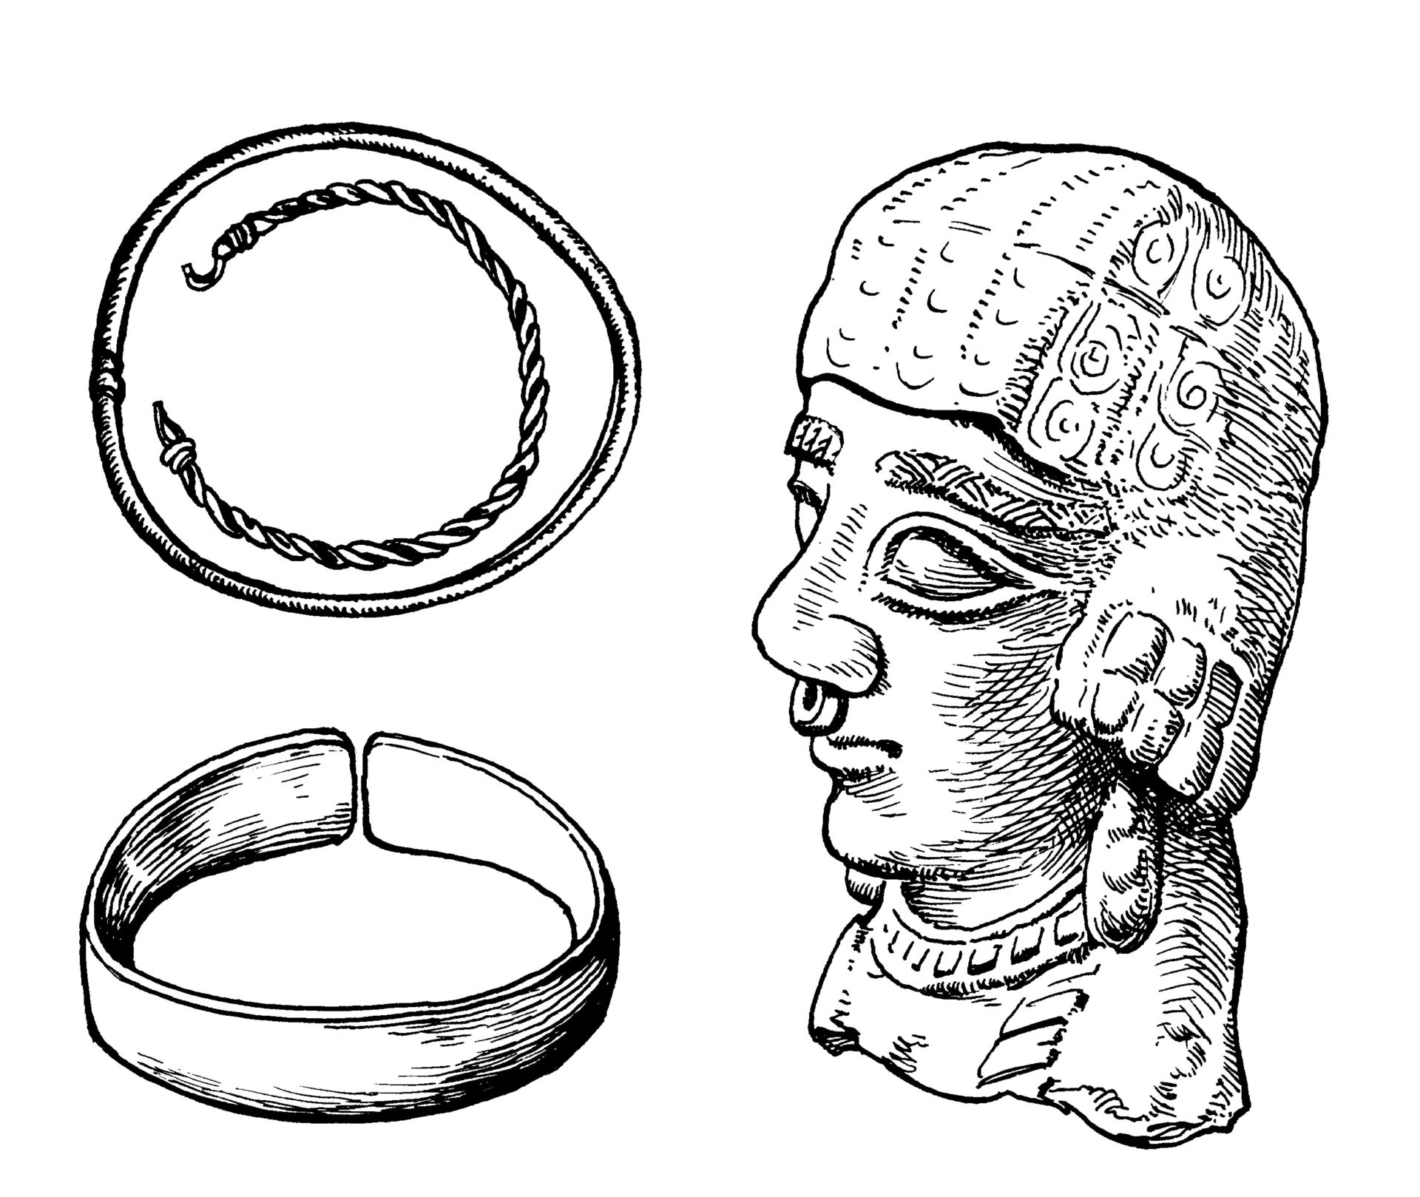
(Image generated by ChatGPT using OpenAI technology)The Greek word enōtion in JDT 10:4 specifically indicates a ring worn in the ear, not in the nose.


Bracelet, armlet, anklet

10.5.2 Bracelet, armlet, anklet

References:Hebrew אֶצְעָדָה (’ets‘adah)NUM 31:50, 2SA 1:10Hebrew עֶכֶס (‘ekes)ISA 3:18Hebrew צָמִיד (tsamid)GEN 24:22, GEN 24:30, GEN 24:47, NUM 31:50, EZK 16:11, EZK 23:42Hebrew צְעָדָה (ts‘adah)ISA 3:20Greek χλιδών (chlidōn)JDT 10:4, SIR 21:21Greek ψέλιον (pselion)JDT 10:4

Description:
Bracelets with antelope-head ends (Walters Art Museum, Public domain, CC BY-SA 3.0, via Wikimedia Commons)The bracelet/armlet was a piece of jewelry worn on the wrist/arm. It was round and made of metal.
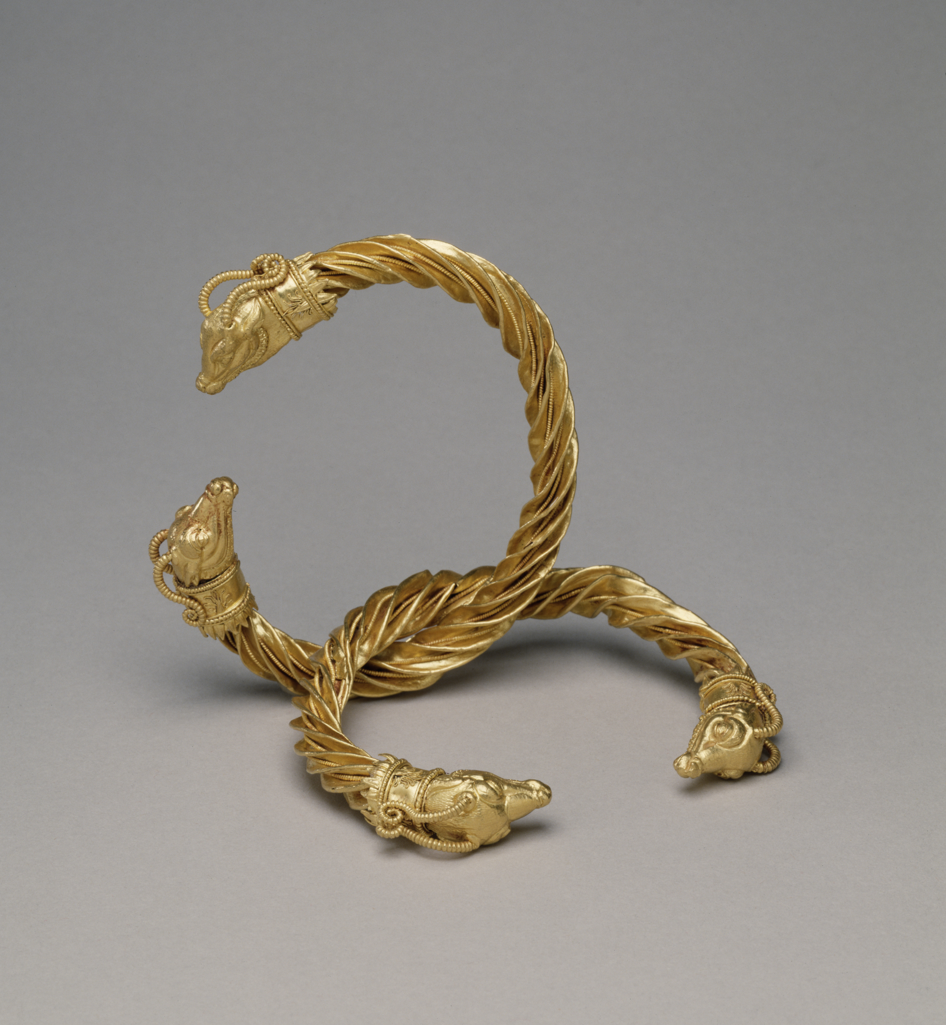

Translation:
The bracelet was worn on the wrist while the armlet was pushed up the arm, usually above the elbow. Where a distinction must be made between one part of the arm and another, the Hebrew word tsamid in EZK 16:11 may be translated “bracelets on your wrists.”
NUM 31:50: Where different words do not exist for a ring worn on the wrist and a ring worn on the upper arm, it is possible to use an inclusive term in this verse; for example, CEV has “jewelry” (CEV).
Translators must be careful not to use a word that indicates an object worn on the arm but that is made of something other than metal. For example, CEV has “arm-band” in 2SA 1:10, but this could be misunderstood in modern English to mean an insignia made of cloth or plastic.
For the Hebrew words ‘ekes and ts‘adah, see the discussion on ISA 3:18–ISA 3:23 at 10.5 Jewelry, ornaments<REALIA:10.5>.
In JDT 10:4 the two Greek words chlidōn and pselion can both mean “bracelet“ (for the arm) and “anklet” (for the leg). Where two distinct words exist, they can both be used. It is also possible to say something like “decorative metal bands for the wrist and the ankle.”

Hair decoration, tiara, ribbon

10.5.3 Hair decoration, tiara, ribbon

References:Greek μίτρα (mitra)JDT 10:3, JDT 16:8

Description:
The tiara was a decorative band, probably made of cloth, wrapped around the head or tied in the hair.

Translation:
Almost all cultures know some kind of hair decoration worn by women. Normally it will be possible to use such a word. Translations vary for the Greek word mitra. GNT and ITCL have “ribbon,” which is good. The word “turban” in NJB may be accurate, but it may sound strange if a turban is normally considered a headdress for men. NAB “fillet” is similar to “ribbon,” but this word is obscure in contemporary English. The word “tiara” in RSV and NRSV presents a nice picture of a woman beautifying her hair, which is the goal of the translator here.

Necklace, chain, cord

10.5.4 Necklace, chain, cord

References:Aramaic הַמְנִיךְ (hamnik)DAN 5:7, DAN 5:7, DAN 5:16, DAN 5:16, DAN 5:29, DAN 5:29Hebrew חָרוּז (charuzim)SNG 1:10Hebrew כּוּמָז (kumaz)EXO 35:22, NUM 31:50Hebrew נְטִיפָה (netifah)JDG 8:26, ISA 3:19Hebrew עֲנָק, ענק (‘anaq (noun or verb))JDG 8:26, PSA 73:6, PRO 1:9, SNG 4:9Hebrew פָּתִיל (pathil)GEN 38:18, GEN 38:25Hebrew רָבִיד (ravid)GEN 41:42, EZK 16:11Hebrew שַׂהֲרוֹן (saharonim)JDG 8:26, ISA 3:18Greek μανιάκης (maniakēs)1ES 3:6

Description and usage:
Necklaces (© Wolfgang Sauber, CC BY-SA 3.0, via Wikimedia Commons)The necklace was a string, band, cord, or chain worn around the neck for ornamentation. Often jewels or other ornaments were attached to it.
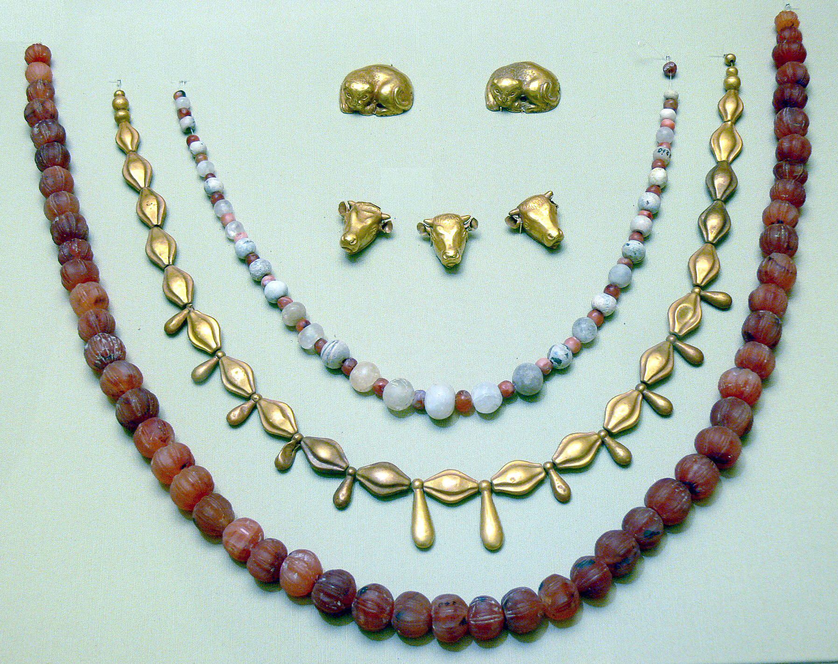

Translation:
GEN 41:42; DAN 5:7; DAN 5:16; DAN 5:29: In these passages a chain of gold is given by a ruler to someone who has been promoted to a high position. The chain in both contexts was probably more substantial than a simple necklace, and it will be better to use a word meaning “chain” rather than one referring to a thin decorative necklace. However, it is important to include in the translation something indicating honor or high rank and not slavery. In some languages a word exists for a symbol of honor or high office that is worn around the neck. Where such a word does not exist or is obscure, the element of honor may be included by expanding the translation; for example, GNT has “chain of honor” in DAN 5:7.
According to some commentators, the Aramaic word hamnik in DAN 5:7; DAN 5:16; DAN 5:29 does not actually refer to a chain but rather to a solid metal collar. NAB has “collar.” In some languages a single verb can be used for wearing purple clothing and the golden collar as symbols of authority. But in others it will be more natural to use two separate verbs for “wearing” clothing and for “wearing” an ornament like a chain or collar around the neck.
SNG 1:10: The Hebrew word charuz (plural, charuzim) actually means a small bead or gem with a hole in it. When many of these were stung onto a string, they formed a necklace. Some translations render charuzim as “necklaces” (NJB, PV), while others prefer to speak about the “jewels” (GNT, NCV) or “precious stones” that made up the necklaces. Others combine the two: RSV “strings of jewels”; NASB “strings of beads”; CEV “necklace of precious stones”; and SPCL “pearl necklaces.”
The meaning of the Hebrew word kumaz (EXO 35:22; NUM 31:50) is uncertain, but it clearly refers to some kind of jewelry. Most translations agree that it indicates something that was worn around the neck, whether “necklaces” (GNT, GECL) or “pendants” (REB, NJPSV).
GEN 38:18; GEN 38:25: In these verses the Hebrew word pathil probably refers to nothing more than a simple cord around the neck, used to hold the signet ring. CEV is good with “cord around your neck” in EXO 30:25.
For the Hebrew words netifah and saharonim, see the discussion on ISA 3:18–ISA 3:23 under 10.5 Jewelry, ornaments<REALIA:10.5>.

