Resource: Human-made Things in the Bible
Human-made Things in the Bible © United Bible Societies, 2025. Adapted from: The Works of Their Hands: Man-made Things in the Bible, by Ray Pritz © 2009 United Bible Societies. This work is licensed under Creative Commons Attribution-ShareAlike 4.0 International (https://creativecommons.org/licenses/by-sa/4.0/).

Human-made Things in the Bible

标题：匕首（dagger）

2.4 标题：匕首（dagger）

经文出处Greek 希：ἐγχειρίδιον (音译：egcheiridion)LJE 1:13

描述和用途
剑（匕首） (© Unknown - Wikimedia Commons)匕首是一种比较短的戳刺武器，尖端锋利，可以轻巧地单手握持，而且容易藏匿。
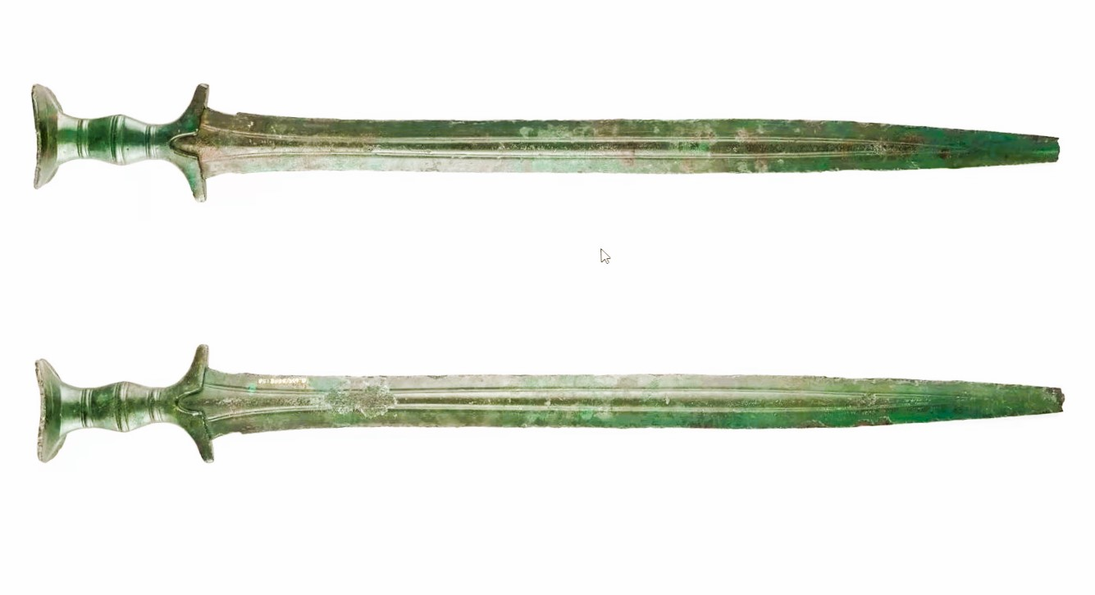

翻译
匕首比短剑还要小，在大多数文化中，可以将其译作“尖刀”。

