Resource: Human-made Things in the Bible
Human-made Things in the Bible © United Bible Societies, 2025. Adapted from: The Works of Their Hands: Man-made Things in the Bible, by Ray Pritz © 2009 United Bible Societies. This work is licensed under Creative Commons Attribution-ShareAlike 4.0 International (https://creativecommons.org/licenses/by-sa/4.0/).

Human-made Things in the Bible

Agriculture and farming

1.1 Agriculture and farming

Yoke

1.1.1 Yoke

References:Hebrew מוֹט, מוֹטָה (mot, motah)LEV 26:13, ISA 58:6, ISA 58:6, ISA 58:9, JER 27:2, JER 28:10, JER 28:12, JER 28:13, JER 28:13, EZK 30:18, EZK 34:27, NAM 1:13Hebrew עֹל (‘ol)GEN 27:40, LEV 26:13, NUM 19:2, DEU 21:3, DEU 28:48, 1SA 6:7, 1KI 12:4, 1KI 12:4, 1KI 12:11, 1KI 12:11, 1KI 12:14, 1KI 12:14, 2CH 10:4, 2CH 10:4, 2CH 10:11, 2CH 10:11, 2CH 10:14, ISA 9:3, ISA 10:27, ISA 10:27, ISA 14:25, ISA 47:6, JER 2:20, JER 5:5, JER 27:8, JER 27:11, JER 27:12, JER 28:2, JER 28:4, JER 28:11, JER 28:14, JER 30:8, LAM 1:14, LAM 3:27, EZK 34:27, HOS 11:4Greek βοοζύγιον (boozugion)SIR 26:7Greek ἑτεροζυγέω (heterozugeō)2CO 6:14Greek κλοιός (kloios)SIR 6:24, SIR 6:29Greek ζυγός (zugos)MAT 11:29, MAT 11:30, ACT 15:10, GAL 5:1, 1TI 6:1, SIR 21:25, SIR 28:19, SIR 28:20, SIR 28:20, SIR 28:25, SIR 33:27, SIR 40:1, SIR 42:4, SIR 51:26, 1MA 8:18, 1MA 8:31, 1MA 13:41, 3MA 4:9, PSS 7:9, PSS 17:30

Description:
Yoked oxen (© Wikimedia Commons)The yoke was a bar or frame of wood by which two draft animals were joined at the neck so that they could work together effectively in pulling a plow, threshing board, harrow, or wagon. A similar device was used on human beings, but then it was usually a single harness, not the double one used for animals.
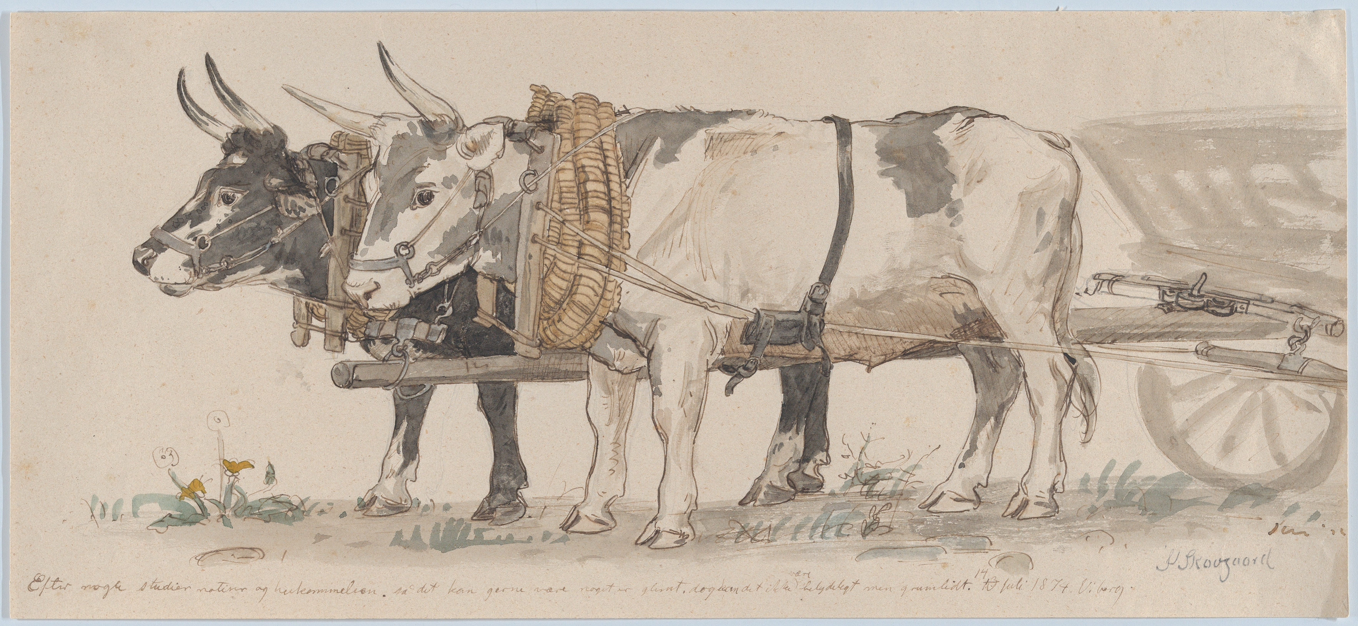

Usage:
Slaves in yokes (© Osama Shukir Muhammed Amin FRCP(Glasg), CC BY-SA 4.0, via Wikimedia Commons)The yoke was secured to the necks of the animals by means of a kind of collar made of wood, cane, or rope. The center of the yoke was attached, by means of a rope or a bar, to the object to be drawn. The animals pulled together, side by side. A yoke was sometimes placed on a human being who had been taken captive (JER 28:10) or made a slave, to restrict movement or to prevent escape.
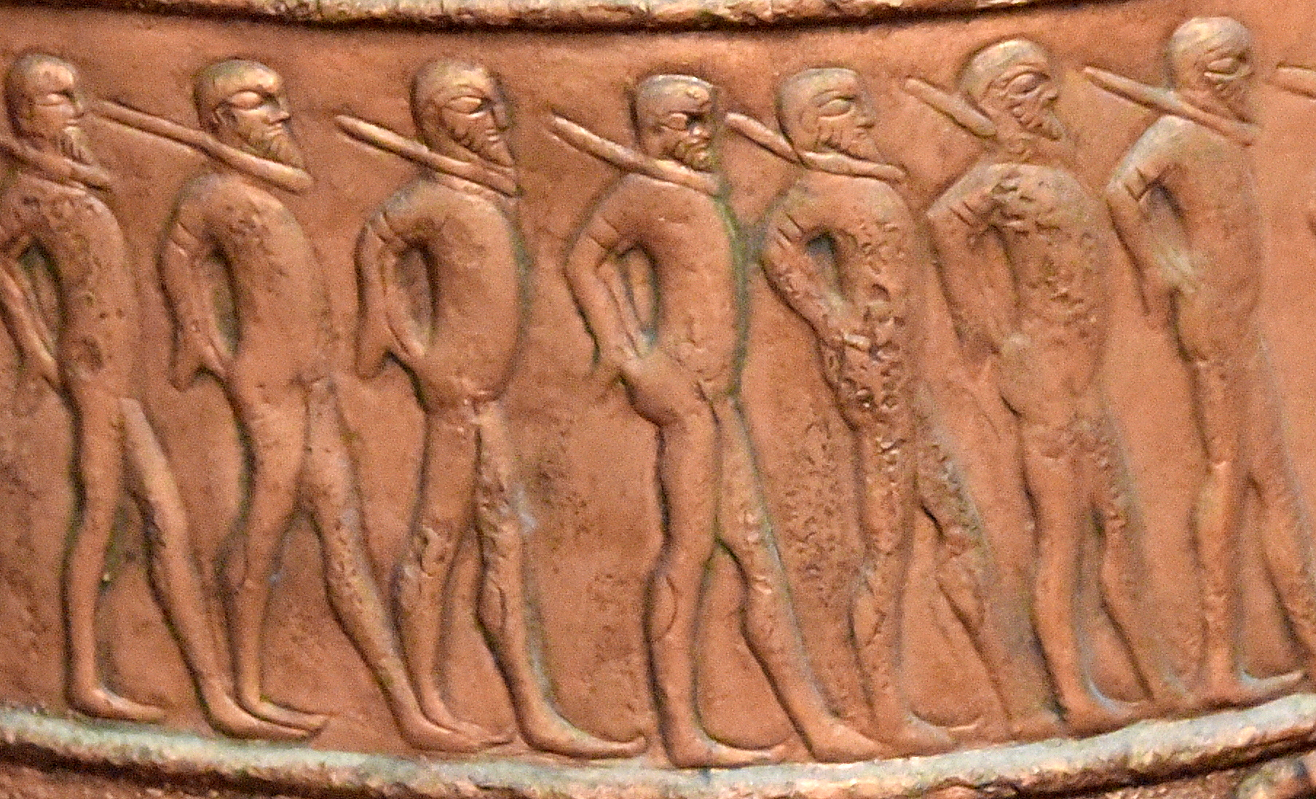

Translation:
Where the yoking of draft animals is unknown or unfamiliar, in NUM 19:2 (and similarly for DEU 21:3) translators may follow GNT, which renders the literal text “on which a yoke has never been placed” as “which has never been worked.”
Always in the New Testament and frequently in the Old Testament, “yoke” appears in figurative contexts. It then becomes a symbol of the subjection and servitude of slaves. In such cases (for example, LEV 26:13; ISA 10:27; JER 28:2, JER 28:14; JER 30:8; EZK 34:27; NAM 1:13; ACT 15:10; GAL 5:1; 1TI 6:1), translators may avoid the literal meaning and translate the figurative sense (LEV 26:13: “… I broke the power that held you down …” [GNT]). Similarly, in SIR 40:1GNT has “… A heavy burden lies on all of us ….”
For the possible reference to a yoke at LAM 5:5, see the comments in A Handbook on Lamentations, page 134.
In SIR 33:27 a yoke is associated with the wearing of a special “harness” or “collar.” This was a device of rope, leather, cane, or wood worn around the neck. The yoke was attached to it. Since it is associated in this verse with control of the animal’s movements, the Italian common language translation (ITCL) renders the word as “reins.” The use of kloios in SIR 6:24; SIR 6:29 is symbolic. In many languages it will be possible to retain the reference to chains and the yoke. However, where a language does not permit such usage, we may say something like “Let all of your actions be ruled by Wisdom” (verse 24) and “If you allow Wisdom to rule you, you will be kept safe, and you will be in control of what happens to you” (verse 29).

Goad

1.1.2 Goad

References:Hebrew דָּרְבָן (darvan)1SA 13:21, ECC 12:11Hebrew מַלְמַד (malmad)JDG 3:31Greek κέντρον (kentron)ACT 26:14, SIR 38:25, 4MA 14:19, PSS 16:4

Description:
Drawing of a man using a goad to spur on a team of oxen (© Unknown - Wikimedia Commons)The goad was a stick, sometimes tipped with a metal point (darvan), used in driving draft animals or herds of domestic animals, such as sheep. The goad had to be long enough to reach the animal from the driver’s position, thus 1–2 meters (3–6 feet).
<image: 2Q==>

Usage:
The driver of a cart or other load stuck the point of the goad into the buttocks of an animal that was not pulling hard enough or in the right direction. The pain stimulus caused the animal to move or change direction.

Translation:
Where draft animals are not known, “a goad” in JDG 3:31 may be translated “a pointed stick” or “a rod with a sharp metal point.” ECC 12:11 may be expanded as follows: “The sayings of the wise are like the sharp sticks that shepherds use to guide sheep …” (GNT; similarly the German common language translation [GECL]) or “The words of experienced men are like goads that stimulate the spirit …” (French common language translation [FRCL]). Another possible rendering is “The words of wise men are sharp and pointed …” (Dutch common language translation [DUCL]).
ACT 26:14: This is the only place in the New Testament where the word goad occurs. It is in the phrase “to kick against the goads” (RSV), meaning to react against authority in such a way as to cause harm or suffering to yourself — to hurt yourself by reacting against a person or command. An alternative rendering for the last half of this verse is “Saul, why are you persecuting me? You are hurting yourself by your resistance.”
In SIR 38:25 the activity of the worker is in focus, so it is unnecessary to find a word to translate this object; for example, GNT has “How can a farm hand gain knowledge, when his only ambition is to drive the oxen and make them work …” Another possibility is “… to get the oxen to move when they want to stop pulling …?”

Whip, scourge

1.1.3 Whip, scourge

References:Hebrew שׁוֹט, שֹׁטֵט (shot, shotet)JOS 23:13, 1KI 12:11, 1KI 12:14, 2CH 10:11, 2CH 10:14, JOB 5:21, JOB 9:23, PRO 26:3, ISA 10:26, ISA 28:15, ISA 28:18, NAM 3:2Greek μαστιγόω, μαστίζω, μάστιξ (mastigoō (verb), mastizō (verb), mastix)MAT 10:17, MAT 20:19, MAT 23:34, MRK 10:34, LUK 18:33, JHN 19:1, ACT 22:24, ACT 22:25, HEB 11:36, HEB 12:6, TOB 13:16, JDT 8:27, WIS 5:11, WIS 12:22, WIS 16:16, SIR 30:14, SIR 23:2, SIR 23:11, SIR 26:6, SIR 28:17, SIR 30:1, SIR 39:28, SIR 40:9, SIR 22:6, 2MA 3:26, 2MA 3:34, 2MA 3:38, 2MA 5:18, 2MA 6:30, 3MA 2:21Greek φραγέλλιον, φραγελλόω (fragellion, fragelloō (verb))MAT 27:26, MRK 15:15, JHN 2:15Latin flagellum2ES 16:20, 2ES 16:21

Description:
Whip (© Clyde L. Cheney - Wikimedia Commons)The whip was an instrument consisting of either a single or multiple thongs with or without weighted tips on the ends. The thongs were usually leather, and the weighted tips would normally have been made of metal in order to increase the force of the blow and to inflict more severe punishment.
<image: 2Q==>

Usage:
Soldier with a whip (© Johnbod, CC BY-SA 4.0, via Wikimedia Commons)When the whip was used on draft animals, it was intended to cause them to move faster. This was done either by striking the animal with the whip or by flicking the whip so that the end of it made a cracking sound, frightening the animal. The whip used on animals was normally without the weighted tips. When the whip was used on human beings, it was for punishment (see DEU 25:2; DEU 25:3).
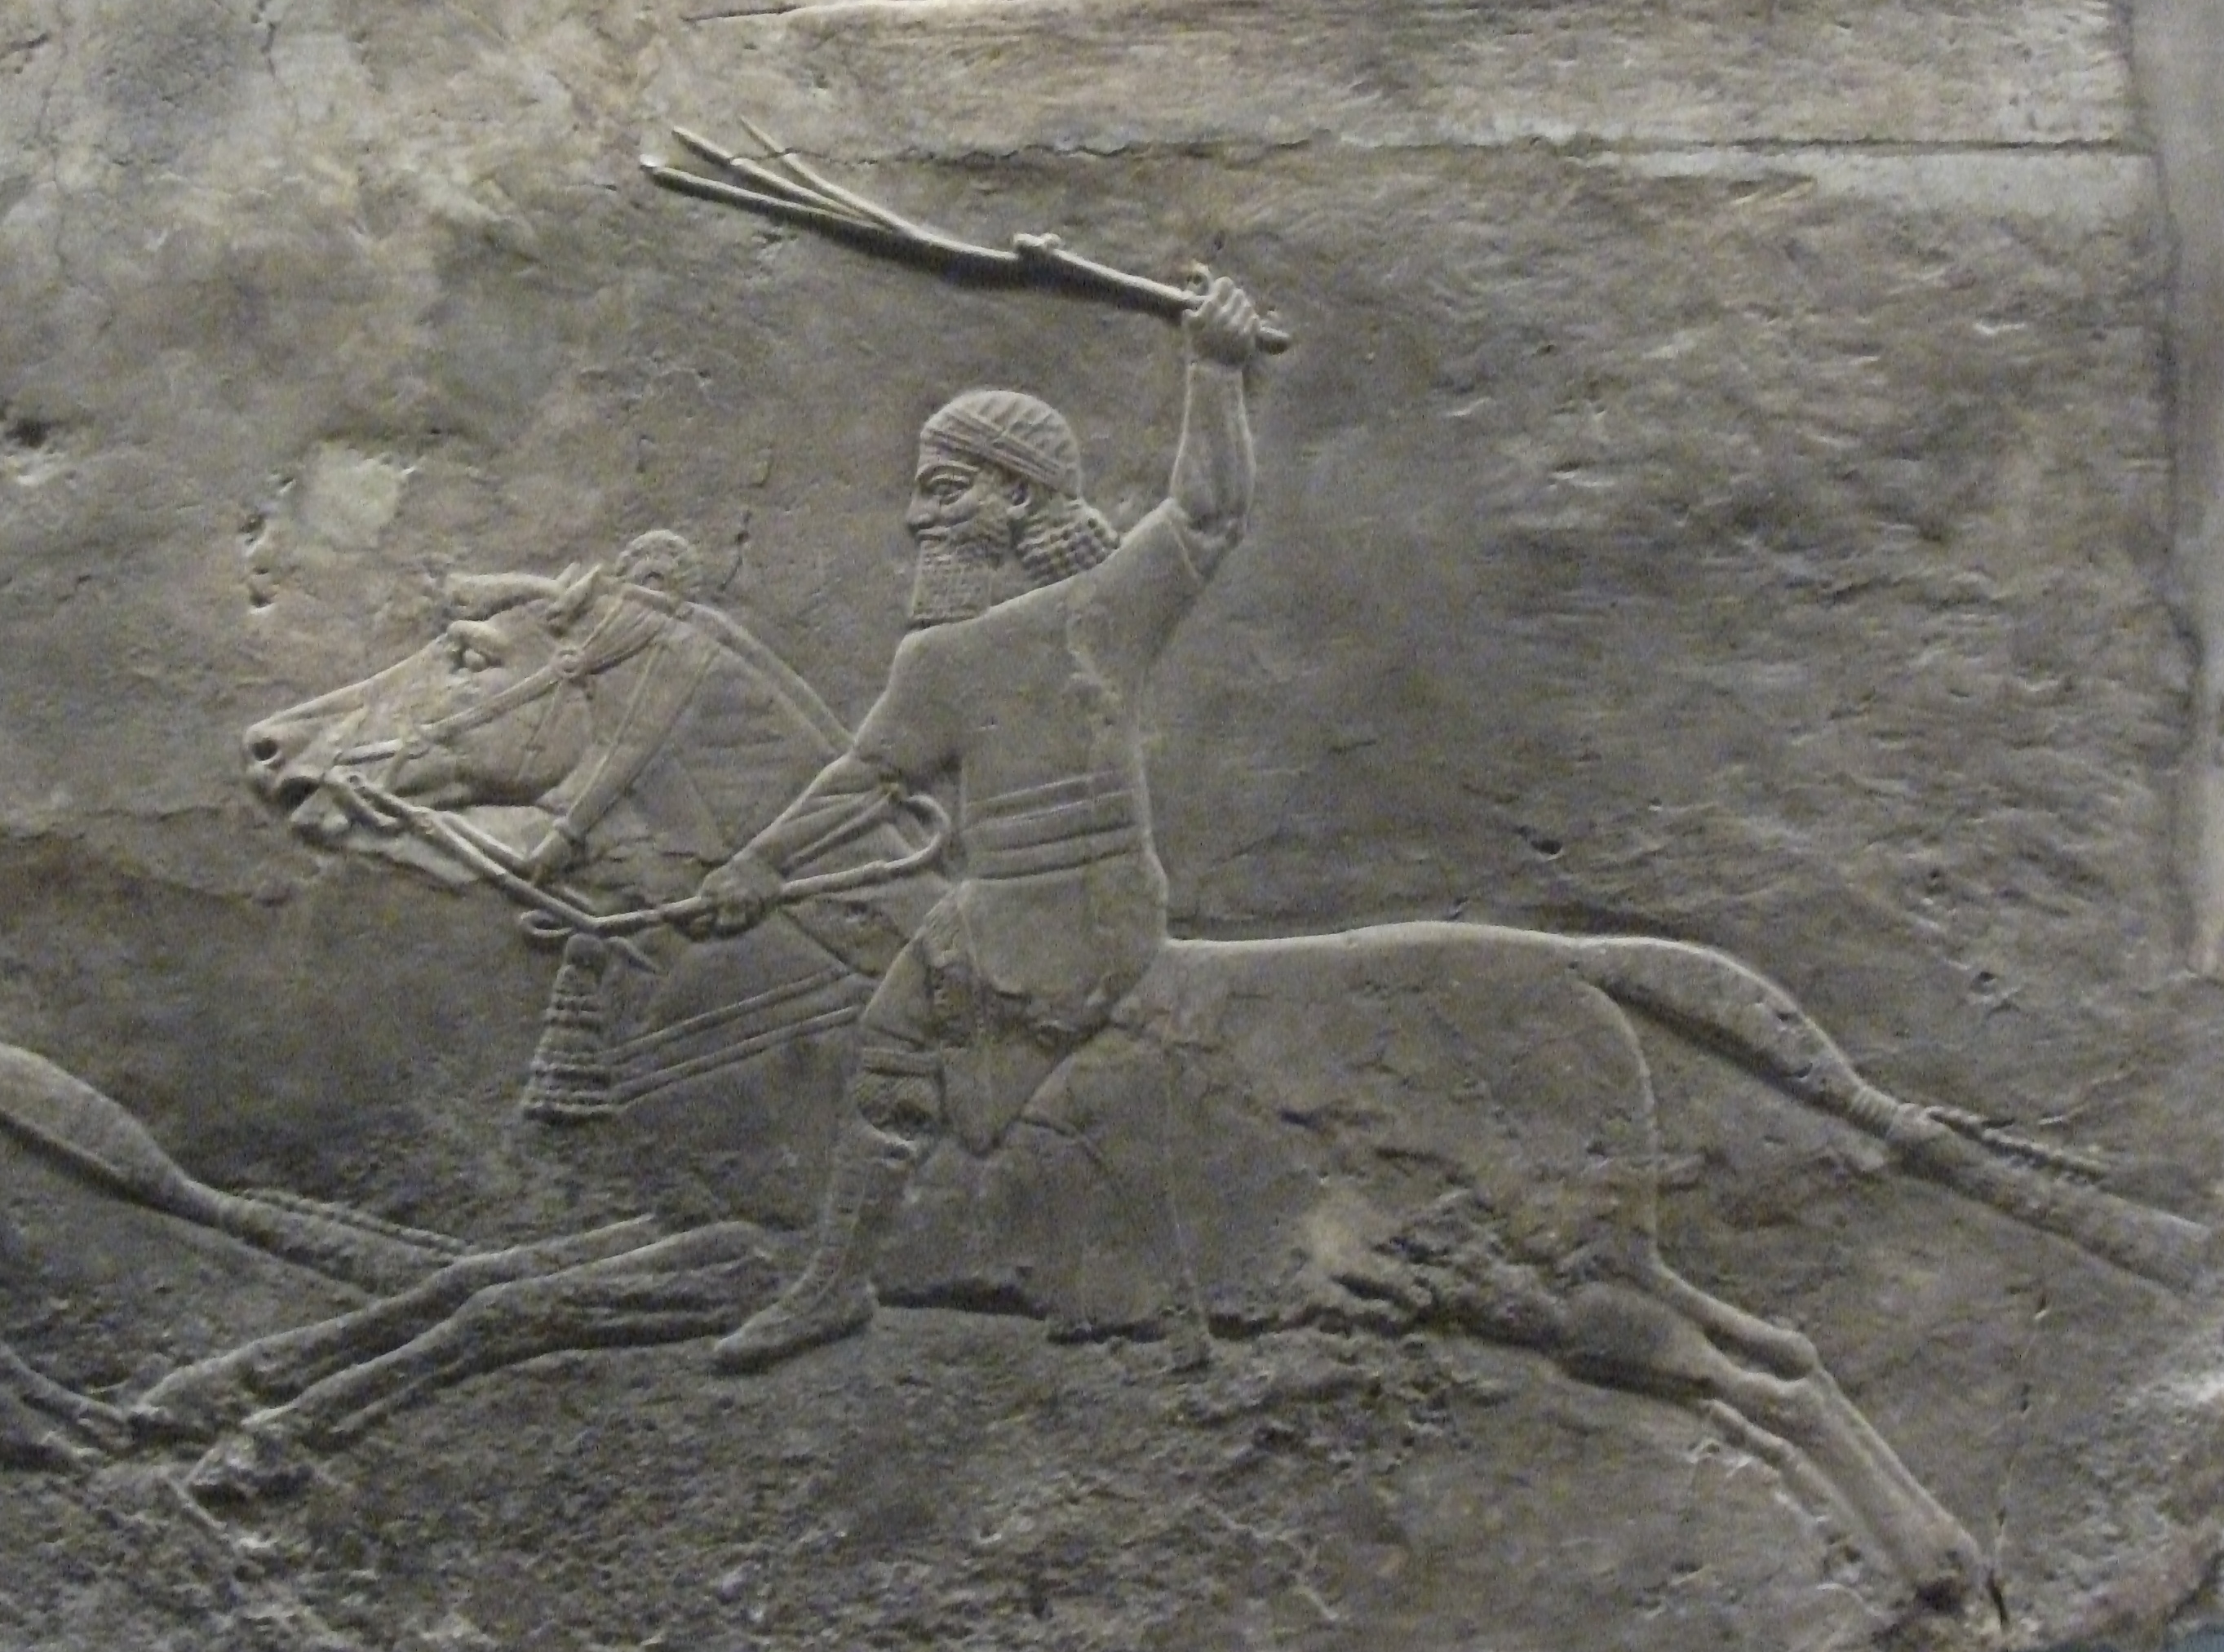

Translation:
Where the word “whip” or “scourge” is used figuratively, it will usually be possible to preserve the meaning without keeping the figure. For example, for the literal clause “You shall be hid from the scourge of the tongue” (JOB 5:21 in RSV), GNT has “God will rescue you from slander.”
PRO 26:3: For the literal phrase “A whip for the horse” (RSV), it may be better to use a verb to describe the action; for example, GNT says “You have to whip a horse.”

Muzzle

1.1.4 Muzzle

References:Hebrew חסם (chasam (verb))DEU 25:4Hebrew מַחְסוֹם (machsom)PSA 39:2Greek φιμός (fimos)SIR 20:29Greek φιμόω (fimoō (verb))1TI 5:18, SUS 1:60, 4MA 1:35Greek κημόω (kēmoō (verb))1CO 9:9

Description and usage:
Muzzled cow used for threshing (Matson Collection, Library of Congress, Public domain)The muzzle was a guard placed over or around the mouth of an animal to prevent it from biting or eating. It was made of rope or leather strips formed into a loose mesh; this allowed the animal to breathe while preventing it from getting anything into its mouth.
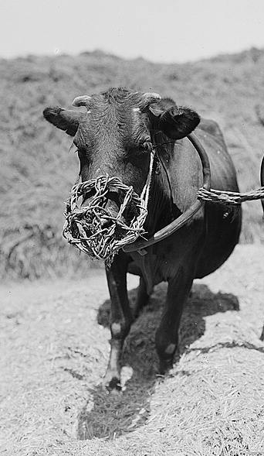

Translation:
The two New Testament references are quotations from DEU 25:4 (where 1TI 5:18 follows the Septuagint and 1CO 9:9 uses an equivalent verb). In some languages it may be necessary to use some kind of descriptive equivalent of “to muzzle an ox,” for example, “to tie the mouth of an ox so that it cannot eat” or “to cover the mouth of an ox so that it cannot eat.” In PSA 39:2 the literal text “I will guard my mouth with a muzzle” may be rendered “I will keep silent” (compare GNT “I will not say anything”).

Plow and plowshare

1.1.5 Plow and plowshare

References:Hebrew אֵת (’eth)1SA 13:20, 1SA 13:21, ISA 2:4, JOL 4:10, MIC 4:3Hebrew חרשׁ (charash (verb))DEU 22:10, JDG 14:18, 1SA 8:12, 1KI 19:19, JOB 1:14, JOB 4:8, PSA 129:3, PSA 129:3, PRO 20:4, ISA 28:24, ISA 28:24, JER 26:18, HOS 10:11, HOS 10:13, AMO 6:12, AMO 9:13, MIC 3:12Greek ἀροτριάω (arotriaō (verb))LUK 17:7, 1CO 9:10, 1CO 9:10, SIR 6:19, SIR 7:12Greek ἄροτρον (arotron)LUK 9:62, SIR 38:25

Description:
Egyptian model of a man plowing (Metropolitan Museum of Art, Public domain, MMA)The plow consisted of a flat triangular blade (the “plowshare”) made of hard wood or metal, connected to a handle. In another design the plowshare was a wooden bar covered with a cylindrical, pointed metal sleeve. Ropes or a wooden pole attached to the handle were connected to the yoke and pulled by one or more animals.
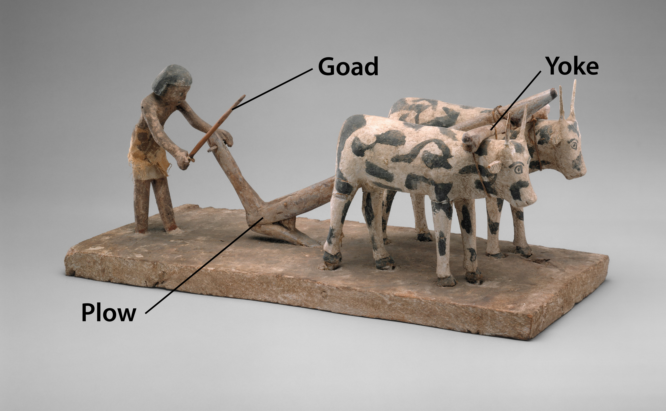

Usage:
The plow was used to cut the soil in preparation for the sowing of seed or the planting of seedlings. (The soil might also be plowed again after the seed was scattered, in order to cover the seed and protect it from the birds and from the sun.) The point of the plowshare cut a shallow furrow in the earth. Plows did not turn over the soil but were used simply to break the surface, seldom to a depth of more than 25 centimeters (10 inches). A man could pull the plow, but more often it was pulled by either oxen or donkeys, while a man walked behind and directed the animals and held the plow in its proper line and depth in the soil.
Plow (© Deutsche Bibelgesellschaft, Stuttgart by United Bible Societies)Some have suggested that an ’eth was a kind of sharp instrument that was used to cut the soil prior to the actual plowing.
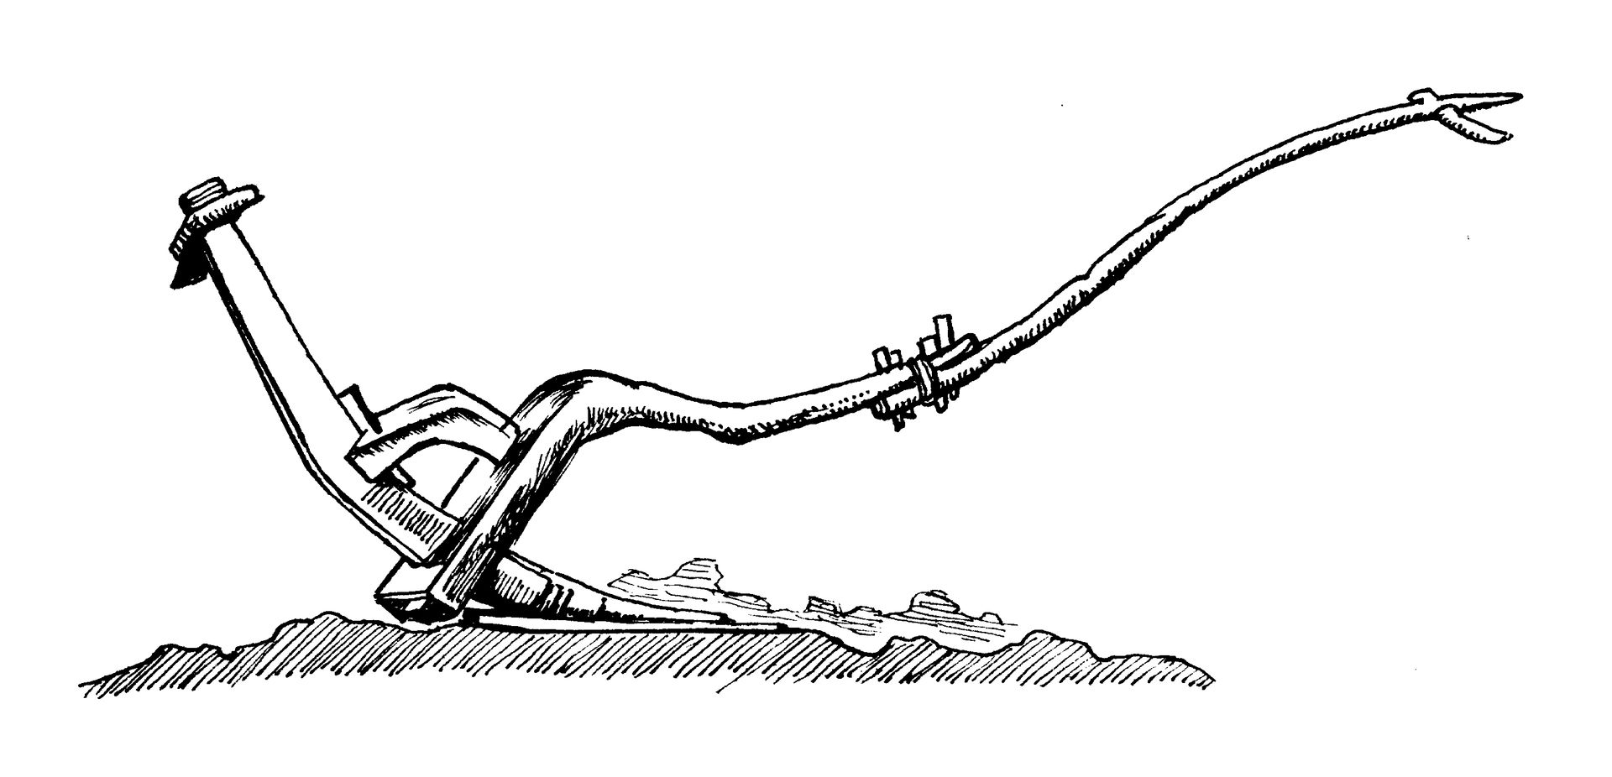

Translation:
In most parts of the world at least some type of plow is known. Where a plow is unknown, translators may use the name of a tool used for the same kind of agricultural work, such as “hoe.” This will not be possible where the text refers to plowing with animals (for example, DEU 22:10; 1KI 19:19). ’Eth refers to the physical similarity of the plowshare and the sword in ISA 2:4; JOL 4:10; and MIC 4:3. Where plows are unknown, in these passages translators may substitute some other farming tool, which could reasonably be formed from a sword or machete or cutlass.
The Hebrew verb charash is used figuratively in several passages. In JER 26:18 and MIC 3:12 it speaks of the total destruction of Jerusalem, and in JOB 4:8 and HOS 10:13 it expresses the idea that doing an evil deed will bring an evil result. For the figurative use of plowing in PSA 129:3, see A Handbook on Psalms, page 1080.

Sickle

1.1.6 Sickle

References:Hebrew חֶרְמֵשׁ (chermesh)DEU 16:9, DEU 23:26Hebrew מַגָּל (magal)JER 50:16, JOL 4:13Greek δρέπανον (drepanon)MRK 4:29, REV 14:14, REV 14:15, REV 14:16, REV 14:17, REV 14:18, REV 14:18, REV 14:19

Description:

Sickle

1.1.6 Sickle

References:Hebrew חֶרְמֵשׁ (chermesh)DEU 16:9, DEU 23:26Hebrew מַגָּל (magal)JER 50:16, JOL 4:13Greek δρέπανον (drepanon)MRK 4:29, REV 14:14, REV 14:15, REV 14:16, REV 14:17, REV 14:18, REV 14:18, REV 14:19

Description:

Sickle

1.1.6 Sickle

References:Hebrew חֶרְמֵשׁ (chermesh)DEU 16:9, DEU 23:26Hebrew מַגָּל (magal)JER 50:16, JOL 4:13Greek δρέπανον (drepanon)MRK 4:29, REV 14:14, REV 14:15, REV 14:16, REV 14:17, REV 14:18, REV 14:18, REV 14:19

Description:

Sickle

1.1.6 Sickle

References:Hebrew חֶרְמֵשׁ (chermesh)DEU 16:9, DEU 23:26Hebrew מַגָּל (magal)JER 50:16, JOL 4:13Greek δρέπανον (drepanon)MRK 4:29, REV 14:14, REV 14:15, REV 14:16, REV 14:17, REV 14:18, REV 14:18, REV 14:19

Description:

Sickle

1.1.6 Sickle

References:Hebrew חֶרְמֵשׁ (chermesh)DEU 16:9, DEU 23:26Hebrew מַגָּל (magal)JER 50:16, JOL 4:13Greek δρέπανον (drepanon)MRK 4:29, REV 14:14, REV 14:15, REV 14:16, REV 14:17, REV 14:18, REV 14:18, REV 14:19

Description:

Sickle

1.1.6 Sickle

References:Hebrew חֶרְמֵשׁ (chermesh)DEU 16:9, DEU 23:26Hebrew מַגָּל (magal)JER 50:16, JOL 4:13Greek δρέπανον (drepanon)MRK 4:29, REV 14:14, REV 14:15, REV 14:16, REV 14:17, REV 14:18, REV 14:18, REV 14:19

Description:

Sickle

1.1.6 Sickle

References:Hebrew חֶרְמֵשׁ (chermesh)DEU 16:9, DEU 23:26Hebrew מַגָּל (magal)JER 50:16, JOL 4:13Greek δρέπανον (drepanon)MRK 4:29, REV 14:14, REV 14:15, REV 14:16, REV 14:17, REV 14:18, REV 14:18, REV 14:19

Description:

Sickle

1.1.6 Sickle

References:Hebrew חֶרְמֵשׁ (chermesh)DEU 16:9, DEU 23:26Hebrew מַגָּל (magal)JER 50:16, JOL 4:13Greek δρέπανον (drepanon)MRK 4:29, REV 14:14, REV 14:15, REV 14:16, REV 14:17, REV 14:18, REV 14:18, REV 14:19

Description:

Sickle

1.1.6 Sickle

References:Hebrew חֶרְמֵשׁ (chermesh)DEU 16:9, DEU 23:26Hebrew מַגָּל (magal)JER 50:16, JOL 4:13Greek δρέπανον (drepanon)MRK 4:29, REV 14:14, REV 14:15, REV 14:16, REV 14:17, REV 14:18, REV 14:18, REV 14:19

Description:

Sickle

1.1.6 Sickle

References:Hebrew חֶרְמֵשׁ (chermesh)DEU 16:9, DEU 23:26Hebrew מַגָּל (magal)JER 50:16, JOL 4:13Greek δρέπανον (drepanon)MRK 4:29, REV 14:14, REV 14:15, REV 14:16, REV 14:17, REV 14:18, REV 14:18, REV 14:19

Description:

Sickle

1.1.6 Sickle

References:Hebrew חֶרְמֵשׁ (chermesh)DEU 16:9, DEU 23:26Hebrew מַגָּל (magal)JER 50:16, JOL 4:13Greek δρέπανον (drepanon)MRK 4:29, REV 14:14, REV 14:15, REV 14:16, REV 14:17, REV 14:18, REV 14:18, REV 14:19

Description:

Sickle

1.1.6 Sickle

References:Hebrew חֶרְמֵשׁ (chermesh)DEU 16:9, DEU 23:26Hebrew מַגָּל (magal)JER 50:16, JOL 4:13Greek δρέπανον (drepanon)MRK 4:29, REV 14:14, REV 14:15, REV 14:16, REV 14:17, REV 14:18, REV 14:18, REV 14:19

Description:

Sickle

1.1.6 Sickle

References:Hebrew חֶרְמֵשׁ (chermesh)DEU 16:9, DEU 23:26Hebrew מַגָּל (magal)JER 50:16, JOL 4:13Greek δρέπανον (drepanon)MRK 4:29, REV 14:14, REV 14:15, REV 14:16, REV 14:17, REV 14:18, REV 14:18, REV 14:19

Description:

Sickle

1.1.6 Sickle

References:Hebrew חֶרְמֵשׁ (chermesh)DEU 16:9, DEU 23:26Hebrew מַגָּל (magal)JER 50:16, JOL 4:13Greek δρέπανον (drepanon)MRK 4:29, REV 14:14, REV 14:15, REV 14:16, REV 14:17, REV 14:18, REV 14:18, REV 14:19

Description:

Sickle

1.1.6 Sickle

References:Hebrew חֶרְמֵשׁ (chermesh)DEU 16:9, DEU 23:26Hebrew מַגָּל (magal)JER 50:16, JOL 4:13Greek δρέπανον (drepanon)MRK 4:29, REV 14:14, REV 14:15, REV 14:16, REV 14:17, REV 14:18, REV 14:18, REV 14:19

Description:

