Resource: Human-made Things in the Bible
Human-made Things in the Bible © United Bible Societies, 2025. Adapted from: The Works of Their Hands: Man-made Things in the Bible, by Ray Pritz © 2009 United Bible Societies. This work is licensed under Creative Commons Attribution-ShareAlike 4.0 International (https://creativecommons.org/licenses/by-sa/4.0/).

Human-made Things in the Bible

Helmet

2.9 Helmet

References:Hebrew כּוֹבַע (kova‘)1SA 17:5, 2CH 26:14, ISA 59:17, JER 46:4, EZK 27:10, EZK 38:5Hebrew מָעוֹז, רֹאשׁ (ma‘oz ro’sh)PSA 60:9, PSA 108:9Hebrew קוֹבַע (qova‘)1SA 17:38, EZK 23:24Greek περικεφαλαία (perikefalaia)EPH 6:17, 1TH 5:8, 1MA 6:35Greek κόρυς (korus)WIS 5:18

Description:
Helmet (© Public Domain - Wikimedia Commons)The helmet was protective armor covering the head. In some helmet designs there were flaps extending down over the ears or even to the neck. Among the Israelites and their immediate neighbors, helmets were usually made of leather. Helmets made of metal were rare and were generally imported from countries to the east and north. See the illustration at 2.3.1 Sheath, scabbard<REALIA:2.3.1>.
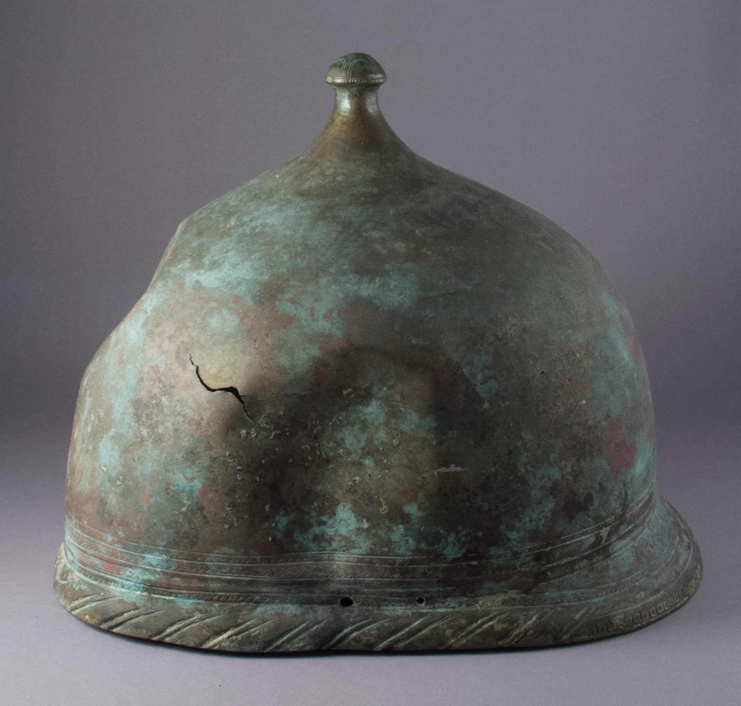

Translation:
Picture of a helmet worn by a soldier (© Jona Lendering - Wikimedia Commons)For languages having no term for “helmet,” translators may use a descriptive equivalent, such as “protection for the head” or “covering for the head in fighting.” The figurative expression “helmet of salvation” in ISA 59:17 and EPH 6:17 may be rendered “salvation, which is like a protection for the head.”
