Resource: Human-made Things in the Bible
Human-made Things in the Bible © United Bible Societies, 2025. Adapted from: The Works of Their Hands: Man-made Things in the Bible, by Ray Pritz © 2009 United Bible Societies. This work is licensed under Creative Commons Attribution-ShareAlike 4.0 International (https://creativecommons.org/licenses/by-sa/4.0/).

Human-made Things in the Bible

Leg armor, leg protectors

2.11 Leg armor, leg protectors

Reference:Hebrew מִצְחָה (mitschah)1SA 17:6

Description and usage:
Roman armor - leg protectors (© MatthiasKabel, CC BY-SA 3.0, via Wikimedia Commons)Leg armor was protective armor for the lower leg. It was made of leather or metal, covered the front half of the leg, and was tied at the back with leather thongs. The leg armor worn by Goliath was made of bronze.
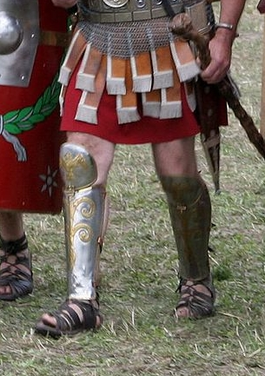

Translation:
The only protection for the lower leg known in many societies today is related to sports such as football. Translators will have to be careful that use of such a word does not sound amusing to the reader (as is possibly the case with the NASB marginal reading “shin guards” in 1SA 17:6). To avoid this, and because the old English word “greaves” is now obscure, modern translations choose descriptive phrases; for example, GNT begins 1SA 17:6 with “His legs were also protected by bronze armor” (similarly CEV).

