Resource: Human-made Things in the Bible
Human-made Things in the Bible © United Bible Societies, 2025. Adapted from: The Works of Their Hands: Man-made Things in the Bible, by Ray Pritz © 2009 United Bible Societies. This work is licensed under Creative Commons Attribution-ShareAlike 4.0 International (https://creativecommons.org/licenses/by-sa/4.0/).

Human-made Things in the Bible

Standard, ensign, banner

2.17 Standard, ensign, banner

References:Hebrew אוֹת (’oth)NUM 2:2, PSA 74:4, PSA 74:4Hebrew דגל (dagal (verb))PSA 20:6, SNG 6:4, SNG 6:10Hebrew דֶּגֶל (degel)NUM 1:52, NUM 2:2, NUM 2:3, NUM 2:10, NUM 2:17, NUM 2:18, NUM 2:25, NUM 2:31, NUM 2:34, NUM 10:14, NUM 10:18, NUM 10:22, NUM 10:25, SNG 2:4Hebrew נֵס (nes)EXO 17:15, NUM 21:8, NUM 21:9, PSA 60:6, ISA 5:26, ISA 11:10, ISA 11:12, ISA 13:2, ISA 18:3, ISA 30:17, ISA 31:9, ISA 49:22, ISA 62:10, JER 4:6, JER 4:21, JER 50:2, JER 51:12, JER 51:27, EZK 27:7Hebrew נסס (nasas (verb))ZEC 9:16Hebrew תֹּרֶן (toren)ISA 30:17

Description and usage:
Various examples of standards (Cyclopedia of Biblical, Theological and Ecclesiastical Literature, Harper 1888, Public domain)The standard was a distinctive device used to identify a particular group. It could be a flag or a board attached to a stick. In many cases it was a metal device or image (such as an eagle or the head of a lion) that was fitted over the end of a pole in much the same way that a spearhead was attached to a spear.
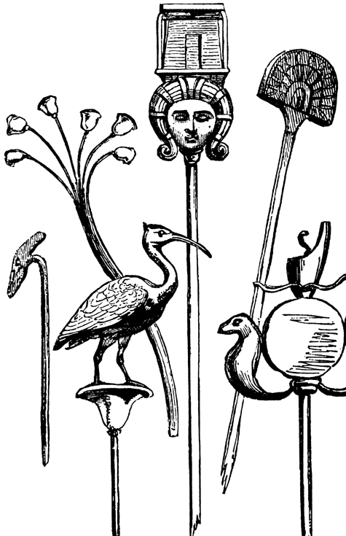

Translation:
Reconstruction of the Titus Arch frieze (Rome), showing a menorah and standards from the temple being carried off by the Roman victors (71 C.E.) (© Original file by Steerpike (File:Arch of Titus Menorah.png), CC BY 3.0, via Wikimedia Commons)The Hebrew words listed above occur in both military and religious contexts. In a time of war the standard was carried with the army into combat and served as a rallying point for the soldiers. If a victory was won or a strategic position was captured, the standard might be set up in that place as a sign of victory. So in a language where flags or military standards are unfamiliar, it is possible to say the following in PSA 74:4: “they have placed their signs of victory here” or “they have put up the signs that show they have defeated us.”
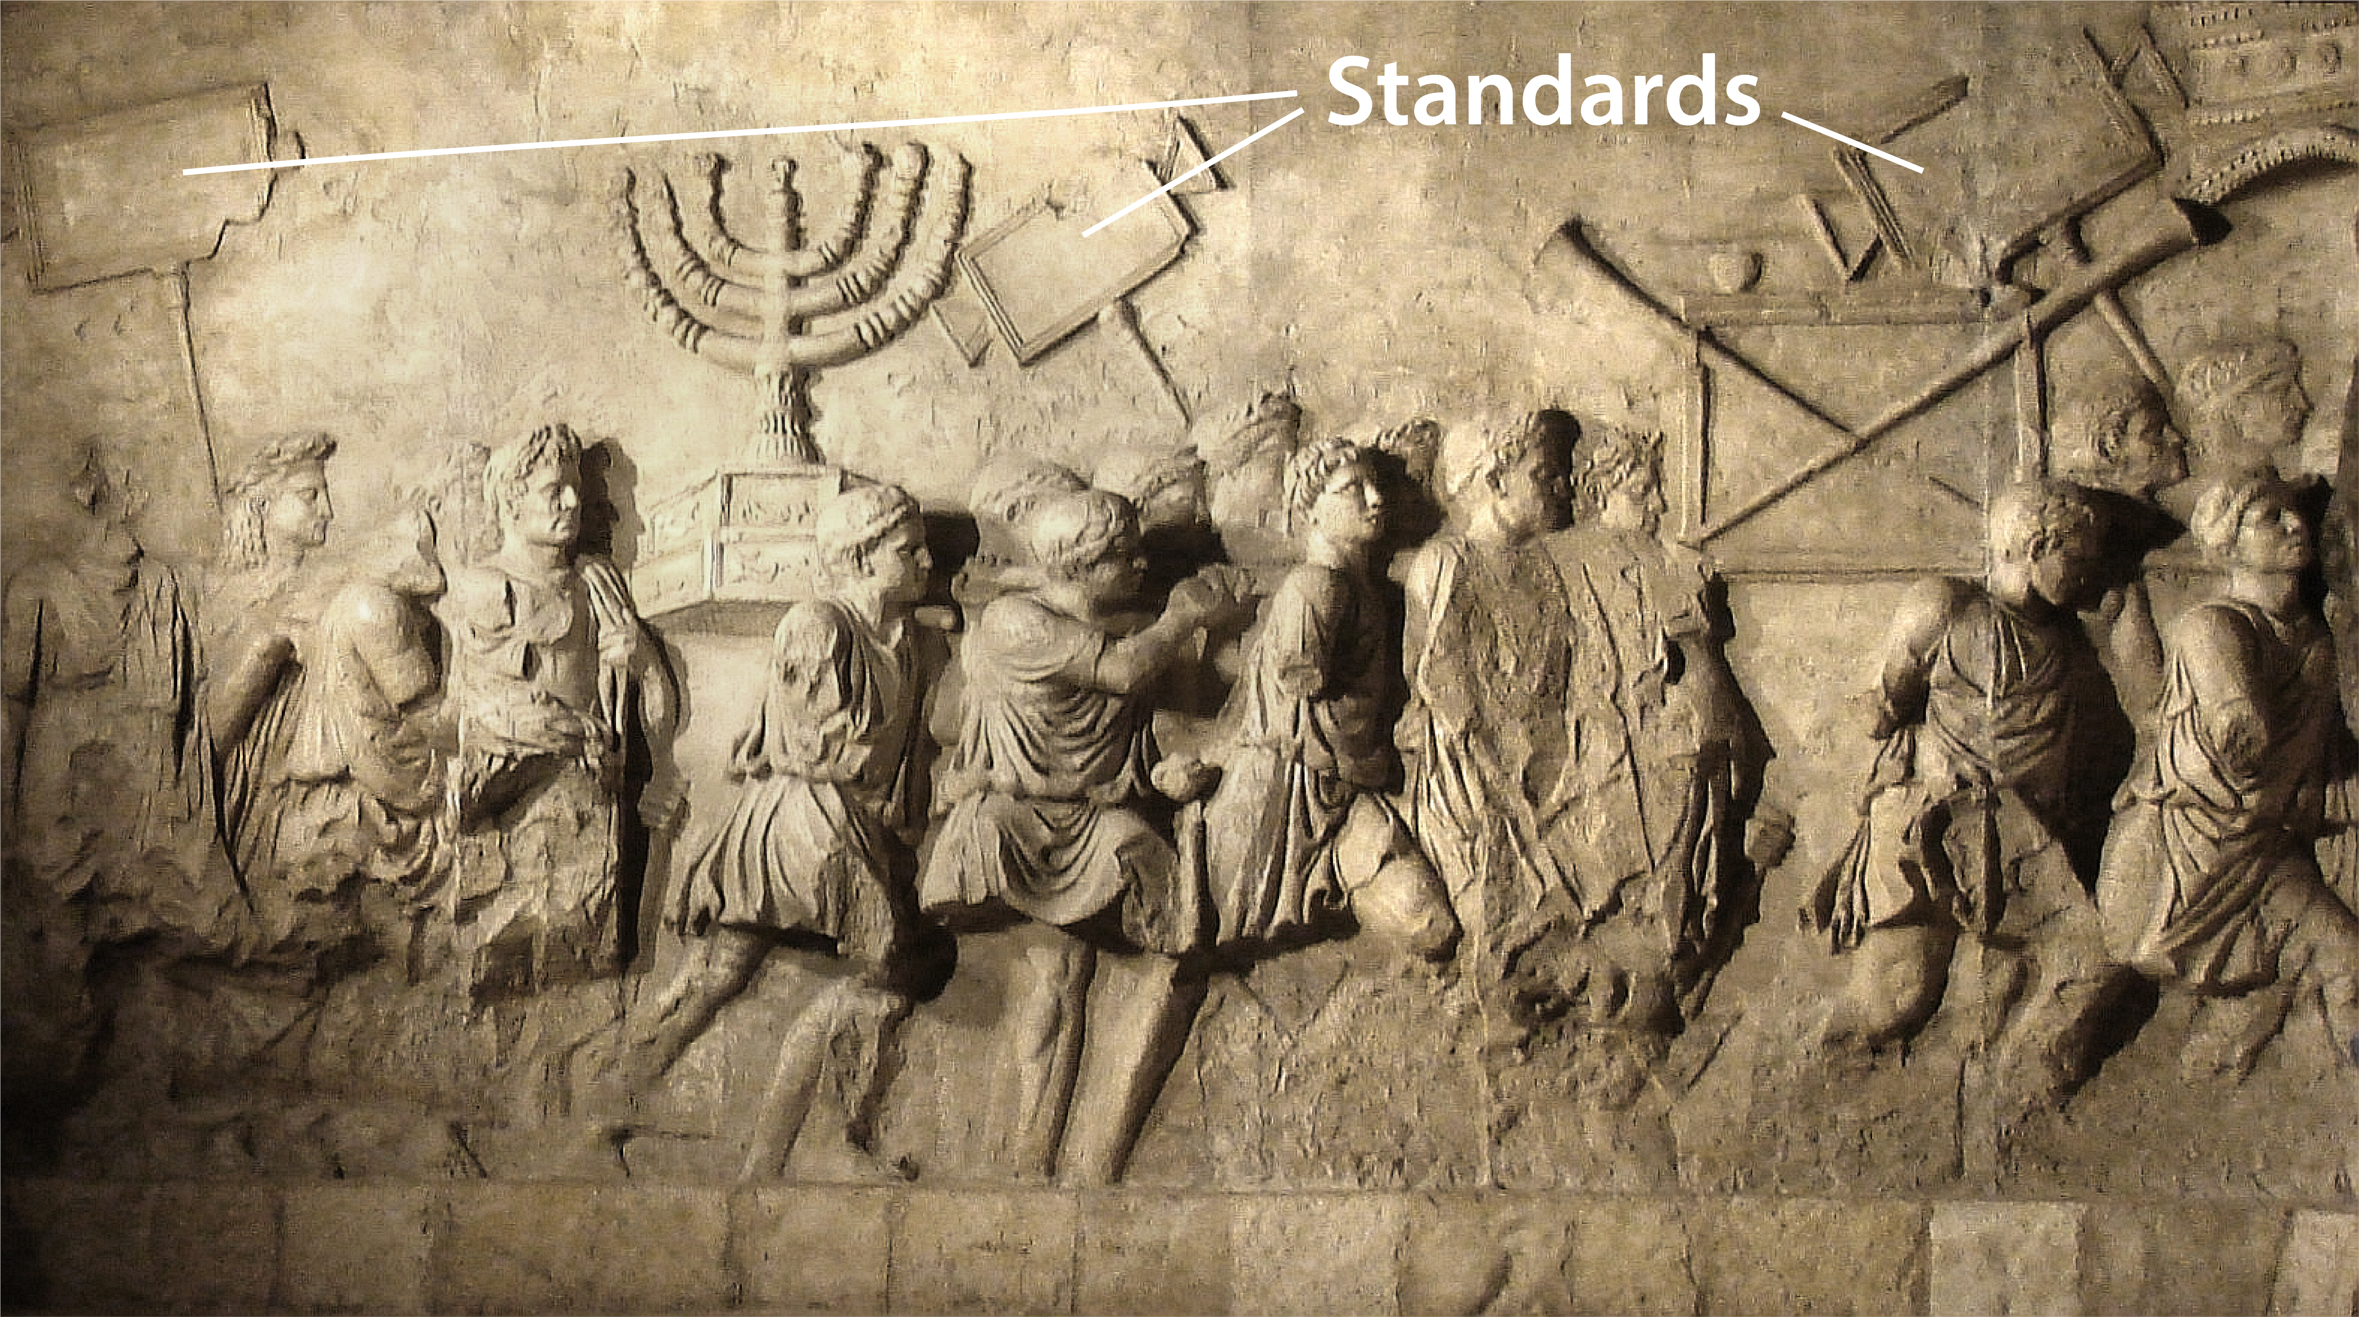
There is a textual problem in EXO 17:16. While the Hebrew text reads kes, meaning “seat” or “throne,” some translations accept an emended text that reads nes, which appears also in the previous verse; for example, for the first half of this verse GNT has “He said, ‘Hold high the banner of the LORD!’ ” Other translations prefer to translate the word kes without emendation; for example, NIV has “He said, ‘For hands were lifted up to the throne of the LORD.’ ”
ZEC 9:16: The precise meaning of the Hebrew verb form mithnossoth is doubtful. If it is related to the word nes, then the literal meaning is “lifted up as an ensign.” However, very few translations (KJV, NAB, Vulgate) express this meaning. Most translators and commentators take the word to be related to a different Hebrew root meaning “to shine” or “to sparkle.”

