Resource: Human-made Things in the Bible
Human-made Things in the Bible © United Bible Societies, 2025. Adapted from: The Works of Their Hands: Man-made Things in the Bible, by Ray Pritz © 2009 United Bible Societies. This work is licensed under Creative Commons Attribution-ShareAlike 4.0 International (https://creativecommons.org/licenses/by-sa/4.0/).

Human-made Things in the Bible

Storehouse

3.12 Storehouse

References:Hebrew בַּיִת, אָסֹף ((beyth) ’asupim)NEH 12:25Hebrew אוֹצָר (’otsar)1CH 27:27, 1CH 27:28, 2CH 11:11, NEH 12:44, NEH 13:12, NEH 13:13, JOB 38:22, JOB 38:22, PSA 33:7, PSA 135:7, ISA 39:2, ISA 39:4, JER 10:13, JER 38:11, JER 51:16Greek ἀποδοχεῖον (apodocheion)SIR 1:17Greek θησαυρός (thēsauros)SIR 41:12, SIR 43:14Greek ταμεῖον (tameion)LUK 12:24

Description:
The places listed above were for general storage. Their shape and structure are undefined. See also 3.13.4 Armory, arsenal<REALIA:3.13.4> and 3.14.1.4 Treasury, strongroom<REALIA:3.14.1.4>.

Translation:
In most of the references listed above it is stated what was being stored. Where the commodity being stored is named, languages may have a special word for the particular place where such a commodity is stored; for example, in 1CH 27:27GNT has “Wine cellars” for the Hebrew word ’otsar. However, in the following verse, where the same word is used together with “oil,” GNT has “Olive oil storage,” because English has no special word for a place to store olive oil.

Grain-store, silo

3.12.1 Grain-store, silo

References:Hebrew אָסָם (’asam)DEU 28:8, PRO 3:10Hebrew אוֹצָר (’otsar)JOL 1:17Hebrew מַאֲבוּס (ma’avus)JER 50:26Hebrew מְגוּרָה (mgurah)HAG 2:19Hebrew מַמְּגוּרָה (mamgurah)JOL 1:17Hebrew מִסְכְּנוֹת (misknoth)EXO 1:11, 1KI 9:19, 2CH 8:4, 2CH 8:6, 2CH 16:4, 2CH 17:12, 2CH 32:28Greek ἀποθήκη (apothēkē)MAT 3:12, MAT 6:26, MAT 13:30, LUK 3:17, LUK 12:18, LUK 12:24Latin promptuarium2ES 5:9

Description and usage:
Grain-store at Megiddo (© Ian Scott, CC BY-SA 2.0, via Wikimedia Commons)The grain-store or silo was a small structure for storing agricultural produce. It normally was made of stone.
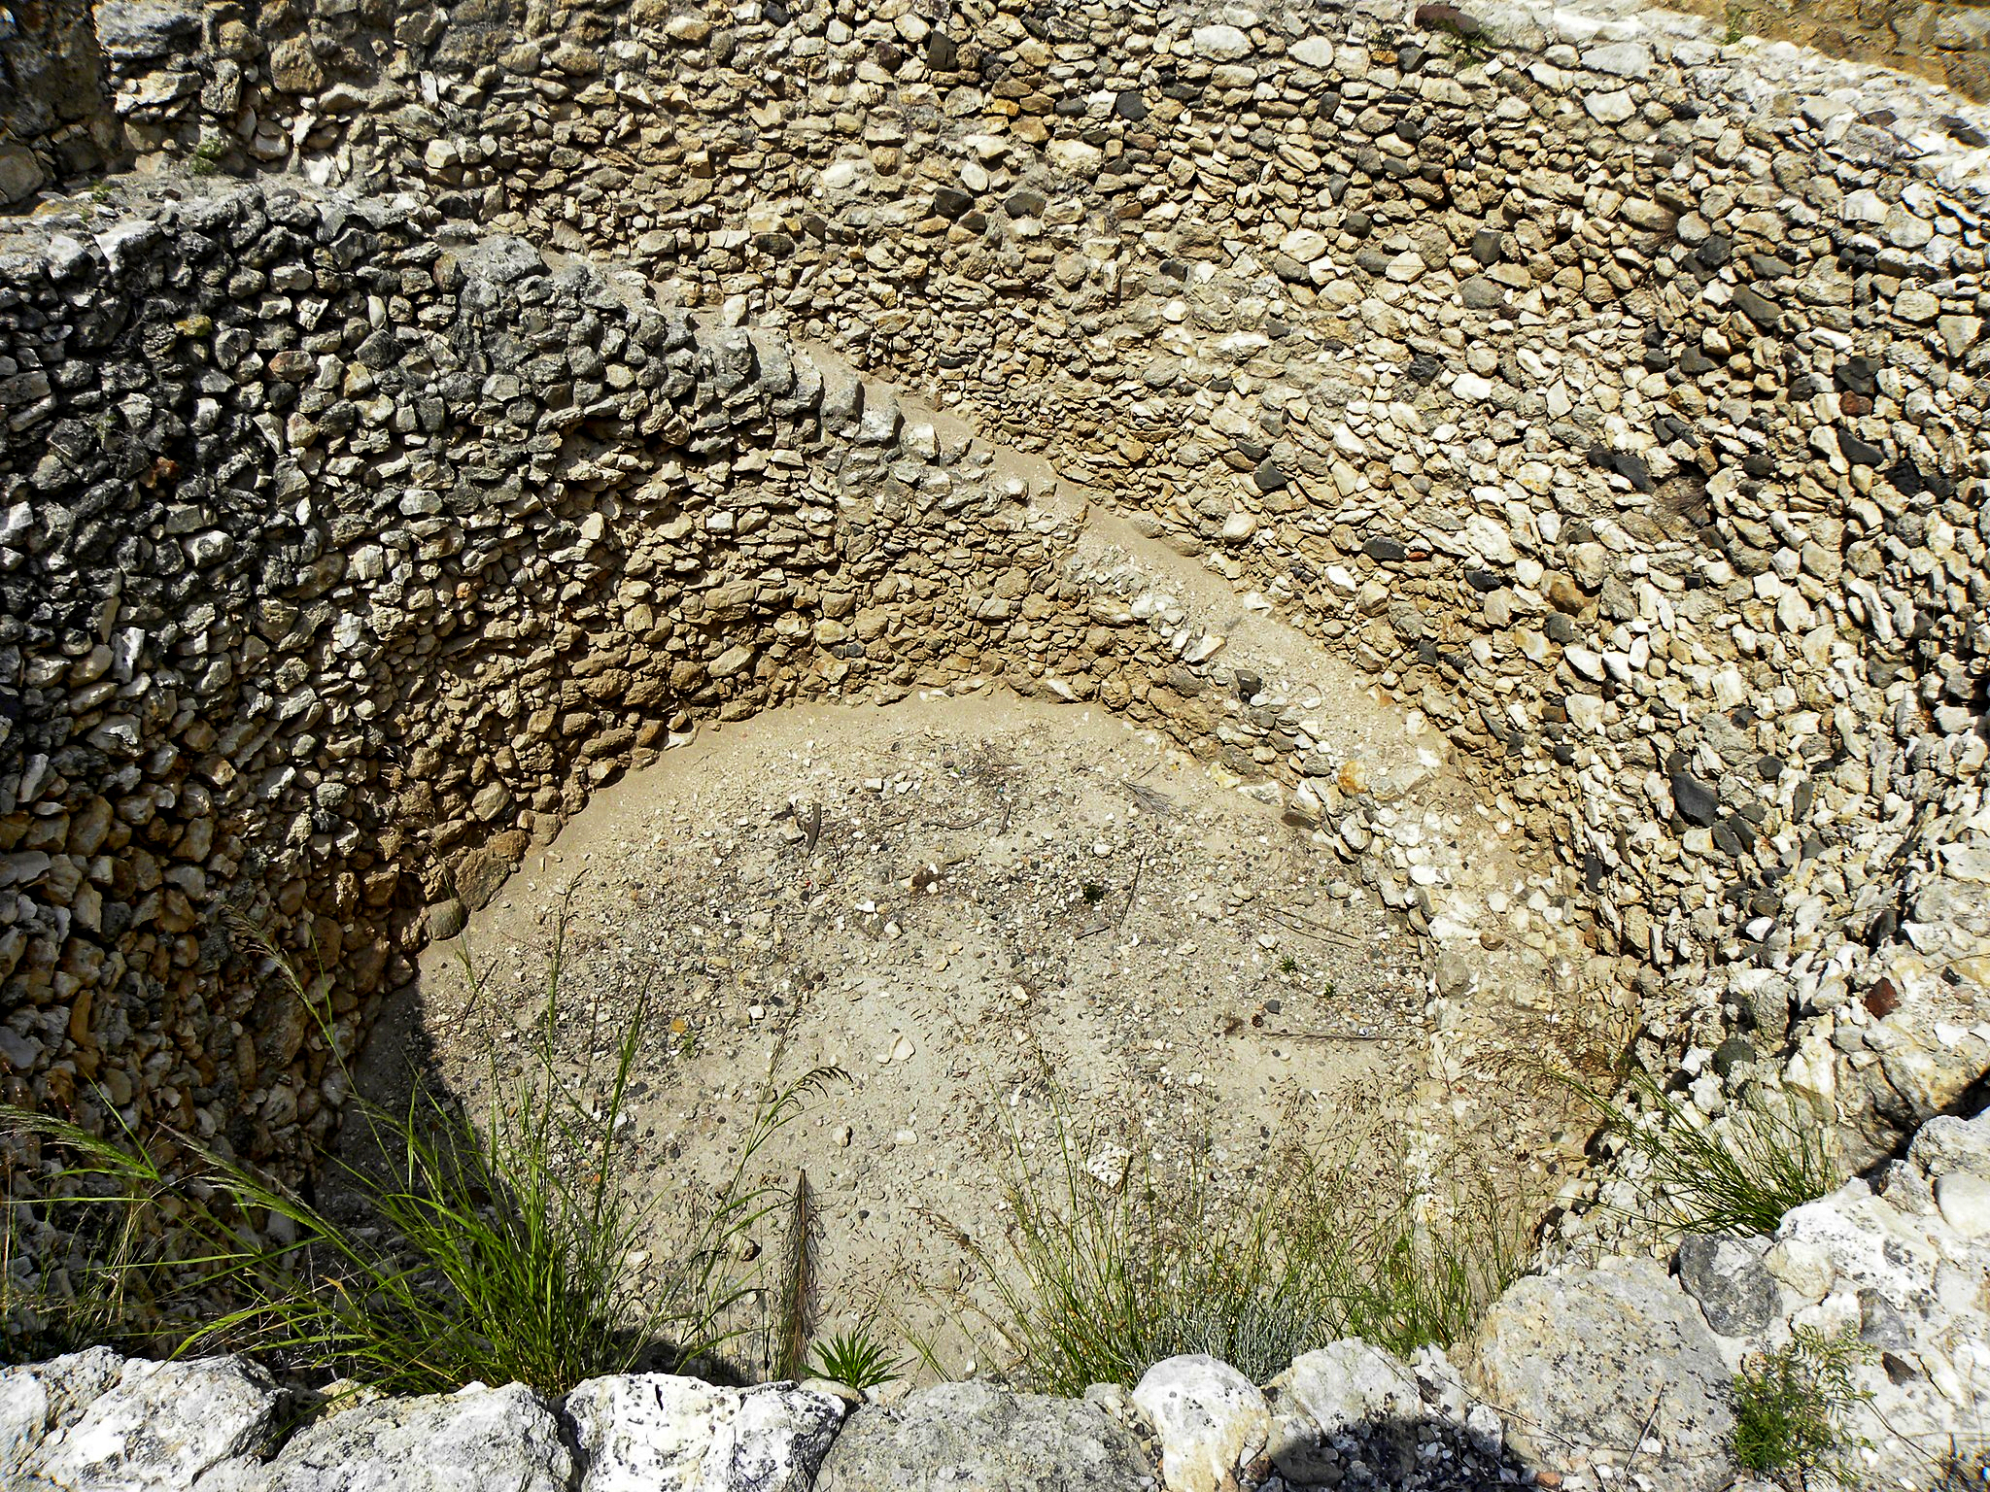

Translation:
In a number of languages an important distinction is made between buildings used to store farm produce and those that are warehouses for other types of material. This structure was actually not a “building” in the sense that it was constructed like a house. The English word “barn” conveys the idea of a large, multi-purpose structure. Something like “grain-store,” “granary,” or “grain bin” will be preferable.
Most of the references to the Hebrew word misknoth (except 2CH 32:28) appear with the word for “city.” The following advice comes from of A Handbook on Exodus (page 22) at EXO 1:11: “The store-cities were special centers built as warehouses for storing grain and other supplies for the government. If such centers are unknown in the receptor culture, it is possible to translate this word as ‘cities in which to store supplies,’ or ‘cities … to serve as supply centers,’ as in TEV [that is, GNT]. In cultures where the only large human settlements are villages surrounded by fences, translators will need other more descriptive ways to translate store-cities; for example, ‘large villages with high walls [or, fences] around them, where supplies are stored’ or ‘large places with high fences around them, where they store grain and other things.’ ”

