Resource: Human-made Things in the Bible
Human-made Things in the Bible © United Bible Societies, 2025. Adapted from: The Works of Their Hands: Man-made Things in the Bible, by Ray Pritz © 2009 United Bible Societies. This work is licensed under Creative Commons Attribution-ShareAlike 4.0 International (https://creativecommons.org/licenses/by-sa/4.0/).

Human-made Things in the Bible

Temples

3.14 Temples

Jewish Temple

3.14.1 Jewish Temple

References:Hebrew בַּיִת (bayith)2SA 7:5, 2SA 7:6, 2SA 7:7, 1KI 3:1, 1KI 3:2, 1KI 5:17, 1KI 5:19, 1KI 5:19, 1KI 5:31, 1KI 5:32Hebrew הֵיכָל (heykal)2SA 22:7, 1KI 6:3, 1KI 6:5, 1KI 7:21, 2KI 18:16, 2KI 23:4, 2KI 24:13, 2CH 3:17, 2CH 4:7, 2CH 4:8, 2CH 26:16, 2CH 27:2, EZR 3:6, EZR 3:10, EZR 4:1, PSA 27:4, PSA 29:9, PSA 48:10, PSA 65:5, PSA 68:30, PSA 79:1, ISA 44:28, ISA 66:6, JER 7:4, JER 7:4, JER 7:4, JER 24:1, JER 50:28, JER 51:11, AMO 8:3, HAG 2:15, HAG 2:18, ZEC 6:12, ZEC 6:13, ZEC 6:14, ZEC 6:15, ZEC 8:9Aramaic הֵיכַל (heykal)EZR 5:14, EZR 5:14, EZR 5:14, EZR 5:15, EZR 6:5, EZR 6:5, DAN 5:2, DAN 5:3Hebrew מוֹעֵד (mo‘ed)PSA 74:4, LAM 2:6Hebrew מִקְדָּשׁ (miqdash)1CH 22:19, 1CH 28:10, 2CH 20:8, 2CH 26:18, 2CH 29:21, 2CH 30:8, 2CH 36:17, NEH 10:40, PSA 68:36, PSA 73:17, PSA 74:7, PSA 78:69, PSA 96:6, ISA 60:13, ISA 63:18, JER 17:12, JER 51:51, LAM 1:10, LAM 2:7, LAM 2:20, EZK 5:11, EZK 8:6, EZK 9:6, EZK 23:38, EZK 23:39, EZK 24:21, EZK 25:3, EZK 37:26, EZK 37:28, EZK 43:21, EZK 44:1, EZK 44:5, EZK 44:7, EZK 44:8, EZK 44:9, EZK 44:11, EZK 44:15, EZK 44:16, EZK 45:4, EZK 45:4, EZK 45:18, EZK 47:12, EZK 48:8, EZK 48:10, EZK 48:21, DAN 8:11, DAN 9:17, DAN 11:31Hebrew קָדוֹשׁ (qadosh)ECC 8:10Hebrew קֹדֶשׁ (qodesh)1CH 23:32, 1CH 24:5, 2CH 29:5, 2CH 29:7, 2CH 30:19, PSA 20:3, PSA 24:3, PSA 63:3, PSA 68:18, PSA 68:25, PSA 74:3, PSA 134:2, PSA 150:1, ISA 43:28, EZK 44:27, EZK 44:27, EZK 45:3, EZK 45:3, EZK 45:3, DAN 8:13, DAN 8:14, DAN 9:24, DAN 9:26Hebrew שֹׂךְ (sok)LAM 2:6Greek ἅγιος (hagios)JDT 4:12, JDT 4:13, JDT 8:21, JDT 8:24, JDT 9:8, JDT 16:20, 1MA 2:12, 1MA 3:43, 1MA 3:51, 1MA 3:58, 1MA 3:59, 1MA 4:36, 1MA 4:41, 1MA 4:43, 1MA 4:48, 1MA 6:18, 1MA 6:54, 1MA 7:33, 1MA 7:42, 1MA 9:54, 1MA 10:42, 1MA 10:39, 1MA 10:39, 1MA 10:44, 1MA 13:3, 1MA 13:6, 1MA 14:15, 1MA 14:15, 1MA 14:29, 1MA 14:31, 1MA 14:36, 1MA 14:42, 1MA 14:48, 1MA 15:7, 2MA 15:17Greek ἁγίασμα (hagiasma)JDT 5:19, SIR 47:10, SIR 47:13, SIR 50:11, 1MA 1:21, 1MA 1:36, 1MA 1:37, 1MA 1:37, 1MA 1:39, 1MA 1:45, 1MA 1:46, 1MA 2:7, 1MA 3:45, 1MA 4:38, 1MA 5:1, 1MA 6:7, 1MA 6:26, 1MA 6:51Greek ἁγιασμός (hagiasmos)3MA 2:18Greek ἱερός (hieros)MAT 4:5, MAT 12:5, MAT 12:6, MAT 21:12, MAT 21:12, MAT 21:14, MAT 21:15, MAT 21:23, MAT 24:1, MAT 24:1, MAT 26:55, MRK 11:11, MRK 11:15, MRK 11:15, MRK 11:16, MRK 11:27, MRK 12:35, MRK 13:1, MRK 13:3, MRK 14:49, LUK 2:27, LUK 2:37, LUK 2:46, LUK 4:9, LUK 18:10, LUK 19:45, LUK 19:47, LUK 20:1, LUK 21:5, LUK 21:37, LUK 21:38, LUK 22:52, LUK 22:53, LUK 24:53, JHN 2:14, JHN 2:15, JHN 5:14, JHN 7:14, JHN 7:28, JHN 8:2, JHN 8:20, JHN 8:59, JHN 10:23, JHN 11:56, JHN 18:20, ACT 2:46, ACT 3:1, ACT 3:2, ACT 3:2, ACT 3:3, ACT 3:8, ACT 3:10, ACT 4:1, ACT 5:20, ACT 5:21, ACT 5:24, ACT 5:25, ACT 5:42, ACT 19:27, ACT 21:26, ACT 21:27, ACT 21:28, ACT 21:29, ACT 21:30, ACT 22:17, ACT 24:6, ACT 24:12, ACT 24:18, ACT 25:8, ACT 26:21, 1CO 9:13, 1CO 9:13Greek ναός (naos)MAT 23:16, MAT 23:16, MAT 23:17, MAT 23:21, MAT 23:35, MAT 26:61, MAT 27:5, MAT 27:40, MAT 27:51, MRK 14:58, MRK 15:29, MRK 15:38, LUK 1:9, LUK 1:21, LUK 1:22, LUK 23:45, JHN 2:19, JHN 2:20, 1CO 3:17, 1CO 3:17, 2CO 6:16, EPH 2:21, 2TH 2:4, REV 3:12, REV 7:15, REV 11:1, REV 11:2, REV 11:19, REV 11:19, REV 14:15, REV 14:17, REV 15:5, REV 15:6, REV 15:8, REV 15:8, REV 16:1, REV 16:17Greek νεώς (neōs)2MA 4:14, 2MA 6:2, 2MA 9:16, 2MA 10:3, 2MA 10:5, 2MA 13:23, 2MA 14:33Greek οἰκία, οἶκος (oikia, oikos)MAT 12:4, MAT 21:13, MAT 21:13, MRK 2:26, MRK 11:17, MRK 11:17, LUK 6:4, LUK 11:51, LUK 19:46, LUK 19:46, JHN 2:16, JHN 2:17, JHN 14:2, ACT 7:47, ACT 7:49, HEB 3:2, HEB 3:5, HEB 10:21Greek σκήνωμα (skēnōma)JDT 9:8Greek τόπος, ἅγιος, ἁγίασμα (topos, hagios topos, topos hagios, topos tou hagiasmatos)MAT 24:15, JHN 11:48, ACT 6:13, ACT 21:28, 2MA 2:18, 2MA 3:18, 2MA 5:17, 2MA 5:19, 2MA 5:19, 2MA 8:17, 2MA 10:7, 2MA 13:23, 3MA 1:9, 3MA 1:9, 3MA 1:23, 3MA 2:14, 4MA 4:9, 4MA 4:12, 1ES 8:75Latin sanctificatio2ES 7:108, 2ES 10:21, 2ES 12:48, 2ES 15:25Latin templum2ES 10:21

Description and usage:
Herod's temple at time of Christ, showing the bridge supported by Wilson's arch at the center left (© Public Domain - Wikimedia Commons)The Temple was the building in Jerusalem in which God was regarded as dwelling and where he was worshiped. From the time it was first built by Solomon, it was the center of worship for the Jewish people. In Jewish history three temples were constructed, all of them quite different from the others. The first Temple, built by Solomon, was destroyed in 587/586 B.C. A new, more modest Temple was built about seventy years later by Zerubbabel and lasted until almost the time of the New Testament, when it was rebuilt by Herod the Great. This third structure was only completed about 63 A.D. and was destroyed by the Roman army seven years later.
<image: 2Q==>

Translation:
A model of the temple mount in Herod's time (© Ray Pritz by United Bible Societies)There are, in fact, four different Jewish temples in the Bible: those built by Solomon, Zerubbabel, and Herod the Great, and the vision of an ideal Temple in the last chapters of Ezekiel. While the same word should be used for all of them, it will be helpful for the reader to have a note or glossary entry explaining the differences between them. It will not normally be necessary—or even advisable—to reflect those differences in translation.
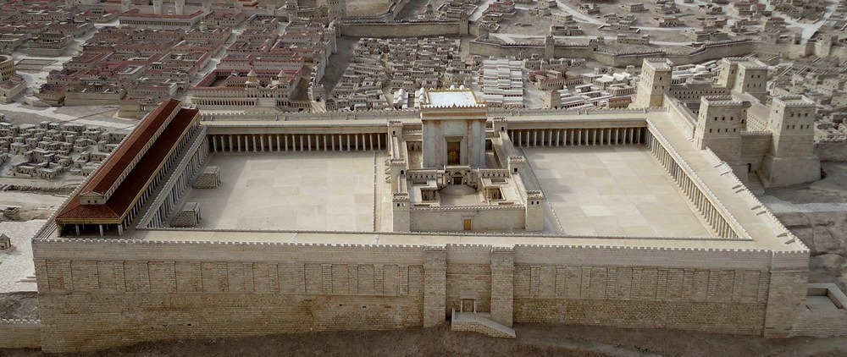
“Temple” may be rendered “house of God,” “place where God dwells,” or “God’s building.” Some languages often say “holy house” or “holy place.” Other renderings are “God’s great singing house” and “God’s big prayer house.”
An artist's conception of Ezekiel's Temple (© Deutsche Bibelgesellschaft, Stuttgart by United Bible Societies)The Hebrew word mo‘ed means literally an appointed time or place of meeting. In the references given above it refers to the Temple as the place where people came for the sacred festivals.
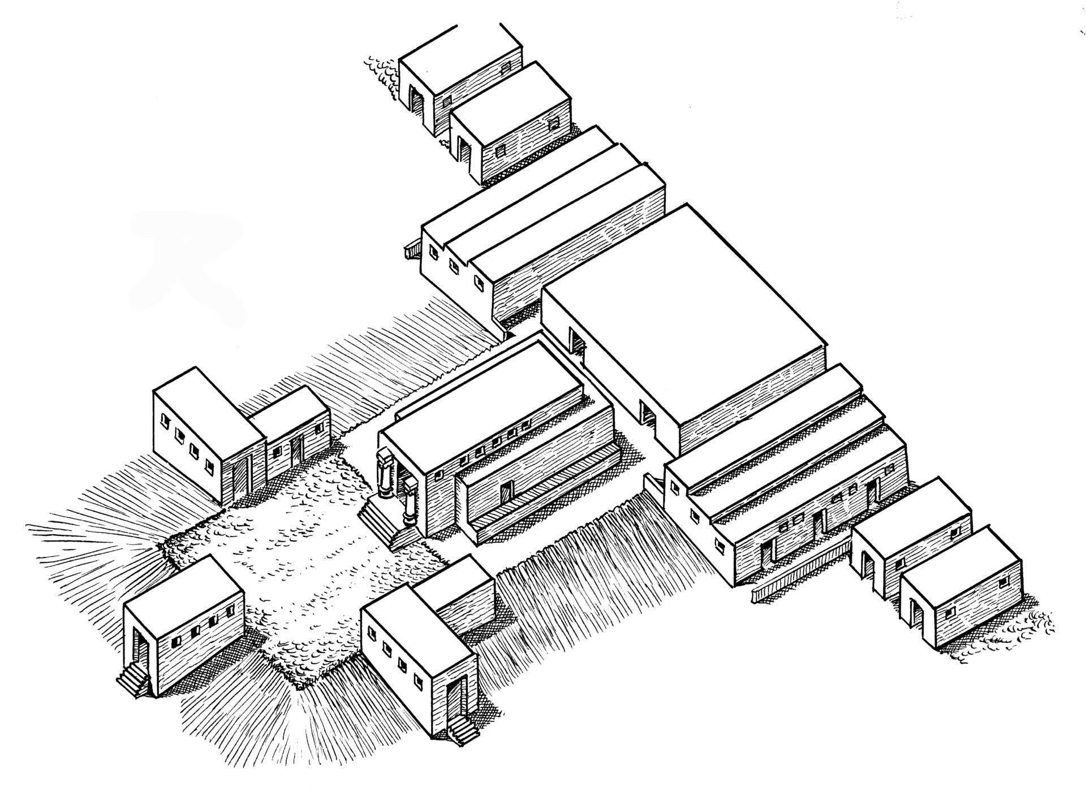
(Image generated by ChatGPT using OpenAI technology)In some languages there is a technical term for “temple,” and this is often carefully distinguished from an expression designating a central sanctuary in which the deity is thought to dwell. In the New Testament the Greek word naos refers to a single building, while the word hieron points to the entire Temple precinct with its buildings, courts, and storerooms. Even though in a number of contexts it is not necessary to distinguish between hieron and naos, in MAT 21:12 (and the parallel passages MRK 11:15; LUK 19:45; JHN 2:14), it is important to indicate this distinction in order not to leave the impression that sacrificial animals were actually being sold inside the central sanctuary. When translating “temple,” translators should avoid using the same term used to translate “synagogue” in the New Testament.
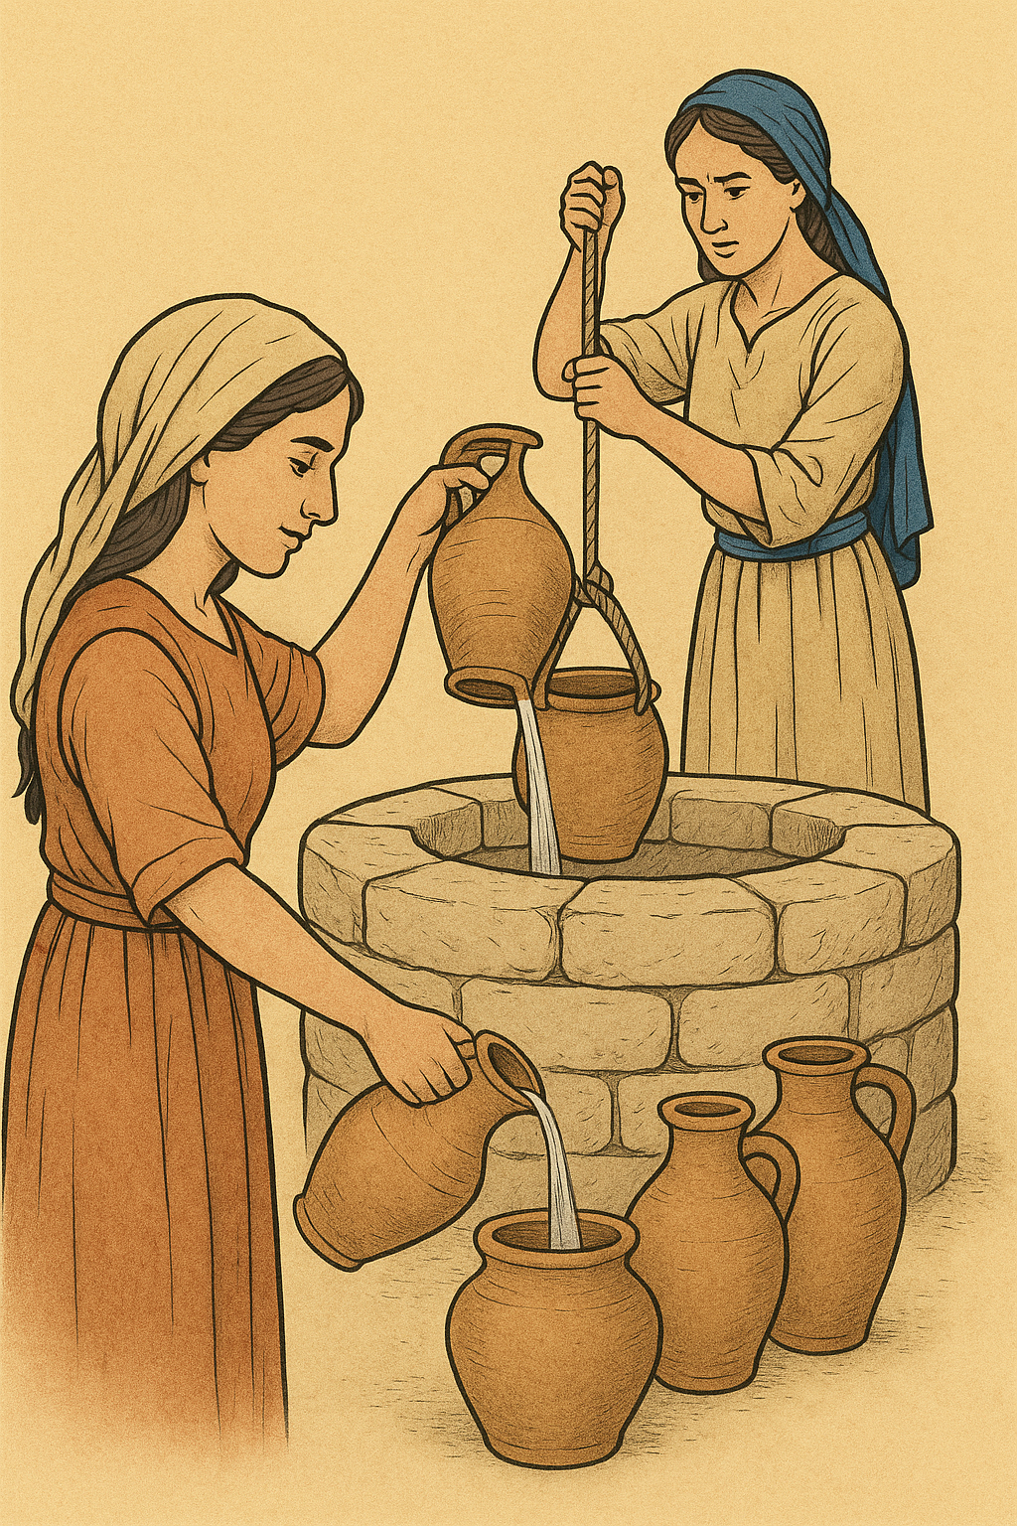

Entrance room, entrance hall

3.14.1.1 Entrance room, entrance hall

References:Hebrew אֵילָם, אוּלָם (’eylam, ’elam, ’ulam)1KI 6:3, 1KI 7:6, 1KI 7:6, 1KI 7:7, 1KI 7:7, 1KI 7:8, 1KI 7:8, 1KI 7:12, 1KI 7:19, 1KI 7:21, 1CH 28:11, 2CH 3:4, 2CH 8:12, 2CH 15:8, 2CH 29:7, 2CH 29:17, EZK 8:16, EZK 40:7, EZK 40:8, EZK 40:9, EZK 40:9, EZK 40:15, EZK 40:16, EZK 40:21, EZK 40:21, EZK 40:22, EZK 40:22, EZK 40:22, EZK 40:22, EZK 40:24, EZK 40:24, EZK 40:25, EZK 40:25, EZK 40:26, EZK 40:26, EZK 40:29, EZK 40:29, EZK 40:29, EZK 40:29, EZK 40:30, EZK 40:31, EZK 40:33, EZK 40:33, EZK 40:33, EZK 40:33, EZK 40:34, EZK 40:34, EZK 40:36, EZK 40:36, EZK 40:39, EZK 40:40, EZK 40:48, EZK 40:48, EZK 40:49, EZK 41:15, EZK 41:25, EZK 41:26, EZK 44:3, EZK 46:2, EZK 46:8, JOL 2:17Hebrew מִסְדְּרוֹן (misdron)JDG 3:23

Description and usage:
The entrance hall was a kind of foyer or anteroom that extended across the entrance of a large building. The entrance hall of the Temple stood higher than the rest of the Temple, and it may not have had a roof. While the biblical text considers it part of the internal space of the sanctuary, it may have served as a kind of forecourt, a transition from the outside courtyard to the inside of the building. Several of the passages above do not refer to the entrance hall of the Temple. JDG 3:23 and 1KI 7:6; 1KI 7:7; 1KI 7:8 refer to the entrance halls of palaces, while some of the passages in Ezekiel (EZK 40:7; EZK 40:8; EZK 40:9, EZK 40:15; EZK 40:16; EZK 40:17; EZK 40:18; EZK 40:19; EZK 40:20; EZK 40:21; EZK 40:22; EZK 40:23; EZK 40:24; EZK 40:25; EZK 40:26; EZK 40:27; EZK 40:28; EZK 40:29; EZK 40:30; EZK 40:31; EZK 40:32; EZK 40:33; EZK 40:34; EZK 40:35; EZK 40:36, EZK 40:39; EZK 40:40; EZK 46:2, EZK 46:8) refer to the entrance halls of the Temple gates.

Translation:
In many languages the only approximate equivalent for the Hebrew word ’ulam may be a small hall inside the entrance to a house. This could be misleading since this word refers to a very large hall, which was even wider than the main building. It may be necessary to add a modifier of size, saying “large entry hall.”

Colonnade, porch, covered walkway, stoa, portico

3.14.1.2 Colonnade, porch, covered walkway, stoa, portico

References:Greek στοά (stoa)JHN 5:2, JHN 10:23, ACT 3:11, ACT 5:12

Description and usage:
Model of covered walkway surrounding Herod's temple (© Ray Pritz by United Bible Societies)The porch was a covered colonnade, open normally on one side, where people could stand, sit, or walk, protected from the weather and the heat of the sun. It consisted of two parallel rows of columns that supported a roof.
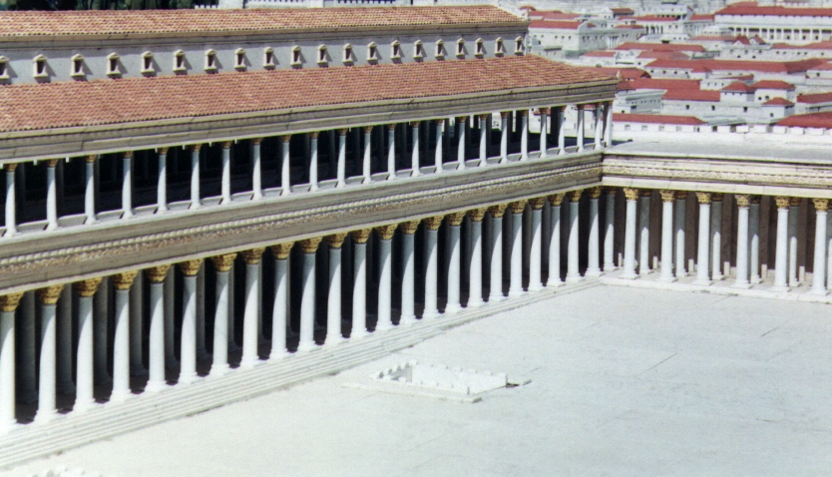

Translation:
In many parts of the world the closest equivalent for the Greek word stoa would be a verandah, an extensive type of porch. Such a porch may be rendered “long outside room” or “room made with pillars and open.” All of the above references except JHN 5:2 are to “Solomon’s Porch,” which was probably located along the eastern edge of the Court of the Gentiles in the Temple complex.

Rooms for boiling meat from sacrifices, kitchens

3.14.1.3 Rooms for boiling meat from sacrifices, kitchens

Reference:Hebrew בַּיִת, בשׁל (beyth mvashlim)EZK 46:24

Description and usage:
In Ezekiel’s description of the Temple, special rooms were designated at the four corners of the outer court for boiling the meat from the sacrifices. The people who brought certain sacrifices were to eat a sacred meal, which was prepared in these rooms by servants (perhaps Levites) designated for the task.

Translation:
Most translations render beyth mvashlim in EZK 46:24 as “kitchen” (RSV, CEV, NIV). NASB has “boiling places.” GECL avoids translating the name of the rooms by saying “Here the Temple servants will cook the meat for the sacred meal of the people.”

Treasury, strongroom

3.14.1.4 Treasury, strongroom

References:Hebrew אֲרוֹן (’aron)2KI 12:10, 2KI 12:11, 2CH 24:8, 2CH 24:10, 2CH 24:11, 2CH 24:11Hebrew בַּיִת, אָסֹף ((beyth) ’asupim)1CH 26:15, 1CH 26:17Hebrew בַּיִת, אוֹצָר ((beyth) ’otsar)DEU 28:12, DEU 32:34, JOS 6:19, JOS 6:24, 1KI 7:51, 1KI 15:18, 1KI 15:18, 2KI 12:19, 2KI 14:14, 2KI 16:8, 2KI 18:15, 2KI 20:13, 2KI 20:15, 2KI 24:13, 2KI 24:13, 1CH 9:26, 1CH 26:20, 1CH 26:20, 1CH 26:22, 1CH 26:24, 1CH 26:26, 1CH 27:25, 1CH 27:25, 1CH 28:12, 1CH 28:12, 1CH 29:8, 2CH 5:1, 2CH 8:15, 2CH 12:9, 2CH 12:9, 2CH 16:2, 2CH 25:24, 2CH 32:27, EZR 2:69, NEH 7:69, NEH 7:70, NEH 10:39, PRO 8:21, EZK 28:4, DAN 1:2, HOS 13:15, MAL 3:10Hebrew בַּיִת, נְכֹאת (beth nkoth)2KI 20:13, ISA 39:2Aramaic גְּנַז (gnaz)EZR 7:20Hebrew גֶּנֶז (genez)EST 3:9, EST 4:7Hebrew גַּנְזַךְ (ganzak)1CH 28:11Greek γαζοφυλάκιον (gazofulakion)MRK 12:41, MRK 12:41, MRK 12:43, LUK 21:1, JHN 8:20, 1MA 3:28, 1MA 14:49, 2MA 3:6, 2MA 3:24, 2MA 3:28, 2MA 3:40, 2MA 4:42, 2MA 5:18, 4MA 4:3, 4MA 4:6, 1ES 5:44, 1ES 8:18, 1ES 8:44Greek θησαυρός (thēsauros)SIR 1:25, 1MA 3:29Greek κορβανᾶς (korbanas)MAT 27:6Greek ταμιεῖον (tamieion)SIR 29:12Greek θησαυρός (thesaurus)4MA 4:7Latin thesaurus2ES 6:40

Description and usage:
Southwest corner of the temple mount (model) (© Ray Pritz by United Bible Societies)The treasury was a place for storing valuables belonging to a king or other national authorities. The Temple in Jerusalem had its own treasury. There was no standard size or structure of a treasury.
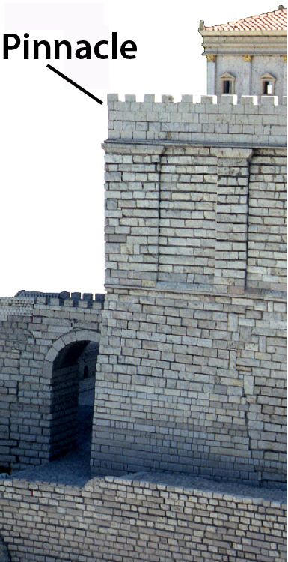

Translation:
The Hebrew word ’aron in 2KI 12:9; 2KI 12:10 and 2CH 24:8; 2CH 24:10; 2CH 24:11 refers to a large collection box. According to 2KI 12:9, a hole was cut in its “door.” This would refer to one surface of the box, presumably its top. People could bring their donations (not coins, which were not yet invented) and insert them into the box through the hole. The donations could then be removed by opening or removing the top.
In some passages the Hebrew word ’otsar refers to treasure (for example, 2KI 24:13; 2CH 12:9), while in other places it indicates the place where treasure was stored, that is, a treasury (for example, 2KI 20:13; 2CH 32:27). The first half of 1KI 15:18 says literally “And Asa took all the remaining silver and gold in the treasuries of the house of the LORD and [he took] the treasures of the king’s house.” No translation consulted makes the distinction, although some render both words “treasures” (RSV), while others render both words “treasuries” (NJPSV). In fact, in many of the references under ’otsar it is not easy to determine if the meaning is “treasure” or “treasure storehouse.” In only three places is there specific reference in Hebrew to a “treasure house” (NEH 10:39; DAN 1:2; MAL 3:10).
Where a word for “treasury” is not available, it may be rendered with a descriptive phrase, such as “safe place where the king’s [or, Temple’s] valuables were kept/were guarded.” An alternative model for the last half of MAT 27:6 is “It is against our Law to put it with the money that belongs to the Temple since it is blood money.”
In the New Testament the Greek word gazofulakion also refers to a box in which donations were collected. According to Jewish tradition, there were thirteen such offering boxes in the Temple, and the receptacles that channeled the money down to the boxes were in the form of trumpets or rams’ horns. As a result, the sound of coins falling into the boxes was rather conspicuous. In some cultures such a collection box may be unknown, or at best people know the container that is passed around to collect money in church. If possible, the translation should indicate that the offering box was in a fixed place and not something passed around. In LUK 21:1NCV has “Temple money box” and adds this note: “A special box in the Jewish place of worship where people put their gifts to God.” PV uses a longer expression, saying “place reserved for them [gifts].”

Pinnacle

3.14.1.5 Pinnacle

References:Greek πτερύγιον (pterugion)MAT 4:5, LUK 4:9

Description:
The pinnacle was the tip or high point of a structure. The passages listed above refer to the pinnacle of the Temple.

Translation:
The precise meaning of the Greek word pterugion is uncertain. Some scholars have proposed “lintel” or “superstructure of the gate [of the Temple].” The Greek word translated “temple” (hieron) in MAT 4:5 and LUK 4:9 refers to the whole area occupied by the sanctuary (see 3.14.1 Jewish Temple<REALIA:3.14.1>), and the pinnacle (literally “small wing”) could designate a corner or extreme point. So some scholars have suggested that it refers to the southwest corner of the Herodian wall surrounding the Temple complex. It is less likely that the word refers to some top corner of the Temple building itself. Common-language translations often render it “very high point” or “highest part.”

Curtain, veil, drape

3.14.1.6 Curtain, veil, drape

References:Hebrew פָּרֹכֶת (paroketh)EXO 26:31, EXO 26:33, EXO 26:33, EXO 26:33, EXO 26:35, EXO 27:21, EXO 30:6, EXO 35:12, EXO 36:35, EXO 38:27, EXO 39:34, EXO 40:3, EXO 40:22, EXO 40:22, EXO 40:26, LEV 4:6, LEV 4:17, LEV 16:2, LEV 16:12, LEV 16:15, LEV 21:23, LEV 24:3, NUM 4:5, NUM 18:7, 2CH 3:14Greek καταπέτασμα (katapetasma)MAT 27:51, MRK 15:38, LUK 23:45, HEB 6:19, HEB 9:3, HEB 10:20, SIR 50:5, 1MA 1:22, 1MA 4:51

Description:
The tabernacle curtain or veil (Image generated by ChatGPT using OpenAI technology)The veil was a hanging cloth that covered the entrance to a room or served as a divider between two parts of a room. In the Tabernacle and in the Temple, it hung in front of the Most Holy Place and divided the Most Holy Place from the Holy Place, standing directly in front of the Covenant Box. Some scholars say the veil did not hang but was draped over the top of the enclosure in which the Covenant Box stood, forming a kind of pavilion. The veil was woven of three colors of wool and one of linen and was decorated with figures of winged creatures. It was a heavy cloth (post-biblical Jewish tradition saying it was as thick as the width of a man’s hand).
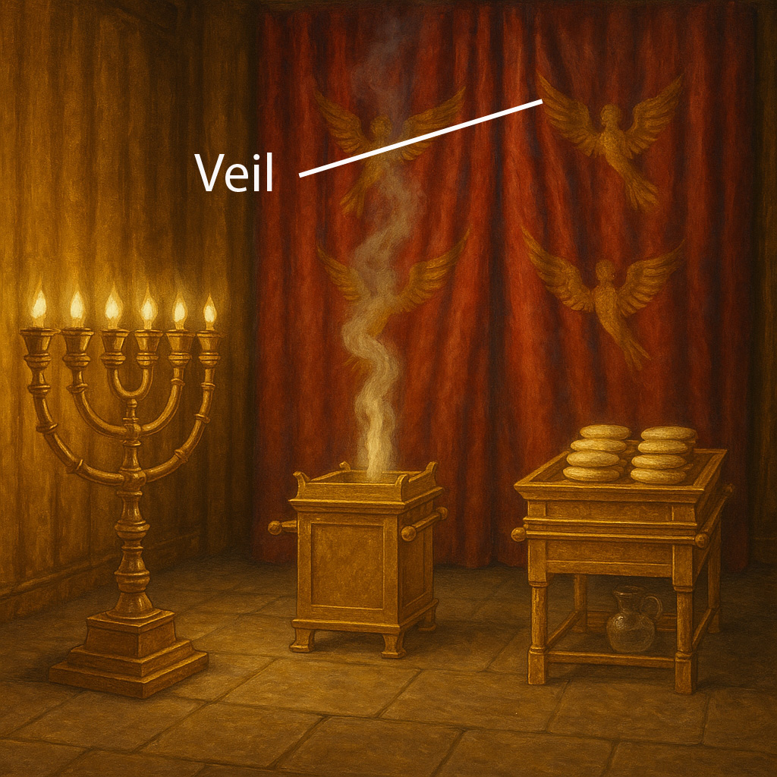

Usage:
In addition to shielding the Most Holy Place from view, the veil served the same purpose for the Covenant Box when it was being moved. When the Tabernacle was dismantled, the veil was lowered from the front (or above) directly onto the Box, thus preventing anyone from seeing the Box even during the transitions.

Translation:
The Hebrew word paroketh literally means “partition.” In Jewish tradition it was identified with a special partition that separated a king from the people. Some languages may have a special word for such a partition.
The Hebrew word paroketh and the Greek word katapetasma in connection with the Temple have been traditionally rendered “veil” in English, but a literal corresponding word for “veil” in another language could be misleading since it might suggest something that merely covers the face. Even a corresponding word for “curtain” could be misleading since it might suggest something that covers a window. Frequently it is necessary to use some kind of descriptive equivalent, for example, “large piece of cloth hanging down from the ceiling” or “large piece of cloth covering the entrance.”
EXO 26:31 provides a description of this object. The “veil” (RSV; Hebrew paroketh) was a “curtain” (GNT), of course, but it is good to distinguish this from the “screen” (RSV; Hebrew masak) at the entrance to the Tabernacle, which was also a curtain (see EXO 26:36 and 3.15.2.3.8 Screen, entrance curtain<REALIA:3.15.2.3.8>). The word masak has the primary meaning of covering something, or even hiding something, while paroketh primarily means making a division and setting something apart. Some translations make no distinction between the two words (GNT, NIV), but others have “curtain/screen” (NRSV, NJPSV, NJB, REB), “veil/curtain” (NAB), “Veil/Screen” (Durham), “screen/covering” (TOT), and even “curtain/veil” (Mft). The paroketh, however, was there to separate the Holy Place from the Most Holy Place (see EXO 26:33). So this information may be brought forward to this verse. This will indicate that it was a “screen” or “veil” to hide the contents of the Most Holy Place. In cultures where a “curtain” such as this is unknown, translators may say “holy [or, taboo] cloth.”
EXO 26:33: “And you shall hang the veil from the clasps” (RSV) is literally “And you [singular] shall place the veil under the clasps.” “The clasps” refers to the gold clasps mentioned in 26.6, which held together the two large pieces of the inner linen layer of the Tabernacle. When this layer was placed over the framework according to the instructions, the row of clasps would be exactly ten cubits (4.5 meters, or 15 feet) from the west end. NAB and NIV suggest with RSV that the veil was suspended from these clasps, but NRSV has corrected this to “under the clasps.” This means “under the row of hooks in the roof of the Tent” (GNT).

Additional Temple features

3.14.1.7 Additional Temple features

References:Hebrew אַתּוּק, אַתִּיק (’atuq, ’atiq)EZK 41:15, EZK 41:15, EZK 41:16, EZK 42:3, EZK 42:3, EZK 42:5Hebrew עָב (‘av)EZK 41:25, EZK 41:26Hebrew שְׂחִיף, עֵץ (schif ‘ets)EZK 41:16Hebrew מִגְרַעַת (migra‘ah)1KI 6:6

Description and translation:
The meaning of the Hebrew word ’atuq /’atiq in EZK 41:15; EZK 41:16; EZK 42:3; EZK 42:5 is unknown. Translations of this term vary widely as follows: “walls” (RSV), “side rooms” (CEV), “galleries” (GNT, NIV), “ledges” (NJPSV), and “corridors” (REB).
The meaning of the Hebrew word ‘av in EZK 41:25; EZK 41:26 is also unknown. The same word appears as some sort of architectural feature in 1KI 7:6, where its meaning is equally obscure. Among a variety of renderings we find “covering” (GNT, CEV), “canopy” (RSV), “overhang” (NIV), and “lattice” (NJPSV).
The Hebrew adjective schif appears only in EZK 41:16 and its meaning is unknown. From the description of Solomon’s Temple in H01100600600058 we learn that many things were made of wood and then overlaid with gold. Since it was difficult to overlay stone with gold, it was sometimes the practice to cover the stone first with a thin layer of wood paneling or veneer and then overlay the wood with gold. Even though there is no mention of gold overlay in Ezekiel’s description of the future Temple, it has been suggested that such a wood veneer covered the inner stone walls and was itself overlaid with gold. A translator should not, of course, introduce gold where none is mentioned. The phrase schif‘ets has been rendered “paneled with wood” (RSV, GNT), “trimmed in wood” (CEV), “covered with wood” (NIV), “framed with wood” (REB), and “overlaid with wood” (NJPSV).
The Hebrew word migra‘ah in 1KI 6:6 describes a structural device in Solomon’s Temple. Against the outer wall of the Temple building were built smaller rooms (see tsela‘ under 3.1.6 Room<REALIA:3.1.6>). This meant that the outer wall of the Temple building formed one wall of these smaller rooms. One end of the crossbeams (mentioned in the Aramaic Targum but not in the text of 1 Kings; see 3.1.5.3 Crossbeam, rafter<REALIA:3.1.5.3>) was set into the outer wall of the small room, while the other end had to take its support from the outer wall of the Temple. Rather than make a hole right through the Temple wall, they made a recess or niche (or narrow ledge) in which the end of the beam sat. This supporting feature is called a migra‘ah. It has been rendered “offsets” (RSV), “recesses” (NJPSV), “ledges” (CEV), or “offset ledges” (NIV).

Other features of the Temple treated elsewhere in this chapter

3.14.1.8 Other features of the Temple treated elsewhere in this chapter

Beams - 3.1.5.3 Crossbeam, rafter<REALIA:3.1.5.3>
Chains - 3.21.4 Chain<REALIA:3.21.4>
Courtyards - 3.20 Courtyard, court<REALIA:3.20>
Doors - 3.1.2 Door, doorway<REALIA:3.1.2>
Doorposts - 3.1.2.4 Doorpost<REALIA:3.1.2.4>
Fortress - 3.13.3.2 Fortress, stronghold, castle, citadel, fort<REALIA:3.13.3.2>
Foundation - 3.1.1 Foundation<REALIA:3.1.1>
Gates - 3.13.3.5 City gate<REALIA:3.13.3.5>
Gateways - 3.1.3 Gate or gateway to house or building complex<REALIA:3.1.3>
Guardrooms - 3.13.3.5.2 Guardroom<REALIA:3.13.3.5.2>
Hinges - 3.1.2.3 Hinge<REALIA:3.1.2.3>
Holy Place - 3.15.2.1 Holy Place<REALIA:3.15.2.1>
Lintels - 3.1.2.5 Lintel<REALIA:3.1.2.5>
Most Holy Place - 3.15.2.2 Holy of Holies, Most Holy Place<REALIA:3.15.2.2>
Networks on capitals - 3.5 Column, pillar, capital<REALIA:3.5>
Pillars - 3.5 Column, pillar, capital<REALIA:3.5>
Roof - 3.1.5 Roof, housetop<REALIA:3.1.5>
Stairs, steps - 3.1.7 Stairs, steps<REALIA:3.1.7>
Stories - 3.1.6.3 Wall<REALIA:3.1.6.3> and 3.1.6.4 Upper room, roof chamber<REALIA:3.1.6.4>
Thresholds - 3.1.2.6 Threshold, doorsill<REALIA:3.1.2.6>
Windows - 3.1.4 Window<REALIA:3.1.4>
Walls - 3.6 Boundary wall, fence<REALIA:3.6>

Pagan temple, idol’s temple

3.14.2 Pagan temple, idol’s temple

References:Hebrew בַּיִת (bayith)JDG 9:27, JDG 9:46, JDG 17:5, 1SA 5:2, 1SA 5:5, 1CH 10:10, 1CH 10:10, 2CH 32:21, EZR 1:7, JER 43:12, JER 43:13, DAN 1:2, NAM 1:14Hebrew מִקְדָּשׁ (miqdash)LEV 26:31, ISA 16:12, EZK 7:24, EZK 21:7, EZK 28:18, AMO 7:9, AMO 7:13Greek εἰδωλεῖον, εἰδώλιον (eidōleion, eidōlion)1CO 8:10, BEL 1:10, 1MA 1:47, 1MA 10:83, 1ES 2:7Greek ἱερόν, ἱερός (hieron, hieros)ACT 19:27, JDT 4:1, BEL 1:8, 1MA 6:2, 1MA 10:84, 1MA 11:4, 2MA 1:13, 2MA 1:15, 2MA 14:33, 3MA 2:28, 3MA 3:16, 3MA 3:16Greek ναός (naos)BEL 1:14, 1ES 1:39, 1ES 6:18, 1ES 6:18Greek οἰκία, οἶκος (oikia, oikos)LJE 1:11, LJE 1:15, LJE 1:18, LJE 1:19, LJE 1:20, LJE 1:30, LJE 1:54, BEL 1:10Greek σκηνή (skēnē)ACT 7:43Greek τέμενος (temenos)1MA 1:47, 1MA 5:43, 1MA 5:44, 2MA 1:15, 2MA 10:2, 2MA 11:3, 3MA 1:7, 3MA 1:13

Description and usage:
The pagan temple was a sanctuary that housed an idol. It would be at least the size of a house or perhaps much larger.

Translation:
It is not always clear in the references listed above if the Hebrew word miqdash refers to non-Israelite places of worship or to the Jewish Temple; for example, in EZK 21:7 some translations have “sanctuaries” (RSV, NJPSV), while others say “Temple” (GECL) or “sanctuary” (NIV, REB), indicating the Jewish Temple.
The Greek terms eidōleion and eidōlion may be rendered “building in which an idol is placed” or “large house in which an idol is worshiped.” Since “idol” is often rendered “statue of a god” (see 4.6 Idols<REALIA:4.6>), these words may be rendered “building in which a statue of a god is worshiped.” Some cultures are familiar with small spirit houses. However, these words indicate a larger shrine, one into which the worshiper could enter. Translators should avoid the strange picture of someone going into a tiny structure.
The Greek word skēnē in ACT 7:43 does not refer to a building but a temporary structure, a “tent” (RSV, GNT). The same word is used in the next verse for the Jewish Tabernacle, although Stephen is not intending a comparison between the two.
Technically, the Greek word temenos does not refer to a building but rather to a defined sacred area in which temples or shrines might be built. Even so, in 1MA 1:47GNT renders it “temples,” while RSV and REB have “sacred precincts” and NJB says “shrines.”

Tower, ziggurat

3.14.3 Tower, ziggurat

References:Hebrew מִגְדָּל (migdal)GEN 11:4, GEN 11:5

Description and usage:
A model of a Babylonian ziggurat (Model of Etemenanki, Pergamonmuseum, Berlin) (O.Mustafin, CC0, via Wikimedia Commons)The ziggurat was a very high tower built for religious or ceremonial purposes. It had a staircase around its outside and a shrine at the top.
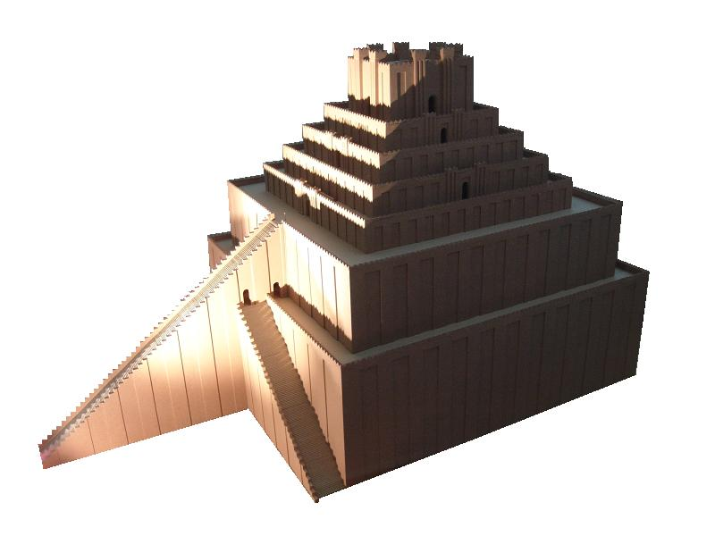

Translation:
In Mesopotamia there are imposing ruins of enormous structures in the form of stepped towers or pyramids, called ziggurats. The most important of these ziggurats are the ones of Ur and of Babylon, dating respectively from the end of the third and the beginning of the second millennium B.C. The ziggurat in Ur is square, measuring 43.3 meters (142 feet) wide by about 62.5 meters (205 feet) long. It has not been possible to calculate precisely its original height, but it appears to have had seven stages or stories. The account of GEN 11:1; GEN 11:2; GEN 11:3; GEN 11:4; GEN 11:5; GEN 11:6; GEN 11:7; GEN 11:8; GEN 11:9 seems to refer to the ziggurat of Babylon. Its nucleus was made of mud bricks and was about 15 meters (50 feet) thick. The platform upon which it was built measured 457 meters (1500 feet) by 415 meters (1360 feet), but the ziggurat itself measured only 91.5 meters (300 feet) on each side. As in the case of the ziggurat in Ur, the one in Babylon had three flights of steps—two lateral ones 30.5 meters (100 feet) high and a central one 40 meters (132 feet) high. According to a tablet found in the ruins of the nearby sanctuary of Esagil, it must have had a height of about 91.5 meters (300 feet). The Greek historian Herodotus (Histories, Book I, 181 [185]) describes this ziggurat as being square and having eight levels or “towers” one on top of the other. Like the ziggurat in Ur, it had a shrine near its middle, to which there was access partly by a flight of steps and partly by a ramp.
In most translations it will be sufficient to translate the Hebrew word migdal as “tower” in GEN 11:4; GEN 11:5. Where there is no appropriate word in the receptor language, translators may say “high house with many stories” or even “very high ladder.”

