Resource: Human-made Things in the Bible
Human-made Things in the Bible © United Bible Societies, 2025. Adapted from: The Works of Their Hands: Man-made Things in the Bible, by Ray Pritz © 2009 United Bible Societies. This work is licensed under Creative Commons Attribution-ShareAlike 4.0 International (https://creativecommons.org/licenses/by-sa/4.0/).

Human-made Things in the Bible

Oil lamp and wick

5.1 Oil lamp and wick

References:Hebrew מָאוֹר (ma’or)EXO 25:6, EXO 27:20, EXO 35:8, EXO 35:14, EXO 35:14, EXO 35:28, EXO 39:37, LEV 24:2, NUM 4:9, NUM 4:16Hebrew נִיר (nir)1KI 11:36, 1KI 15:4, 2KI 8:19, 2CH 21:7, PRO 21:4Hebrew נֵר (ner)EXO 25:37, EXO 25:37, EXO 27:20, EXO 30:7, EXO 30:8, EXO 35:14, EXO 37:23, EXO 39:37, EXO 39:37, EXO 40:4, EXO 40:25, LEV 24:2, LEV 24:4, NUM 4:9, NUM 8:2, NUM 8:2, NUM 8:3, 1SA 3:3, 2SA 21:17, 2SA 22:29, 1KI 7:49, 1CH 28:15, 1CH 28:15, 1CH 28:15, 2CH 4:20, 2CH 4:21, 2CH 13:11, 2CH 29:7, JOB 18:6, JOB 21:17, JOB 29:3, PSA 18:29, PSA 119:105, PSA 132:17, PRO 6:23, PRO 13:9, PRO 20:20, PRO 20:27, PRO 24:20, PRO 31:18, JER 25:10, ZEP 1:12, ZEC 4:2, ZEC 4:2Greek λύχνος (luchnos)MAT 5:15, MAT 6:22, MRK 4:21, LUK 8:16, LUK 11:34, LUK 11:36, LUK 12:35, LUK 15:8, JHN 5:35, 2PE 1:19, REV 18:23, REV 21:23, REV 22:5, SIR 26:17, LJE 1:18, 1MA 4:50, 2MA 1:8, 2MA 10:3Latin lucerna2ES 12:42, 2ES 14:25Latin lumen2ES 10:2

References:

Wick:Hebrew פִּשְׁתָּה (pishtah)ISA 42:3, ISA 43:17Greek λίνον (linon)MAT 12:20

Description:
Oil lamps, Roman period (© Combirom2 Wikimedia Commons)The oil lamp produced light by burning a wick saturated with oil contained in a relatively small vessel. The vessel was oblong, usually made of clay. While lamps could vary in size, an average home oil lamp measured about 13 by 8 by 4 centimeters (5 by 3 by 1.5 inches). It could take several forms. One form was simply a shallow dish filled with oil with a wick floating in it. Another kind of lamp was about the same size but closed, making it easier to carry without spilling the oil. In its top were two holes, a smaller one into which the wick was inserted, and a larger one for refilling the oil. The wick was usually made of linen.
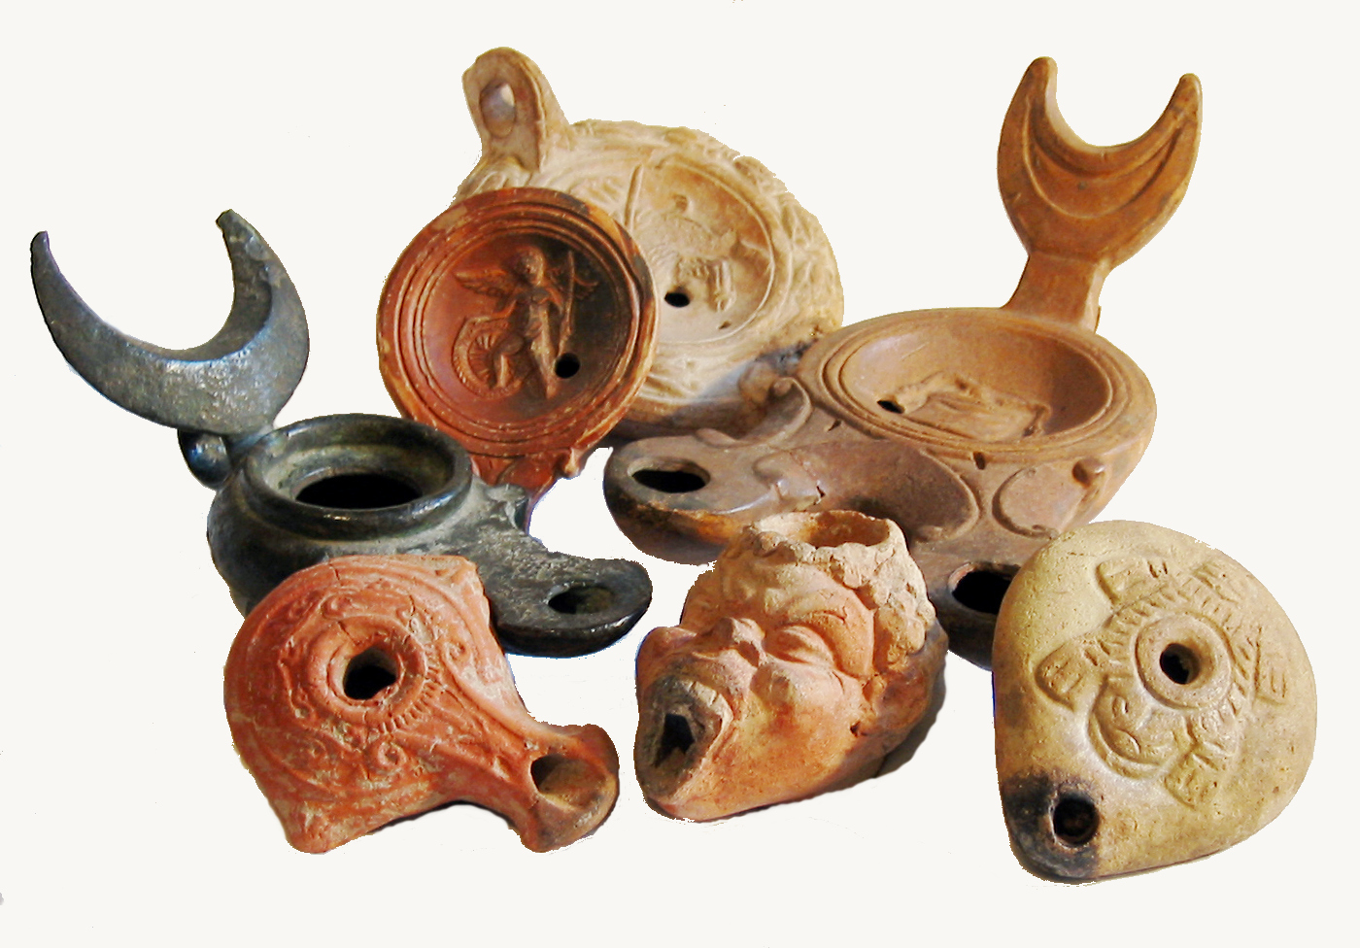

Usage:
Oil lamp, Roman period (© Davidbena, CC BY-SA 4.0, via Wikimedia Commons)The body of the lamp was filled with oil, into which the wick was placed. The wick was lit and periodically had to be trimmed as it burned down. The lamp lit a small area. It gave off more or less light and smoke, depending on the quality of the oil used and the condition of the wick. Olive oil was the most common fuel, although in the very earliest times fish oil was also used. (see also 1.10.5 Anointing oil<REALIA:1.10.5>, 1.15.1 Oil, ointment<REALIA:1.15.1>, and 9.3 Olive oil<REALIA:9.3> for further uses of olive oil.)
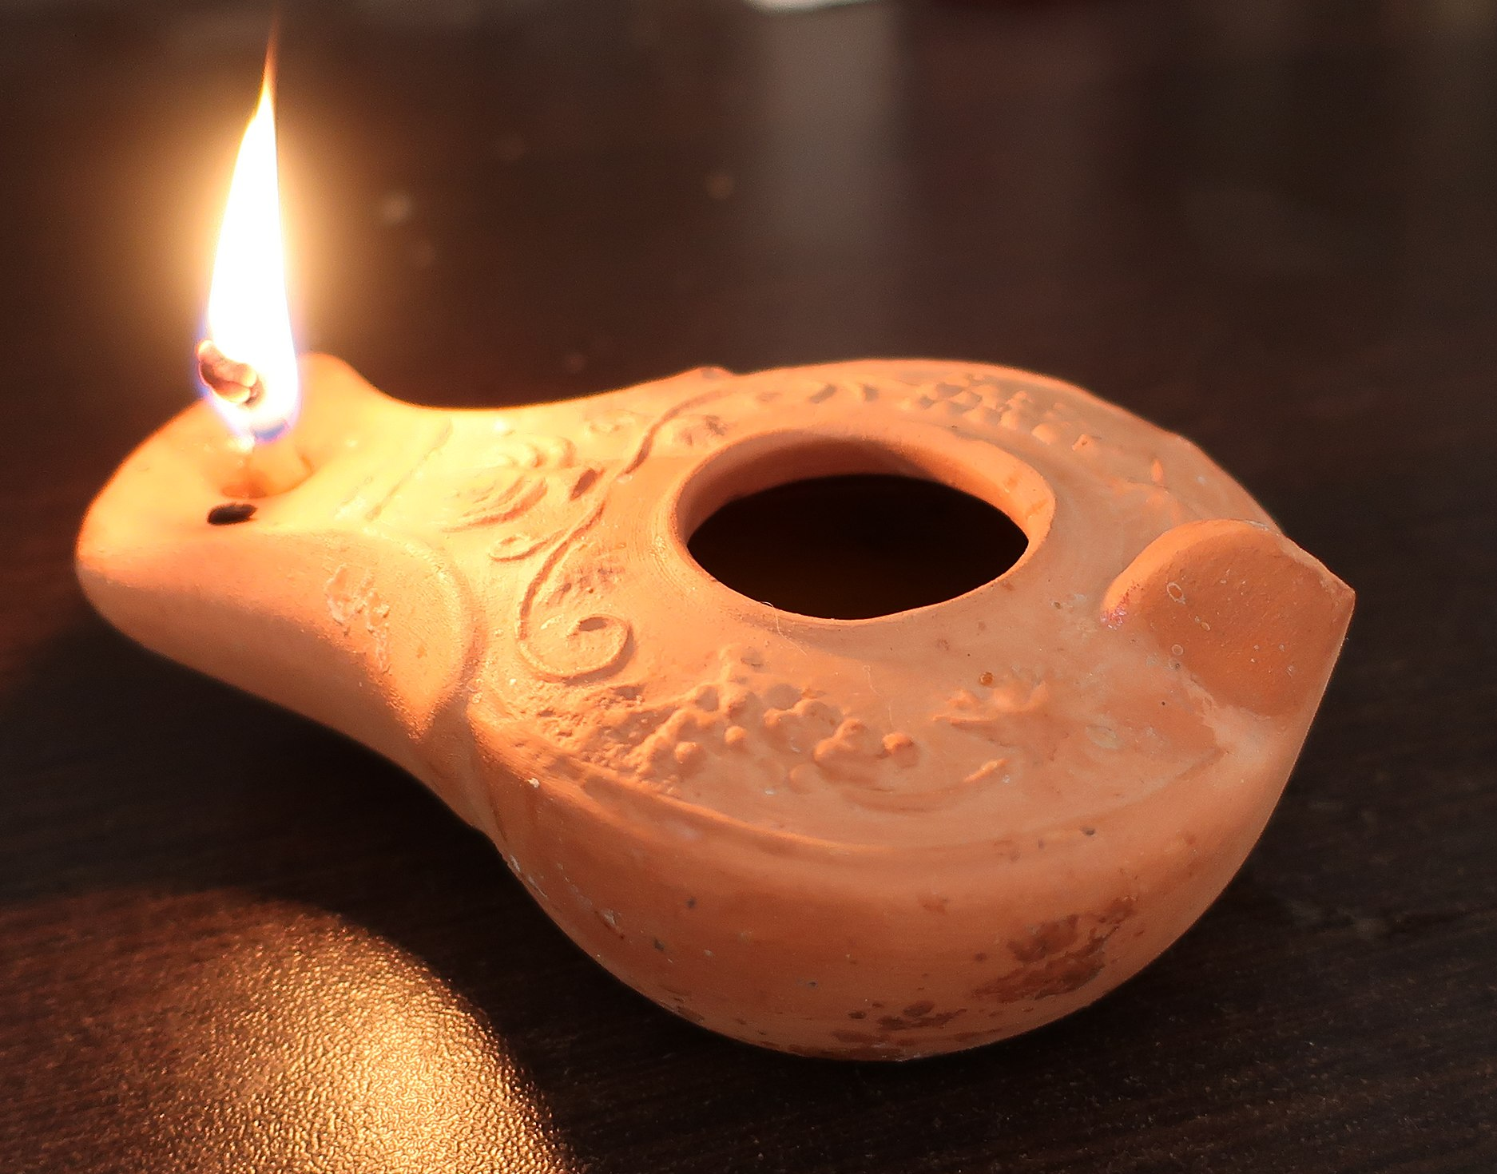

Translation:
In some languages the closest equivalent for “oil lamp” is “kerosene lamp.” Translators should avoid an expression that suggests a flashlight or any sort of electric light, which would be highly anachronistic. It is possible to say “lantern” or “light.” Another good cultural equivalent could be the candle, which works on the same principle as the oil lamp, only with solid fuel rather than oil. Candles were known in the ancient world, although they are not mentioned in the Bible.
As an object whose purpose is to give light, the lamp is sometimes used figuratively in Scripture. All the occurrences of the Hebrew word nir and the Greek word lucerna are figurative. The Hebrew word ner is used figuratively of Israel’s king (2SA 21:17), God or some something about him, such as his protection, guidance, blessing or word (2SA 22:29; JOB 21:17; PSA 18:29; PSA 119:105; PRO 6:23), life or death as the extinguishing of life (JOB 18:6; JOB 21:17; PSA 132:17; PRO 13:9; PRO 20:20; PRO 24:20), the spirit of man (PRO 20:27), peace or normalcy (JER 25:10), and thoroughness (ZEP 1:12). The Greek word luchnos is figurative of a person’s enlightenment (MAT 6:22; LUK 11:34, LUK 11:36), preparedness (LUK 12:35), prophetic voice (JHN 5:35), and a person’s face (SIR 26:17).
“Lamp” is often used metaphorically for a person’s life; for example, at JOB 21:17 (RSV “How often is it that the lamp of the wicked is put out?”) A Handbook on The Book of Job (page 398) points out that this line speaks of premature or unexpected death.
In several places the light-giving element of the lamp becomes a metaphor for God’s direction, usually supplied by his word, as a person walks through life. An example is PSA 119:105, which NIV renders “Your word is a lamp to my feet and a light for my path.”
While translators will usually agree that a particular passage is figurative, they may not always agree concerning the exact nature of the figure; for example, GNT and GECL do not agree about the meaning of the lamp imagery in JOB 29:3. This line is literally “when his lamp shone upon my head” (RSV). GNT says “God was always with me then,” while GECL has “He gave me success every day.”
For JER 25:10 see the comments at 5.10 Millstones, mill<REALIA:5.10>.
When translating the Hebrew word pishtah in ISA 42:3, more formal translations use the literal rendering “wick”; for example, for the whole line RSV has “and a dimly burning wick he will not quench.” Common-language translations usually avoid such a word-for-word rendering that will not be commonly understood. Several good examples are GNT “He will not … put out a flickering lamp,” CEV “He won’t … put out a dying flame,” and NCV “He will not … put out even a weak flame.” Where a translator prefers to retain the image of the wick, it may be rendered “small strip of cloth.”

