Resource: Human-made Things in the Bible
Human-made Things in the Bible © United Bible Societies, 2025. Adapted from: The Works of Their Hands: Man-made Things in the Bible, by Ray Pritz © 2009 United Bible Societies. This work is licensed under Creative Commons Attribution-ShareAlike 4.0 International (https://creativecommons.org/licenses/by-sa/4.0/).

Human-made Things in the Bible

Lampstand

5.2 Lampstand

References:Hebrew מְנוֹרָה (mnorah)2KI 4:10, ZEC 4:2, ZEC 4:11Aramaic נֶבְרְשָׁה (nevrshah)DAN 5:5Greek λυχνία (luchnia)MAT 5:15, MRK 4:21, LUK 8:16, LUK 11:33, REV 1:13, REV 1:20, REV 1:20, REV 2:1, REV 2:5, REV 11:4

Description and usage:
Lampstands (© Deutsche Bibelgesellschaft, Stuttgart by United Bible Societies)The lampstand was a stand designed to hold a single lamp or a series of lamps. It could be made of a variety of materials and took various shapes and sizes. Its purpose was to raise the light higher than the level of the floor or table and so light a larger area. For the lampstand in the Tabernacle, see 4.3.4 Lampstand, menorah<REALIA:4.3.4>.
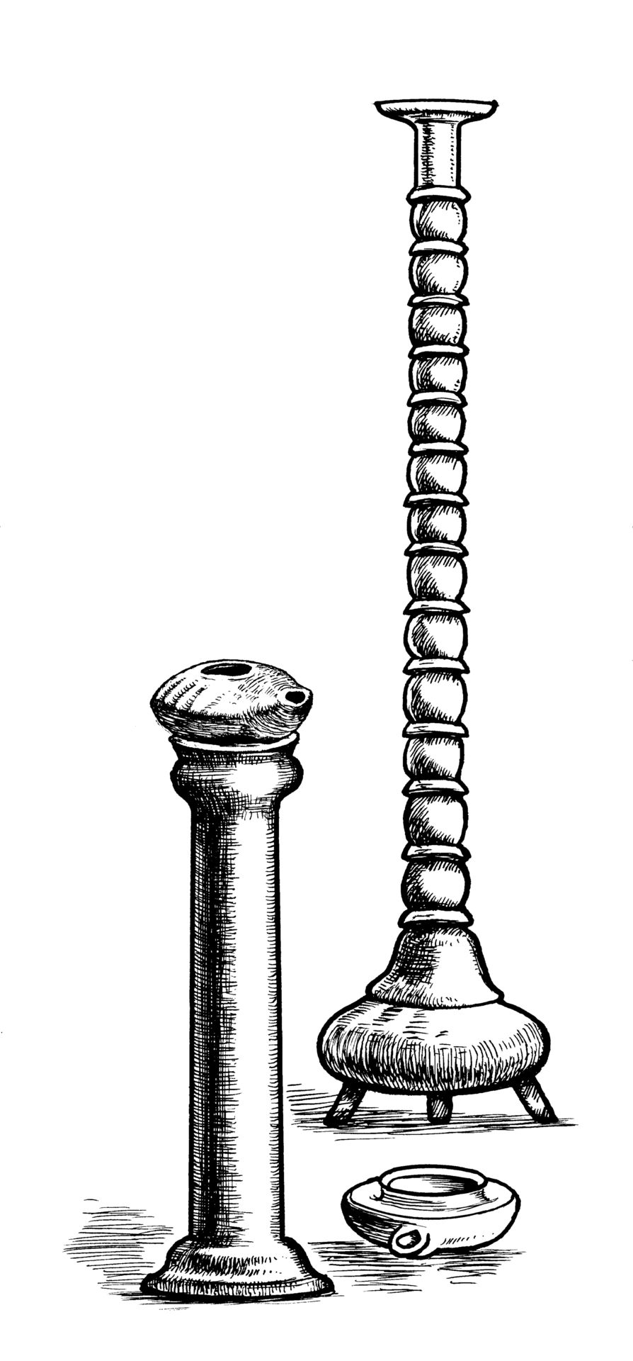

Translation:
Oil lamps (© Zde Wikimedia Commons)Since there is no special word for “lampstand” in many cultures, this may have to be translated “lamp holder,” “thing on which lamps are placed,” or “place for putting lamps.” Where the translator has chosen to render the oil lamp as “candle,” the appropriate word for a candleholder could be used.
<image: Z>
DAN 5:5: The writing on the wall is said to have been “opposite the lampstand” (RSV). This would be in the most clearly illuminated part of the banquet hall. This should probably be stated clearly in most languages. GNT has “where the light from the lamps was shining most brightly.” Also possible is “where the light was strongest” or “where people could see very clearly.”

