Resource: Human-made Things in the Bible
Human-made Things in the Bible © United Bible Societies, 2025. Adapted from: The Works of Their Hands: Man-made Things in the Bible, by Ray Pritz © 2009 United Bible Societies. This work is licensed under Creative Commons Attribution-ShareAlike 4.0 International (https://creativecommons.org/licenses/by-sa/4.0/).

Human-made Things in the Bible

Outer garment, cloak, mantle, robe

6.2 Outer garment, cloak, mantle, robe

References:Hebrew כְּסוּת (ksuth)DEU 22:12Hebrew מַחֲלָצוֹת (machalatsah)ISA 3:22, ZEC 3:4Hebrew מִטְפַּחַת (mitpachath)RUT 3:15, ISA 3:22Hebrew מְעִיל (m‘il)1SA 2:19, 1SA 15:27, 1SA 18:4, 1SA 24:5, 1SA 24:12, 1SA 24:12, 1SA 28:14, 2SA 13:18, 1CH 15:27, EZR 9:3, EZR 9:5, JOB 1:20, JOB 2:12, JOB 29:14, PSA 109:29, ISA 59:17, ISA 61:10, EZK 26:16Hebrew מַעֲטֶפֶת (ma‘atefeth)ISA 3:22Hebrew שַׂלְמָה (salmah)EXO 22:8, EXO 22:25, DEU 24:13, DEU 29:4, JOS 9:5, JOS 9:13, JOS 22:8, 1KI 10:25, 1KI 11:29, 1KI 11:30, 2CH 9:24, NEH 9:21, JOB 9:31, PSA 104:2, SNG 4:11, MIC 2:8Hebrew שִׂמְלָה (simlah)GEN 9:23, GEN 35:2, GEN 37:34, GEN 41:14, GEN 44:13, GEN 45:22, GEN 45:22, EXO 3:22, EXO 12:34, EXO 12:35, EXO 19:10, EXO 19:14, EXO 22:26, DEU 8:4, DEU 10:18, DEU 21:13, DEU 22:3, DEU 22:5, JOS 7:6, JDG 8:25, RUT 3:3, RUT 3:3, 2SA 12:20, 2SA 12:20, PRO 30:4, ISA 3:6, ISA 3:7, ISA 4:1, ISA 9:4Aramaic סַרְבָּל (sarbal)DAN 3:21, DAN 3:27Greek διπλοΐς (diplois)BAR 5:2Greek ἐπενδύτης (ependutēs)JHN 21:7Greek ἱμάτιον (himation)MAT 5:40, MAT 9:16, MAT 9:16, MAT 9:20, MAT 9:21, MAT 14:36, MAT 17:2, MAT 21:7, MAT 21:8, MAT 24:18, MAT 27:31, MAT 27:35, MRK 2:21, MRK 5:27, MRK 5:28, MRK 5:30, MRK 6:56, MRK 9:3, MRK 10:50, MRK 11:7, MRK 11:8, MRK 13:16, MRK 15:20, MRK 15:24, LUK 5:36, LUK 5:36, LUK 6:29, LUK 7:25, LUK 8:27, LUK 8:44, LUK 19:35, LUK 19:36, LUK 22:36, LUK 23:34, JHN 13:4, JHN 13:12, JHN 19:2, JHN 19:5, JHN 19:23, JHN 19:24, ACT 7:58, ACT 9:39, ACT 12:8, ACT 14:14, ACT 16:22, ACT 18:6, ACT 22:20, ACT 22:23, HEB 1:11, HEB 1:12, JAS 5:2, 1PE 3:3, REV 3:4, REV 3:5, REV 3:18, REV 4:4, REV 16:15, REV 19:13, REV 19:16Greek ἱματισμός (himatismos)LUK 7:25, LUK 9:29, JHN 19:24, ACT 20:33, 1TI 2:9, JDT 12:15, LJE 1:11, LJE 1:19, LJE 1:32, LJE 1:57, 1MA 11:24Greek περιβόλαιον (peribolaion)1CO 11:15, HEB 1:12Greek ποδήρης (podērēs)REV 1:13, SIR 27:8Greek στολή (stolē)MRK 12:38, MRK 16:5, LUK 15:22, LUK 20:46, REV 6:11, REV 7:9, REV 7:13, REV 7:14, REV 22:14, JDT 10:7, JDT 16:7, JDT 16:8, ESG 5:1, ESG 6:8, ESG 6:11, ESG 8:15, SIR 6:29, SIR 6:31, SIR 45:10, SIR 50:11, BAR 4:20, BAR 5:1, 1MA 6:15, 1MA 10:21, 1MA 14:9, 2MA 3:15, 2MA 5:2, 1ES 4:17, 1ES 4:54, 1ES 5:44, PSS 11:7Greek φαιλόνης (failonēs)2TI 4:13Greek χλαμύς (chlamus)MAT 27:28, MAT 27:31, 2MA 12:35

Description and usage:
(Image generated by ChatGPT using OpenAI technology)The cloak was a long, flowing outer garment reaching to the feet. It was generally a loose-fitting cloth that was draped around the body and held in place in the middle by a sash wrapped around the waist (see 6.6 Waistband, sash, belt<REALIA:6.6>) or some means of fastening such as pins or buttons. The cloak was worn at all levels of society, including also priests and other religious leaders. It served more purposes than just an outer covering. Women sometimes carried bowls or other implements or grain (see EXO 22:26) in its folds. For poorer people it also served as a covering when sleeping. For this reason Jewish law prohibited taking a person’s robe overnight as a guarantee (EXO 22:26 [25]).
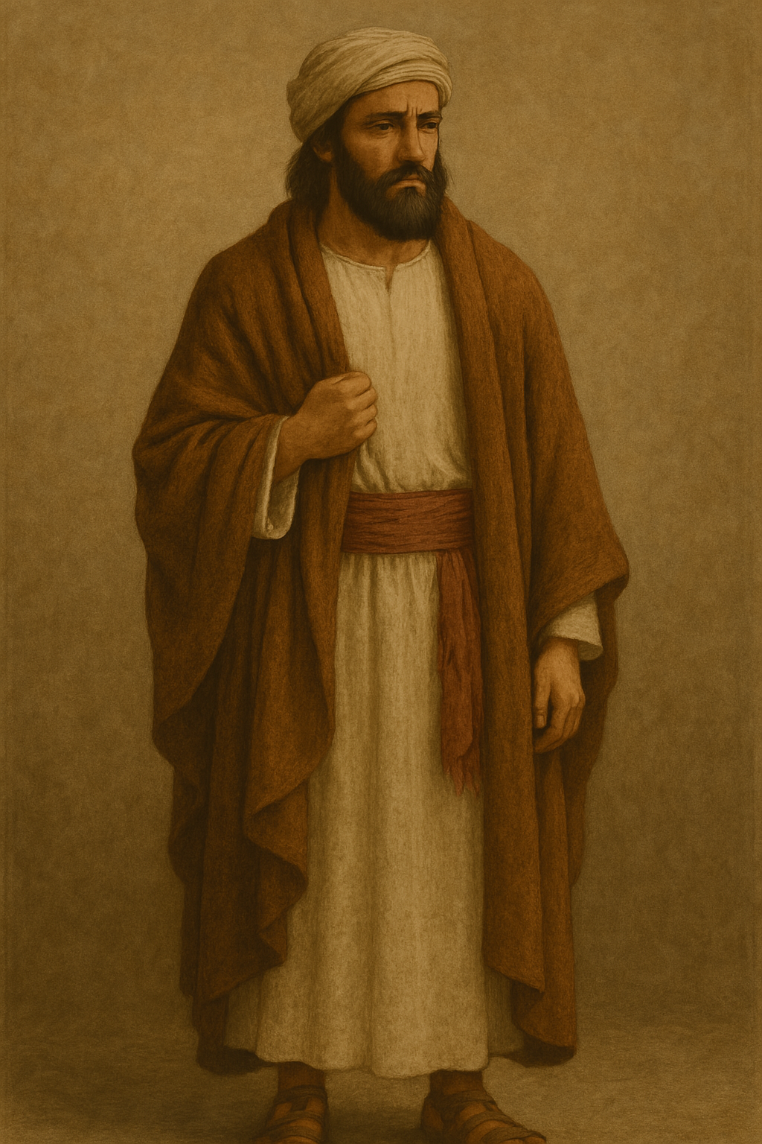
For the robe of the High Priest, see 4.5.3 Robe<REALIA:4.5.3>.

Translation:
The outer garment is referred to by a number of Hebrew and Greek terms that are not easily distinguished. The choice of an equivalent for these terms relating to “outer garment” will depend largely upon the specific context and the usage in each receptor language. The most common equivalent is usually a term meaning “coat.” In some passages the long robe is culturally significant as an indication of high social status and dignified occupation or activity.
Some Bible passages refer to people tearing their clothes. This was done as an act of grief (see GEN 37:34; JOS 7:6; 2SA 1:11; 2SA 3:31; 2SA 13:31; 2KI 5:7; EZR 9:3; EZR 9:5; EST 4:1; JOB 1:20; JOB 2:12). Translators may expand the expression for tearing clothes; for example, in JOB 1:20 a GNT has “Then Job got up and tore his clothes in grief,” where the addition of “in grief” makes clear the purpose of the gesture. It is also possible to translate the meaning of the gesture only; for example, “Job stood up full of grief” or “Job got to his feet, his heart broken.” Where there is a common local custom used to display grief, it may be helpful to keep the biblical custom in the text and to compare it to the local custom in a note; for example, the note may read “This is equivalent to the practice of painting the face to show that the person is in mourning.”
RUT 3:15: The Hebrew word mitpachath would normally be expected to mean a kind of “veil” (KJV; compare ISA 3:22). In this context, however, it is clear that a veil of thin material would not have been strong enough to carry the weight of the barley. Older translations understood it to be a kind of “mantle” (RSV), while modern translations prefer something like “cloak” (GNT, REB). Others look for a more modern equivalent, such as “cape” (CEV) or “shawl” (NJPSV, NCV).
ISA 3:22: Sheffer suggests translating the Hebrew word machalatsoth (plural of machalatsah) in this verse as “loincloths.” It is probably better to say “cloaks” or “shawls.”
1TI 2:9: The Greek word himatismos in this verse is the general word for garments of any kind, but since women are being referred to, then the word “dresses” (GNT) will fit this context if “dresses” are the natural wear in a translator’s culture. However, in cultures where women wear some other type of clothing, translators should use a more general word, as the Greek does.

Hem, corner of a garment

6.2.1 Hem, corner of a garment

References:Hebrew כָּנָף (kanaf)NUM 15:38, NUM 15:38, DEU 22:12, DEU 23:1, DEU 27:20, RUT 3:9, 1SA 15:27, 1SA 24:6, 1SA 24:12, 1SA 24:12, JER 2:34, EZK 5:3, EZK 16:8, HAG 2:12, HAG 2:12, ZEC 8:23

Description:
A Pharisee, wearing phylactery and prayer shawl (Image generated by ChatGPT using OpenAI technology)The hem was the lower edge of an outer garment (see 6.2 Outer garment, cloak, mantle, robe<REALIA:6.2>).
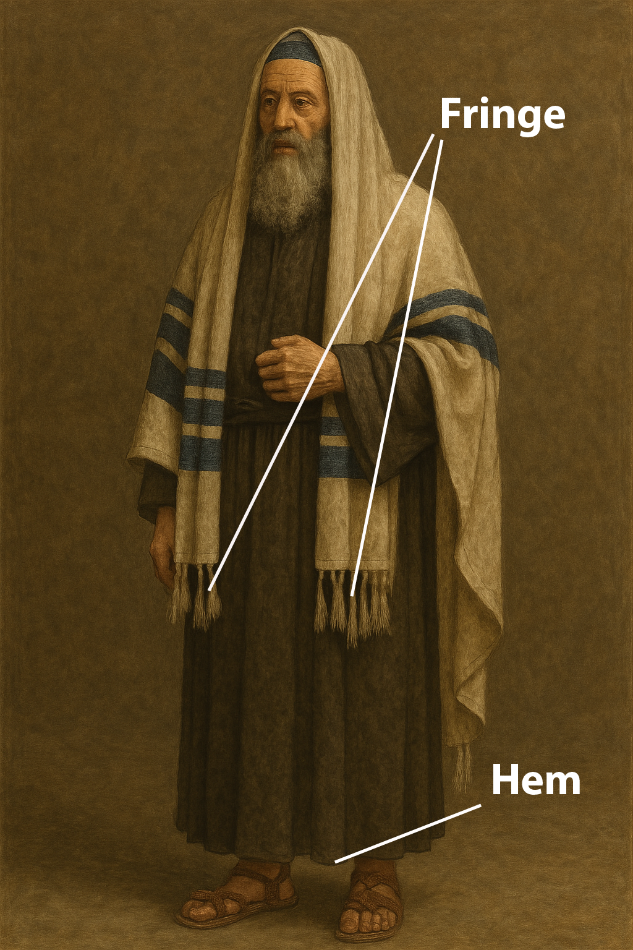

Usage:
See 6.2.1.1 Fringe, tassel<REALIA:6.2.1.1>.

Translation:
Most translations render the Hebrew word kanaf in NUM 15:38 and DEU 22:12 as “corners” (RSV, GNT). In NUM 15:38CEV says “bottom edge,” which may also serve as a model.
ZEC 8:23: While the word kanaf indicates the lower edge of a garment, it is sometimes used for the garment itself (compare JER 2:34; EZK 16:8). In such passages it may be possible to use a word for the outer garment. Two models for the first part of ZEC 8:23 are “When this happens, ten people from nations with different languages will grab a Jew by his clothes” (CEV) and “At that time, ten men from different countries will come and take hold of a Judean by his coat” (NCV). GNT “In those days ten foreigners will come to one Jew” is also possible, although it loses the element of urgency conveyed by the act of grabbing hold of the robe.

Fringe, tassel

6.2.1.1 Fringe, tassel

References:Hebrew צִיצִת (tsitsith)NUM 15:38, NUM 15:38, NUM 15:39Hebrew גָּדִל (gadil)DEU 22:12Greek κράσπεδον (kraspedon)MAT 9:20, MAT 14:36, MAT 23:5, MRK 6:56, LUK 8:44

Description:
Fringes on a prayer shawl (DRosenbach, Public domain, via Wikimedia Commons)The decorative tassel was attached to the bottom edge of a long, outer robe, specifically to one of the robe’s four corners.
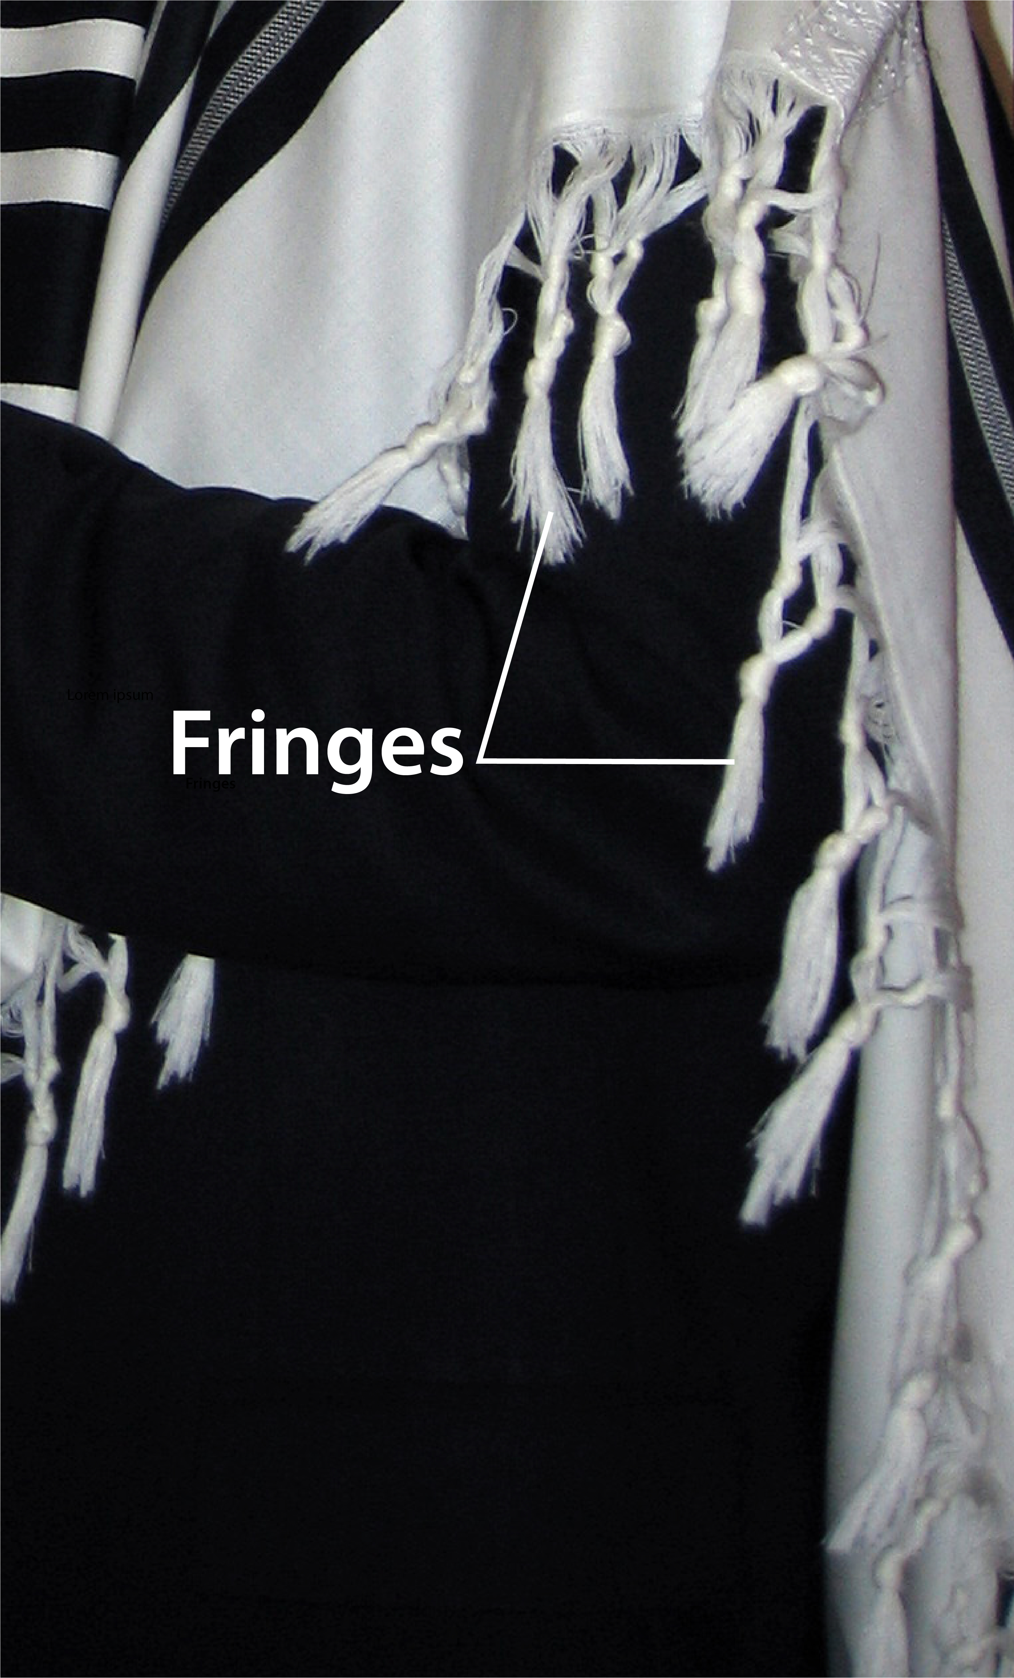

Usage:
According to NUM 15:37–NUM 15:41 and DEU 22:12, Israelite men were required to wear tassels on the four corners of their outer garments (see 6.1 Clothing (generic)<REALIA:6.1>). These tassels reminded them of their obligation to keep the commandments of the Mosaic Law.

Translation:
In MAT 23:5 the Greek word kraspedon refers to the tassels worn at the four corners of outer garments. It is also possible that in all instances in which kraspedon is used in reference to Jesus’ clothing (MAT 9:20; MAT 14:36; MRK 6:56; LUK 8:44), the reference may be specifically to the tassels and not merely to the edge of his garment. The interpretation of such passages depends upon how Jesus may have understood and followed the Mosaic Law and the manner in which the authors may have understood the meaning of kraspedon.
In some languages the literal phrase “tassels on the corners” (RSV) in NUM 15:38 may be rendered “decorated corners” or “ribbons at the corners.” Where a word for tassel does not exist or would be obscure, translators may use a descriptive phrase; for example, NCV renders the second clause of this verse as follows: “Tie several pieces of thread together and attach them to the corners of your clothes.”

Train

6.2.2 Train

References:Hebrew שׁוּל (shulayim (plural of shul))EXO 28:33, EXO 28:33, EXO 28:34, EXO 39:24, EXO 39:25, EXO 39:26, ISA 6:1, JER 13:22, JER 13:26, LAM 1:9, NAM 3:5Greek ἔνδυσις (endusis)ESG 5:1

Description:
The train was a long cloth that extended from the bottom of a robe or dress, dragging behind a person as he or she walked. Sometimes a servant would walk behind holding the train off of the ground, so that it would not become dirty.

Translation:
ISA 6:1: Translations treat the Hebrew word shulayim here with varying degrees of precision. Thus KJV has “his train,” which is the exact meaning but may not be well understood by the modern reader. REB “skirt of his robe” and NRSV “hem of his robe” focus on the bottom edge of the long robe (see 6.2.1 Hem, corner of a garment<REALIA:6.2.1>). Common-language translations tend to refer to the whole garment by saying “his robe” (GNT, CEV). NCV is good with “His long robe.”
In ESG 5:1 it will normally be sufficient to say something like “the other holding up a long part of her robe which extended behind her.” Where the idea of a “train” is unknown, it will be important to indicate that the cloth extended well behind Esther and to not give the impression that the servant is lifting up the bottom of her dress.

Buckle, brooch, clasp

6.2.3 Buckle, brooch, clasp

References:Hebrew חָח (chach)EXO 35:22Greek πόρπη (porpē)1MA 10:89, 1MA 11:58, 1MA 14:44

Description and usage:
Robe pin (fibula) (© Marcus Cyron, CC BY-SA 3.0, via Wikimedia Commons)The buckle was a kind of clasp or pin used to fasten a cape or robe at the shoulder. It served as a symbol of rank, and the wearing of it was granted as a privilege.
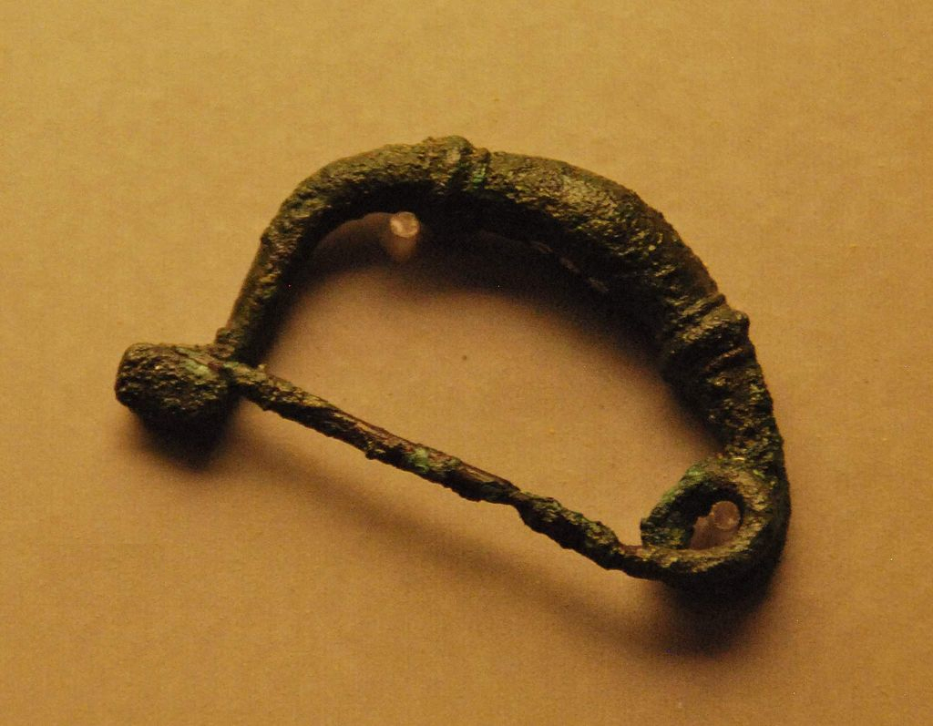

Translation:
Some cultures may have a special symbol worn by certain privileged or honored persons. It may be a piece of jewelry worn on the clothing, a necklace, a special headgear, or something else. It may be possible to use such a word in all three references for the Greek word porpē.
The Hebrew word chach in EXO 35:22 refers to some kind of jewelry, perhaps a brooch or even a kind of ring (see 10.5.1 Earring, nose ring<REALIA:10.5.1>). In other contexts it refers to a device placed in the nose of a prisoner by which he was led around against his will (see 1.3.3 Fishing spear, harpoon<REALIA:1.3.3>).

