Resource: Human-made Things in the Bible
Human-made Things in the Bible © United Bible Societies, 2025. Adapted from: The Works of Their Hands: Man-made Things in the Bible, by Ray Pritz © 2009 United Bible Societies. This work is licensed under Creative Commons Attribution-ShareAlike 4.0 International (https://creativecommons.org/licenses/by-sa/4.0/).

Human-made Things in the Bible

Saddle, saddle cloth

8.4 Saddle, saddle cloth

References:Hebrew בֶּגֶד, חֹפֶשׁ, רִכְבָּה (bigde chofesh lrikbah)EZK 27:20Hebrew חבשׁ (chavash (verb))GEN 22:3, NUM 22:21, JDG 19:10, 2SA 16:1, 2SA 17:23, 2SA 19:27, 1KI 2:40, 1KI 13:13, 1KI 13:13, 1KI 13:23, 1KI 13:27, 1KI 13:27, 2KI 4:24Hebrew כַּר (kar)GEN 31:34Hebrew מַד (mad)JDG 5:10Hebrew מֶרְכָּב (merkav)LEV 15:9

Description and usage:
(Image generated by ChatGPT using OpenAI technology)The saddle was a seat placed on the back of an animal to enable a person to ride. It could also serve as a rack on which baggage was carried. Saddles could take many forms, from specially shaped wood to a simple piece of cloth.
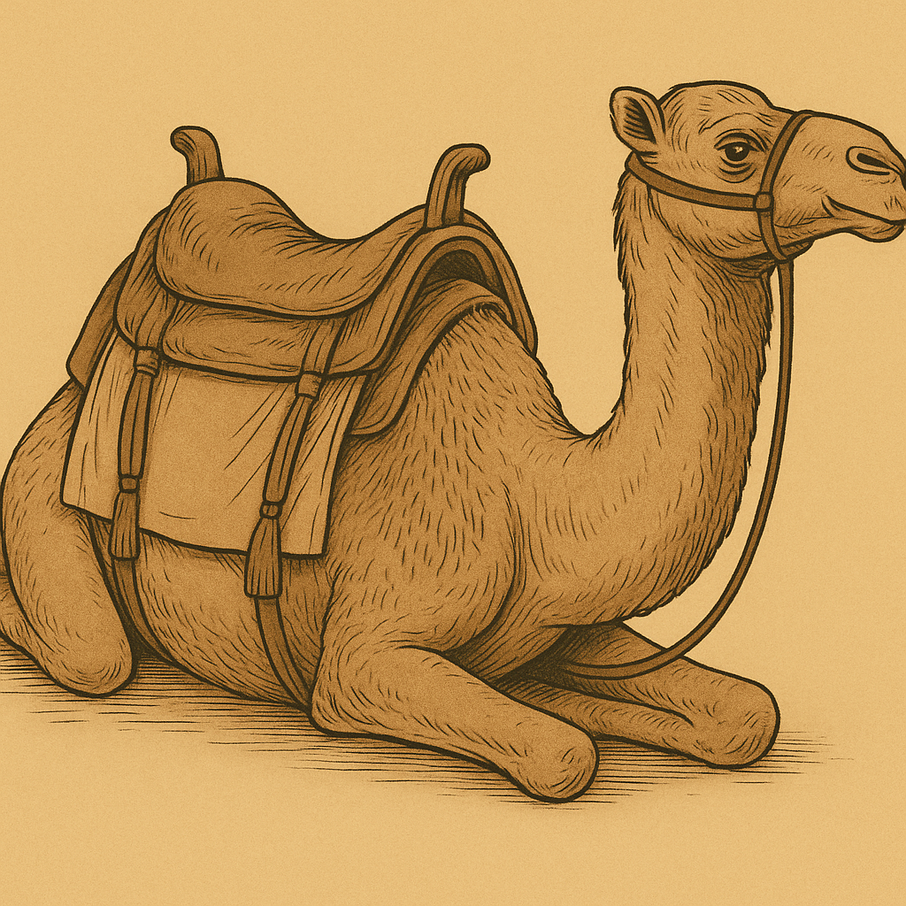

Translation:
The Hebrew verb chavash always occurs in the context of an animal prepared or being prepared for riding. Where a specific term for “saddle” is lacking, the second clause in GEN 22:3 may be rendered “he prepared his donkey for riding.”
(Image generated by ChatGPT using OpenAI technology)GEN 31:34: The Hebrew word kar appears only here, and its exact meaning is uncertain. It is variously rendered “saddle” (RSV, NIV), “saddlebag” (GNT), “the cushion she used as a saddle” (CEV), “[camel]bag” (REB), “cushion” (NJB), and “saddle basket” (GECL). From the context it is evident that it was something that Rachel could sit on and that her father would not have thought it strange that she did so. On the other hand, she had hidden some household idols (see 4.6.1 Teraphim, household idol<REALIA:4.6.1>) in (or under) this thing, so we may assume that it was more than just a cloth laid over the camel. Camel saddles could be rather elaborate. Sometimes the saddle was an entire large basket or litter in which a person sat. At other times a wooden frame was placed over the camel’s humped back. Over this frame were draped cloths and blankets to cushion the ride and to separate the rider’s legs from the animal’s back. In either of these arrangements, it would not have been difficult for Rachel to find recesses in which to hide a number of small idols. The text does not say that Rachel is sitting on the camel but rather on the camel’s saddle, and it is clear from the context that she is in her tent. When travelers arrived at their camp for the night, it was the custom to remove the saddle and store it in the tent. If it was a wooden frame, then it also served as a place to sit. The wooden frame, shaped to fit over the camel’s back, created a fairly large hollow area as it sat on the floor of the tent. Rachel had evidently hidden the idols under her chair.
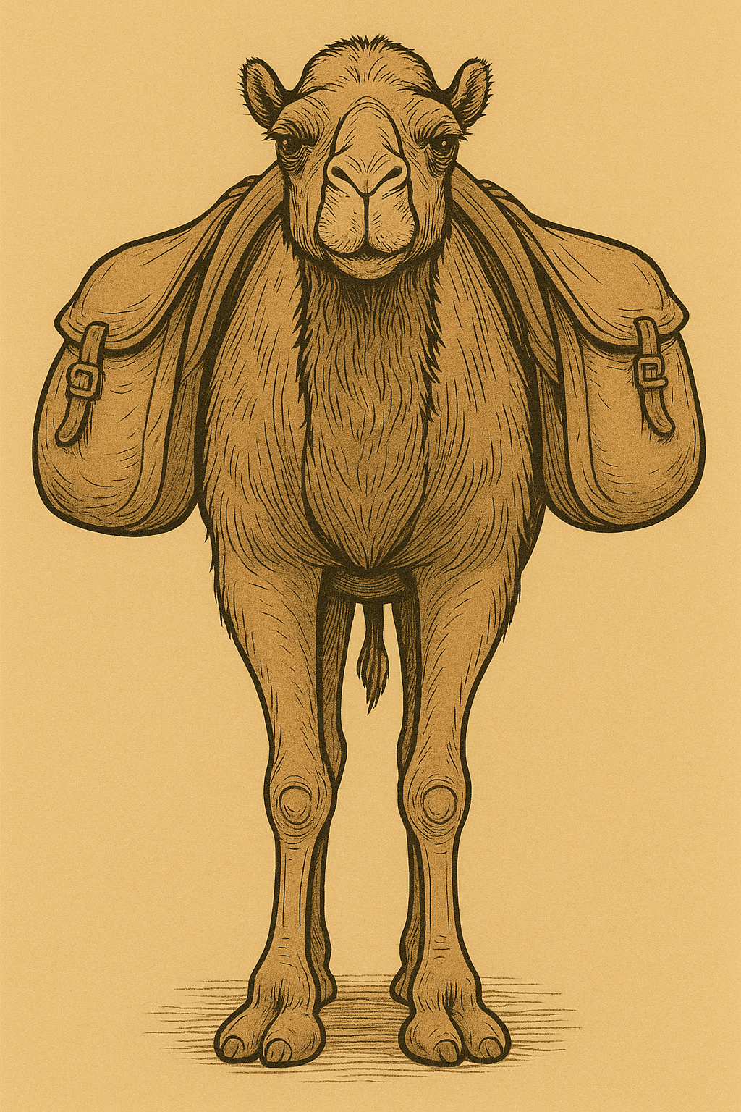
This frame allow the rider to sit on the camel (© Aziz Kingrani, CC BY-SA 4.0, via Wikiedia Commons)In LEV 15:9 the Hebrew word merkav could refer to a saddle, a cloth, or even the seat of a chariot. In some languages there may be no technical term for “saddle.” In any case, it is better to express the idea generally here, as in REB, which renders the whole verse as “Everything on which this person sits when riding will be unclean.”
<image: 2Q==>
JDG 5:10: See the discussion on the meaning of the Hebrew word mad at 5.17 Carpet, rug<REALIA:5.17>.
For “saddlebags,” see the comments on the Hebrew word mishpthayim at 1.2.1 Sheep pen, sheepfold<REALIA:1.2.1>.

