Resource: Human-made Things in the Bible
Human-made Things in the Bible © United Bible Societies, 2025. Adapted from: The Works of Their Hands: Man-made Things in the Bible, by Ray Pritz © 2009 United Bible Societies. This work is licensed under Creative Commons Attribution-ShareAlike 4.0 International (https://creativecommons.org/licenses/by-sa/4.0/).

Human-made Things in the Bible

Bread

9.4 Bread

References:Hebrew חֲבִתִּים (chavitim)1CH 9:31Hebrew חַלָּה (chalah)EXO 29:2, EXO 29:23, LEV 2:4, LEV 7:12, LEV 7:12, LEV 7:13, LEV 8:26, LEV 8:26, LEV 24:5, LEV 24:5, NUM 6:15, NUM 6:19, NUM 15:20, 2SA 6:19Hebrew כַּוָּן (kawan)JER 7:18, JER 44:19Hebrew לְבִיבָה (lvivah)2SA 13:6, 2SA 13:8, 2SA 13:10Hebrew לֶחֶם (lechem)GEN 3:19, GEN 14:18, GEN 18:5, GEN 21:14, GEN 25:34, GEN 27:17, GEN 28:20, GEN 31:54, GEN 31:54, GEN 37:25, GEN 39:6, GEN 41:54, GEN 41:55, GEN 43:25, GEN 43:31, GEN 43:32, GEN 45:23, GEN 47:12, GEN 47:13, GEN 47:15, GEN 47:17, GEN 47:17, GEN 47:19, GEN 49:20, EXO 2:20, EXO 16:3, EXO 16:4, EXO 16:8, EXO 16:12, EXO 16:15, EXO 16:22, EXO 16:29, EXO 16:32, EXO 18:12, EXO 23:25, EXO 25:30, EXO 29:2, EXO 29:23, EXO 29:23, EXO 29:32, EXO 29:34, EXO 34:28, EXO 35:13, EXO 39:36, EXO 40:23, LEV 3:11, LEV 3:16, LEV 7:13, LEV 8:26, LEV 8:31, LEV 8:32, LEV 21:6, LEV 21:8, LEV 21:17, LEV 21:21, LEV 21:22, LEV 22:7, LEV 22:11, LEV 22:13, LEV 22:25, LEV 23:14, LEV 23:17, LEV 23:18, LEV 23:20, LEV 24:7, LEV 26:5, LEV 26:26, LEV 26:26, LEV 26:26, NUM 4:7, NUM 14:9, NUM 15:19, NUM 21:5, NUM 21:5, NUM 28:2, NUM 28:24, DEU 8:3, DEU 8:9, DEU 9:9, DEU 9:18, DEU 10:18, DEU 16:3, DEU 23:5, DEU 29:5, JOS 9:5, JOS 9:12, JDG 5:8, JDG 7:13, JDG 8:5, JDG 8:6, JDG 8:15, JDG 13:16, JDG 19:5, JDG 19:19, RUT 1:6, RUT 2:14, 1SA 2:5, 1SA 2:36, 1SA 2:36, 1SA 9:7, 1SA 10:3, 1SA 10:4, 1SA 14:24, 1SA 14:24, 1SA 14:28, 1SA 16:20, 1SA 17:17, 1SA 20:24, 1SA 20:27, 1SA 20:34, 1SA 21:4, 1SA 21:5, 1SA 21:5, 1SA 21:7, 1SA 21:7, 1SA 21:7, 1SA 22:13, 1SA 25:11, 1SA 25:18, 1SA 28:20, 1SA 28:22, 1SA 30:11, 1SA 30:12, 2SA 3:29, 2SA 3:35, 2SA 3:35, 2SA 6:19, 2SA 9:7, 2SA 9:10, 2SA 9:10, 2SA 12:17, 2SA 12:20, 2SA 12:21, 2SA 13:5, 2SA 16:1, 2SA 16:2, 2SA 16:2, 1KI 5:2, 1KI 5:23, 1KI 7:48, 1KI 11:18, 1KI 13:8, 1KI 13:9, 1KI 13:15, 1KI 13:16, 1KI 13:17, 1KI 13:18, 1KI 13:19, 1KI 13:22, 1KI 13:22, 1KI 13:23, 1KI 14:3, 1KI 17:6, 1KI 17:6, 1KI 17:11, 1KI 18:4, 1KI 18:13, 1KI 21:4, 1KI 21:5, 1KI 21:7, 1KI 22:27, 2KI 4:8, 2KI 4:8, 2KI 4:42, 2KI 4:42, 2KI 6:22, 2KI 18:32, 2KI 25:3, 2KI 25:29, 1CH 9:32, 1CH 12:41, 1CH 16:3, 1CH 23:29, 2CH 4:19, 2CH 13:11, 2CH 18:26, EZR 10:6, NEH 5:14, NEH 5:15, NEH 5:18, NEH 9:15, NEH 10:34, NEH 13:2, JOB 3:24, JOB 6:7, JOB 15:23, JOB 20:14, JOB 22:7, JOB 24:5, JOB 27:14, JOB 28:5, JOB 33:20, JOB 42:11, PSA 14:4, PSA 37:25, PSA 41:10, PSA 42:4, PSA 53:5, PSA 78:20, PSA 78:25, PSA 80:6, PSA 102:5, PSA 102:10, PSA 104:14, PSA 104:15, PSA 105:16, PSA 105:40, PSA 127:2, PSA 132:15, PSA 136:25, PSA 146:7, PSA 147:9, PRO 4:17, PRO 6:8, PRO 6:26, PRO 9:5, PRO 9:17, PRO 12:9, PRO 12:11, PRO 20:13, PRO 20:17, PRO 22:9, PRO 23:3, PRO 23:6, PRO 25:21, PRO 27:27, PRO 27:27, PRO 28:3, PRO 28:19, PRO 28:21, PRO 30:8, PRO 30:22, PRO 30:25, PRO 31:14, PRO 31:27, ECC 9:7, ECC 9:11, ECC 10:19, ECC 11:1, ISA 3:1, ISA 3:7, ISA 4:1, ISA 21:14, ISA 28:28, ISA 30:20, ISA 30:23, ISA 33:16, ISA 36:17, ISA 44:15, ISA 44:19, ISA 51:14, ISA 55:2, ISA 55:10, ISA 58:7, ISA 65:25, JER 5:17, JER 11:19, JER 37:21, JER 37:21, JER 38:9, JER 41:1, JER 42:14, JER 44:17, JER 52:6, JER 52:33, LAM 1:11, LAM 4:4, LAM 5:6, LAM 5:9, EZK 4:9, EZK 4:13, EZK 4:15, EZK 4:16, EZK 4:16, EZK 4:17, EZK 5:16, EZK 12:18, EZK 12:19, EZK 13:19, EZK 14:13, EZK 16:19, EZK 16:49, EZK 18:7, EZK 18:16, EZK 24:17, EZK 24:22, EZK 44:3, EZK 44:7, EZK 48:18, DAN 10:3, HOS 2:7, HOS 9:4, HOS 9:4, AMO 4:6, AMO 7:12, AMO 8:11, OBA 1:7, HAG 2:12, MAL 1:7Hebrew מַעוֹג, עֻגָה (ma‘og, ‘ugah)GEN 18:6, EXO 12:39, NUM 11:8, 1KI 17:12, 1KI 17:13, 1KI 19:6, EZK 4:12, HOS 7:8Hebrew נִקּוּדִים (niqudim)1KI 14:3Hebrew פַּת (path)GEN 18:5, LEV 2:6, LEV 6:14, JDG 19:5, RUT 2:14, 1SA 2:36, 1SA 28:22, 2SA 12:3, 1KI 17:11, JOB 31:17, PSA 147:17, PRO 17:1, PRO 23:8, PRO 28:21Hebrew צַפִּיחִת (tsapichith)EXO 16:31Hebrew רָקִיק (raqiq)EXO 29:2, EXO 29:23, LEV 2:4, LEV 7:12, LEV 8:26, NUM 6:15, NUM 6:19, 1CH 23:29Hebrew תֻּפִינִים (tufin)LEV 6:14Greek ἄρτος (artos)MAT 4:3, MAT 4:4, MAT 6:11, MAT 7:9, MAT 14:17, MAT 14:19, MAT 14:19, MAT 15:33, MAT 15:34, MAT 15:36, MAT 16:5, MAT 16:7, MAT 16:8, MAT 16:9, MAT 16:10, MAT 16:11, MAT 16:12, MAT 26:26, MRK 6:37, MRK 6:38, MRK 6:41, MRK 6:41, MRK 6:44, MRK 6:52, MRK 8:4, MRK 8:5, MRK 8:6, MRK 8:14, MRK 8:14, MRK 8:16, MRK 8:17, MRK 8:19, MRK 14:22, LUK 4:3, LUK 7:33, LUK 9:13, LUK 9:16, LUK 11:5, LUK 15:17, LUK 22:19, LUK 24:30, LUK 24:35, JHN 6:5, JHN 6:7, JHN 6:9, JHN 6:11, JHN 6:13, JHN 6:23, JHN 6:26, JHN 21:9, JHN 21:13, ACT 2:42, ACT 2:46, ACT 20:7, ACT 20:11, ACT 27:35, 1CO 10:16, 1CO 10:17, 1CO 10:17, 1CO 11:23, 1CO 11:26, 1CO 11:27, 1CO 11:28, 2CO 9:10, 2TH 3:8, TOB 1:17, JDT 10:5, WIS 16:20, SIR 10:27, SIR 12:5, SIR 14:10, SIR 15:3, SIR 33:25, BEL 1:33, 1ES 9:2Latin panis2ES 1:19, 2ES 5:18, 2ES 14:43, 2ES 15:19, 2ES 15:58

Description:
Bread was dough made from the flour of various grains, mixed with oil or water, and baked for eating.

Translation:
“Bread,” as the basic, staple food of ancient times, often appears in Scripture with the more general meaning of “food.” So the expression “to eat bread” means “to eat a meal” (see GEN 37:25; GEN 43:32; EXO 2:20;). Since the bread was not usually cut with a knife but rather broken or torn with the hands, the expression “to break bread” means “to eat” or “to eat a meal” (see JER 16:7; ACT 2:42; ACT 2:46; ACT 20:7).
In many passages the word that indicates one unit of bread is simply “bread,” as, for example, in MAT 14:17, where the disciples say “All we have here are five loaves [literally ‘five breads’]” (GNT). In many languages it will be more natural to substitute the word “loaf” for “bread.”
The Hebrew word chalah refers to bread of higher quality since it was made with more expensive flour, called soleth in Hebrew (see 9.4.1 Plain flour<REALIA:9.4.1> and 9.4.2 Fine flour<REALIA:9.4.2>). In some languages it will be possible to make a distinction between this bread and the bread of lower quality.
The Hebrew word kawan in JER 7:18 and JER 44:19 refers to bread that was intended not as food but as an offering to a pagan goddess. It may have been shaped like the goddess or marked with her image; translations reflect both possibilities. Similarly, in 2SA 13:6; 2SA 13:7; 2SA 13:8; 2SA 13:9; 2SA 13:10 the Hebrew word lvivah may indicate a special shape (heart-shaped?). In 2SA 13:6CEV renders it “special bread” and adds this footnote: “Or ‘heart-shaped bread’ or ‘dumplings.’ ” Translators are advised to follow this example. The point of the story here is that the “special bread” or “special cake” was something better than average, which could help to revive a sick person or at least cheer him up.
The Hebrew word raqiq refers to very thin bread, perhaps even crisp. It appears most often connected to the Hebrew word matsah, which means “unleavened bread” (see 9.4.4 Unleavened bread<REALIA:9.4.4>). In these passages (EXO 29:2; LEV 2:4; LEV 7:12; NUM 6:15; NUM 6:19; 1CH 23:29), it will be best to translate it as a unit together with the word for “unleavened bread” (see the suggestions at 9.4.4 Unleavened bread<REALIA:9.4.4>). In EXO 16:31 the Hebrew word tsapichith probably has about the same meaning.
EXO 29:2; LEV 7:12; LEV 8:26 (following comments adapted from A Handbook on Leviticus at LEV 7:12, page 95): These verses mention three types of unleavened bread (RSV “unleavened cakes mixed with oil, unleavened wafers spread with oil, and cakes of fine flour well mixed with oil” in LEV 7:12) to accompany animal sacrifices: (1) The first type was a perforated loaf made with flour mixed with oil but without yeast. (2) The second type was a kind of thin, round bread also made without yeast, but on which olive oil was spread. It was similar to biscuits or possibly pancakes. It is mistakenly called “wafers” in RSV and KJV. Neither should it be translated “cakes,” which will be misleading in most languages. General terms should be used for these first two types of bread, as long as both terms indicate that they are made without yeast. (3) There is some question about exactly what is meant by the third kind of bread. It was apparently to be similar to the first type, perhaps pierced or perforated, but there is no mention of its being made without yeast and no indication that it was actually baked. This has led some commentators to assume that it was merely a kind of dough made of choice flour and oil. However, GNT seems to understand the text to imply both that it was unleavened and that it was baked. Since David shared such loaves with people (2SA 6:19), it seems best to assume they were baked. And although “unleavened” is not explicitly mentioned for the third type, the contrast with LEV 7:13 probably indicates that they were made without yeast. Translators will need to find three different words or descriptive phrases for these three types of unleavened bread.
LEV 6:14: The Hebrew word tufin, which is translated “baked” in RSV and some other English versions, is difficult and uncertain. A number of other translations and commentaries have understood the word to mean “broken” (NIV, NAB) or “crumbled” (GNT, REB). Still others, following the Septuagint, see it as referring to a kind of pastry (NJB, TOB). Translators should probably look for an equivalent to the idea of breaking or crumbling into small pieces. But it may be advisable to add a footnote explaining the uncertainty concerning this term and the different possible translations of it.
The Greek word artos refers to a relatively small and generally round loaf of bread. It was considerably smaller than typical present-day loaves of bread and thus more like “rolls” or “buns.”

Plain flour

9.4.1 Plain flour

References:Hebrew קֶמַח (qemach)NUM 5:15, JDG 6:19, 1SA 1:24, 1SA 28:24, 2SA 17:28, 1KI 5:2, 1KI 17:12, 1KI 17:14, 1KI 17:16, 2KI 4:41, 1CH 12:41, ISA 47:2, HOS 8:7Greek ἄλευρον (aleuron)MAT 13:33, LUK 13:21

Description:
Flour was the product of grinding kernels of grain. The grains most commonly used were wheat or barley. Flour was the main ingredient of bread, which was the staple food in ancient times (see 9.4 Bread<REALIA:9.4>).

Translation:
In Hebrew there are two words that refer to ground grain. The first word soleth refers to a kind of semolina or coarser wheat flour. It is a product that is less finely ground than the flour referred to by the second word qemach. However, the first type was considered a more sumptuous kind of flour, used primarily in ritual offerings. The second type, on the other hand, was just ordinary flour (made from barley or wheat) and was rarely used in offerings to God. In translation the primary focus should not be on the fineness of the grinding, but on the high quality of the one type of flour as opposed to the commonness of the other type. If the translator has trouble finding corresponding terminology, it is possible to use an ordinary word for the common flour or meal and the same word qualified by “best” or “finest” for the more luxurious product (compare NJPSV “choice flour”). In some languages “wheat flour” is rendered “ground wheat” or “powdered wheat.”

Fine flour

9.4.2 Fine flour

References:Hebrew סֹלֶת, קֶמַח (soleth, qemach soleth)GEN 18:6, GEN 18:6, EXO 29:2, EXO 29:40, LEV 2:1, LEV 2:2, LEV 2:4, LEV 2:5, LEV 2:7, LEV 5:11, LEV 6:8, LEV 6:13, LEV 7:12, LEV 14:10, LEV 14:21, LEV 23:13, LEV 23:17, LEV 24:5, NUM 5:15, NUM 6:15, NUM 7:13, NUM 7:19, NUM 7:25, NUM 7:31, NUM 7:37, NUM 7:43, NUM 7:49, NUM 7:55, NUM 7:61, NUM 7:67, NUM 7:73, NUM 7:79, NUM 8:8, NUM 15:4, NUM 15:6, NUM 15:9, NUM 28:5, NUM 28:9, NUM 28:12, NUM 28:12, NUM 28:13, NUM 28:20, NUM 28:28, NUM 29:3, NUM 29:9, NUM 29:14, JDG 6:19, 1SA 1:24, 1SA 28:24, 2SA 17:28, 1KI 5:2, 1KI 5:2, 1KI 17:12, 1KI 17:14, 1KI 17:16, 2KI 4:41, 2KI 7:1, 2KI 7:16, 2KI 7:18, 1CH 9:29, 1CH 12:41, 1CH 23:29, ISA 47:2, EZK 16:13, EZK 16:19, EZK 46:14, HOS 8:7Greek σεμίδαλις (semidalis)REV 18:13, SIR 35:2, SIR 38:11, SIR 39:26, BEL 1:3, 2MA 1:8

Description:
Fine flour was a fine grade of wheat flour.

Translation:
See 9.4.1 Plain flour<REALIA:9.4.1>. In some languages “fine flour” is best rendered “expensive flour.”

Loaf

9.4.3 Loaf

References:Hebrew כִּכָּר (kikar)EXO 29:23, JDG 8:5, 1SA 2:36, 1SA 10:3, 1CH 16:3, PRO 6:26, JER 37:21Hebrew צְלִיל (tslil)JDG 7:13

Description:
(Image generated by ChatGPT using OpenAI technology)The loaf was a unit of bread. The normal loaf was round and flat, about the size of a man’s hand with fingers spread. However, sizes and shapes could vary widely. It has been suggested that there were three kinds of loaves: a small loaf like a modern roll or biscuit; a big, round loaf; and a flat, thin bread that was used to scoop up food. Generally, bread made of wheat was eaten by richer people, while bread made of barley was the food of the poor (JDG 7:13; JHN 6:7).
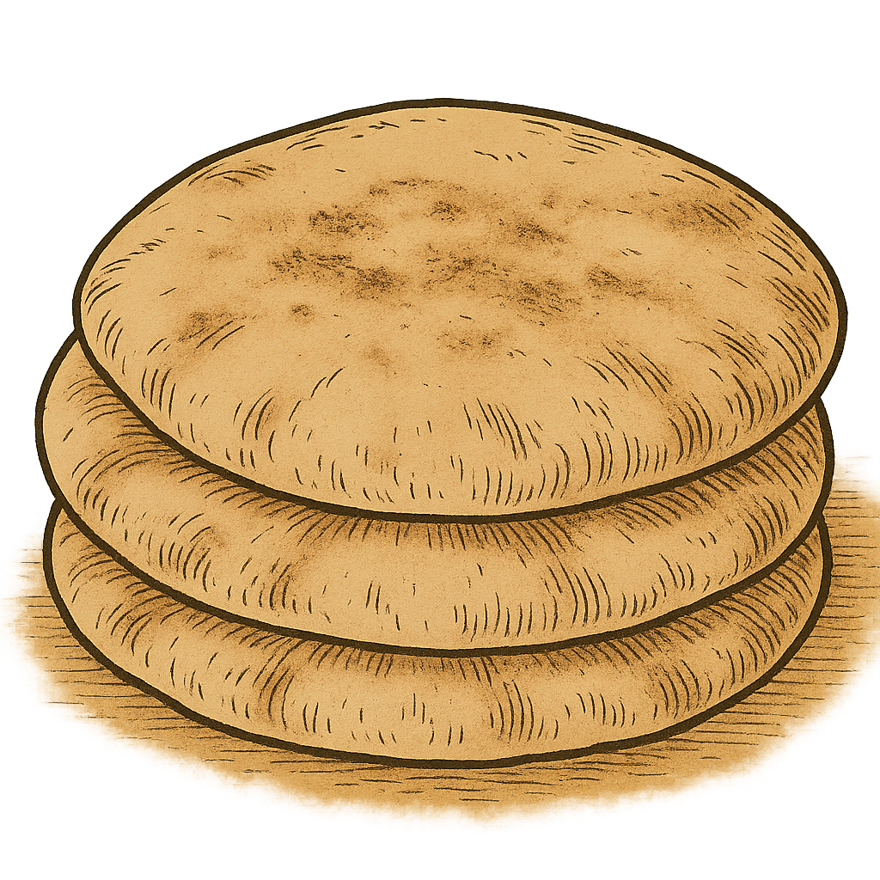

Translation:
A stack of flat bread (pita) (© jeffreyw, CC BY 2.0, via Wikimedia Commons)Most languages that have a word for bread will also have a word for “loaf,” that is, an individual unit of bread. In many places in Scripture, the word that indicates one unit of bread is simply “bread,” so it may be rendered “loaf” in these places (see the discussion under 9.4 Bread<REALIA:9.4>).
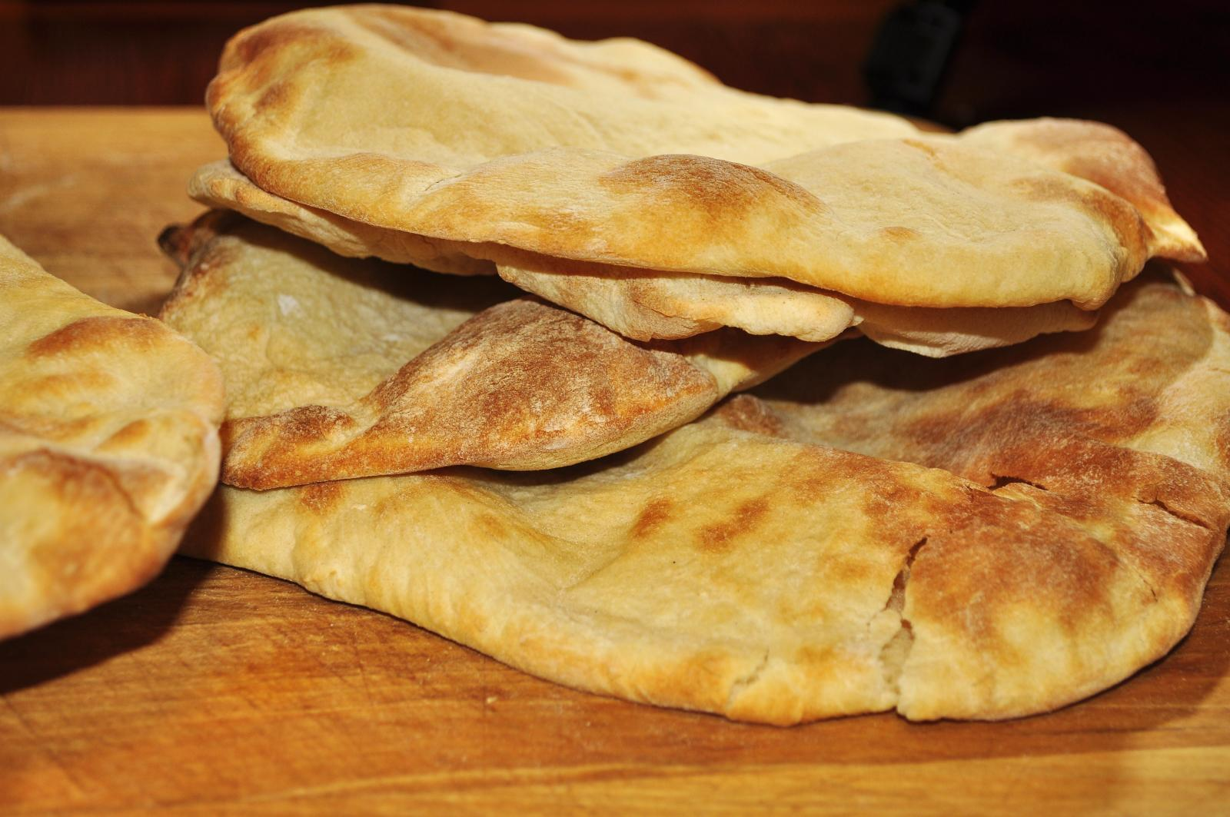
JDG 7:13: The important characteristic of the barley loaf in this verse is that it rolls down the hill. Where a language distinguishes between types of loaves according to shape, a word for a round loaf would be appropriate here.
Consecrated bread, bread of the presence, showbread: See 4.3.5.1 Consecrated bread, bread of the presence, showbread<REALIA:4.3.5.1>.

Unleavened bread

9.4.4 Unleavened bread

References:Hebrew מַצָּה (matsah)GEN 19:3, EXO 12:8, EXO 12:15, EXO 12:17, EXO 12:18, EXO 12:20, EXO 12:39, EXO 13:6, EXO 13:7, EXO 23:15, EXO 23:15, EXO 29:2, EXO 29:2, EXO 29:2, EXO 29:23, EXO 34:18, EXO 34:18, LEV 2:4, LEV 2:4, LEV 2:5, LEV 6:9, LEV 7:12, LEV 7:12, LEV 8:2, LEV 8:26, LEV 8:26, LEV 10:12, LEV 23:6, LEV 23:6, NUM 6:15, NUM 6:15, NUM 6:17, NUM 6:19, NUM 6:19, NUM 9:11, NUM 28:17, DEU 16:3, DEU 16:8, DEU 16:16, JOS 5:11, JDG 6:19, JDG 6:20, JDG 6:21, JDG 6:21, 1SA 28:24, 2KI 23:9, 1CH 23:29, 2CH 8:13, 2CH 30:13, 2CH 30:21, 2CH 35:17, EZR 6:22, PRO 13:10, PRO 17:19, ISA 58:4, EZK 45:21Greek ἄζυμος (azumos)MAT 26:17, MRK 14:1, MRK 14:12, LUK 22:1, LUK 22:7, ACT 12:3, ACT 20:6, 1CO 5:7, 1CO 5:8, 1ES 1:11, 1ES 1:17, 1ES 7:14

Description:
Unleavened bread (© Edsel Little, CC BY-SA 2.0, via Wikimedia Commons)Unleavened bread was a thin cracker-like bread resulting from baking the dough quickly before fermentation could cause it to rise.
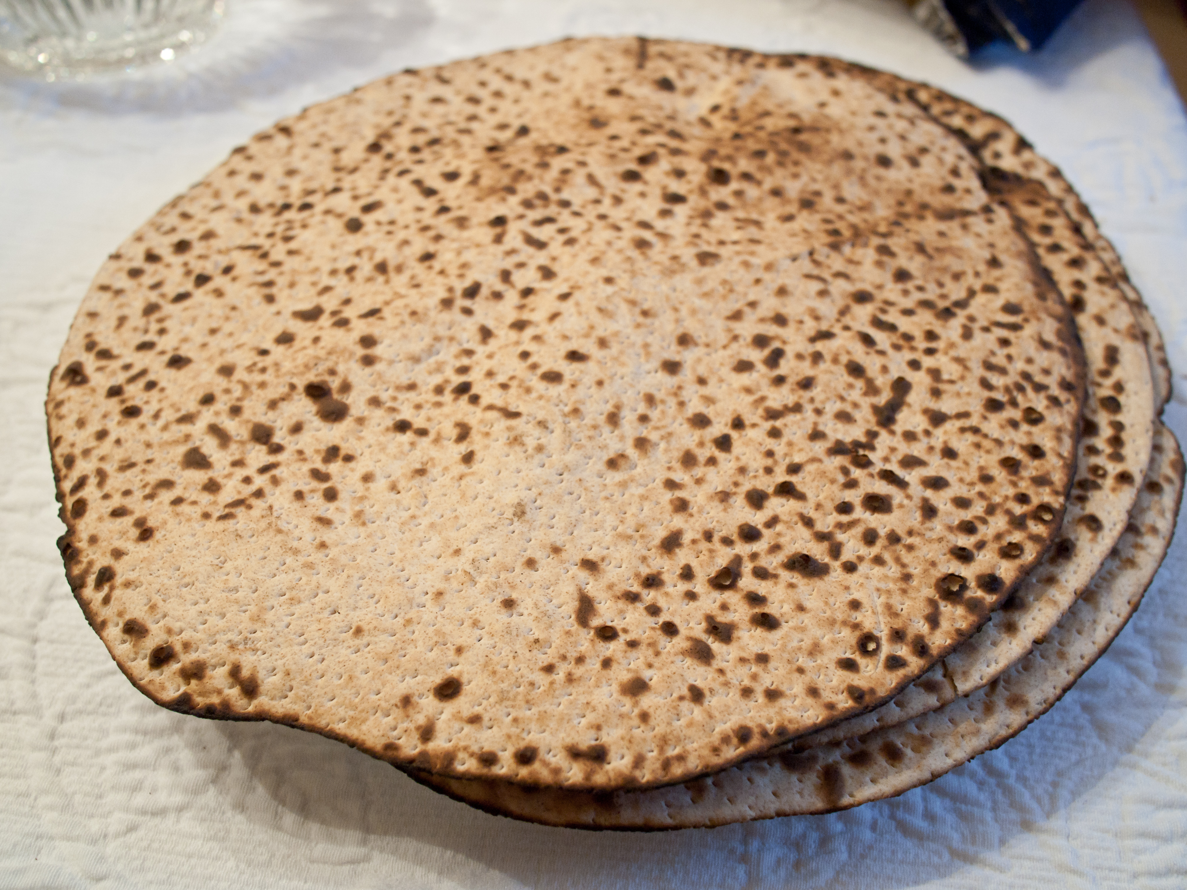

Usage:
When the people of Israel left Egypt in a hurry, they baked their bread quickly before it had time to rise. Such bread became a symbol of their redemption from Egypt and was included as a special feature of the Feast of Passover, which celebrated that redemption. It was also included in some of the sacrificial offerings.

Translation:
The phrase “unleavened bread” may be rendered “bread made without yeast” or “bread that does not rise.” Some languages will have to say “bread lacking that which causes it to rise.”
Except for 1CO 5:7; 1CO 5:8, in which the Greek word azumos occurs in a highly figurative passage referring to pure and true life, this term is used exclusively in the New Testament in reference to the Feast of Unleavened Bread.

