Resource: Human-made Things in the Bible
Human-made Things in the Bible © United Bible Societies, 2025. Adapted from: The Works of Their Hands: Man-made Things in the Bible, by Ray Pritz © 2009 United Bible Societies. This work is licensed under Creative Commons Attribution-ShareAlike 4.0 International (https://creativecommons.org/licenses/by-sa/4.0/).

Human-made Things in the Bible

Weights

11.1 Weights

The metric and imperial equivalents given in the tables are rounded-off approximations. While they should suffice for purposes of translation, they are not intended to present a high degree of mathematical precision.
Old Testament:
Name: Talent (kikar)
Equivalence: 60 minas
Metric: 34 kilograms
Imperial: 75 pounds
Name: Mina (maneh, mna)
Equivalence: 50 shekels
Metric: 0.6 kilogram
Imperial: 1.25 pounds
Name: Shekel (sheqel)
Equivalence:——
Metric: 12 grams
Imperial: 0.4 ounce
Name: Pim (pim)
Equivalence: 0.7 shekel
Metric: 8 grams
Imperial: 0.3 ounce
Name: Beqa (beqa‘)
Equivalence: 0.5 shekel
Metric: 6 grams
Imperial: 0.2 ounce
Name: Gerah (gerah)
Equivalence: 0.05 shekel
Metric: 0.6 gram
Imperial: 0.02 ounce
New Testament and Deuterocanon:
Name: Talent (talanton)
Equivalence: (See 11.6 Money<REALIA:11.6>)
Name: Pound (litra)
Equivalence:——
Metric: 327 grams
Imperial: 11.5 ounces

Gerah

11.1.1 Gerah

References:Hebrew גֵּרָה (gerah)EXO 30:13, LEV 27:25, NUM 3:47, NUM 18:16, EZK 45:12

In all of these references, the gerah only appears as a definition of the shekel, of which it is 1/20; that is, the gerah has no significance apart from the shekel. If the name “shekel” is retained in translation, then the name “gerah” may also be kept. If the word “shekel” is translated, it may still be possible to retain the word “gerah,” because you will just be saying it is 1/20 of the unit used for “shekel.”

Beqa

11.1.2 Beqa

References:Hebrew בֶּקַע (beqa‘)GEN 24:22, EXO 38:26

In EXO 38:26 a beqa‘ is defined as half a shekel. In GEN 24:22 it is the weight of a gold nose ring. NRSV just converts it to the shekel weight by saying “a gold nose-ring weighing a half shekel.” The beqa‘ equals 10 gerahs.

Pim

11.1.3 Pim

References:Hebrew פִּים (pim)1SA 13:21
This stone weight has its name, 'pim', inscribed on it in ancient Hebrew letters (Funhistory, CC0, via Wikimedia Commons)“The charge was a pim” (haptsirah fim): The meaning of these two Hebrew words is highly conjectural. While most translators agree with RSV that they indicate some unit of payment, others have thought that they refer to another kind of metal implement. However, the KJV rendering “file” (which would hardly need sharpening but which could itself be used to sharpen things) is surely incorrect. Archaeologists in the land of Israel have found a number of small round stone objects, each weighing about 7.5 grams (¼ ounce; that is about ⅔ of a shekel) and inscribed with the word pim (= fim).
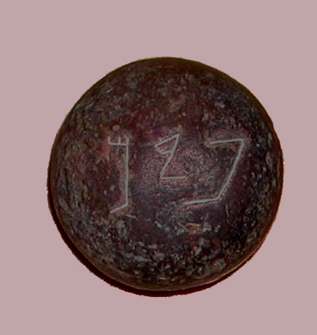

Peres, Parsin

11.1.4 Peres, Parsin

References:Aramaic פְּרֵס (peres)DAN 5:25, DAN 5:28

The basic meaning of the Aramaic word peres (plural form parsin) is “division,” “split,” “partition,” or “separation.” It seems in the context of DAN 5:25–DAN 5:28 to indicate either half a mina or half a shekel. However, this meaning is of little significance in the narrative and does not need to be reflected either in the translation or in a note. The first sentence of CEV for these verses is a good model: “The words written there are mne’, which means ‘numbered,’ teqel, which means ‘weighed,’ and parsin, which means ‘divided.’ ” To this CEV adds the following footnote: “In the Aramaic text of verse 25, the words ‘mene, tekel, parsin,’ are used, and in verses 26–28 the words ‘mene, tekel, peres’ (the singular of ‘parsin’) are used. ‘Parsin’ means ‘divided,’ but ‘peres’ can mean either ‘divided’ or ‘Persia.’ ”

Pound

11.1.5 Pound

References:Greek λίτρα (litra)JHN 12:3, JHN 19:39

JHN 12:3: In this verse the “pound” (RSV; litra in Greek) of costly ointment would have been kept in a relatively small container, something that would hold about a third of a kilogram. This corresponds to the volume of a small jar or tin can today. PV says “half a liter.”
In focus here is not so much the amount of perfume but rather its high value. Translators should ensure that the amount of the ointment chosen to translate this verse would indeed be expensive (about a year’s wages; see the discussion under dēnarion below, 11.6.2.6 Drachma<REALIA:11.6.2.6>).
It may be most effective to substitute a container for the volume and begin this verse with “Mary took a bottle of very expensive perfume” (GW).
JHN 19:39: RSV understands a litra to be equal to a pound, so at the end of this verse it has “about a hundred pounds’ weight.” This is misleading since the Roman litra contained only about three quarters of a modern pound. For this reason many English translations say “about 75 pounds” (so NIVNCV). In the metric system this will be “about 30 kilos” (FRCL).

