Resource: unfoldingWord® Open Bible Stories
unfoldingWord® Open Bible Stories © 2022 unfoldingWord. Released under CC BY-SA 4.0 license. unfoldingWord® Open Bible Stories has been adapted in the following languages: Tok Pisin, Arabic (عربي), French (Français), Hindi (हिंदी), Indonesian (Bahasa Indonesia), Portuguese (Português), Russian (Русский), Spanish (Español), Swahili (Kiswahili), and Simplified Chinese (简体中文) from unfoldingWord® Open Bible Stories © 2022 unfoldingWord. Released under CC BY-SA 4.0 license by Mission Mutual

unfoldingWord® Open Bible Stories

25. Shetani Anamjaribu Yesu
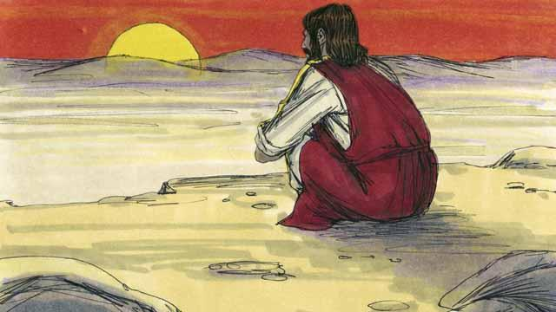
Mara tu Yesu alipokwisha kubatizwa, Roho Mtakatifu alimwongoza Yesu nyikani, huko alifunga siku arobaini mchana na usiku. kisha Shetani alifika kumjaribu Yesu ili atende dhambi.
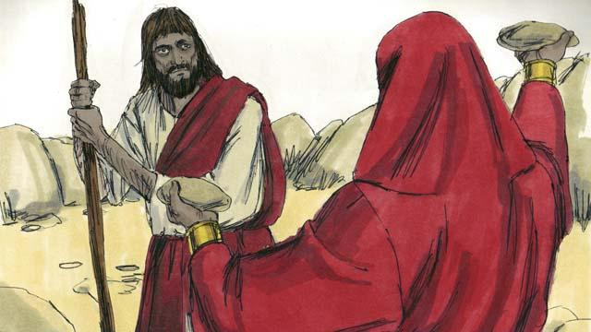
Shetani alimjaribu Yesu akisema; "Kama wewe ni mwana wa Mungu yaamuru mawe haya yawe mikate upate kula".
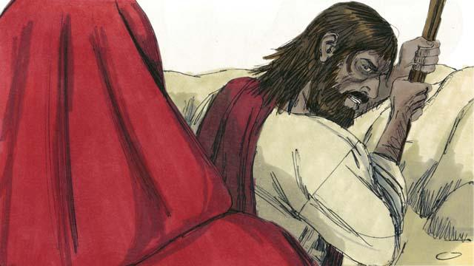
Yesu akajibu; "Imeandikwa katika neno la Mungu, watu hawahitaji mkate pekee ili wapate kuishi, bali wanahitaji kila neno linalosemwa na Mungu".
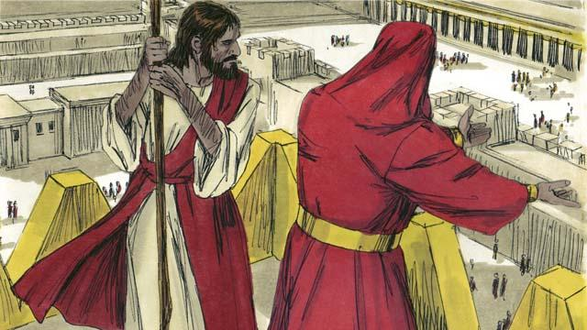
Kisha Shetani alimchukua Yesu mpaka juu ya mnara wa hekalu na kumwambia; "Kama wewe ni Mwana wa Mungu jirushe mwenyewe chini, kwa vile imeandikwa, Mungu atakuagizia malaika wake wakuchukue ili usijigonge mguu wako katika jiwe".
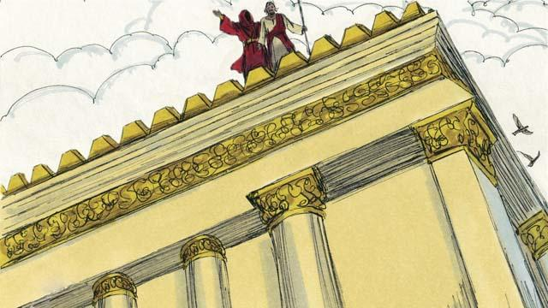
Lakini Yesu alimjibu Shetani kwa kunukuu Maandiko akisema; " Katika neno la Mungu, anaagiza watu wake, usimjaribu Bwana Mungu wako".
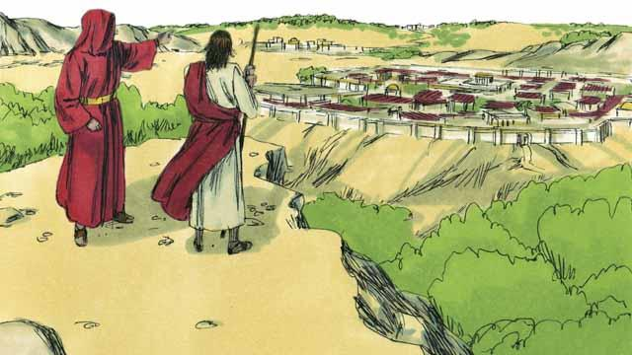
Kisha Shetani alimwonyesha Yesu falme zote za ulimwengu na fahari zake zote na akasema; "Nitakupa hivi vyote iwapo utanisujudia na kuniabudu mimi".
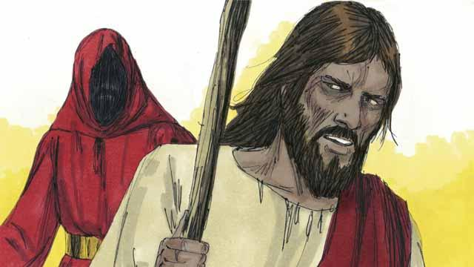
Yesu akajibu; ondoka kwangu Shetani! Katika neno la Mungu ameagiza, "Mwabudu Bwana Mungu wako na kumtumikia Yeye peke yake".
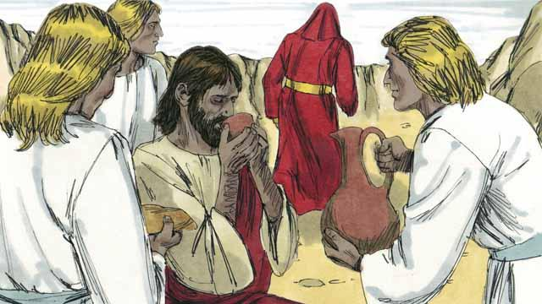
Yesu hakujitia chini ya majaribu ya Shetani, hivyo Shetani aliondoka akamwacha. kisha malaika walikuja na kumhudumia Yesu.
Simulizi ya Biblia Kutoka: Mathayo 4:1–11;
Marko 1:12–13; Luka 4:1–13

